Experiment No.8.

Program Name: An M-File to implement the Gauss Elimination method.

Problem: Solve the following system of equations by Gauss Elimination method.

2x1+3x2-x3+2x4=7

x1+x2+x3+x4=2

x1+x2+3x3-2x4=-6

x1+2x2+x3-x4=-2

Main file:

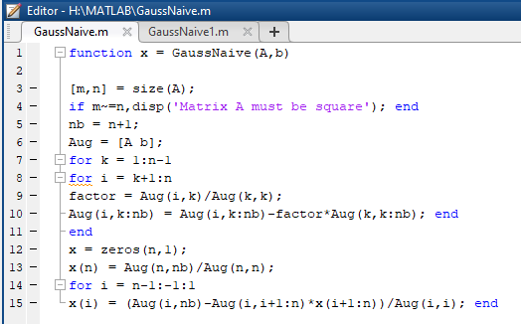

Input & output file:

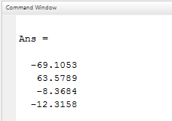 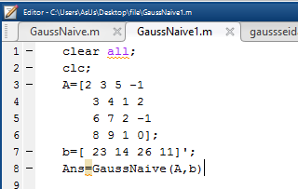

Main file:



Input & output file:

