Experiment No.9

Program Name: An M-File to implement the Gauss Seidel iterative method.

Problem: Solve the following system of equations by Gauss Seidel iterative method.

10x+2y+z=9

2x+20y-2z=-44

-2x+3y+10z=22

Main File:

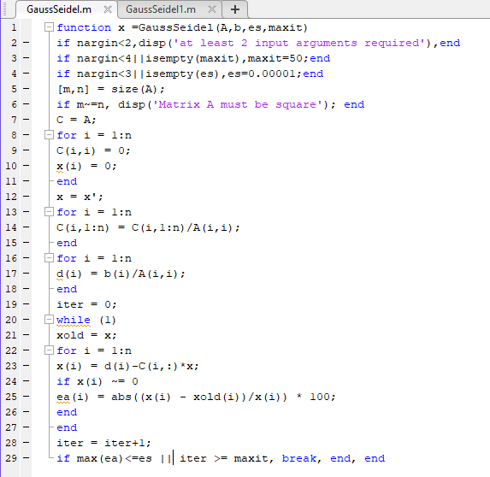

Input & output file:

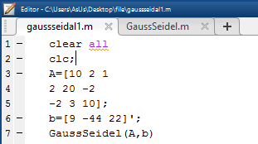

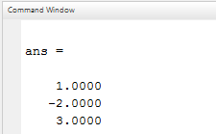

Input & output file of another program

