Settings Component

Content
Introduction 2
References 2

Introduction
The settings component is intended to store the specific settings of each component.

Guidelines
We intend to provide end users and developers with a standardized way of editing, storing and retrieving settings.
At this moment we already have the PersistentINI class that provides persistent storage to each component. It can be used a model to base the new class for settings that would ideally replace the need for PersistentINI.

STORAGE format
This section defines the data format that will be stored on the database.
- Title
- Type (defined on the Type section)
- Group (optional, defined on the Group section)
- Content
- X position or screen percentage (optional)
- Y position or screen percentage (optional)
- XX position (optional)
- YY position (optional)

Type
This section defines the available types of settings that are available to components and end-users.
- checkbox
- combobox
- textbox

Groups
Groups allow splitting the settings onto logical groups that entail specific settings. Each group shall have a title displayed as:
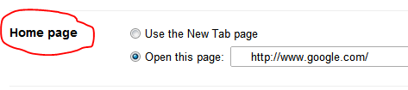
Setting items are displayed according to their group.

User interface
The user shall be able of changing the settings that are available for each component.

Security
Different layers of security that are advised:
- View and edit settings
- Add new settings

Questions
- Where do we define the type and format of the settings?
  - Each component should be able of adding new settings to their instance of the Settings component.
  - On each startup, it will create them if they do not exist and just move forward if they are already available?
- Esthetical issues
  - How can we add horizontal lines, images and group different sets of options?
    - Should we follow the example set by google forms?
- How are the permissions to edit available options managed?
  - Hard coded inside component and later modified on a per client basis?
  - We need user management, permission groups and so forth
    - Should it be added as a child component?

