Centrum application

This document details the Centrum application, focusing on the procedures between Centrum client and server running on local and remote instances of Remedium.

Index
- Introduction
- Purpose
- Properties on Process Manager
- Protocol scenarios
- References

Introduction
Centrum, from the Latin translation of “center”, is a role assigned to a machine that becomes considered as the central point of a given network, let it be a clan or Castrum.
Actors inside a given network will resort to a specific Centrum whenever in need of enrolling for the first time on a clan or Castrum. This act is also valid for cases when the connection between two actors is broken and needs to be reestablished.

Guidelines
The Centrum is used to help the other Remedium applications communicate with other instances of Remedium across a given group.
We separate this application in two different roles: a client and a server. We also define that can only exist one Centrum application running per Remedium instance.
Each Remedium instance will activate the Centrum application and start the Centrum client roles. We do not need to enable Centrum server role by default, this is an action that should be performed by the network administrator on a given Remedium instance of his choice.
When a Remedium instance is initiated, the Centrum application is initiated and starts the Centrum Client role, which in turn attempts to communicate with a Centrum Server that is typically located somewhere across the network cloud.
The Centrum Client knows where to find a Centrum Server because this value is manually set by the network administrator on each Remedium instance of the group under his control.
This initial call is made on a best-effort-delivery [1] effort, meaning that our Centrum Client has no idea if his message will indeed arrive to the designated Centrum Server or not.

Eventually, a message addressed to the Centrum Client will be placed on the Message Queue of the Remedium instance where the Centrum Client is located.
The Centrum Client receives this message and updates its status information on the Process Manager. The values present on the Process Manager are then used by other applications such as the Triumvir (Triumvir Client), which periodically pools the Centrum information located at the Process Manager to know the location of the designated Triumvir Server.

Properties on Process Manager
On this section we define the properties of the Centrum application that are found on the Process Manager, do not assume that all of them will be available since they are created on a per-use basis.
All values in the properties are defined as text (string) even though they will represent values such as numbers, time representations and so forth. We present below a table where each property is listed along with the intended type of value that is represented and its purpose.
Each application is responsible for converting the text value onto the intended value representation.
Designation | Type | Purpose
LastTriumvirUpdateRequest | Time | Marks the last time when an update request was issued
LastTriumvirUpdateSuccessful | Boolean | If there was a successful update from the Centrum Server, this value is true
LastTriumvirUpdate | Time | Marks the last time when an update was made, if none was made then this value is zero.

Protocol scenarios
The behavior protocol scenarios intended for interactions between Centrum Client and Centrum Server is depicted on the following scenarios.

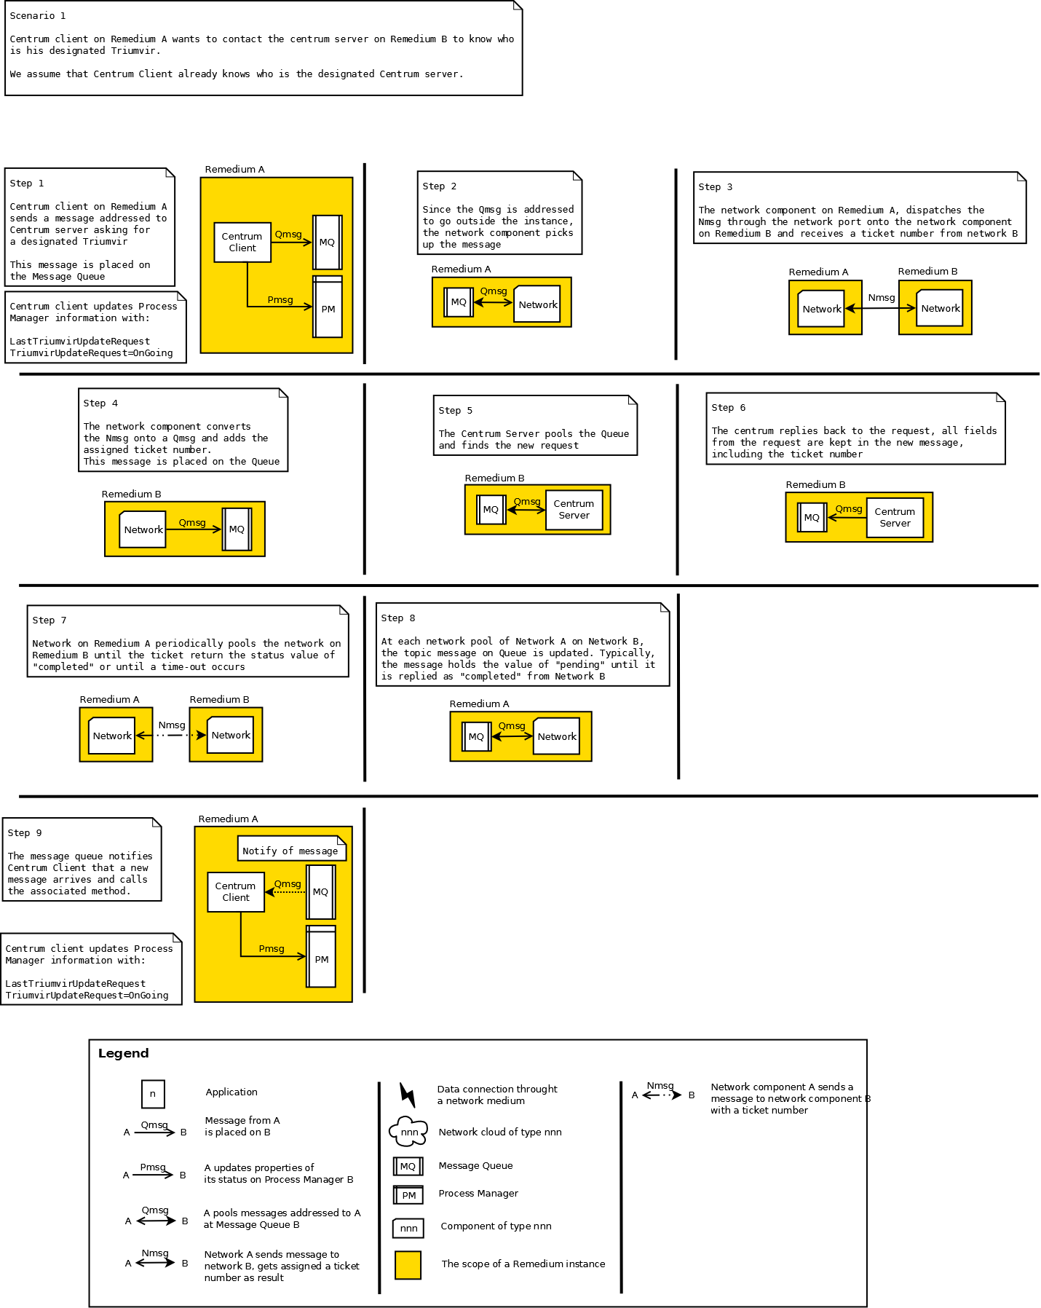

References

[1] http://en.wikipedia.org/wiki/Best_effort_delivery

