Introduce yourself with Scratch!

Your first Scratch assignment is to create a scenario in which a sprite introduces you to your classmates.

***Creating Your Game***

1. Choose any sprite from the Scratch library to represent yourself.





1. Choose any backdrop from the library and insert it into your scene.
2. Now it is time to write your script (or program). First, let’s tell the program when to display the speech bubble. From the “Events” scripts menu choose “When the green flag is clicked”. Every block that is connected to this event will be executed in the order specified.

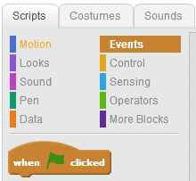

1. Your sprite will be talking, so choose the “say” block from the “Looks” scripts menu. Type your narrative in the field where “Hello!” originally appears. Make sure to adjust the number of seconds so that your text can be read easily.

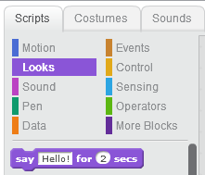

***Requirements***

Include the following information in your dialogue.

* Your name
* Why you are taking this class
* Your current career aspirations
* Your favorite part of the school day
* Your least favorite part of the school day
* Acitvities/Athletics in which you plan to participate
* Anything else you would like to share