**Brian Kolovich**

**MSDS 7346 Cloud Computing Mini Project 5**

**1) Sign up for MongoDB Atlas account**

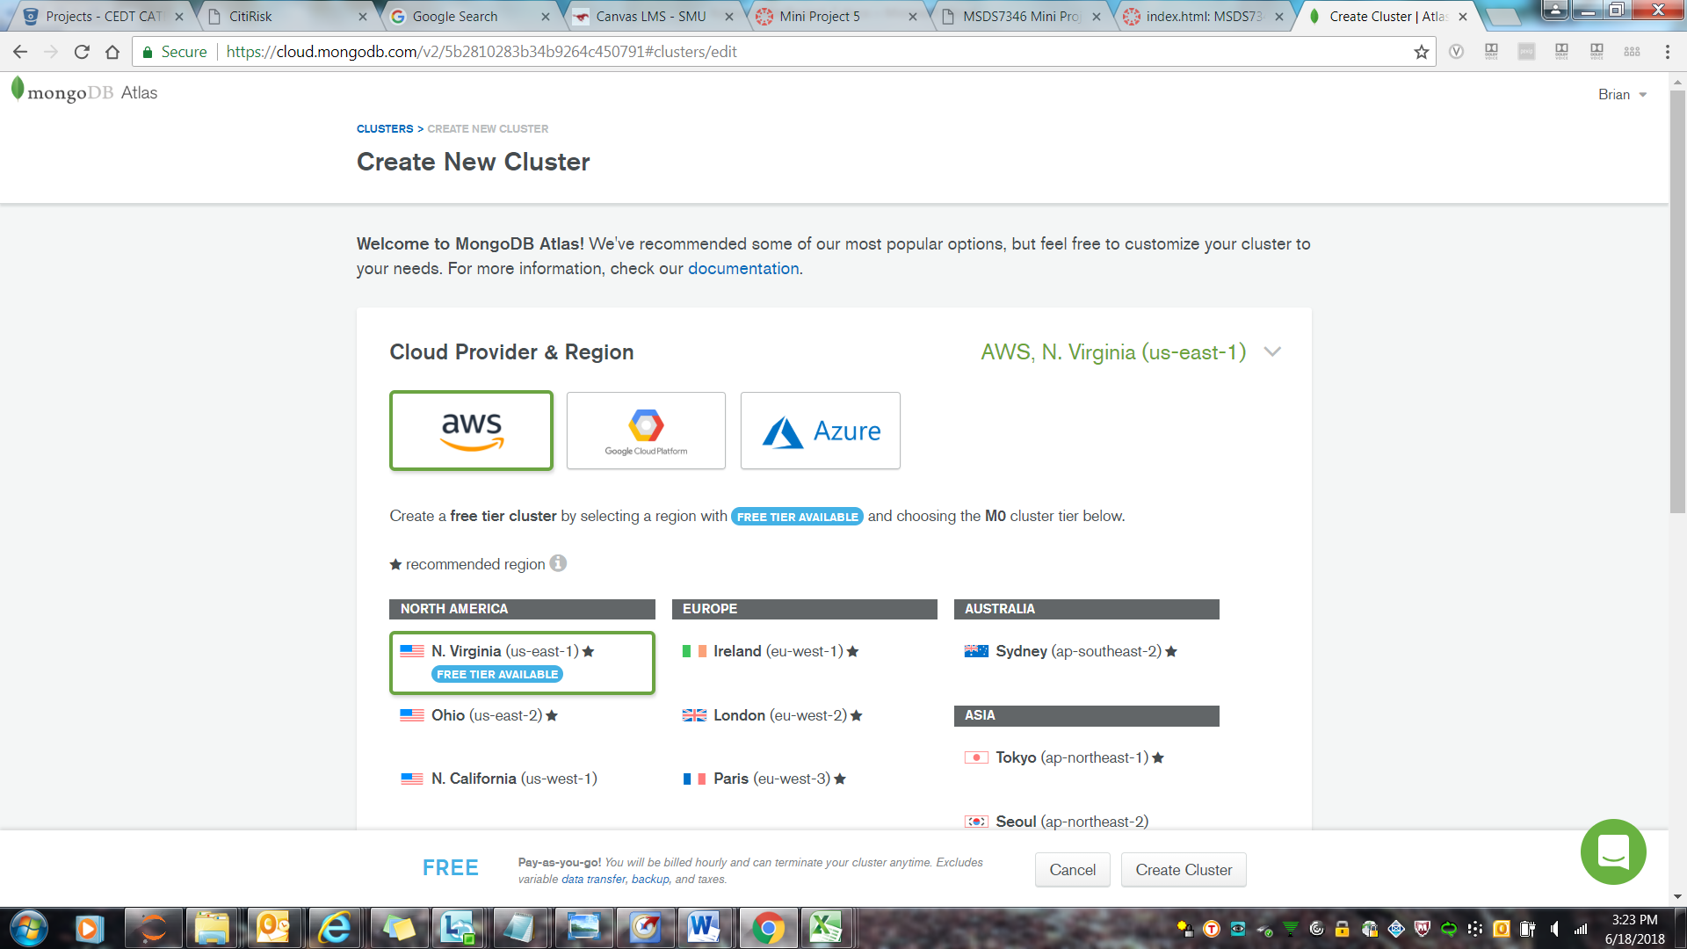

**2) Create a cluster in MongoDB Atlas**

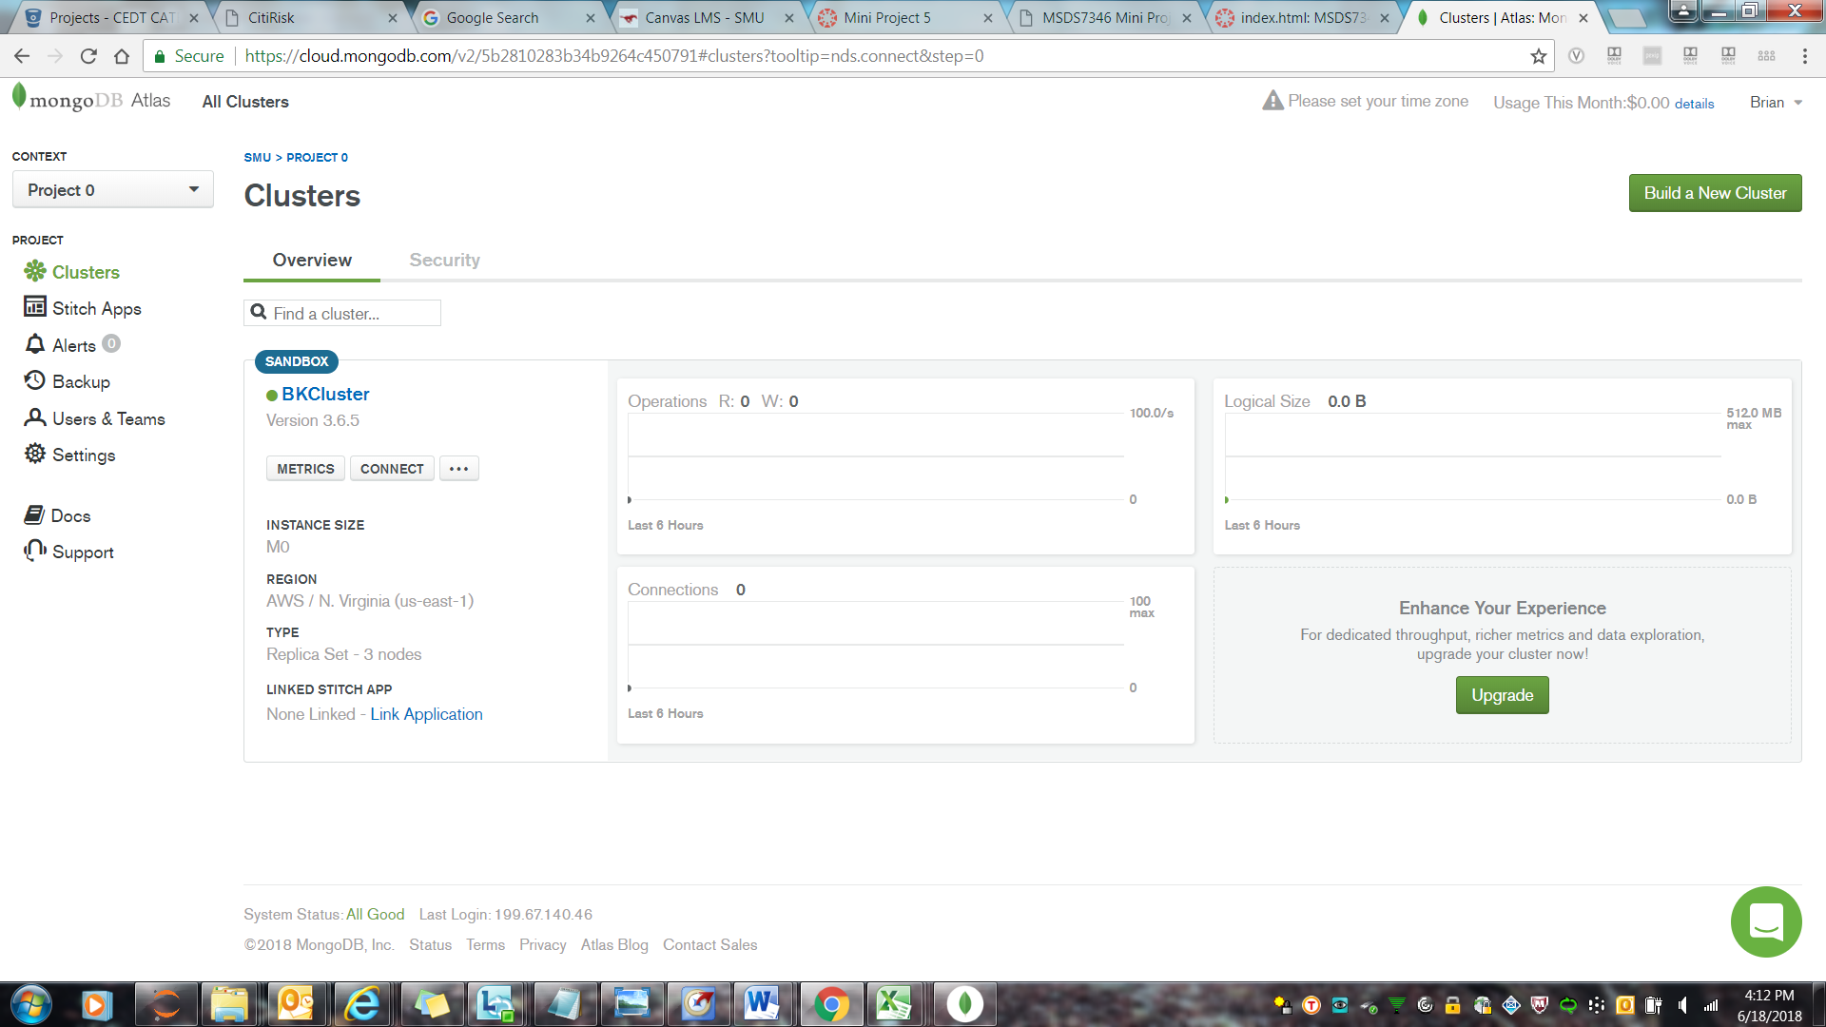

**3) Download MongoDB Compass**

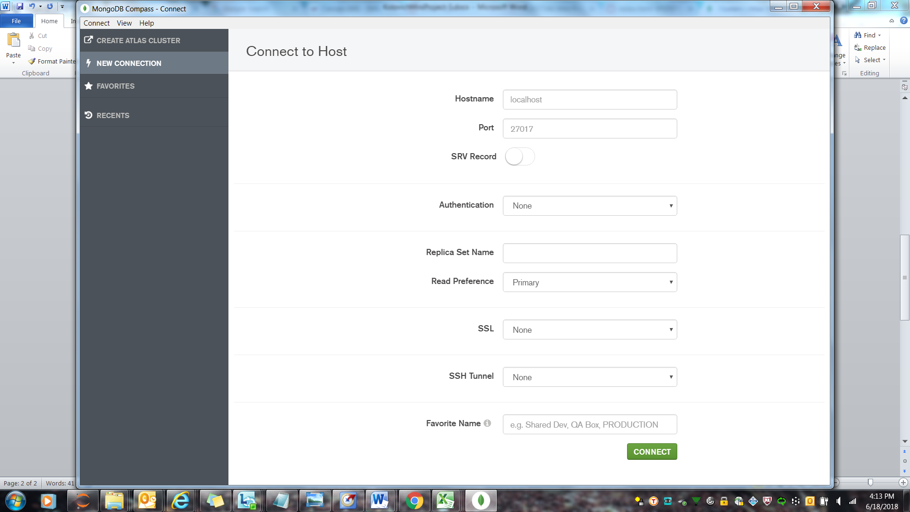

**4) Connect MongoDB Compass to Atlas’s cluster**

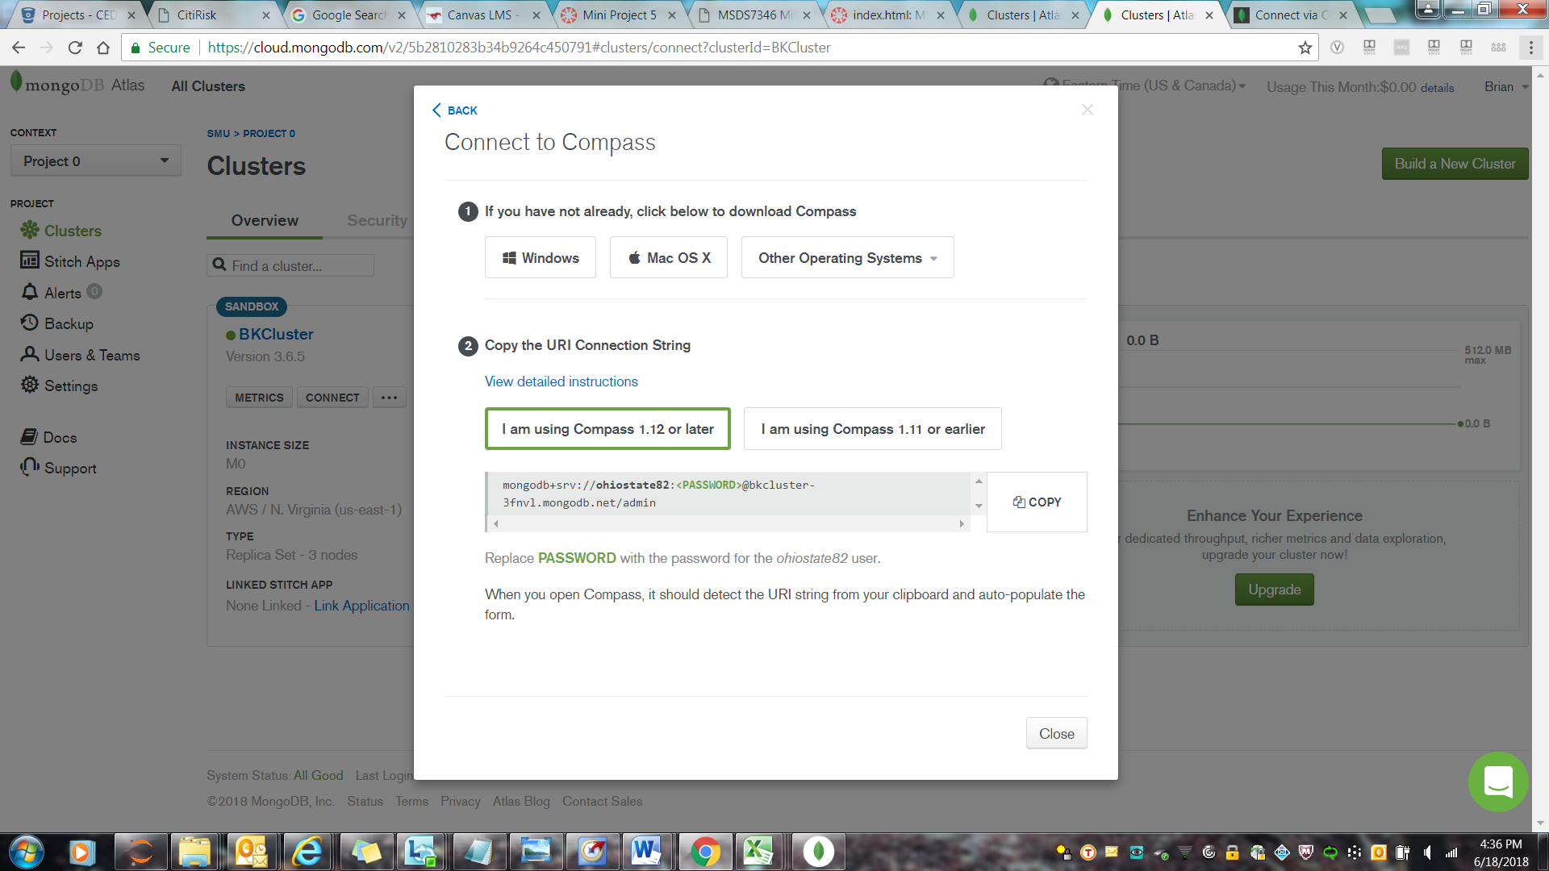

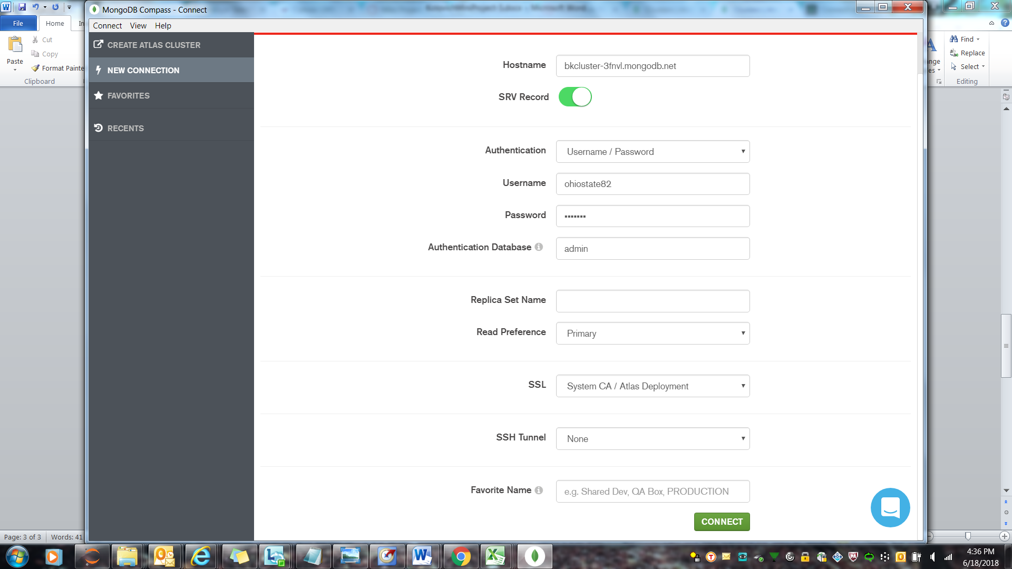

**5) Experiment with Compass as stated above**