**Brian Kolovich**

**MSDS 7346 Cloud Computing Midterm Exam**

Question 1 : In this problem you will create a Google compute engine instance and setup a web-server on the instance.

1. **If you do not already have Google subscription, please sign up and then create a new project.**

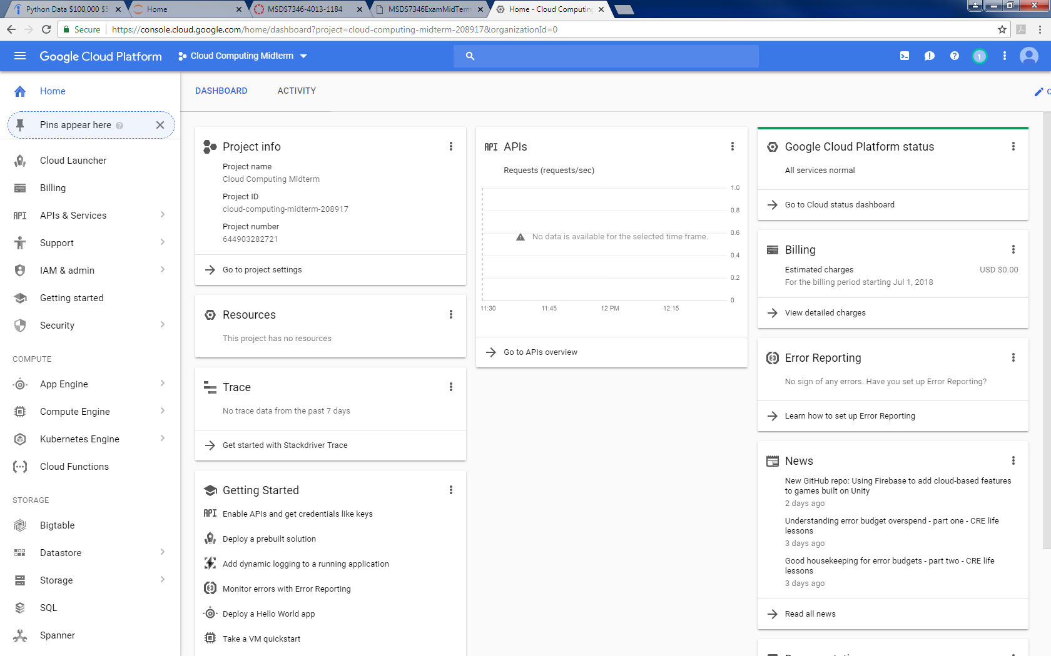

1. **Log into the Google Cloud Platform account and open up a Compute Engine console**

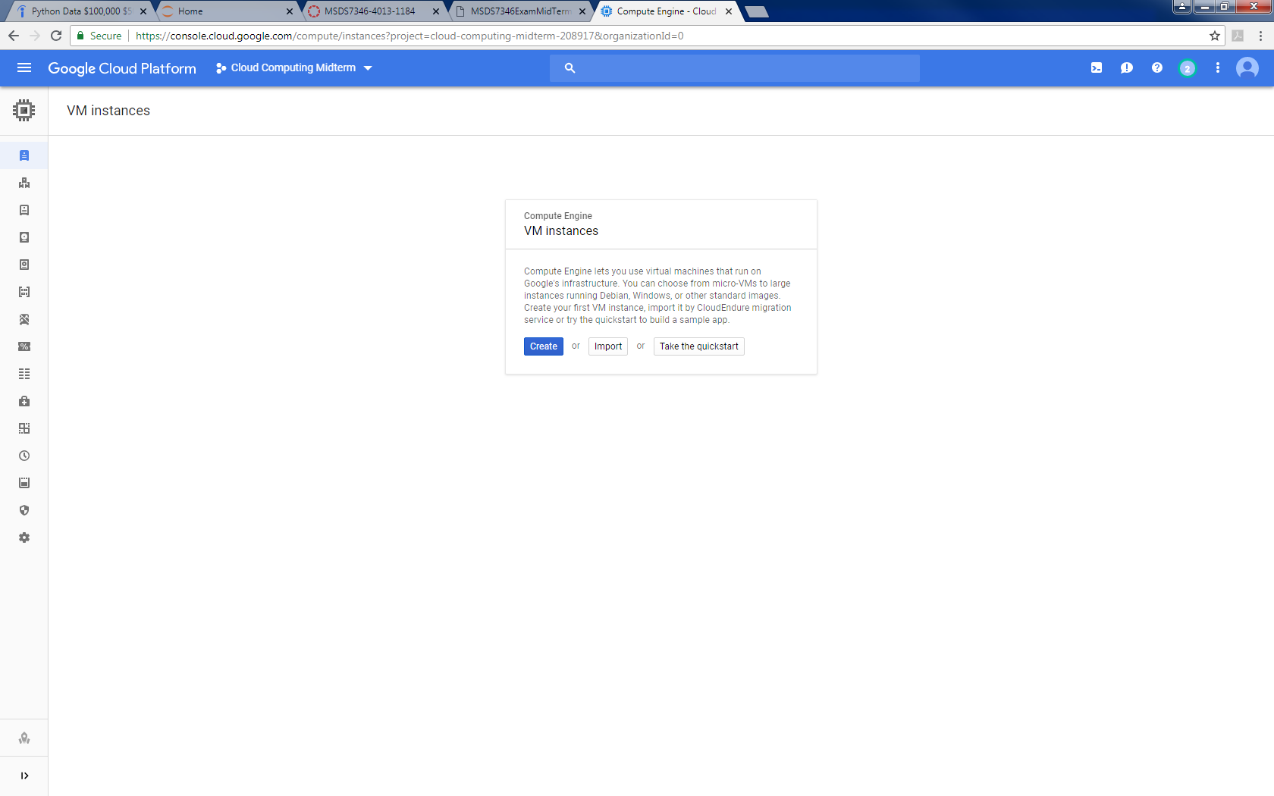

1. **Create a new instance**

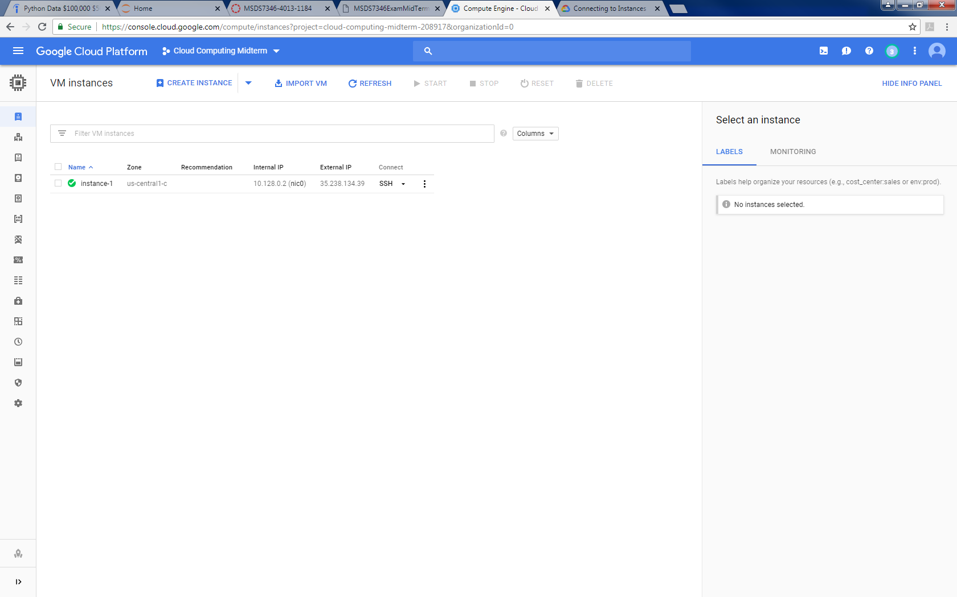

1. **Connect to that instance using ssh**

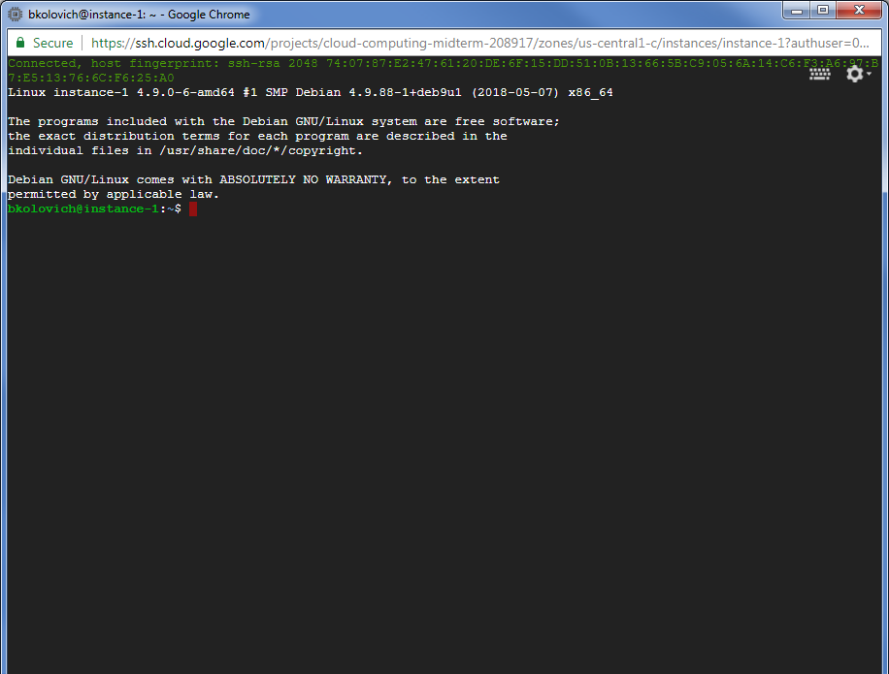

1. **Install apache server. Use ”apt-get” command to install ”apache2”**

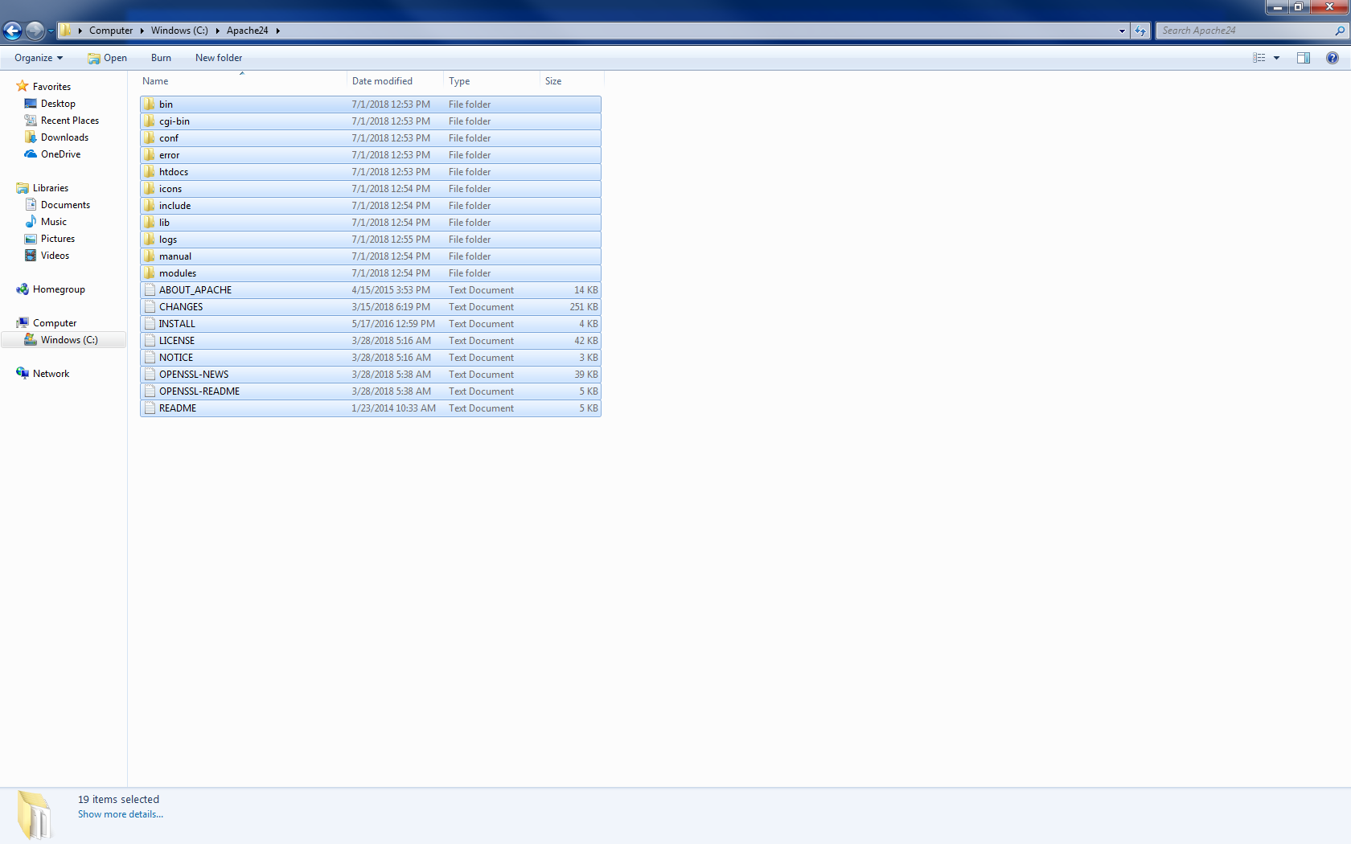

1. **Open up the web page using the public IP address and view the webpage.**

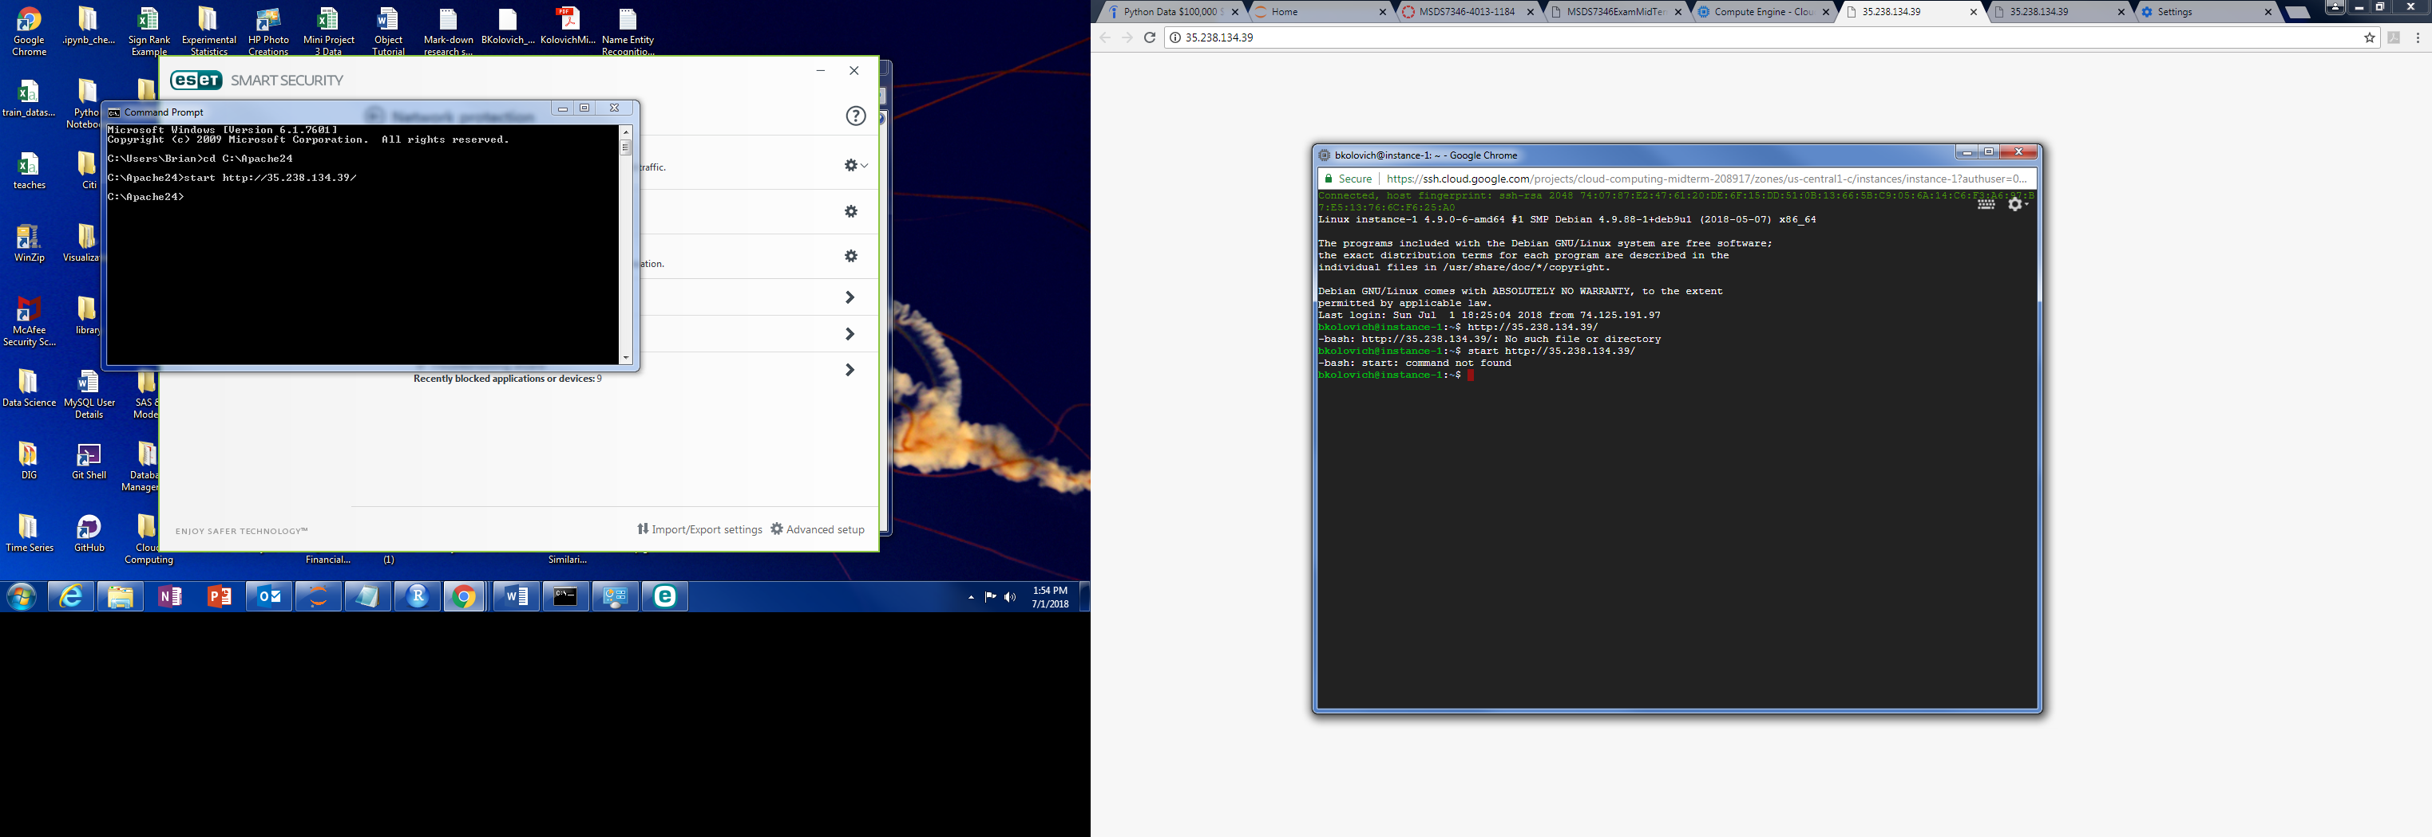

Question 2 : In this problem you will create a MySQL database using the Google Cloud SQL service.

1. **From the Google Cloud Console launch Cloud SQL**

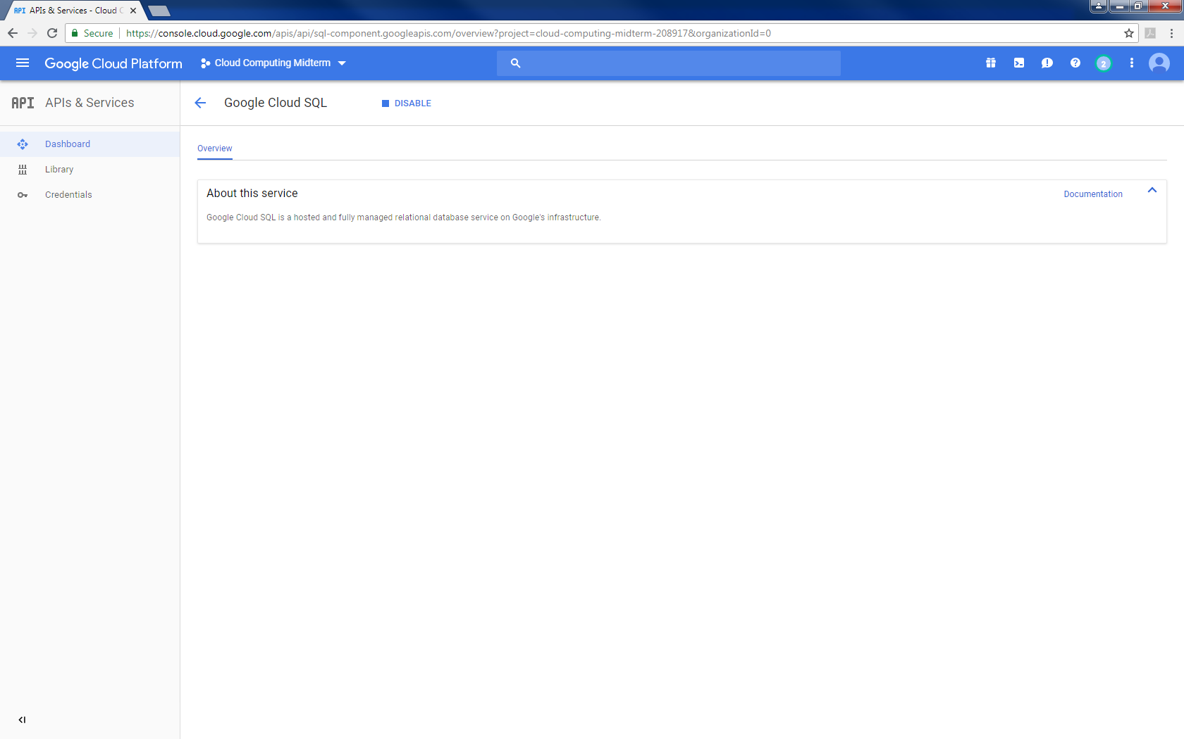

1. **Launch MySQL**

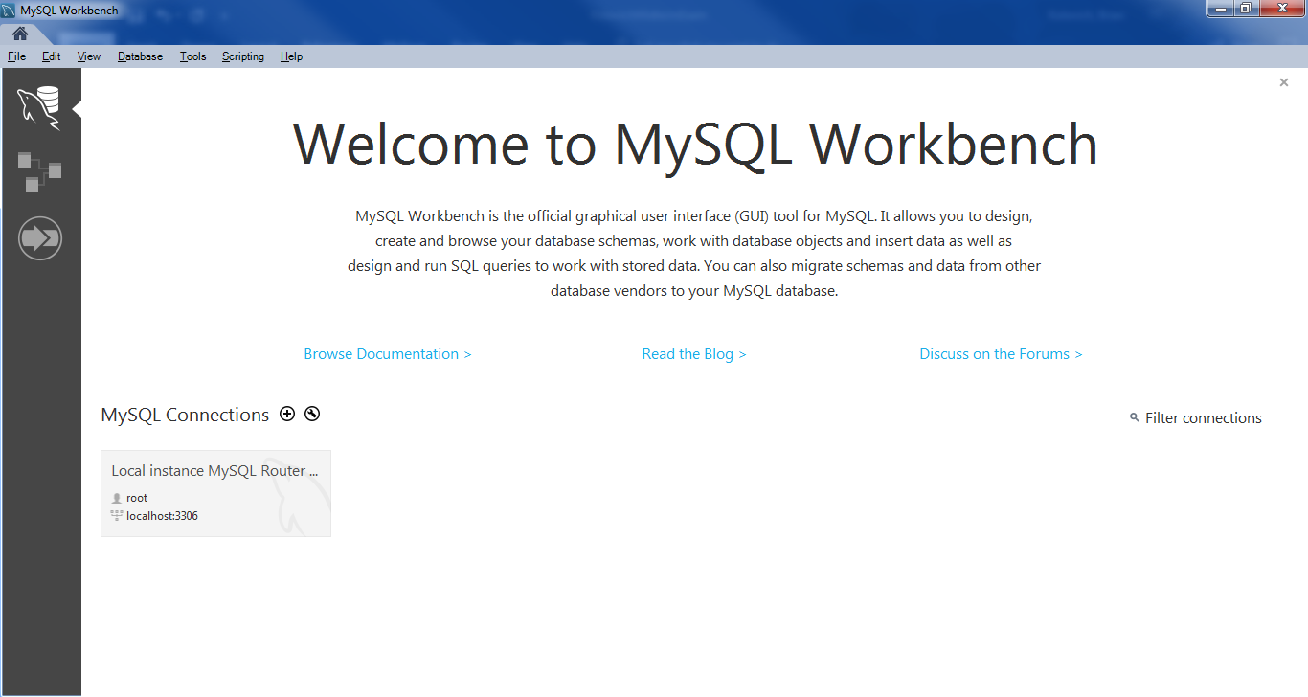

1. **Specify anyone to access the MySQL instance.**

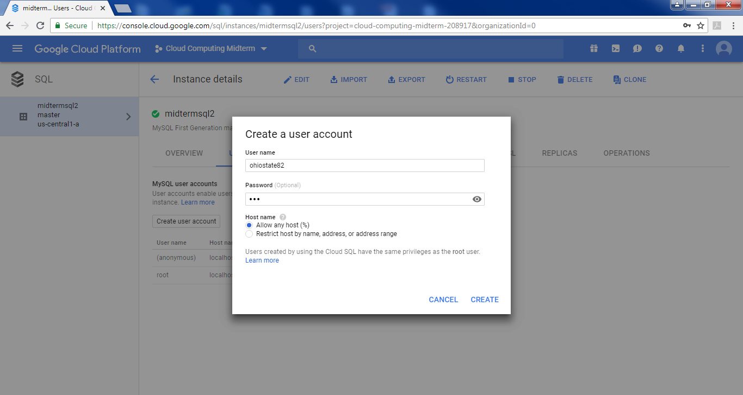

1. **Connect to the MySQL instance using the MySQLWorkbench running on your local machine.**

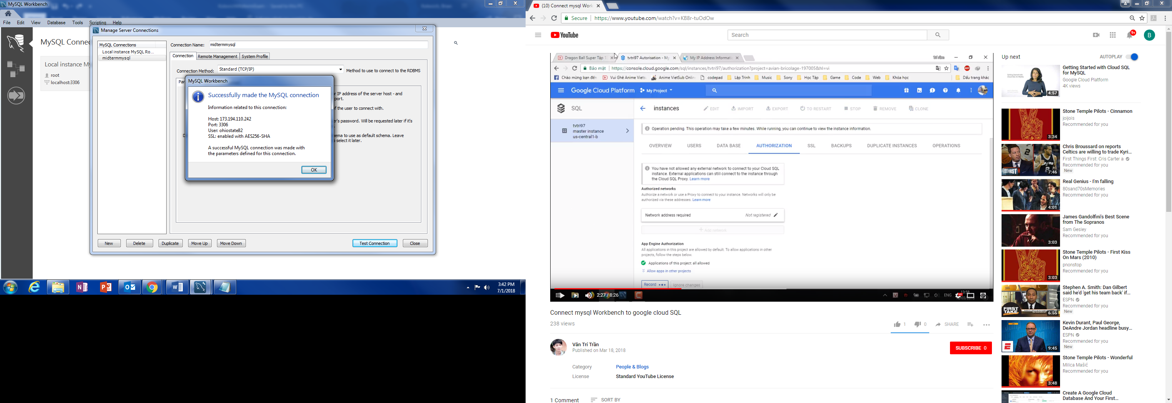

1. **Create a database from within MySQLWorkbench**

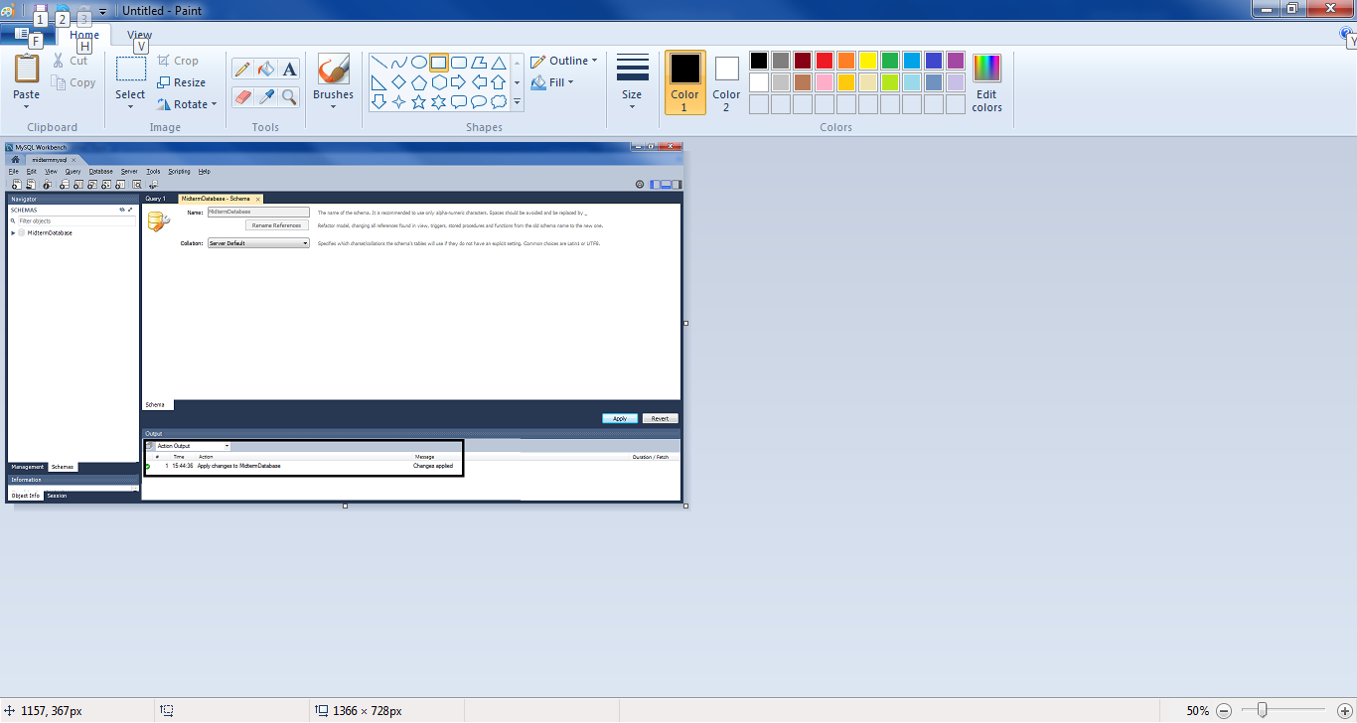

**6) Make sure it shows up in the Google Cloud Console.**

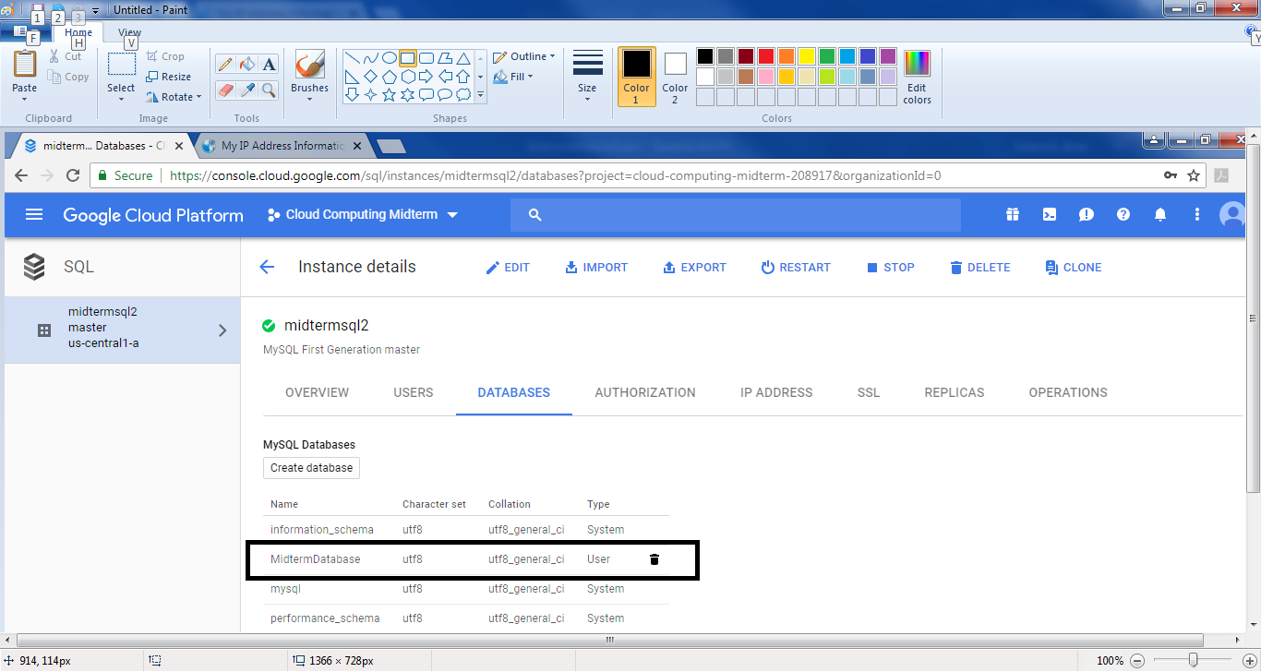

Question 3 : Install a static website on Google Cloud Storage.

1. **Use the bluesky static website on Google Cloud Storage**
2. **Make that website publicly available**

**3) Specify anyone to access the MySQL instance.**