**Brian Kolovich**

**MSDS 7346 Cloud Computing Mini Project 3**

Question 1: Host a static website on AWS S3

I have provided a static website as part the mini project. Upload the website to AWS S3 bucket as we did in the class. Change the title of the website to make the website public. Make sure it is accessible from outside.

Submission: Submit screenshots of S3 bucket, and the website.

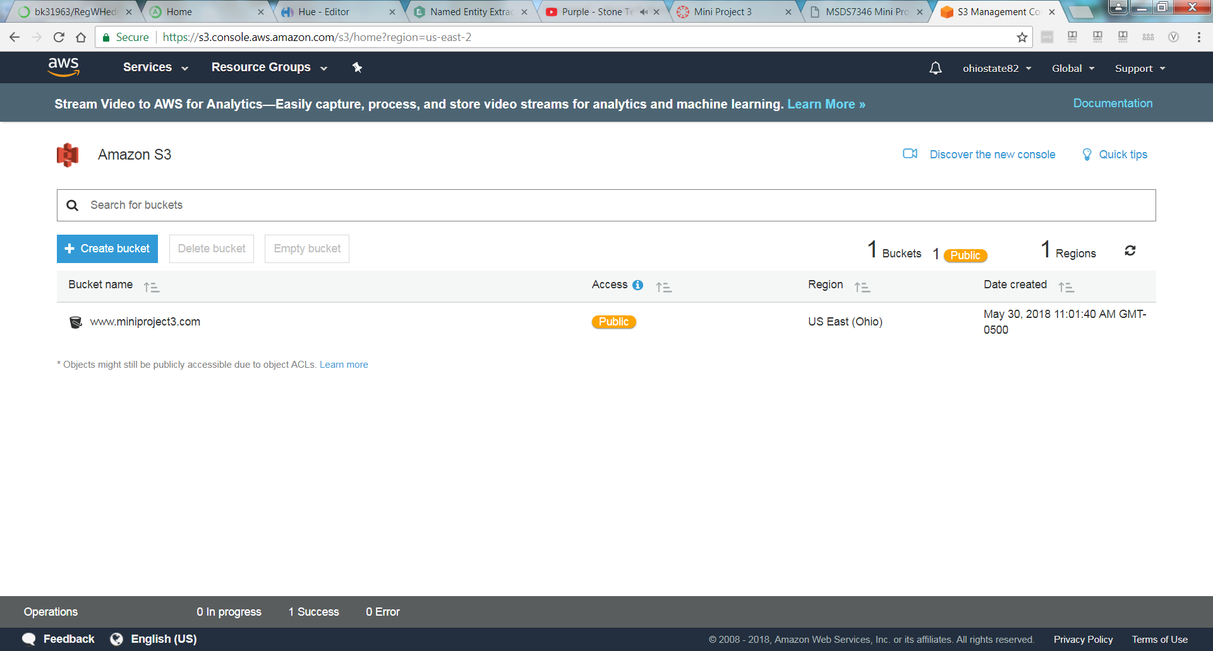

https://s3.console.aws.amazon.com/s3/buckets/www.miniproject3.com/?region=us-east-2&tab=properties

**Take screenshot of this site**

http://www.miniproject3.com.s3-website.us-east-2.amazonaws.com

Question 2: Distribute content using AWS CloudFront – CDN

In this problem you will take the static website developed in the previous question and distribute it to the edge network using AWS CloudFront. CloudFront is available in the “Network & Content delivery” section of AWS Services. This enables you to push the content closer to the user using edge network provided by AWS. You are expected to experiment with CloudFront and distribute your static website. Since you are distributing a static website, you will use HTTP/HTTPS to deliver the content. You can use all edge locations or only US and Europe, for the purposes of this exercise it is not critical which locations you use.

Once the website is deployed access it using couple of different browsers and a mobile device. In the CloudFront, look under ”Report & Analytics” and check ”Usage” and ”Viewers”.

Submission: Submit screenshots of the ”Usage” and ”Viewers” under CloudFront.