Run the ‘HairAndTortoiseForm.cs’ file from the C# IDE/Visual Studio to play:

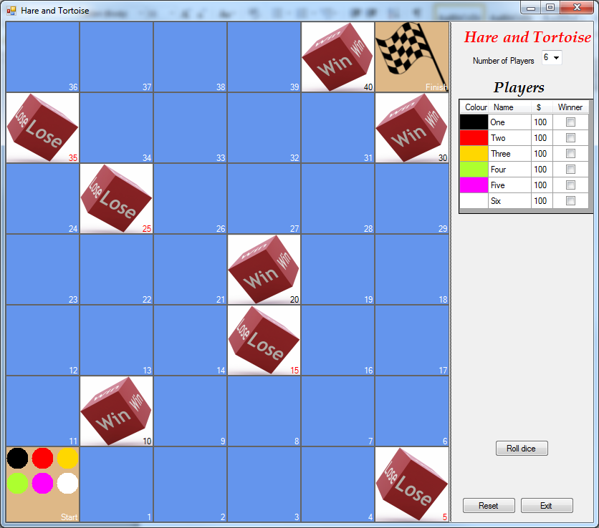

The above screenshot shows the game with 6 players, at the start of the game. Each of the 6 players has a coloured token (or “piece”) on the Start square. (If you want to see a bigger picture, right-click on the screenshot, select **Format Picture...,** then the **Size** tab, and then increase the **Height** – or **Width** – to 80% or more.).

# The Hare and Tortoise Game

This is entirely fictitious board game and bears no resemblance to the fable of the Hare and the Tortoise (by Aesop) or any existing on-line game of the same name.

The game is played with a board consisting of 40 actual squares, a pair of six-sided dice and can be played by 2 or more players up to a limit of 6. The squares are numbered 1 to 40.

The game commences with all players starting off the board. (Think of the Start as being square 0.) One at a time, the players take a turn. This involves rolling the pair of dice and advancing their respective tokens on the board the required number of squares. When all the players are done with their turn, it is called *a round*.

Each player has a sum of money, they all start with $100.

There are three types of squares on the board: “ordinary”, “bad investment lose’ and “lottery win”.

Squares 5, 15, 25 and 35 are “Bad Investment lose” squares. The effect when a player’s token lands on one of them is to subtract $25 from the player’s current sum of money, if the player has less than $25 his sum is set to zero. The sum cannot go below zero.

Squares 10, 20, 30 and 40 are “Lottery Win” squares. The effect when a player’s token lands on one of them is to add $10 to that player’s sum of money. As well the player continues his turn, rolls the dice again. Note: landing on the 40th square the player receives the additional money and the game is finished witout rolling the dice again.

The game continues until a player moves beyond the 40th square, reaching the Finish. (Think of the Finish as being square 41.) Players cannot move beyond the Finish.

When one or more players have finished, the winner will be the player who has the most money at this point of time, even if that particular player hasn't reached the Finish. Note that there may be more than one player with the highest amount of money, in this case they are all winners.