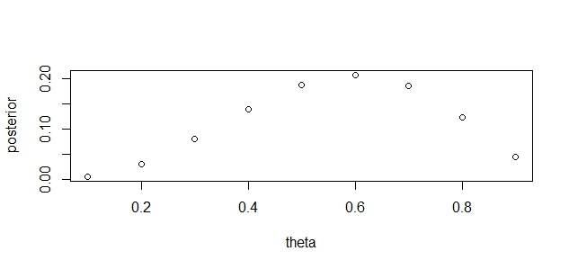

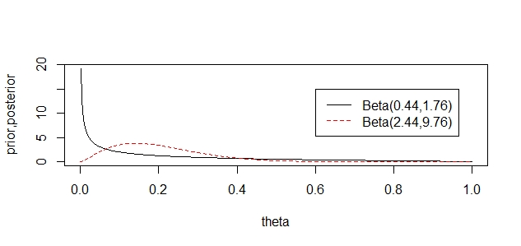

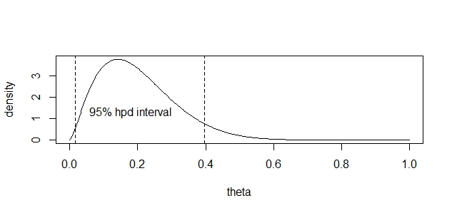

> hpd

[1] 0.01724634 0.39701437

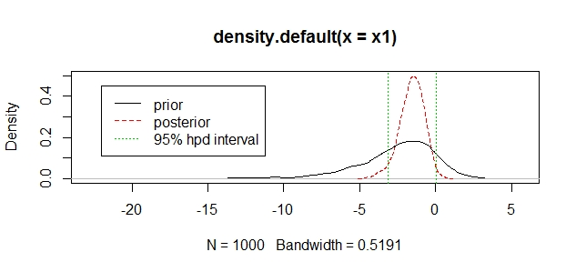

hpd2 #95% hpd interval

[1] -3.19365078 0.06963648

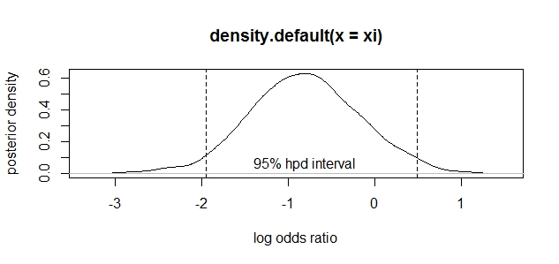

> mean(xi) #추정치

[1] -0.7884797

> sd(xi)/sqrt(1000) #표준오차

[1] 0.01973863

> hpd #95% hpd interval

[1] -1.9838082 0.4028487