**QC Homework #4 (Attribute Control Charts)**

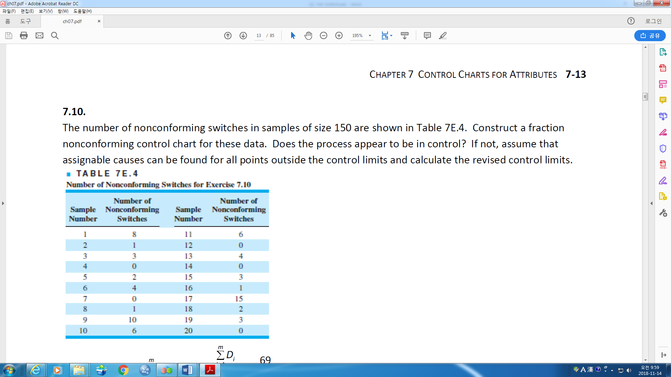

1. The number of nonconforming switches

in samples of size 150 are shown in Table.

Construct a fraction nonconforming control

chart for these data. Does the process appear

to be in control? If not, assume that assignable

causes can be found for all points outside the

control limits and calculate

the revised control limits.

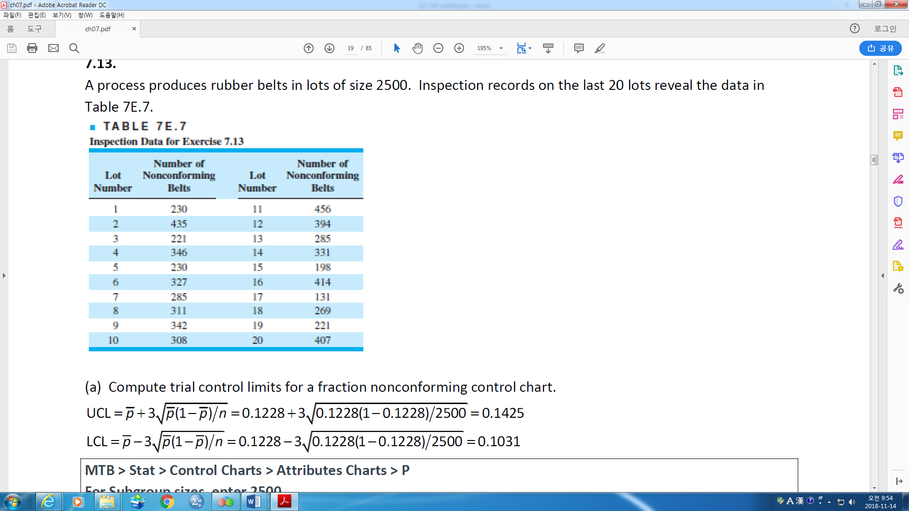

1. A process produces rubber belts in lots

of size 2500. Inspection records on the last

20 lots reveal the data in Table.

1. Compute trial control limits for a fraction

nonconforming control chart.

1. If you wanted to set up a control chart

for controlling future production,

how would you use these data to obtain

the center line and control limits for the chart?

1. A control chart indicates that the current process fraction nonconforming is 0.02. If 50 items are inspected each day, what is the probability of detecting a shift in the fraction nonconforming to 0.04 on the first day after the shift? By the end of the third day following the shift?
2. Diodes used on printed circuit boards are produced in lots of size 1000. We wish to control the process producing these diodes by taking samples of size 64 from each lot. If the nominal value of the fraction nonconforming is *p* = 0.10, determine the parameters of the appropriate control chart. To what level must the fraction nonconforming increase to make the *β*-risk equal to 0.50? What is the minimum sample size that would give a positive lower control limit for this chart?
3. A process is being controlled with a fraction nonconforming control chart. The process average has been shown to be 0.07. Three-sigma control limits are used, and the procedure calls for taking daily samples of 400 items.

(a) Calculate the upper and lower control limits.

(b) If the process average should suddenly shift to 0.10, what is the probability that the shift would be detected on the first subsequent sample?

(c) What is the probability that the shift in part (b) would be detect on the first or second sample taken after the shift?

1. None