**A4: Web Site Planning**

## Objectives

Use the website planning process introduced in this week’s lecture to begin planning and design for your website.

## Description

Please follow the steps below to figure out your network details. There are two parts to this assignment:

Part 1: Creating a local setup

Part 2: Setting up GitHub Pages

Part 3: Planning and Designing your Website

## What to Hand In

Post this document, with all the items in red filled out and name the file as “lis351-a4-[your name].docx” to Canvas on the “A4: Planning your website” assignment page.

## Part 1: Creating a local setup

Follow the steps below to set up your local environment to build and test your website.

1. Download a free text editor. You will use the editor to hand-code HTML and CSS for your website. I recommend TextEdit (MacOS), Notepad++ (Windows) or Visual Studio Code (Work for all systems).
2. Open the text editor you downloaded in the previous step and copy/paste the following HTML code to the document:

| <!DOCTYPE html>  <html lang="en">  <meta charset="UTF-8">  <title>Page Title</title>  <meta name="viewport" content="width=device-width,initial-scale=1">  <link rel="stylesheet" href="">  <style>  </style>  <script src=""></script>  <!--- Code above this line will not be displayed on the browser -->  <body>  <p> Hello world! </p>  </body>  </html> |
| --- |

1. Save the file with the name “index.html” and close the document. Open the document in a web browser (e.g., Google Chrome, Mozilla Firefox).
2. Navigate to the “index.html” file you created in step 1 and edit the code by adding the following text inside the <p> tag (excluding the quotation marks) [replace ***[Enter your name]*** with your name]:

“My name is ***[Enter your name]***”

1. Save “index.html,” return to your browser, and refresh your browser.
2. At this point, you should see “Hello World” and on a new line, “My name is [Enter your name]” on your web browser.
3. Over the next few weeks, you can use this process to write and test HTML code to ensure it displays on a web browser.

**What to submit for Part 1**:

Take a side-by-side screenshot of the text editor with your HTML code on the left side and the web browser on the right side (1 point)

[Attach your screenshot]

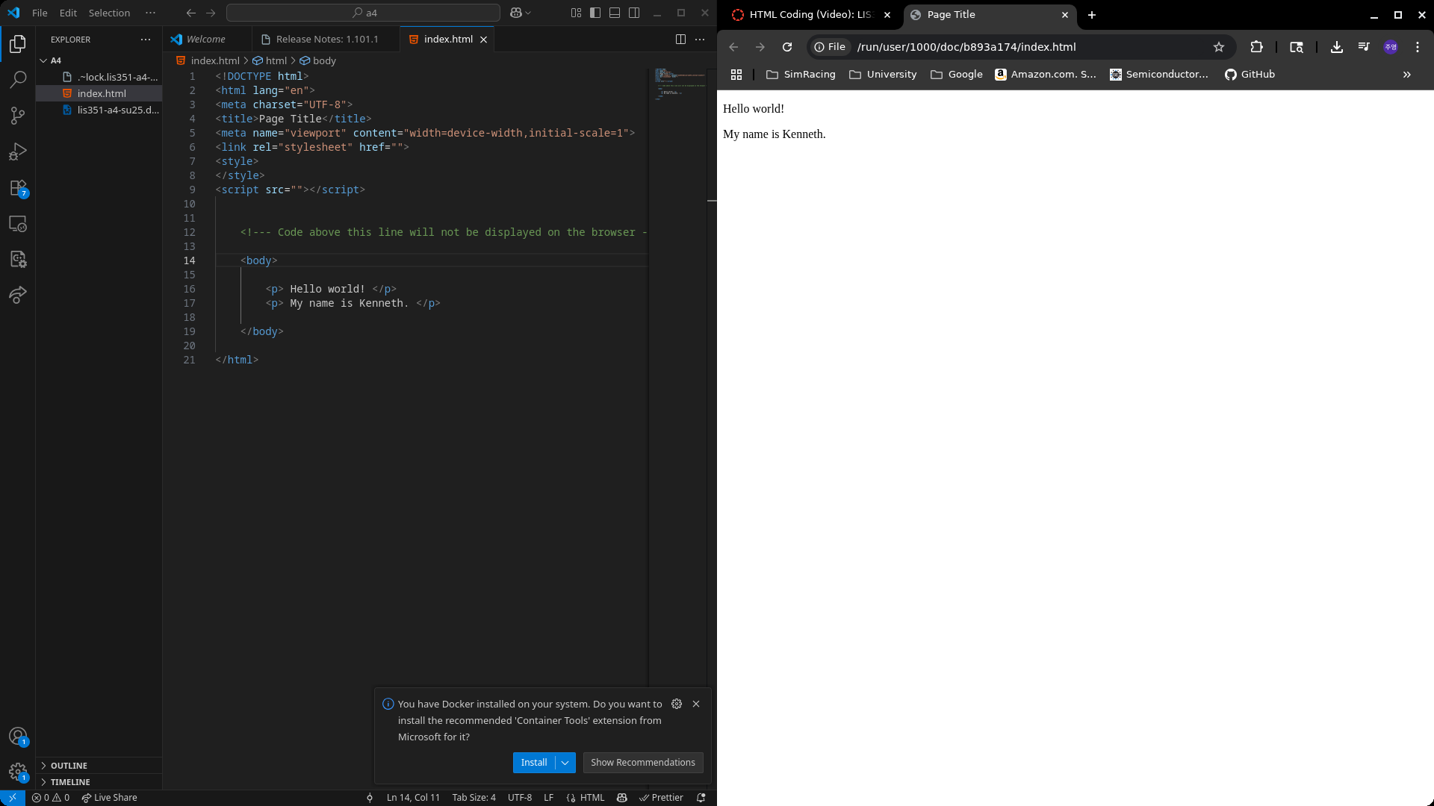

## Part 2: Setting up GitHub Pages

You will need a hosting service to publish your website on the Internet. We will use GitHub to host your website.

1. Create a GitHub account: <https://pages.github.com/>
2. Create a GitHub Pages site by following the instructions: [Creating a GitHub Pages site](https://docs.github.com/en/pages/getting-started-with-github-pages/creating-a-github-pages-site).
   1. *When naming the Repository which you will use for hosting your website, make sure the Repository name must be [Owner name/your GitHub username].github.io*
      1. *And here is an example:*

Your Repository should include your Owner name associated with your account **.github.io** In the image below, the owner’s name is **lis351-jackson** (circled in the image below,)so the Repository name will be **lis351-jackson.github.io**



* + 1. *Notes: Since this is your own GitHub account, not the account just for this course, so you don’t need to include “LIS 351” in your username*
  1. Set the repository as “Public”, and check in “Add a README file”

1. Save your Repository by clicking on “Create repository”. Now you’re ready to begin publishing HTML documents to the Internet.
2. Upload the HTML file (“index.html”) you created in Part I.
   1. To upload a file, select the “Add File” button at the top of the Repository 

1. Upload and Save the index.html page
2. Wait ~5 minutes and refresh your browser
3. Next, navigate to your website’s URL by opening a web browser (e.g., Chrome, Firefox) and pasting the name of your Repository (you created this in Step 2 🡪 **lis351-jackson.github.io**)

**Note**: When you are ready to publish your website, you should upload files to this Repository.

**What to submit for Part 2**:

(1.5 point) Take a screenshot of your website and Repository and include the URLs for both

[

add your URLs and screenshot in the space as below, replacing the example information

Website URL: <https://ohjy1006kenneth.github.io/lis351-kenneth.github.io/>

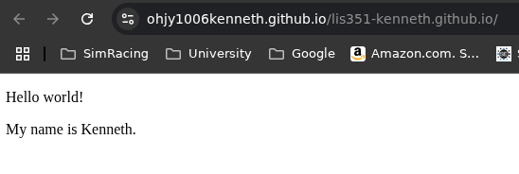

Website repository URL: <https://github.com/ohjy1006kenneth/lis351-kenneth.github.io>

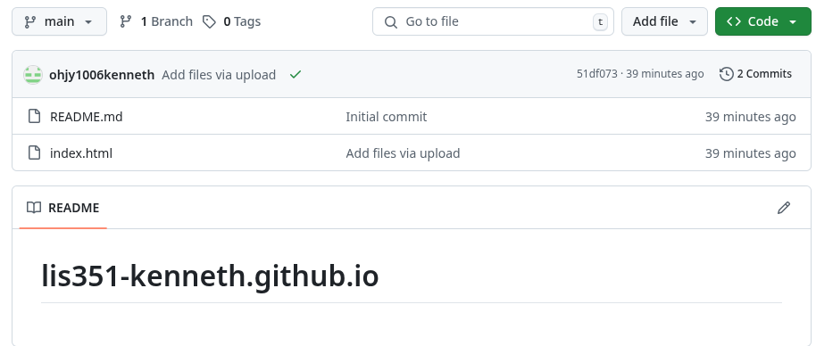

Notes: You need to ensure that the screenshot includes the website URL and that the URL is clearly visible.

]

## Part 3: Planning and Designing your website

These weeks we talk about website design and development. In the space below, you should state your websites. In this section, you should begin planning and designing your website. To be clear, there are other activities in the design process; however, we’ll focus on identifying the minimum requirements for Project 1.

**Notes:** This section can be either *the same as* or *completely different from* your final website in M1, so there is no need to overly consider M1 when completing this part.

1. Statement of purpose and goals for your website (2-4 sentences, 0.5 point)

I would like to create a digital portfolio. The purpose is to showcase my own or others’ creative or academic work. The goals of the website include uploading personal projects, resumes, and personal descriptions.

1. Definition of audience. Who will visit the website, and what will they use it for? (0.25 point)

Employers will visit the website. They will use it to decide if a student is a good fit for the job.

You should create a website style guide by choosing fonts and colors for your website

1. Typography choices and justification. [CSS Web Safe Fonts](https://www.w3schools.com/cssref/css_websafe_fonts.asp) (0.25 point)

Verdana. It is clear and easy to read.

1. Choose a color palette. [Adobe color wheel](https://color.adobe.com/create/color-wheel) (0.25 point)



**Page descriptions/site map.** To help plan for the web pages you will create using HTML, you should consider the information you want to display on your website. The homepage of your website (the index.html file) will list other pages in a navigation bar. In the space below, list the pages you want to create and give them a name and a brief description. M1 requires you create at least *five interlinked web pages*. (0.5 point)

[Add at least four other webpage names/descriptions in the table below]

| **Web page** | **Web page description** |
| --- | --- |
| index.html | The landing page for my website and will include a brief introduction about me and links to other top-level pages |
| about.html | A personal introduction page that gives insight to my background, education and skills |
| publications.html | Page that showcases my publications |
| resume.html | Page that will have my resume |
| projects.html | Page that showcases my projects |
| hobbies.html | Page that includes my hobbies |
|  |  |

After you’ve created the page descriptions, generate the site map (You can edit the text below). The pages with direct lines to one another are linked on that page. On the index.html (or home page), you will find links to about.html, publications.html, resume.html, projects.html, hobbies.html. [Your site map doesn’t need to have three levels like the example.] (0.5 point)

[Click on the box to add the .html names of your web pages]



**Creating Folders.** You should create the folders where your web pages will be stored. The structure of the files should be like the site map you created in the previous step. You should also add the index.html. You’ll notice that in each folder, there is a .html file with the same name (0.25 point)

[Create your folder structure based on the site map you created above and attach a screenshot below]

