# Action RPG

## User Interface

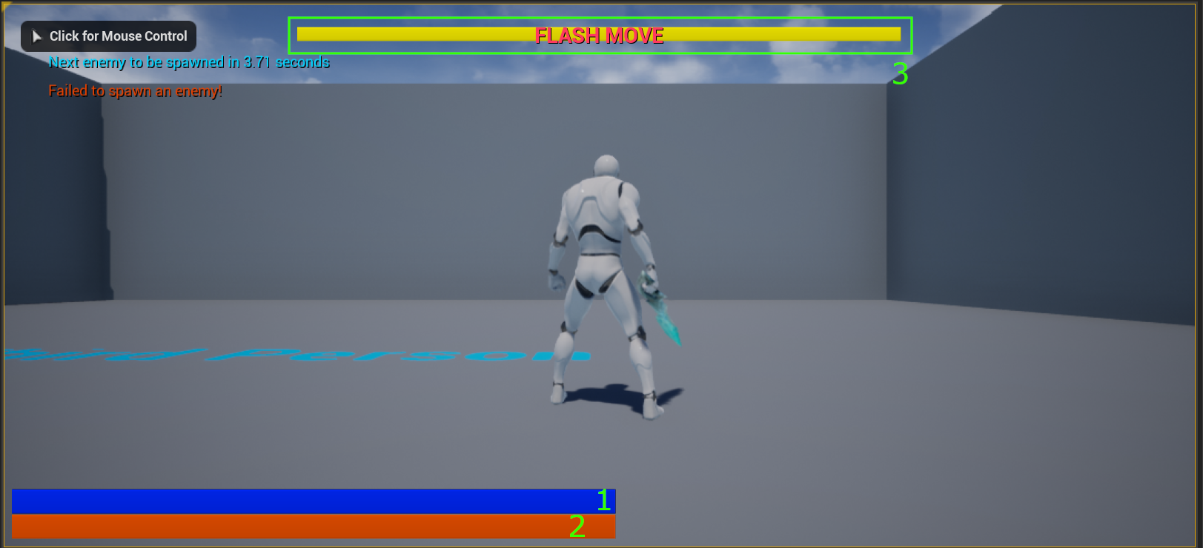

1. HP Bar: Indicating the player’s HP
2. Special Move Meter: Once filled, the player can trigger Blink Strike special attack
3. Flash Move Countdown: This will show up when the Flash Move skill is triggered. Indicating the skill’s remaining effective time.

## Control

### Mouse and Keyboard

* **Movement:** WASD to move forward, backward, left, and right respectively
* **Camera Control:** Mouse
* **Attack:** Left mouse button
* **Dodge:** Right mouse button
* **Blink Strike (special attack):** Left shift + left mouse button
* **Jump:** Spacebar
* **Target Selection:** Q

### Gamepad

* **Movement:** Left analog stick
* **Camera Control:** Right analog stick
* **Attack:** Left face button
* **Dodge:** Right shoulder button
* **Blink Strike (special attack):** Right face button
* **Jump:** Bottom face button
* **Target Selection:** Top face button

## Gameplay

### Enemy

Randomly spawned every 3 seconds (max of 5)

### Skills

#### Attack

Normal physical attack. Can be chained up to 3 combos. Every attack fills the Special Attack meter by 5%.

#### Flash Move

When the dodge action is activated at the last minute before getting hit, a special skill called Flsh Move will be activated. This skill gives the player 3 seconds of invincibility and doubles the attack + movement speed. Flash Move also fills the special attack gauge by 50%.

#### Blink Strike

This skill can only be used once the Special Attack meter is filled. Once activated, the character will be teleported to the selected target and perform a special attack that deals 3 times more damage than the normal attack. The first attack after performing Flash Move will be Blink Strike by default and won’t consume the Special Attack meter.