Why Was This Changed? A Local, Grounded RAG Assistant for Code Review History
Alyssa Chua Sin Ru | Kwek Tze Xuan | Liu Ziheng, Clifton
A0303226U | A0306924A | A0272185B
Abstract: Developers often need to know why a piece of code was changed, and the answer is usually buried in pull-request descriptions and review threads. We built PR Explainer, a fully local retrieval-augmented generation (RAG) assistant that answers such “why” questions from GitHub pull requests and GitLab merge requests on a consumer GPU, citing the excerpts it used or replying that the reason is not found. We treat each stage of the pipeline as a design decision and test it: how to chunk a pull request, which retriever to use, how to make the model refuse, whether post hoc checks help, and which model to deploy. On 231 SWE-bench Verified Django tasks, dense retrieval with Qwen3-Embedding-0.6B ranked the fixing pull request higher than BM25 and than hybrid (reciprocal rank) fusion on MRR@5 in every configuration; fixed 512-token chunks delivered the most evidence into a fixed context budget, and structure-aware chunks were as good or better at equal size. On the recommended research question, hybrid search did not significantly improve context relevance or reduce hallucination: its deficit on long bug reports largely closed on short queries, it was numerically ahead on natural-language “why” questions without surviving correction, and on GitLab Runner it answered exactly the same 5 of 18 unanswerable questions as dense retrieval. What did change hallucination was the instruction. With identical context, a strict grounded prompt matched plain RAG on correctness (30 vs 30 of 52 strictly correct) and answered fewer unanswerable questions (5 vs 13 of 18, pre-registered, Holm p = 0.023), although that difference weakens under a human reading of paraphrased refusals; a closed-book model was never strictly correct. A faithfulness gate and activation steering each reduced hallucinated answers only by also removing correct ones. The retriever decides what the model sees; the prompt decides whether the model admits that the answer is not there.
Keywords: Retrieval-augmented generation, hybrid search, code review, grounding, hallucination, dense retrieval, activation steering

1 Introduction
Understanding the rationale behind a code change matters for maintenance, debugging and code review. In collaborative development, pull requests (PRs) record the change together with its description, commit messages, review comments and discussion, which sometimes explain the decisions behind it. Finding that explanation in a long history is hard: the reason may be scattered across several comments, or never stated at all [3], [4]. Large language models (LLMs) can explain code, but without the development history they can only guess why it was written. Retrieval-augmented generation (RAG) [2] addresses this by retrieving relevant records and generating an answer grounded in them.
Two things can go wrong. First, retrieval may miss the evidence. A PR mixes descriptions, diffs and discussion, and finding the right PR does not mean that the part holding the reason reaches the model; fixed-size chunking can split related text. Second, even with the right evidence, the model may answer beyond it. For “why” questions this is especially harmful: a fluent but invented reason looks like documentation. An assistant that says “not found” when the history gives no reason is more useful than one that always answers.
Privacy is a further constraint. Organisations using GitLab, which is widely adopted across industries [1], may keep proprietary code and internal discussions in private repositories that they are reluctant to send to external AI services. We therefore built the assistant to run entirely locally: indexing, retrieval and generation all run on a consumer laptop or desktop GPU, with small open models. Private repositories were not available for research, so we used public histories: Django as the main repository, with SymPy (GitHub) and GitLab Runner (GitLab) as transfer checks across projects and platforms.
We answer the course brief’s research question (RQ0) and four design questions that building the assistant raised (RQ1–RQ4):
- RQ0 (hybrid search). Does a hybrid search strategy, combining dense vector retrieval with keyword-based BM25, significantly improve context relevance and reduce hallucinations compared with dense retrieval alone in a local RAG pipeline?
- RQ1 (retrieval). Which chunking and retrieval setup best finds the PR that explains a change, and does structure-aware chunking help at equal chunk size?
- RQ2 (grounding). Does a strict grounded prompt reduce hallucinated reasons compared with plain RAG and closed-book answering, and at what cost in answers that could have been given?
- RQ3 (mitigation). Can a post hoc faithfulness gate, or activation steering, reduce hallucination further without losing correct answers?
- RQ4 (deployment). Which local model should the assistant run: does a larger, or less heavily quantised, model refuse more reliably when the evidence is missing?
Table 15 (Section 8) summarises the answer to each question and how strong its evidence is. In short: dense retrieval is the right default; hybrid search changes what the model sees but not whether it hallucinates; the grounded prompt, not the retriever or a post hoc check, is what makes the model admit missing evidence; and neither a faithfulness gate nor activation steering removes hallucinated answers without removing correct ones.
Our contributions are (i) a fully local, citation-producing assistant whose pull-request document model transfers unchanged from GitHub to GitLab; (ii) a retrieval benchmark built from SWE-bench Verified, with a look-alike distractor pool that removes the surface cues separating fixing PRs from random ones; (iii) a pre-registered comparison of grounded, plain-RAG and closed-book answering on a held-out GitLab repository, with a blind human read of every hallucinated answer; and (iv) two negative results on post hoc mitigation, with an explanation of why a single steering vector cannot make refusal depend on the evidence. Sections 4 to 7 follow the order of the design decisions: chunking and retrieval, including the hybrid question (Section 4), answering and refusing (Section 5), mitigation by steering (Section 6) and the application that combines the chosen settings (Section 7).
Throughout, tuning rules and test families were written down and committed before the corresponding test runs. The one exception in timing is Django’s Experiment 2 scoring: the strict abstention rule, the handling of hedged answers and the primary test family were fixed after the frozen answers had been generated and first counted, though before any test was run (Section 5.1). We label every result as pre-registered, exploratory (planned but outside the pre-declared test families, or with rules fixed after some results were seen) or post hoc (chosen after seeing the results). No model was trained or fine-tuned at any point; all models are used as released.

2 Related Work
Retrieval-augmented generation and retrievers. RAG combines a retriever with a generator so that answers can draw on an external corpus [2]. Sparse retrieval with BM25 [5] scores exact term matches and remains a strong baseline, particularly out of domain: on the BEIR benchmark BM25 outperformed several dense retrievers in zero-shot settings [22]. Dense retrievers embed queries and passages in one vector space [21]; recent instruction-tuned embedders such as Qwen3-Embedding [6] are trained on far more data, including code. Hybrid retrieval combines the two, most simply by reciprocal rank fusion (RRF), which sums 1/(k + rank) over the rankers [7]. Bruch et al. [23] found that a tuned convex combination of normalised scores usually beats RRF and that RRF is sensitive to its parameters, so the benefit of hybrid search depends on how scores are fused and on how strong each retriever is alone. Most evidence that hybrid search helps comes from natural-language passages; code-retrieval benchmarks such as CodeSearchNet [35] and CodeRAG-Bench [34] show that text mixing code and prose behaves differently. Experiment 1 and its hybrid follow-ups (Sections 4.6 and 5.9) test this choice on pull requests, with two kinds of query.
Chunking and context. Long documents are split into passages, and a document can be scored by its best passage [10]. The retrieval unit matters: Chen et al. [24] found that indexing finer units (propositions) can beat passages or sentences at the same context size, which is why we compare structure-aware and fixed-size chunks at equal size, not only at their tuned sizes. How the retrieved text is laid out also matters: language models use information at the start and end of a long context better than in the middle [25], which motivated our comparison of score-ordered and PR-grouped excerpts (arms S0 and S0-G, Section 5.1).
Software engineering benchmarks and change rationale. SWE-bench [8] links real GitHub issues to the PRs that resolved them, and its Verified subset [9] keeps only human-checked, well-specified issues; we reuse it as a retrieval benchmark in which the bug report is the query and the fixing PR the answer. Studies of commit messages show that developers often fail to state why a change was made [3]. Recent work extracts fine-grained change rationale from several artifacts at once (commits, PRs and issues) and summarises it with an LLM, finding that no single artifact type holds the whole rationale [4]. Our assistant targets the same need, but answers a developer’s question with citations and is evaluated on whether it refuses when the reason is absent.
Grounding, refusal and evaluation. A grounded assistant should decline when the context does not contain the answer. The RGB benchmark [26] calls this negative rejection and found that LLMs often fail at it, answering from irrelevant context instead; a recent survey [27] reviews abstention more broadly, including the tension between refusing and being useful that we measure directly. ALCE [19] evaluates LLMs that generate text with citations, measuring whether cited passages support the generated statements. Reference-free RAG metrics such as RAGAS [28] score context relevance and faithfulness with an LLM, and FActScore [29] splits text into atomic claims and checks each against a source. Fact-checking models such as MiniCheck [15] and HHEM-2.1-Open [16] score whether a claim is supported by a grounding document and can serve as a post hoc filter; we use MiniCheck as a gate and HHEM as a cross-check. LLM judges agree well with people on many tasks but have known biases [30], so we validate ours against a human rater.
Activation steering. Contrastive activation addition [18] computes a steering vector as the mean difference between a model’s activations on contrasting pairs of responses, and adds it to the residual stream at inference time to shift behaviour without changing weights. Related methods shift activations along directions linked to truthfulness [32] or to other high-level concepts [33]. Most relevant here, Arditi et al. [31] found that refusal in chat models is mediated by a single direction in the residual stream: adding it makes a model refuse, and removing it suppresses refusal. That finding predicts what we observe in Section 6, where a vector built to trade refusing against answering moves the model along one answer–refuse axis whether or not the evidence is present.
Gap. Prior work evaluates hybrid retrieval mostly on prose, extracts change rationale offline, and studies abstention on general question answering. We combine the three in one local system for “why” questions about code history, and evaluate retrieval, refusal and mitigation on the same questions under rules fixed before the tests.

3 System and Data

3.1 System overview
Every stage of the assistant runs locally on consumer hardware, with no cloud API. A pull request (PR) history is converted into one structured text document per PR, which is split into chunks. The chunks are embedded and indexed in Qdrant, an open-source vector database run in embedded local mode, which stores both the sparse vectors used for keyword search and the dense vectors used for semantic search. For each question a retriever ranks the chunks. The highest-ranked chunks, optionally supplemented with related chunks from the same PR, are packed into a fixed token budget and passed to a small open-source language model served locally through Ollama, which answers with citations to the chunks it used (Fig. 1).
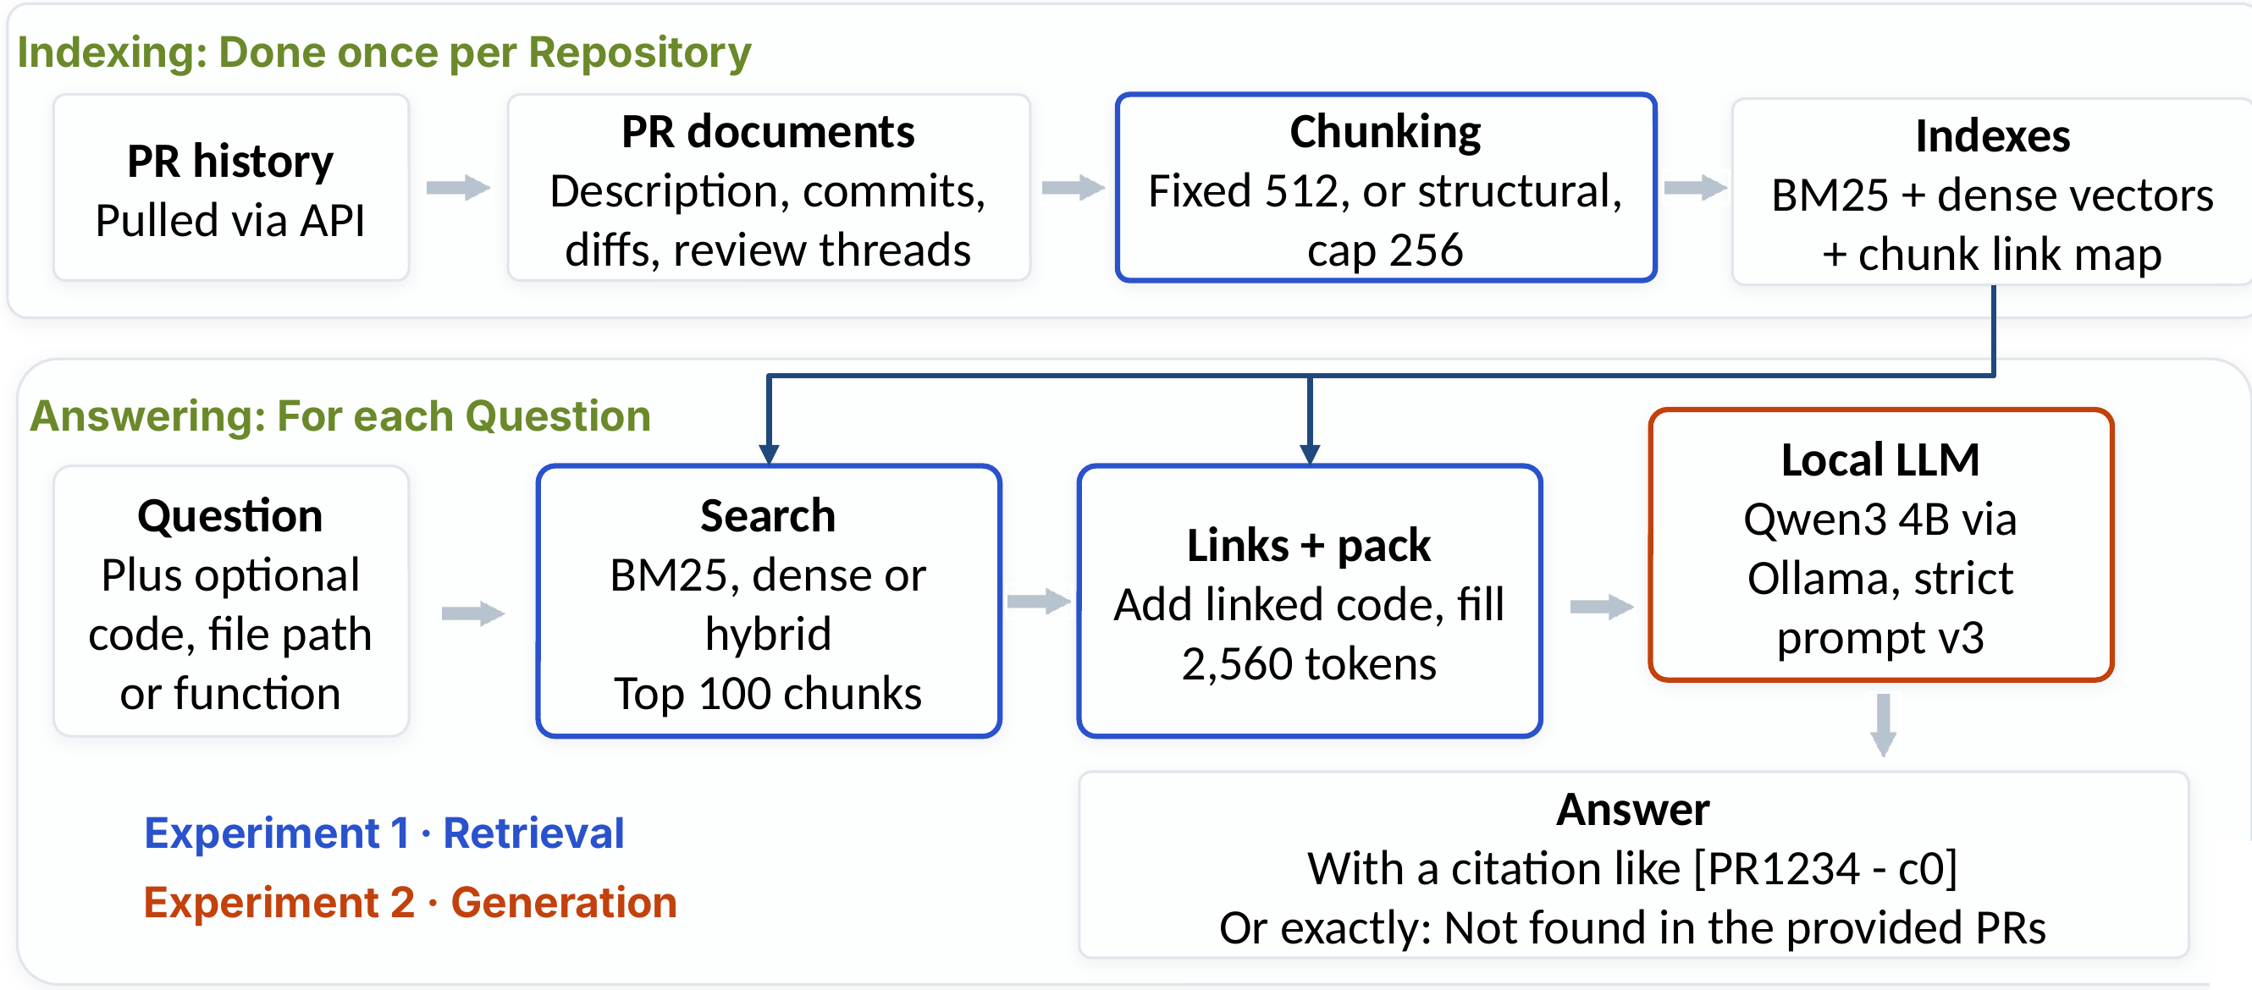
Fig. 1. System architecture. Indexing runs once per repository; answering runs for each question. Blue boxes are varied in Experiment 1 (retrieval), the orange box in Experiment 2 (generation).
The pipeline is written directly in Python with sentence-transformers and the Qdrant client rather than a framework such as LangChain or LlamaIndex. This gives full control over chunk boundaries, scoring and context assembly, and lets every intermediate result be recorded for evaluation. Experiment 1 evaluates chunking and retrieval; Experiment 2 evaluates answer generation on top of the retrieval setting chosen in Experiment 1.

3.2 Document representation
Each PR is one document made of, in fixed order: the title and description; the commit messages; the code changes, divided into diff hunks, each labelled with the path of the file it modifies; the review comment threads attached to specific lines of code; and the general conversation comments. Comments posted by bot accounts are removed, because they repeat across PRs and carry no rationale; nothing else is filtered. GitLab merge requests (MRs) have the same components, so the document model transfers to GitLab without change. During construction, the character span of every part is recorded, together with the lines added or removed in each diff. Chunks, model citations and evaluation evidence therefore share one coordinate system, and a retrieved chunk can be traced back to its exact location in the PR.

3.3 Chunking
Fixed-size chunking divides the document into consecutive windows of N tokens, each overlapping the previous window by O tokens. It ignores the boundaries between parts, so a chunk may join the end of a description to the start of a diff, or split a review discussion. Structural chunking follows the PR’s own organisation: one chunk per description, commit-message block, diff hunk, review thread and conversation comment. Parts longer than a size cap are divided at line breaks, and each hunk chunk is prefixed with its file path so that it can be read on its own. All sizes are measured in a model-independent unit, words plus individual punctuation symbols, so that sizes are comparable across retrievers with different tokenizers.

3.4 Retrieval
Sparse retrieval uses Okapi BM25 [5] with its standard parameters k₁ = 1.2 and b = 0.75:
sBM25q,c=t∈q​ft,q⋅IDFt⋅ft,ck1+1ft,c+k11-b+bcavgdl, IDFt=ln1+N-nt+0.5nt+0.5
Because PR text mixes natural language with code, a code-aware tokenizer splits identifiers at case changes, underscores and dots while also keeping the whole identifier (getUserById is indexed as getuserbyid, get, user, by and id), and lower-cases, stop-word-filters and stems ordinary words. A self-test showed that the Qdrant implementation matches a reference BM25 formula to within 3 × 10⁻⁷ and returns the same top result as the rank_bm25 library.
Dense retrieval embeds each chunk with Qwen3-Embedding-0.6B [6], small enough to run in half precision on a 4 GB laptop GPU. Following the model’s recommended usage, a short task instruction is prepended to each query (“Given a bug report for a software project, retrieve parts of pull requests (description, code changes, review comments) that fix the bug”) but not to the chunks, and chunks are ranked by cosine similarity, $s_{dense}\left(q,c\right)=e_{q}⋅e_{c}/\left(\left|e_{q}\right|\left|e_{c}\right|\right)$. Texts are truncated at 1,024 tokens.
Hybrid retrieval fuses the BM25 and dense rankings by reciprocal rank fusion (RRF) [7] with k = 60, each method contributing its top 100 chunks with equal weight:
sRRFc=m∈{BM25, dense}​1k+rmc
RRF combines rank positions rather than raw scores, so the two methods’ scores, which lie on different scales, need no normalisation.

3.5 Relation links and the context budget
At the settings selected in this study, structural chunks average about 110 tokens and fixed-size chunks about 455. Passing a fixed number of top chunks to the model would give the fixed-size method roughly four times as much text. Instead, every method fills the same context budget, B = 2,560 tokens (five 512-token chunks). The budget was fixed in advance and not tuned: it equals a top-five context at the largest chunk size in the tuning grid. Most PRs fit inside it (the median pool A PR is 729 tokens, and 325, or 15%, exceed 2,560). In Experiment 2 the full prompt used a median of 3,269 model tokens (maximum 3,873) over all 1,104 Django generations, within the 8,192-token window with room for a 512-token answer, and a median answer took 2.9 s (4B) or 3.3 s (8B) on an RTX 5070.
Retrieving the right PR also does not guarantee that its most useful part is retrieved: a description may match the query while the code it describes does not. A relation factor α therefore lets each retrieved chunk bring in linked chunks from the same PR. A description or commit message links to the PR’s hunks; a review thread links to the hunk it comments on (by file path and line, or else to that file’s hunks); a hunk links to the PR’s other hunks, nearest first; and a fixed-size chunk, which has no structural label, links to its neighbours. Links never cross PR boundaries. Each candidate chunk x receives the packing score
$$s\left(x\right)=max\left(\frac{1}{r\left(x\right)}, \max_{c: x∈L\left(c\right)}\frac{α}{r\left(c\right)}\right)$$
where r(x) is its retrieval rank (the first term is zero if x was not retrieved) and L(c) is the set of chunks linked to c. With α = 0.5, for example, a chunk linked from the top result scores the same as the second-ranked chunk; α = 0 recovers the plain ranking. Chunks are added in descending order of s(x) while x∈C​x≤B; a chunk that does not fit is skipped. Linked chunks compete for the same budget, so they can enter only by displacing lower-scored chunks, and the amount of text given to the model never increases.

3.6 Datasets
Choosing the datasets. Private repositories were not available, so we looked for public PR histories in which the correct evidence is known in advance. SWE-bench Verified provides this for GitHub: each task links a human-checked bug report to the PR that fixed it, so retrieval can be scored without new labels, and Django is its largest repository. We found no comparable labelled dataset for GitLab. GitLab’s public documentation and handbook are well-used RAG corpora, but they are articles without merge requests, diffs or review threads, so they would test a different task. We therefore built the GitLab set ourselves from GitLab Runner, a large public GitLab project with active review, taking an MR whose description closes an issue as the answer to that issue, the same construction as SWE-bench. SymPy, the next-largest Python repository in SWE-bench Verified, gives a second GitHub project with ready-made labels.
Experiment 1: SWE-bench Verified, Django. SWE-bench [8] pairs real GitHub issues with the PRs that fixed them; in SWE-bench Verified [9], human annotators confirmed that each issue is well specified. We use its 231 Django tasks, the largest single repository in the benchmark. The query is the bug report and the correct answer is the fixing PR (#7530 to #17087, created November 2016 to July 2023). The primary queries are the full bug reports; a secondary set uses only their first line. Ground truth is the fixing PR at PR level, and its added or removed lines at line level. The tasks are split into 50 development and 181 test tasks by SHA-256 hash, so the split is reproducible without a random number generator (fingerprint b57872f8e804ec6b). All tuning used the development set.
Distractor pools. Each pool holds the 231 fixing PRs plus 2,000 distractors (2,231 PRs; Table 1). Pool A draws distractors from all other Django PRs of the same period in a fixed pseudo-random order. A size filter excluded 28 PRs with more than 100 changed files or 50,000 tokens, mostly accidental merges of release branches, which held about 78% of all text; no fixing PR is near either limit (at most 20 files and 9,977 tokens). A same-ticket filter replaced 16 distractors whose title names the same Trac ticket as a fixing PR. Pool A is not filtered on merge state; its median PR is 729 tokens long (90th percentile 3,344). A separate time-window pool for each bug report, following [20], was considered but would have needed about 10 hours of downloading and 14 hours of GPU embedding per chunk setting. Fixing PRs differ from random distractors on the surface: all 231 touch the tests/ folder and 230 of 231 have a title starting “Fixed #N” (after leading spaces are stripped), against 53% and 47% of pool A distractors; all 231 fixing PRs are merged, against 68% of distractors. Pool H removes this cue: each distractor is merged, touches tests/, has a “Fixed #N” or “Refs #N” title and comes from the same module as a fixing PR (the first three path components, e.g. django/db/models), with a fallback order fixed in advance, which filled the 2,000 slots with 1,786, 155 and 59 distractors from the three tiers. 1,476 of pool H’s 2,000 distractors are not in pool A, and its PRs are longer, giving about 1.5 times as many chunks. Pool H was tuned separately on the same 50 development tasks.
Data checks. None of the 231 bug reports contains the fixing PR’s ticket number. A task is flagged as copied text when the fixing PR shares at least ten consecutive words with its bug report, such as a quoted traceback (17 of 50 development and 45 of 181 test tasks); such text is kept because it occurs naturally.
 | Pool A | Pool H
Distractor selection | Fixed pseudo-random order, same period | Look-alike fixes, same module
PRs (fixing + distractors) | 2,231 (231 + 2,000) | 2,231 (231 + 2,000)
Distractors not in the other pool | – | 1,476
Fixed 512/77 chunks (mean tokens) | 8,837 (455) | 13,239 (476)
Structural cap-256 chunks (mean tokens) | 33,298 (110) | 51,028 (111)
Table 1. Retrieval pools (Experiment 1).
Experiment 2: Django “why” questions. The questions ask why a change was made in a pool A Django PR. They were drafted by an LLM (Claude), one per shortlisted PR, each with a reference answer and supporting quotes verified to occur verbatim in the PR, and were reviewed by Kwek and by a second LLM reviewer (Codex). Questions sharing six or more consecutive words with their PR were flagged by a copy check, so that retrieval could not succeed by matching copied wording. The test set has 50 answerable and 17 unanswerable questions: 10 no-reason questions, whose PR is in the index but states no reason (5 from test PRs, 5 from development PRs); 5 removed questions, whose PR is excluded from the index; and 2 redacted questions, whose PR is kept but whose reason sentences are removed. Two further redacted questions were dropped before analysis because the kept text still gave the reason away. A separate development set (40 answerable, 5 no-reason) was used only to choose α for one arm and to finalise the prompts. Question identifiers give the type: q (answerable), nr (no reason), rm (removed) and rk (redacted), followed by the PR or MR number.
Transfer: GitLab Runner and SymPy. To check whether the Django settings carry over to another project and platform, the pipeline was applied unchanged to two further repositories. GitLab Runner (gitlab-org/gitlab-runner, on GitLab) has a pool of 231 task MRs plus 2,000 distractors built in the same way as Django’s pool A. The GitLab pipeline was first developed on a pilot pool of 300 MRs (30 tasks and 270 distractors); those 30 tasks are excluded from the scaled Experiment 1 results. Because SWE-bench has no GitLab tasks, a task is an MR whose description closes an earlier public issue, and the issue is the query. For Experiment 2, 70 “why” questions (52 answerable, 8 no-reason, 10 removed) were written by Claude in a session that had seen no generated answers. They were checked by two automated passes (Codex and DeepSeek) and by Kwek on 11 rows, rather than by two people as planned; every no-reason question has a person’s read. SymPy (Liu) uses 75 SWE-bench tasks plus 2,000 other PRs for Experiment 1 and 22 hand-checked questions (15 answerable, 7 unanswerable) for Experiment 2. Both are exploratory transfer checks: their labels and data differ from Django’s, so they are not compared with Django as like for like.

4 Experiment 1: Retrieval

4.1 Design and metrics
On each pool we cross the two chunking methods with the three retrievers, and add a size-matched fixed-size baseline without overlap whose chunk length equals the mean structural chunk length (110 tokens for pool A, 111 for pool H). The tuned fixed chunks are about four times longer than structural ones, so this baseline separates the effect of following the PR’s structure from the effect of chunk size. Within a chunking condition all retrievers index the same chunks. Each retriever returns its top 100 chunks, which are turned into a PR ranking in which each PR takes the rank of its best chunk [10].
The primary metrics are PR-level Hit@5 and MRR@5, where $r_{q}$ is the rank of the fixing PR for query q:
Hit@5=1Qq​Irq≤5, MRR@5=1Qq​Irq≤5rq
Links act after the search, so these do not depend on α. Context metrics describe what the language model would receive, the packed context $C_{q}$. With $G_{q}$ the changed lines of the fixing PR and $R_{q}$ the lines of any PR covered by $C_{q}$ (at least half of a line’s characters inside packed chunks), budget line recall is $\left|G_{q}∩R_{q}\right|/\left|G_{q}\right|$ and precision is $\left|G_{q}∩R_{q}\right|/\left|R_{q}\right|$. These metrics reward code only; descriptions and comments contain no changed lines, and explanatory text is evaluated in Experiment 2. Gold-in-budget is the share of queries for which any chunk of the fixing PR is in $C_{q}$; it shows whether links push the fixing PR out of the context.

4.2 Tuning protocol
All tuning used the 50 development tasks, with selection rules fixed in a script before they were applied. Stage 1 chose chunk settings from fixed 128, 256 or 512 tokens with 0% or 15% overlap, and structural caps of 256 or 512, by PR-level MRR@5 averaged over the three retrievers (ties within 0.005 to the higher Hit@5, then the smaller setting). One setting was chosen per chunking method, so retrievers are always compared on identical chunks. Stage 2 chose α from {0, 0.25, 0.5, 1} per chunking × retriever by budget line recall, subject to a safety rule: α > 0 was allowed only if gold-in-budget stayed within 0.02 (one development task) of its α = 0 value. BM25’s k₁ and b, RRF’s k, the budget and the embedding model were not tuned.
Both pools selected fixed 512-token chunks with 77-token (15%) overlap and a structural cap of 256; Hit@5 decided all three ties. On pool A the development MRR@5 averaged over retrievers ranged only from 0.847 to 0.894 across the eight settings, about one or two tasks out of 50. The selected α values differ between pools (Table 2), and several were decided by a single development task, so α is fragile. The group locked all settings before any test run. Each pool’s test set was then run exactly once with the tuned settings and once with untuned defaults (fixed 256 tokens without overlap, structural cap 512, α = 0). Nothing was re-run or re-tuned after the test results were seen. Two changes were made during development, both before any test run: the packing score changed from 1/(60 + r) to 1/r, because the flatter score never admitted a linked chunk, and the same-ticket filter was added (re-running the chunk grid selected the same settings).
Chunking | Retriever | Pool A | Pool H
Fixed 512/77 | BM25 | 0 | 0.5
Fixed 512/77 | Dense | 1 | 0.5
Fixed 512/77 | Hybrid | 0.5 | 0
Structural 256 | BM25 | 0 | 0
Structural 256 | Dense | 0.5 | 0.25
Structural 256 | Hybrid | 0 | 0
Table 2. Relation factor α selected on the development set. The size-matched baseline uses the fixed-size α of the same retriever.
Statistics. The unit of analysis is the query; comparisons are paired on the 181 test queries and the pools are analysed separately. We report 95% percentile bootstrap intervals (1,000 resamples) [11], the exact McNemar test for Hit@5 [12], and a paired permutation test (10,000 sign flips) with a paired bootstrap interval for MRR@5 and budget recall [13]. Experiment 1 is not corrected for multiple comparisons, so we give most weight to effects that are consistent across retrievers and pools. The planned comparisons are retrievers within chunking, fixed 512/77 against structural and structural against size-matched within retriever, links against no links, and tuned against untuned settings of the same chunking method. One comparison was added after the test results and is labelled post hoc: structural chunks with links against size-matched fixed chunks with links.
Implementation. Experiment 1 ran on a Windows 11 laptop with an NVIDIA RTX 3050 Ti (4 GB), using Qdrant (qdrant-client 1.19.1) in embedded mode and Qwen3-Embedding-0.6B through sentence-transformers and PyTorch 2.14 in half precision. Embeddings were cached so that each unique chunk is embedded once. The pool A development grid took about 4 hours, the pool H grid about 13 hours (about 150,000 new embeddings), and the four test runs about 11.5 hours. Truncation at 1,024 tokens affected at most 16 chunks in any run but 10 of the 181 test bug reports.

4.3 Results: ranking the fixing PR
Table 3 gives PR-level Hit@5 and MRR@5 on the test set. Dense retrieval ranked the fixing PR highest in every configuration on both pools (pre-registered comparison). It beat BM25 on both metrics everywhere (p < 0.001), with MRR@5 gains of 0.20–0.28, and beat hybrid retrieval on MRR@5 everywhere, by 0.06–0.10 (p ≤ 0.005). On Hit@5, dense and hybrid mostly did not differ significantly (p = 0.06–1.00), the only exception being the size-matched baseline on pool A (0.97 vs 0.93, p = 0.039). Both usually place the fixing PR in the top five; the difference lies in how high. Hybrid in turn beat BM25 on all metrics (p < 0.001). Fusing BM25 into a strong dense ranking therefore cost precision at the top rather than adding recall.
Pool H was harder. For fixed 512 chunks, BM25 dropped most (MRR@5 0.738 → 0.669); for structural chunks, all three retrievers lost about 0.05 MRR@5 (dense 0.909 → 0.858). The order of the retrievers was unchanged.
Chunking | BM25 A | BM25 H | Dense A | Dense H | Hybrid A | Hybrid H
Fixed 512/77 | 0.83 / 0.74 | 0.81 / 0.67 | 0.98 / 0.94 | 0.97 / 0.91 | 0.96 / 0.88 | 0.96 / 0.86
Structural (cap 256) | 0.76 / 0.63 | 0.72 / 0.58 | 0.97 / 0.91 | 0.95 / 0.86 | 0.93 / 0.82 | 0.94 / 0.76
Size-matched fixed | 0.79 / 0.66 | 0.73 / 0.62 | 0.97 / 0.91 | 0.96 / 0.88 | 0.93 / 0.84 | 0.93 / 0.80
Table 3. PR-level Hit@5 / MRR@5 on the test set (n = 181). A = pool A, H = pool H.
Chunking at the PR level. Fixed 512/77 had a higher MRR@5 than structural chunking for every retriever (for dense, p = 0.039 on pool A and p < 0.001 on pool H). Against the untuned settings, structural cap 256 vs 512 never differed significantly; fixed 512/77 vs 256/0 was significant on MRR@5 on pool A for BM25 (p = 0.029) and dense (p = 0.042), but not on pool H.
Short queries and copied text. With only the first line of the bug report as the query, BM25 improved (fixed 512/77, pool A: MRR@5 0.738 → 0.834) dense fell slightly (0.937 → 0.927) and hybrid rose slightly (0.876 → 0.894), so dense remained highest on both pools but by a smaller margin (Section 4.6). On the 45 copied-text test tasks every retriever scored higher than on the other 136, BM25 most (fixed 512/77, pool A: 0.867 vs 0.696); on the tasks without copied text the order was unchanged (dense 0.924, hybrid 0.843, BM25 0.696).

4.4 Results: what reaches the model
Ranking the fixing PR first does not mean that its relevant code reaches the model. Table 4 gives budget line recall and precision without links (α = 0). Unlike the PR-level metrics, these depend strongly on chunking. Fixed 512 chunks gave the highest recall for every retriever on both pools: with dense retrieval they covered 86% of the fixing PR’s changed lines on pool A and 82% on pool H, against 67% and 56% for structural chunks (differences 0.17–0.26 across retrievers and pools, p < 0.001). Their precision was also higher (0.14 vs 0.11 for dense on pool A), so the extra coverage did not dilute the context.
Chunking | BM25 A | BM25 H | Dense A | Dense H | Hybrid A | Hybrid H
Fixed 512/77 | 0.65 / 0.10 | 0.59 / 0.09 | 0.86 / 0.14 | 0.82 / 0.13 | 0.80 / 0.13 | 0.74 / 0.11
Structural (cap 256) | 0.44 / 0.07 | 0.38 / 0.06 | 0.67 / 0.11 | 0.56 / 0.09 | 0.64 / 0.10 | 0.53 / 0.08
Size-matched fixed | 0.40 / 0.06 | 0.37 / 0.05 | 0.61 / 0.09 | 0.53 / 0.07 | 0.58 / 0.08 | 0.51 / 0.07
Table 4. Budget line recall / precision without links (α = 0), B = 2,560, test set (n = 181).
Structure at equal size. This advantage reflects chunk size rather than chunking method. With size held constant, structural chunks had higher recall than size-matched fixed chunks on pool A for all three retrievers: BM25 0.44 vs 0.40 (p = 0.003), dense 0.67 vs 0.61 (p = 0.001) and hybrid 0.64 vs 0.58 (p = 0.001). On pool H structural chunks were again slightly higher, but no difference was significant (dense p = 0.091). PR-level MRR@5 did not differ significantly at equal size on either pool. Following the PR’s structure therefore performs at least as well as fixed splitting at the same size, and better on pool A, probably because structural chunks keep each diff hunk intact. Precision was low everywhere (0.05–0.14) because it credits only changed lines: descriptions, comments and unchanged context lines all count against it, even when they hold the explanation an answer needs. It should be read comparatively.
Relation links. Links raised budget recall significantly in every tested combination, while PR-level metrics are unchanged by design (Table 5, Fig. 2). The largest gains were for structural chunks with dense retrieval (pool A 0.666 → 0.924; pool H 0.559 → 0.858). Structural chunks with links reached the level of fixed 512 chunks with links on pool A (0.924 vs 0.923), but not on pool H (0.858 vs 0.890; p = 0.08 in a group member’s test, post hoc). In the post hoc comparison, structural chunks with links beat size-matched fixed chunks with links by about 0.16 budget recall on both pools (pool A 0.924 vs 0.763; pool H 0.858 vs 0.698; paired permutation p < 0.001). This is the strongest evidence for structural chunking in Experiment 1: once the budget is filled through the PR’s own links, structure is worth more than the same number of tokens cut blindly.
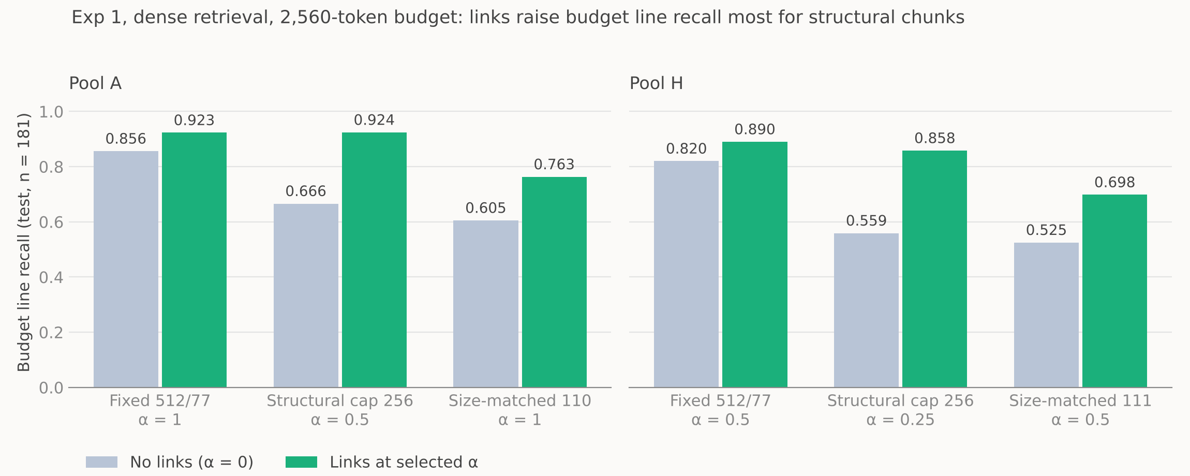
Fig. 2. Budget line recall without and with relation links (dense retrieval, test set, n = 181), each condition at its own selected α. Structural chunks gain most; with links they match fixed 512 chunks on pool A (0.924 vs 0.923) but not on pool H (0.858 vs 0.890; p = 0.08, post hoc). The comparison of structural and size-matched chunks with links is post hoc (Section 4.2). Links also push the fixing PR out of the budget for some tasks, which the chart does not show (Table 5 and “The cost of links”).
Pool | Condition (α) | Budget recall | Gold-in-budget
A | Fixed 512/77, dense (1) | 0.856 → 0.923 | 0.978 → 0.978
A | Fixed 512/77, hybrid (0.5) | 0.800 → 0.841 | 0.934 → 0.901
A | Structural 256, dense (0.5) | 0.666 → 0.924 | 0.989 → 0.950
A | Size-matched fixed, dense (1) | 0.605 → 0.763 | 0.989 → 0.967
H | Fixed 512/77, BM25 (0.5) | 0.594 → 0.641 | 0.762 → 0.724
H | Fixed 512/77, dense (0.5) | 0.820 → 0.890 | 0.961 → 0.950
H | Structural 256, dense (0.25) | 0.559 → 0.858 | 0.978 → 0.950
H | Size-matched fixed, dense (0.5) | 0.525 → 0.698 | 0.983 → 0.972
Table 5. Effect of relation links on the test set (dense unless stated): budget line recall and gold-in-budget, α = 0 → selected α.
The cost of links. Links can evict the fixing PR: when a wrong PR ranks first, its linked chunks fill the budget. On the test set this happened more often than the development safety rule allowed, for example structural + dense on pool A, where gold-in-budget fell from 0.989 to 0.950 (about 7 of 181 tasks). The development margin of 0.02 is a single task out of 50, so a loss of about 4% on test is within sampling noise, but it shows that α chosen on 50 tasks does not guarantee safety.

4.5 Transfer of the retrieval findings (exploratory)
SymPy (75 tasks, Django’s settings unchanged): dense again ranked highest. With fixed 512/77 chunks, Hit@5 / MRR@5 were 0.720 / 0.637 for BM25, 0.960 / 0.886 for dense and 0.907 / 0.802 for hybrid; dense beat hybrid on MRR@5 (p = 0.007, unadjusted). With structural chunks, dense led hybrid on MRR@5 (0.779 vs 0.721) without a significant difference (p = 0.111).
GitLab Runner (231 tasks + 2,000 distractors, dense, fixed 512/77; Holm family of four, pre-registered, with permutation tests primary): on the 201 tasks not used in the pilot, Hit@5 was 169/201 and MRR@5 0.722 at both α values. Turning links on (α 1 vs 0) lost the correct MR from the budget for 12 tasks and gained it for none (167 → 155; Holm p = 0.002). Budget precision (0.072 → 0.088, Holm p = 0.022) and F1 (0.089 → 0.110, Holm p = 0.004) rose, and recall rose from 0.453 to 0.480 (permutation Holm p = 0.165; Wilcoxon sensitivity Holm p = 0.022). The labels are closing references rather than SWE-bench fixes, so these are not compared with Django as like for like, but the eviction cost of links reappears more clearly on a new repository, which supports the choice, made earlier for Experiment 2, of α = 0 for the fixed-chunk arm F0.

4.6 Hybrid search revisited: short queries and “why” questions
The brief’s research question asks whether hybrid search improves context relevance over dense retrieval alone. Experiment 1 answers no for full bug reports, but those queries are long, code-heavy texts on which BM25 is weak, and they are not the questions the assistant serves. We therefore compared dense and hybrid retrieval on two further query types, with the same retrievers, pools and chunks and nothing tuned (Table 6). For short queries we use the first-line test runs of Experiment 1; the runs were planned, but their dense–hybrid tests were computed after the main results had been seen, so they are secondary and uncorrected. For “why” questions we use the 50 Django and 52 GitLab Runner answerable questions of Experiment 2 (Section 3.6), ranked by dense retrieval (arm F0) and by the hybrid retriever of arm H0 (Section 5.2). A rule file with its own Holm family of six tests was committed on 13 Nov, before any GitLab hybrid retrieval was run; the two Django Hit@5 and span counts had already been seen, so the Django tests are post hoc. Before the GitLab run, the dense contexts rebuilt from F0’s saved rankings were checked to equal F0’s stored contexts for all 70 questions.
Query | Setting | Metric | Dense | Hybrid | p (Holm p)
Full bug report | Pool A, fixed 512/77 | MRR@5 | 0.937 | 0.876 | < 0.001
Full bug report | Pool H, fixed 512/77 | MRR@5 | 0.913 | 0.858 | 0.005
Full bug report | Pool A, structural 256 | MRR@5 | 0.909 | 0.815 | < 0.001
Full bug report | Pool H, structural 256 | MRR@5 | 0.858 | 0.762 | < 0.001
First line | Pool A, fixed 512/77 | MRR@5 | 0.927 | 0.894 | 0.005
First line | Pool H, fixed 512/77 | MRR@5 | 0.885 | 0.862 | 0.14
First line | Pool A, structural 256 | MRR@5 | 0.895 | 0.863 | 0.027
First line | Pool H, structural 256 | MRR@5 | 0.839 | 0.822 | 0.42
“Why” question | Django (n = 50) | Hit@5 | 43 | 47 | 0.125 (0.63)
“Why” question | Django (n = 50) | MRR@5 | 0.758 | 0.839 | 0.027 (0.16)
“Why” question | Django (n = 50) | Span in context | 42 | 43 | 1.0 (1.0)
“Why” question | GitLab Runner (n = 52) | Hit@5 | 51 | 51 | 1.0 (1.0)
“Why” question | GitLab Runner (n = 52) | MRR@5 | 0.897 | 0.913 | 0.68 (1.0)
“Why” question | GitLab Runner (n = 52) | Span in context | 47 | 50 | 0.375 (1.0)
Table 6. Dense vs hybrid retrieval by query type, test sets. Bug-report rows (n = 181, α = 0): paired permutation test, uncorrected. “Why” rows: Hit@5 and span in context are counts (exact McNemar); MRR@5 by paired permutation; Holm over the six “why” tests in brackets.
Results. On full bug reports dense retrieval led hybrid by 0.055–0.096 MRR@5, significantly in all four settings. On first-line queries the lead shrank to 0.017–0.033 and was no longer significant on pool H, because BM25 improved sharply on short queries (fixed 512/77: +0.096 MRR@5 on pool A and +0.117 on pool H, p ≤ 0.002) while dense changed little (−0.010 and −0.028, not significant). On “why” questions the direction reversed: hybrid ranked the gold PR higher on Django (MRR@5 0.758 → 0.839, unadjusted p = 0.027) and put the answer span in context for three more GitLab questions, but no test survived Holm correction (smallest Holm p = 0.16).
Reading. Hybrid’s loss in Experiment 1 is largely a property of the queries. Fusing in BM25 hurts when BM25 is weak, on long, code-heavy bug reports, and helps a little when the query is a short natural-language question that shares words with the PR’s description. On this evidence hybrid search does not significantly improve context relevance on any query type, and dense retrieval is never significantly worse than hybrid on the questions the assistant serves. We therefore keep dense retrieval, which also needs only one index; Section 5.9 asks whether the retriever changes hallucination. Fusion was untuned RRF with equal weights; a tuned weighted fusion [23] might do better, and we did not test it.
Summary of Experiment 1. Dense retrieval is the clear choice for bug-report queries, and no worse than hybrid on “why” questions. Fixed 512-token chunks deliver the most changed code within the budget, largely because they are larger; at equal size, structural chunks are as good or better, and in a post hoc comparison with links they were clearly better. Links increase coverage but can push the correct PR out of the budget. Caveats: α choices are pool-dependent and decided by single development tasks; the dev and test numbers come from one run each; and Experiment 1 is uncorrected for multiple comparisons.

5 Experiment 2: Generation
Experiment 2 asks whether a strict grounded prompt makes a small local model answer “why was this changed?” faithfully, and say “Not found in the provided PRs” when the PR gives no reason. No learning took place in Experiment 2: no model weights were trained or updated. The human checks (question checks, blind correctness labels and the validation of the LLM judge) were used to measure the system and to validate the judge and the labels, not to train anything.

5.1 Method
Retrieval and context. Every arm uses Experiment 1’s dense retriever over pool A, with a query instruction reworded for “why” questions (“Given a question about why a change was made in a Django pull request, retrieve the pull request excerpts (description, commit messages, review comments or discussion) that state the reason”), written before any retrieval result was seen and not tuned, and Experiment 1’s packing into the 2,560-token budget. For generation the links are extended with explanation links: a diff hunk links to the review thread that discusses it, every chunk links to its PR’s title and description, and each conversation comment links to its neighbours. These add the text where developers state reasons, which Experiment 1’s code-only links exclude. The settings were frozen on 22 Oct, before any test generation.
Arms. Table 7 lists the arms. F0, S0, S0-G and S-0.25 are the frozen test arms; S-0.25’s α was chosen on the development questions. W-F and H0 were added after the frozen results had been seen and are reported as exploratory, outside the pre-declared families.
Arm | Chunking / ranking | α | Excerpt order | Status
F0 | Fixed 512/77, dense | 0 | Score | Frozen
S0 | Structural cap 256, dense | 0 | Score | Frozen
S0-G | Structural cap 256, dense | 0 | Grouped by PR | Frozen
S-0.25 | Structural cap 256, dense | 0.25 | Grouped by PR | Frozen
W-F | Fixed 512/77 ranking; whole parent PRs packed | – | Rank | Exploratory
H0 | Fixed 512/77, hybrid (RRF) | 0 | Score | Exploratory
Table 7. Experiment 2 arms (Django).
Prompts and models. Excerpts are inserted with short identifiers (e.g. [PR1234-c0]) that the model can cite. The strict grounded prompt (v2) tells the model to answer only from the excerpts, in at most three sentences; to cite only the excerpt that states the reason; and to reply with exactly “Not found in the provided PRs” if the excerpts do not state it. Prompt v3 adds one rule targeting a failure seen during development: a description of what changed (a diff, title, commit summary or test) is not a reason why. Both prompts were frozen and hashed before the test runs. The models are Qwen3-4B-Instruct-2507 (4-bit) and Qwen3-8B, served by Ollama 0.40.4 with temperature 0, seed 42, thinking disabled and an 8,192-token context window, on a desktop RTX 5070 (12 GB). Each frozen arm × prompt × model answered 69 questions (the 67 analysed plus two redacted questions dropped from every analysis), 552 answers per model.
Outcomes. An answer counts as an abstention only if, after citations are removed, it consists solely of the refusal sentence (the strict rule); hedged answers count as answered. On unanswerable questions, unanswerable answered is the hallucination outcome (lower is better). An answer is overlap-cited if it has at least one citation, every citation is valid, and at least one cited chunk overlaps a reference quote; contain-cited, where a cited chunk must fully contain a quote, is a sensitivity analysis. These scoring rules and the 60-test family were fixed on 23 Oct, after the frozen answers had been generated and first counted but before any test was run, so the Django families are pre-declared rather than strictly pre-registered. The answer span is in context when a chunk overlapping a reference quote is among the packed chunks; this separates retrieval misses from generation errors. Correctness was labelled by an LLM judge (Codex) as correct, partial or wrong against the reference answer, blind to arm, model and prompt, with citations removed and rows shuffled. Strict counts only correct; lenient also counts partial. The judge was validated against an independent human rater (Chua) on a stratified sample of 80 answers, labelled blind to the judge’s labels [14].
Faithfulness and the gate. MiniCheck [15] scores whether each answer sentence is supported by the cited chunks (primary premise) and by the full context (secondary); HHEM-2.1-Open [16] is a cross-check. The gate score of an answer is its weakest sentence,
$$g\left(a\right)=\min_{u∈S\left(a\right)}P\left(\text{supported}∣u,E\left(a\right)\right),$$
where S(a) is the set of claim sentences and E(a) the text of the cited chunks. If g(a) < 0.5, or the answer cites no valid excerpt, it is replaced by the refusal sentence. The gate trades coverage for reliability. The threshold of 0.5 was set in planning, but the rule file was committed after the faithfulness scores were computed, so all gate results are exploratory.
Statistics. Arms and prompts are compared by exact McNemar tests on the 50 answerable questions, with Holm correction [17] within pre-declared families: primary (60 tests: 2 models × 10 arm/prompt contrasts × 3 outcomes: answered, abstained although the answer was in context, overlap-cited), contain-cited (20 tests) and correctness (40 tests: strict and lenient). No arm is called best unless it wins a test with Holm p < 0.05 in its family. Results on the 17 unanswerable questions are counts with unadjusted p-values. A 15-question sensitivity drops two no-reason questions (nr9172, nr13883) whose PRs contain contextual clues.

5.2 Results on Django
Pre-declared families: no arm or prompt difference survives Holm (smallest Holm p: primary 0.76, contain-cited 0.31, correctness 1.0). With 50 questions, differences between arms are a few questions either way and are reported as counts. The largest unadjusted difference was 4B F0/v3 vs S0/v3 on overlap-cited answers, 31 vs 20 of 50 (14/3 discordant, p = 0.013, Holm p 0.76), but under the contain-cited metric it shrinks to 12/4 (p = 0.077), so it is not treated as a finding. Table 8 summarises the 4B with prompt v3. S-0.25 has the highest answered, overlap-cited and correct counts in Table 8, but its lead over S0-G (0/7 discordant on both answered and overlap-cited, p = 0.016, Holm p 0.92) is a shift towards answering, not better grounding: the seven extra right chunks were already in S0-G’s context, none arrived through a link, and S-0.25 also answered more unanswerable questions (5 vs 2 of 17).
Arm | Answered /50 | Overlap-cited /50 | Strict correct /50 | Lenient correct /50 | Unanswerable answered /17
F0 | 35 | 31 | 23 | 31 | 3
S0 | 32 | 20 | 19 | 29 | 4
S0-G | 34 | 25 | 25 | 30 | 2
S-0.25 | 41 | 32 | 30 | 36 | 5
Table 8. Django test arms, 4B with prompt v3 (counts; Codex correctness labels). Unanswerable answered is out of 17.
Model size and prompt (counts only). The 8B answered more unanswerable questions than the 4B in every arm and prompt: 11–14 of 17 against 2–7 (9–12 vs 2–5 of 15). The larger model is more willing to give a reason, not more willing to refuse. Prompt v3 lowered the 4B’s unanswerable answers in every arm (F0 7 → 3, S0 7 → 4, S0-G 6 → 2, S-0.25 7 → 5), while the 8B changed by 0–2; no single v2 → v3 test reached p < 0.05 (unadjusted p 0.125–0.5). The cost falls on answerable questions. On the 4B, refusals although the answer span was in context rose in every arm (F0 7 → 9, S0 5 → 12, S0-G 6 → 10, S-0.25 4 → 5; S0 0/7, p = 0.016, Holm p 0.92). On the 8B, v3 lowered overlap-cited answers in every arm (by 2 to 6 of 50) while cutting unanswerable answers by at most 2.
Correctness (Codex judge). Strict correctness ranged from 19 to 30 of 50 for the 4B and 21 to 27 for the 8B; lenient from 29 to 38 and 34 to 40. None of the 40 correctness tests reached p < 0.05 even unadjusted (smallest p 0.070), so no arm or prompt is ranked on correctness. Agreement between Codex and Chua on the 80-answer sample was Cohen’s κ 0.675 [0.511, 0.816] over three labels, 0.692 for strict and 0.772 for lenient. Of the 13 disagreements, 9 were Chua correct / Codex partial, so Codex is stricter than a human on correct vs partial, and strict counts may run low.
Faithfulness and the gate (exploratory). Mean sentence-level support (MiniCheck, cited chunks) ranged from 0.36 to 0.68 across strata and was highest for F0 in every model × prompt, though the chunks packed into the contexts are longer for fixed than for structural chunking (mean 396 vs 92 units; the pool means in Section 3.5 are 455 and 110), so support is not strictly comparable across chunkings. Within each model and prompt, however, support was not correlated with the length of the cited premise (Spearman ρ −0.01 to 0.15, all p > 0.05), so premise length alone does not explain F0’s higher scores. At 0.5 the gate kept 301 of 659 answered answerable rows, 229 of 453 overlap-cited answers and 59 of 141 answers to unanswerable questions (15 of these 59 from nr9172 and nr13883). As a detector the gate is weak on Django: treating answers to unanswerable questions as positives and all answered answerables as negatives, MiniCheck’s AUROC was 0.538 [0.437, 0.656] for the 4B and 0.572 [0.468, 0.673] for the 8B, close to chance. HHEM separated them better (0.669 [0.563, 0.784] and 0.732 [0.622, 0.824]; against judged-correct answers 0.698 and 0.775), but this is a point-estimate difference with overlapping intervals, and the gate keeps MiniCheck, which was the planning choice. The positives and negatives are answers to different questions, so the AUROC measures separation between question types, not an error rate per answer. The failure analysis below suggests why a sentence-level check misses invented reasons: they are usually built from true statements about what changed (the diff, title or commit message), and the cited chunk does support each of those statements. One gate-passed answer to nr10042, for example, restated the PR title (“silence them in the default verbosity”) as the reason and added “making the output cleaner”.
Failure modes. A fixed-rule failure analysis, with human tags from Chua on a 10-row sample of gate-passed unanswerable answers, found three dominant ways to fail: inventing a reason when the PR is present but gives none (5 of the 10 sample rows); describing what changed as why (3 of 10), the failure prompt v3 targets; and borrowing a reason from a neighbouring PR with valid-looking citations (2 of 10; by rule, 60 of 798 answered rows with at least one citation cited no chunk of the question’s own PR). The model also over-abstained: on 70 of 688 answerable rows with the answer span in context, it refused. Eight of the ten gate-passed rows were invented or what-as-why answers, which is the pattern that makes the MiniCheck gate fail as a detector.
Exploratory arms. W-F (whole-PR packing, proposed after the test results) put the answer span in context for 10 fewer questions than F0 (32 vs 42 of 50), because 17 of the 60 question PRs exceed the 2,560-token budget and whole PRs crowd each other out. On the 31 questions where both arms had the span, W-F was correct on 1–2 more questions than F0 under lenient labels; no pre-declared W-F vs F0 test reached p < 0.05. This answers a question raised at our presentation, whether chunking is worth it when PRs are short: in pool A 325 PRs (15%) exceed the budget, and chunking is what lets the evidence from long PRs fit. H0 (hybrid ranking, otherwise F0) placed the gold PR in the top five for 47 vs 43 of 50, with no sign of Experiment 1’s hybrid drop on these “why” queries. Strict correctness rose in all four model × prompt cells (for example 4B v2 21 → 32), but no test survived Holm in H0’s own family of 16 (smallest Holm p 0.118), and there was no evidence of a change in hallucination (unanswerable answered 7 → 8, 3 → 2, 13 → 12, 13 → 11). H0’s labels come from a later Codex session and have no human validation. Sections 4.6 and 5.9 extend the comparison to retrieval metrics and to GitLab Runner.

5.3 Transfer to SymPy and GitLab Runner (exploratory)
SymPy (Liu; 4B, prompt v3, Django’s settings unchanged; counts only, no tests). F0 answered 10 of 15 answerable questions with 9 strictly correct and none wrong, and answered 4 of 7 unanswerable questions; S0-G answered 14 of 15 with 8 strictly correct on the lower of two raters’ labels (12 on the upper) and answered 5 of 7 unanswerables. The two raters (Chua and Kwek, blind and independent) agreed on 20 of 24 answers (κ 0.515), and all four disagreements were on S0-G, so the F0 vs S0-G order on strict correctness depends on the label-merge rule, which was fixed before the key was opened. An H0 arm on SymPy put the span in context for 15 vs 12 of 15 and answered 12 vs 9 (F0 rerun on the same GPU), with 11 vs 8 strictly correct, the same direction as on Django. Only 13 of 22 F0 answers were identical across the two GPUs with identical contexts, so a difference of one or two questions can be hardware alone.
GitLab Runner, F0 vs C1 (4B, prompt v3; rule signed before generation; Holm family of 3). C1 adds links at α = 1 to F0. Neither arm was better: strict correct 33 vs 32 of 52 (Holm 1.0), answered 43 vs 44, unanswerable answered 5 vs 3 of 18. These labels are provisional (Kwek on 20 rows, Codex on 67; Kwek–Codex agreement κ 0.177), so this comparison is reported only as a check. The more informative GitLab results are the baselines below.

5.4 GitLab Runner: grounded prompt against plain RAG and closed book
This comparison asks whether the grounded prompt actually reduces hallucination, as opposed to only measuring it, a question raised at our final presentation. The original plan also had plain-RAG and closed-book conditions on Django; they were dropped from the frozen Django test after an early run on the old setup, in which the plain RAG prompt answered 9 of 10 unanswerable questions with the 4B model against 4 of 10 for the strict prompt. All three arms use the 4B model with F0’s decoding settings (Ollama 0.40.4, temperature 0, seed 42, 8,192-token context, 512 output tokens) on the 70 GitLab Runner questions (52 answerable, 8 no-reason, 10 removed). The arms differ only in prompt and context:
- F0 (grounded): the strict v3 prompt over F0’s dense, fixed 512/77 context: cite the excerpt or reply “Not found in the provided PRs”.
- P0 (plain RAG): F0’s exact chunks (checked to be identical in ids and tokens for all 70 questions), with the prompt “You are a helpful assistant. Use the following context from GitLab Runner merge requests to answer the question.” It has no citation or refusal rule.
- CB (closed book): no context; “You are a helpful assistant. Answer the question about the GitLab Runner project.”
The rule file (arms, scoring, tests and the sensitivity analyses) was committed before any P0 or CB answer existed. F0’s answers had been generated on 6 Nov and were therefore already seen. As a reproducibility check, F0 was regenerated in full: 70 of 70 answers were byte-identical to the stored run, so the baselines ran under F0’s exact conditions.
Scoring. P0 and CB are never told the refusal sentence, so the strict rule of Section 5.1 would count every one of their outputs as answered. The pre-registered primary scoring is therefore a lenient refusal regular expression, applied identically to all three arms; the strict rule is secondary, and a broader regular expression, written after F0’s answers were seen but before any baseline answer existed, is a sensitivity analysis. The pre-registered hallucination outcome is “unanswerable answered”: an answer to a question whose MR states no reason, or whose MR was removed from the pool.

5.4.1 Pre-registered result: unanswerable questions
Table 9 gives the counts and Fig. 3 shows them as shares. Tests are exact McNemar, F0 against each baseline, in one pre-registered Holm family of four (two comparisons × two outcomes).

Outcome | F0 | P0 | CB | F0 vs P0: b/c, Holm p | F0 vs CB: b/c, Holm p
Unanswerables answered /18 | 5 | 13 | 18 | 0/8, 0.023 | 0/13, 0.001
Answerables answered /52 | 43 | 47 | 51 | 1/5, 0.219 | 1/9, 0.043
Table 9. GitLab Runner baselines, lenient scoring (pre-registered primary). b/c = questions answered only by F0 / only by the other arm.
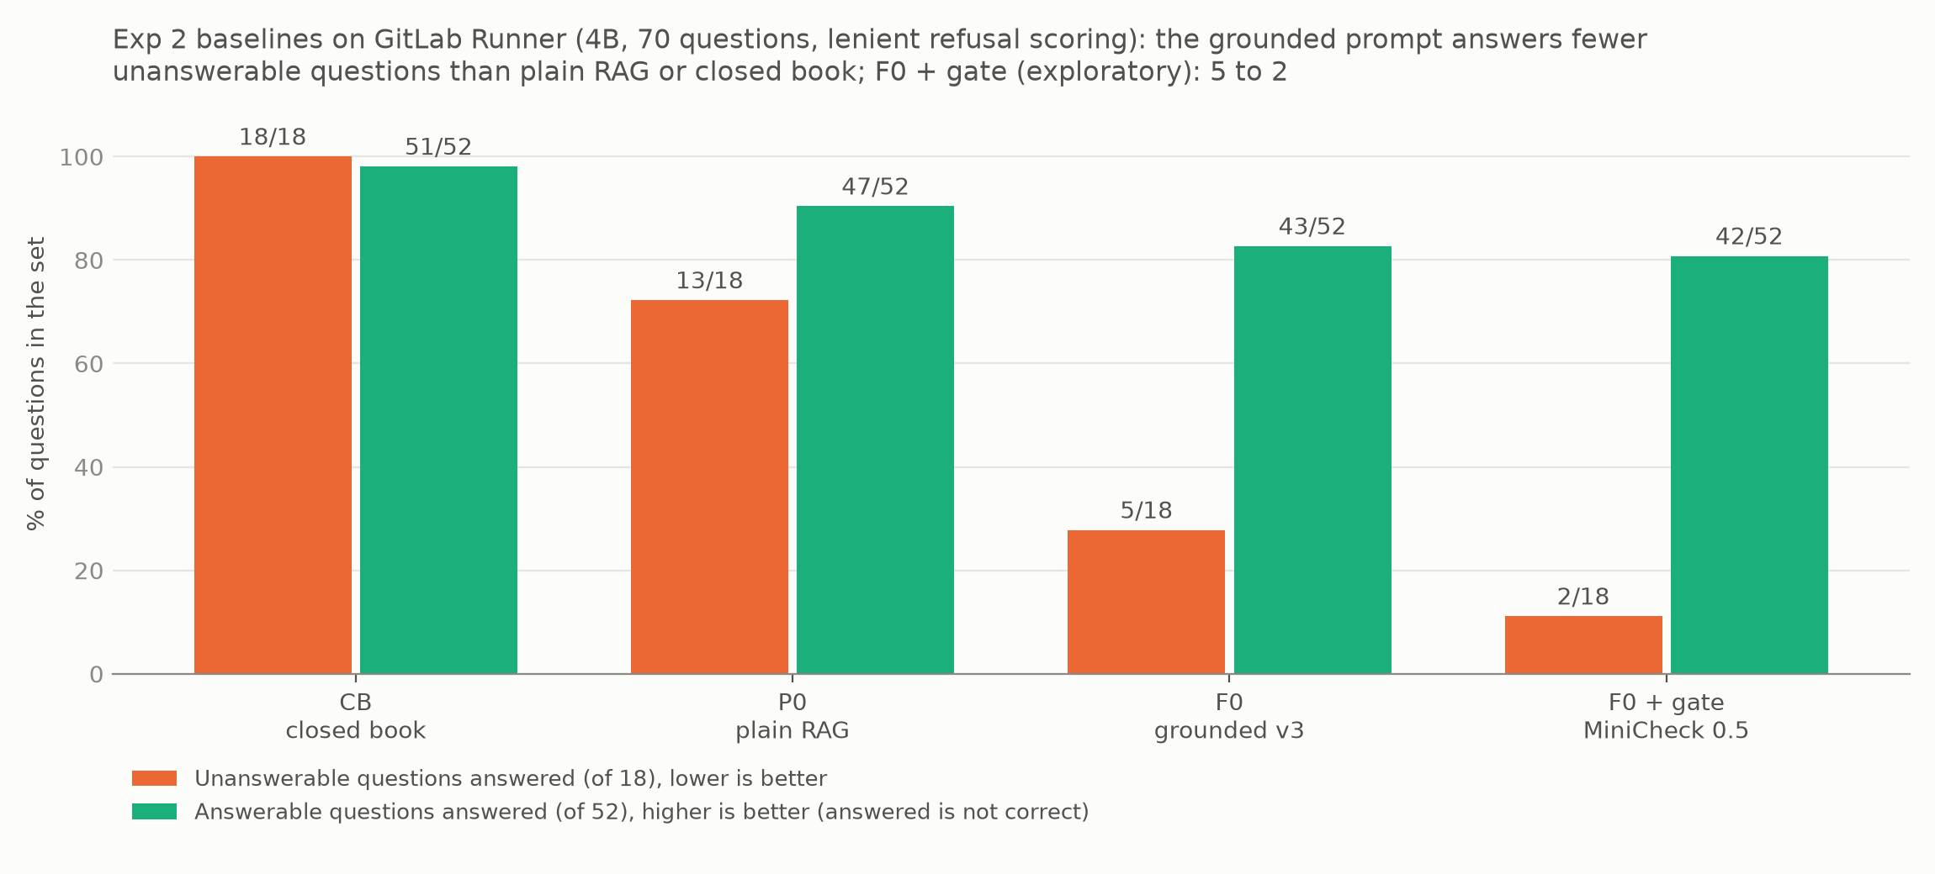
Fig. 3. Answered questions per arm on GitLab Runner (4B, lenient scoring). Orange: unanswerables answered (of 18, lower is better). Green: answerables answered (of 52; answered is not correct). F0 + gate is exploratory (Section 5.7).
As pre-registered, with the same retrieved context the grounded prompt answered 5 of 18 unanswerable questions and the plain RAG prompt 13; all eight discordant questions favoured F0 (Holm p = 0.023). The closed-book model answered all 18 (Holm p = 0.001). The pre-registered sensitivity analyses keep the direction: without the two doubtful no-reason questions nr3177 and nr4460, F0 answers 3 and P0 11 of 16 (Holm p 0.023); with the broad refusal regex, F0 answers 5 and P0 12 (Holm p 0.047). On answerable questions, P0 answered slightly more than F0 (47 vs 43, not significant) and CB answered 51 (Holm p 0.043), but answering is not being right (Section 5.5).
Caveat: the F0 vs P0 difference is sensitive to how refusals are scored; F0 vs CB is robust. A reading of the answers after the run found that one P0 answer (nr3147) is a refusal written in markdown bold (“does not explain”), which both regexes miss, and that four more P0 “answers” reject the question’s premise instead of giving a reason (rm3960, rm3119, nr4102, rm584). If all five were counted as non-answers, F0 vs P0 would fall to 0/3 discordant questions (p = 0.25). The pre-registered scores stand; Section 5.6 reports a blind human read of all answered unanswerables. F0 vs CB stays far apart under every reading.

5.5 GitLab Runner: correctness on answerable questions (secondary)
Answering is not the same as being right: CB answered 51 of 52 answerable questions without seeing any MR. All 147 distinct answers to answerable questions under strict scoring (F0 43, P0 52, CB 52) were therefore labelled correct, partial or wrong in one blind sheet, with citations stripped and rows shuffled. Correct means the full gold reason with every claim true; partial means the reason is present but with a false, misleading or self-contradictory claim, or half of a two-part reason missing; wrong means a different or invented reason, a denied premise, or no reason. All 147 were labelled by one person, Liu, working from label suggestions drafted by Claude that he checked row by row. The labels were committed before the blind key was opened. An unanswered question counts as not correct. Tests are exact McNemar, unadjusted, and secondary.
Arm | Strictly correct /52 | Leniently correct (correct + partial) /52 | Wrong /52 | Not answered (strict) /52
F0 (grounded) | 30 | 42 | 1 | 9
P0 (plain RAG) | 30 | 47 | 5 | 0
CB (closed book) | 0 | 3 | 49 | 0
Table 10. Correctness on the 52 GitLab Runner answerable questions (single blind labeller; secondary; unadjusted).
F0 vs P0: strict 4/4 discordant (p = 1.0), lenient 1/6 (p = 0.125). F0 vs CB: strict 30/0 (p = 1.9 × 10⁻⁹), lenient 40/1 (p = 3.8 × 10⁻¹¹). The full F0 re-run received the same label as F0 on all 52 questions, and an independent recount reproduced every count and p-value.
Three readings follow. First, grounding does not raise correctness on answerable questions: plain RAG is fully correct as often as F0 (30 each) and is correct or partly correct slightly more often (47 vs 42, not significant), because it answers every question while F0 declines 9. Second, the grounded prompt gives fewer wrong answers (1 vs 5), so its value lies in what it does not say rather than in what it gets right. Third, closed-book answering is almost never right (0 strictly correct), so the correct answers come from retrieval, not from the model’s memory of GitLab Runner.
Caveats. There is a single labeller. F0 had earlier, provisional labels (Kwek on 20 rows and Codex on 67); they gave 33/52 strict and 40/52 lenient against Liu’s 30/52 and 42/52, with the same label on 32 of 43 answers (Cohen’s κ 0.39 over three labels; 0.59 for correct vs not). Strict counts could therefore move by a few with a second labeller. Some citation-stripped answers still contain empty brackets left by removed citations, which hint at the arm, so blinding is imperfect.

5.6 GitLab Runner: what the answered unanswerables say (post hoc)
Everything in this subsection is post hoc and does not rescore the pre-registered result. Because “unanswerable answered” lumps together different behaviours, Liu read all 36 answered unanswerables (F0 5, P0 13, CB 18) blind to the arm (rows shuffled; key opened afterwards; category suggestions drafted by Claude and decided by him). Table 11 gives the categories.
Category | F0 | P0 | CB
Invented reason | 2 | 3 | 10
What-as-why (restates the change as its reason) | 1 | 1 | 1
Premise denial (claims the change did not happen) | 0 | 4 | 7
Grounded in the MR text, on a debatable no-reason label | 2 | 4 | 0
Refusal missed by the scorer | 0 | 1 | 0
Answered, pre-registered | 5 | 13 | 18
Table 11. Blind human read of the answered unanswerables (post hoc; single reader).
Counting a confident false claim as invented reason, what-as-why or premise denial gives F0 3, P0 8 and CB 18 of 18. On this reading, F0 vs CB remains clear (0/15 discordant, p = 0.0001, unadjusted), but F0 vs P0 goes the same way without being significant (1/6, p = 0.125). A second, independent tagging gives the same picture: Codex tagged all answered unanswerables, and Kwek tagged P0’s and CB’s as a check. Mapped (post hoc) to honest / false premise / invents, Codex’s tags give “not honest” answers of F0 5, P0 12 and CB 18 of 18 (3, 11 and 16 of 16 without nr3177 and nr4460); Kwek agreed with Codex on honest vs not for 29 of 31 P0 and CB rows. Cohen’s κ for that split is about 0 (−0.03) only because each tagger marked a single row honest (a prevalence effect), so raw agreement is the meaningful figure. Agreement on which kind of dishonesty (invents vs false premise) was poor (19/31, κ 0.19), so only the combined count is reported from the tags.
The read shows that the kind of error changes with the prompt. Premise denial is plain RAG’s failure mode: 4 of P0’s 13 answered unanswerables, none of F0’s. Given retrieved context but no instruction to refuse, P0 often “corrected” the user with a related fact from a neighbouring MR (for example, citing a different setting’s 5 s–5 min backoff to deny that a 5 s cap existed). The grounded prompt’s “cite or say Not found” rule appears to turn these into refusals. Closed-book answering fails by both invention and denial, including plainly fabricated facts. The read also found that nr1372 and nr1781, like nr3177 and nr4460, have debatable no-reason labels: the models answered them from the MR text. A premise denial is false only if the question is right, and the question checks for this set were mostly automated (Section 3.6), which is a further caveat.

5.7 The faithfulness gate on GitLab Runner (exploratory)
The MiniCheck gate of Section 5.1 was applied unchanged, with its Django threshold of 0.5 and the Django code imported directly. On F0 it removed 3 of the 5 answered unanswerables (rm3846, nr3177, nr3805) at the cost of one answered answerable question (q3831, support 0.497), which Liu’s labels (Section 5.5) mark correct (Table 12). These F0 decisions repeat the earlier GitLab gate run exactly. On P0, the gate removes nearly everything, because P0 rarely cites (46 of its 60 lenient-answered rows had no valid citation) and uncited answers are gated by rule. “P0 + gate” therefore shows that plain RAG does not cite, not that its answers are unsupported.
Arm | Unanswerables answered /18 | Answerables answered /52
F0 | 5 → 2 | 43 → 42
P0 | 13 → 0 | 47 → 4
Table 12. Gate on GitLab Runner, before → after (exploratory; lenient scoring).
These figures replace the Django gate figures for the purpose of judging the gate’s cost on a held-out repository. On Django, MiniCheck separated answers to unanswerable questions from answers to answerable ones at close to chance (AUROC 0.54–0.57, Section 5.2), so the low cost on GitLab may partly reflect that F0’s answered unanswerables there were weakly supported, rather than a reliable detector.

5.8 Does retrieval carry through into generation? (descriptive)
On GitLab Runner the gold MR was in the top five for 51 of 52 answerable questions, and the answer span reached the packed context for 47. On those 47, F0 answered 42: 30 correct, 11 partial and 1 wrong on Liu’s labels (Section 5.5). On the 5 questions where retrieval did not deliver the span, F0 refused 4 and answered 1, partly correctly. With the evidence missing, the grounded model mostly refused rather than invented, though n = 5. On Django the answer span reached the context for 42 to 44 of 50 questions in every frozen arm, so the frozen arms differ in the shape of the context rather than in whether the evidence arrived, and they cannot test carry-through. The F0 vs S0 gap in overlap-cited answers (Section 5.2) is not robust to the citation metric and is not used as evidence here; a post hoc split by gold-PR length placed most of it in the longest third (12 vs 4 of 16; counts only, no test). On these counts, getting the evidence into the context is a precondition for a correct answer, which is what Experiment 1 measures.

5.9 Hybrid retrieval and hallucination on GitLab Runner (exploratory)
The second half of the brief’s question is whether hybrid search reduces hallucination. On Django the exploratory H0 arm (Section 5.2) showed no sign of it: unanswerable answered went 7 → 8, 3 → 2, 13 → 12 and 13 → 11 across the four model × prompt cells. We repeated the comparison on GitLab Runner under the rule file of Section 4.6, committed before any GitLab hybrid retrieval or generation. H0 is F0 with one change, the hybrid ranking of Section 3.4 (RRF of code-aware BM25 and the same dense ranking, k = 60, depth 100, nothing tuned); the model, prompt v3, decoding settings, packing and scoring are F0’s (Section 5.4). The pre-declared tests are exact McNemar, H0 vs F0, in a Holm family of two. The rule file stated in advance that a significant reduction was impossible: F0 answers 5 of 18 unanswerables, so even a fall to zero gives p = 0.0625.
Outcome | F0 (dense) | H0 (hybrid) | b/c | Holm p
Unanswerables answered /18 | 5 | 5 | 0/0 | 1.0
Answerables answered /52 | 43 | 46 | 1/4 | 0.75
Overlap-cited /52 (descriptive) | 40 | 42 | – | –
After gate: unanswerables answered /18 | 2 | 3 | – | –
After gate: answerables answered /52 | 42 | 41 | – | –
Table 13. Hybrid (H0) vs dense (F0) retrieval on GitLab Runner, 4B, prompt v3, lenient scoring (exploratory; rule committed before the run). b/c = answered only by F0 / only by H0. Gate rows are descriptive.
Hybrid retrieval answered exactly the same five unanswerable questions as dense retrieval (Table 13), under lenient and strict scoring alike, and both arms answered 3 of 16 without the doubtful nr3177 and nr4460. It answered three more answerable questions (46 vs 43, Holm p = 0.75), in line with its slightly higher span-in-context count (50 vs 47, Section 4.6). None of the 70 hybrid contexts was identical to F0’s, so the unchanged hallucination count is not because the two arms saw the same text. After the MiniCheck gate the arms were level (41 vs 42 answerables, 3 vs 2 unanswerables). Correctness was not labelled for H0: F0’s only human labeller was not available in time, and labels from a second rater would confound rater with arm (the two raters’ κ on F0 was 0.39, Section 5.5).
Answer to the brief’s research question. In this pipeline, hybrid search did not significantly improve context relevance (Section 4.6), and there was no evidence that it reduced hallucination: on GitLab Runner it left the hallucination outcome unchanged question by question, and on Django it moved it by at most two questions in either direction. Changing what the model sees did not change whether it refused; changing the instruction did (Section 5.4).

6 Activation Steering

6.1 Motivation and framing
Sections 5.4 to 5.7 show that the grounded prompt reduces hallucinated answers but does not remove them, and that a post hoc gate removes more only at a cost. A natural next question, raised at our final presentation, is whether the human-checked GitLab Runner questions can be used to learn better behaviour, and what mix of grounded and refusal examples to learn from. Training weights was out of scope in the time left, so we tested a learning-free alternative, activation steering by contrastive activation addition (CAA) [18], which adds a fixed vector, computed from contrasting example responses, to the model’s hidden activations while it generates. No weights are changed: this is neither reinforcement learning nor fine-tuning. The human-checked set is used to build the vector, and the mix of examples becomes the ratio of refusal to grounding pairs that the vector is built from. The experiment is exploratory and on the GitLab Runner transfer set; its protocol was written and committed before any GPU run.

6.2 Method
Model and data. The frozen Hugging Face Qwen3-4B-Instruct-2507 (bf16, greedy decoding, at most 512 new tokens) answered the 70 GitLab Runner questions with F0’s prompts and contexts, which were rebuilt and checked to be identical to the stored F0 run for all 70. The baseline is the same model with no steering. (Ollama’s 4-bit model, used elsewhere, agreed with the unsteered Hugging Face model on answer vs refuse for 63 of 70 questions, κ 0.746.)
Contrast pairs. Each pair has a chosen (wanted) and a rejected (failure) response to the same prompt, built by script without human or LLM judgement. Refusal pairs teach “refuse when the evidence is absent”: for each unanswerable question, chosen = “Not found in the provided PRs”, rejected = F0’s stored answer if F0 answered, otherwise a scripted what-as-why answer built from the MR title; and for each answerable question re-packed with its own MR excluded (a “twin”), chosen = the refusal, rejected = the gold answer citing an unrelated chunk. Grounding pairs teach “answer when the evidence is present”: for each answerable question with the answer span in context, chosen = the gold answer with its gold citation, rejected = the refusal or a what-as-why answer citing the same chunk. Liu checked the 20 automatically flagged pairs by hand, and five were dropped before any GPU run: three twins whose context still contained the reason, and the pairs for nr3177 and nr4460, whose no-reason labels are doubtful. This left 159 pairs.
Vector and application. For layer L, each response’s activations are averaged over its response tokens; the pair difference is mean(chosen) − mean(rejected), and the vector is the mean difference over the training pairs. During generation, strength × vector is added to that layer’s output at the last prompt position and at every generated token. The ratio is the share of refusal to grounding pairs used to build the vector: 40:60, 50:50 or 60:40, taken as exact subsets of each fold’s training pairs.
Selection and testing. We used 5-fold cross-validation over questions (14 per fold, stratified by type), so a question’s own pairs never build the vector that answers it. For each fold and ratio, a setting was chosen on training MRs only from layers {14, 20, 25} × strengths {0.5, 1, 2, 4} plus no steering, by J = refusal rate on unanswerables + answer rate on answerables − 1, dropping any setting with more than 10% degenerate outputs. Each held-out question was then answered once per ratio with its fold’s chosen setting. The pre-registered tests are exact McNemar, steered vs unsteered, in one Holm family of 9 (3 ratios × 3 outcomes): unanswerables answered out of 18 (primary), answerables answered out of 52, and overlap-cited out of 52. Correctness, labelled blind by Liu (87 distinct answers: 43 correct, 15 partial, 29 wrong), is secondary and unadjusted. A sweep over all settings is descriptive. Claude’s independent checking script recomputed every outcome, the selection, the folds and the tests from the raw outputs and found no discrepancy.

6.3 Results
Chosen settings. The 40:60 vector was never chosen (every fold preferred no steering), so its results equal the unsteered model’s. 50:50 steered in 1 of 5 folds (layer 20, ×4) and 60:40 in 4 of 5 (layer 20, ×2 or ×4). The vectors were small: 0.08–0.27 of the typical residual-stream norm.
Ratio | Unanswerables answered /18 | Answerables answered /52 | Overlap-cited /52
Unsteered | 7 | 48 | 45
40:60 | 7 (Holm 1) | 48 (Holm 1) | 45 (Holm 1)
50:50 | 5 (2/0, Holm 1) | 44 (4/0, Holm 0.75) | 37 (8/0, Holm 0.0625)
60:40 | 6 (1/0, Holm 1) | 43 (5/0, Holm 0.44) | 17 (28/0, Holm < 0.001)
Table 14. Activation steering, pre-registered tests (exact McNemar vs unsteered; Holm over 9). b/c = only unsteered / only steered.
Pre-registered result. Steering did not significantly reduce hallucination (primary outcome 7 → 5 at 50:50 and 7 → 6 at 60:40, Holm p 1). With 18 unanswerable questions, significance would need a split of about 7 to 0. The only significant effect was harmful: at 60:40, overlap-cited answers fell from 45 to 17 of 52 (Holm p < 0.001).
Correctness (secondary). Strict correctness fell from 39 to 31 of 52 at 50:50 (8/0, p = 0.008) and to 12 at 60:40 (27/0, p < 10⁻⁷); lenient fell from 47 to 38 and 20. At 40:60 nothing changed (39 and 47). The unsteered model is best on correctness.
Baseline model and quantisation (post hoc). The unsteered Hugging Face model (bf16) was strictly correct on 39 of 52 answerable questions, against 30 for the deployed Ollama 4-bit model on the same contexts with the same labeller (Section 5.5). Matching the two label sets question by question explains the gap. Five of the nine points are questions that the 4-bit model refused and the bf16 model answered correctly (q3408, q3881, q6056, q3239, q2227); every question the bf16 model refused, the 4-bit model also refused. The other four are the net of six partial-to-correct and two correct-to-partial changes on answers that are close paraphrases, often differing by one added clause, labelled in different sessions. Quantisation therefore appears to make the model more cautious rather than less accurate when it does answer, and part of the gap is within the labeller’s own session-to-session variation.
Post hoc: paraphrased refusals. Steered models often refused in their own words (“The excerpts do not state the reason…”), which the strict scorer counts as answers. Counting these as refusals, post hoc, unanswerables answered fell from 7 to 5 at 50:50 (p = 0.5) and to 3 at 60:40 (p = 0.125), while answerables answered fell from 48 to 41 (p = 0.016) and 38 (p = 0.002). On this reading steering does reduce hallucinated answers, but it costs about two to four times as many real answers.
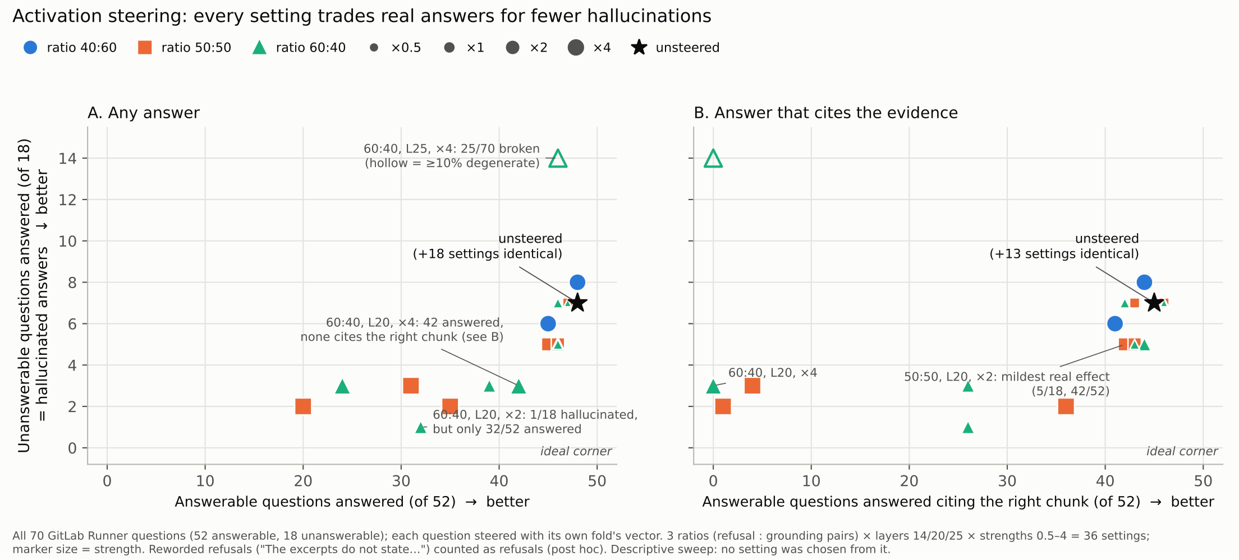
Fig. 4. Activation-steering sweep (descriptive; all 70 questions, each with its own fold’s vector; paraphrased refusals counted as refusals, post hoc). Left: unanswerables answered against answerables answered. Right: the same against answers citing the right chunk.
The sweep shows a trade-off, not an improvement. Across all 36 settings (Fig. 4), no setting reduced hallucination without losing answers; every point lies on one trade-off curve. For example, 60:40 at layer 20 ×2 answered only 1 of 18 unanswerables but only 32 of 52 answerables; 50:50 at layer 20 ×2, the mildest real effect, gave 5 and 45. Strong settings (×4) broke citations (50:50 layer 20 ×4: 1 of 52 overlap-cited) or produced degenerate output (60:40 layer 25 ×4: 25 of 70 degenerate).

6.4 Why steering trades refusal against hallucination
The cosine similarity between the refusal and grounding parts of each vector was about −0.77 to −0.90. The two families therefore push along nearly the same “answer vs refuse” axis, in opposite directions, and the ratio mainly sets how far and which way the combined vector points along it; ratio and strength largely trade off. 40:60 nearly cancels, which is why it was never selected. A single added vector shifts the model’s overall propensity to refuse, but it cannot make refusal depend on whether the evidence is in the context, which is the behaviour we need. Half of the grounding pairs also contrast a correct reason with a what-as-why answer rather than answering with refusing, which further tilts every mix towards refusal. Teaching evidence-conditional refusal would need a method that changes behaviour conditionally, such as fine-tuning on preference pairs, which we leave to future work (Section 10).

7 Application
PR Explainer is a local web and desktop application that answers “why was this changed?” questions about a repository’s pull requests. It runs on one computer, and its only network calls go to a local Ollama instance. It uses the final configuration chosen from Experiments 1 and 2: dense retrieval over fixed 512-token chunks with relation links (α = 1, pool A), the 2,560-token budget, the 4B model and the strict grounded prompt v3 (temperature 0, seed 42). This exact combination was not evaluated end to end on Django: there, Experiment 2’s F0 used fixed chunks without links, and links at α = 1 were tested only on GitLab Runner (arm C1, no difference from F0). The links follow Experiment 1’s Django tuning, where they raised budget recall for fixed chunks with dense retrieval (0.856 → 0.923) without losing the fixing PR from the budget (0.978 in both). On GitLab Runner, however, the same links pushed the correct MR out of the budget for 12 of 201 tasks (Section 4.5). For repositories other than Django, links should therefore be switched off (α = 0), which is the setting Experiment 2 evaluated. Each answer cites the excerpts it used, and the Sources panel highlights the cited passage, with a link to the PR (Fig. 5). When the excerpts state no reason, strict mode declines to answer and points the user to the excerpts (Fig. 6). A switch selects the standard (plain RAG) prompt instead. SymPy and GitLab Runner are also available, but they use Django’s settings unchanged and untuned, so their answers are exploratory.
Why these settings. Each setting follows from a design question in Sections 4 to 6. Dense retrieval was never significantly worse than hybrid on any query type and needs one index instead of two (Sections 4.6 and 5.9). Fixed 512-token chunks deliver the most evidence within the budget (Section 4.4). The strict grounded prompt is what turns missing evidence into a refusal (Section 5.4). The 4B model refused unanswerable questions far more reliably than the 8B (Section 5.2), and its 4-bit build answers in about 3 s on a 12 GB GPU, at the cost of refusing a few answerable questions that the bf16 model answers (Section 6.3). Neither post hoc mitigation is on by default (Sections 5.7 and 6).
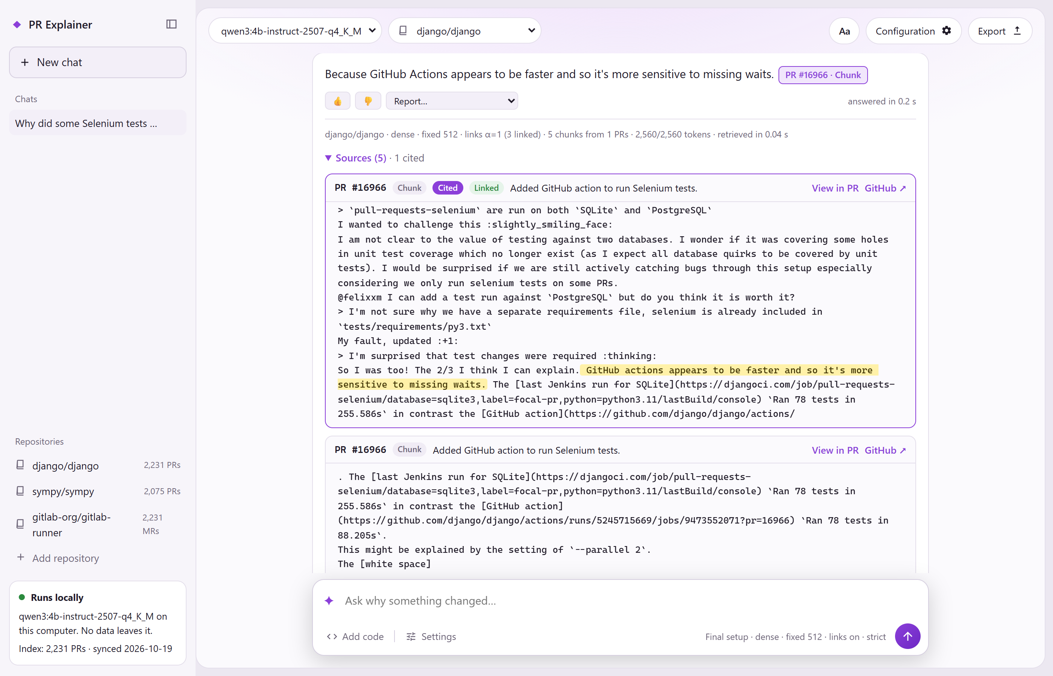
Fig. 5. A strict-mode answer to an answerable Django test question (q16966), with its citation chip and the Sources panel open on the cited excerpt; the supporting passage is highlighted.
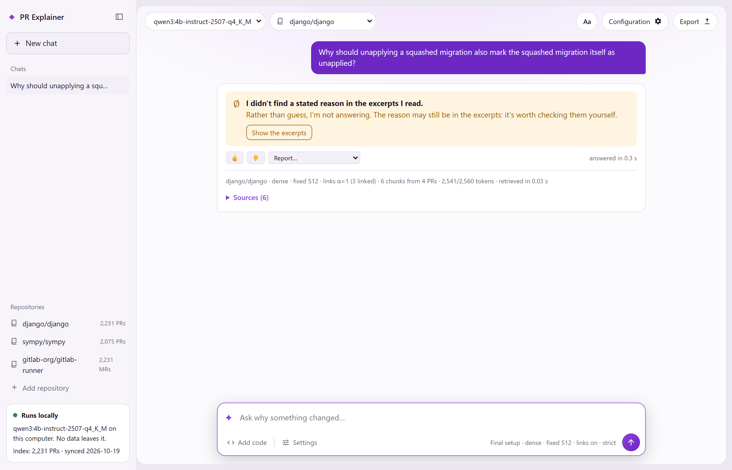
Fig. 6. For a Django test question whose PR states no reason (nr14500), strict grounding declines to answer and points the user to the retrieved excerpts.
Two features are design elements for future work, not results.
Feedback loop. Users can rate an answer (👍/👎) or report a problem type: wrong answer, invented reason, borrowed from another PR, or describes what, not why (Fig. 7). They can also give the correct PR and a comment. Each click appends one line to a local log with the question, answer, model, prompt, settings, retrieved and cited chunk ids, and the rating, marked as not yet reviewed. The application does not learn from this log. It is kept for human review before any reuse. Reviewed entries could later serve as regression tests, data to calibrate the gate, retrieval tuning data (through the correct-PR field), or preference pairs for steering or preference-based fine-tuning. User labels would be noisy: on GitLab Runner, even our own raters agreed at only κ 0.177 and 0.39.
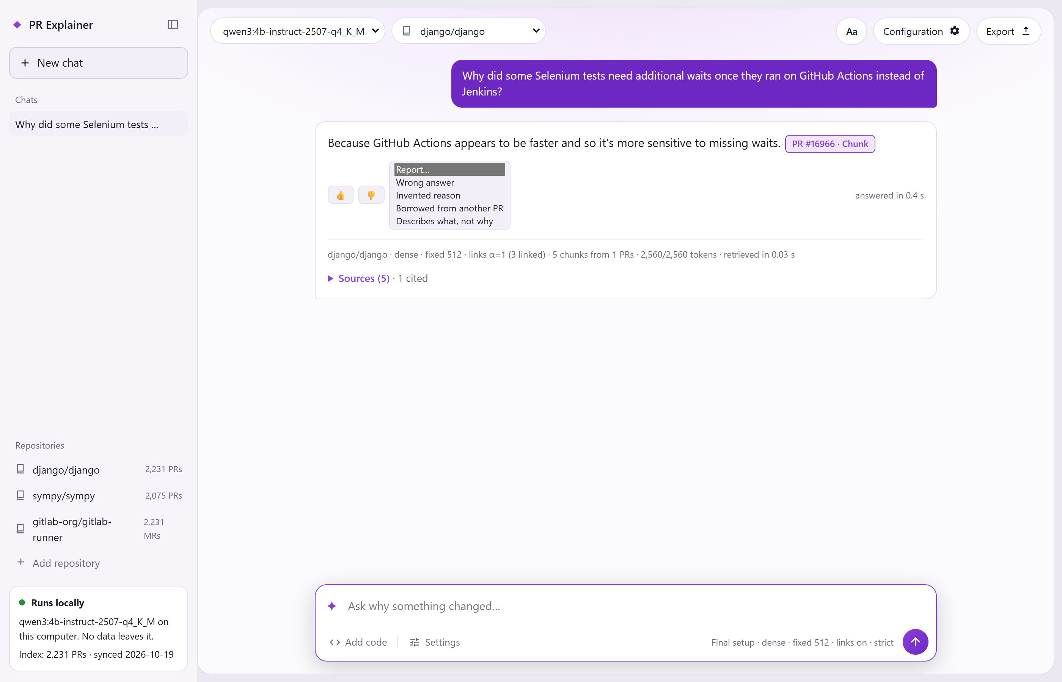
Fig. 7. Feedback controls under an answer, with the four report types listed; reports are logged for human review only. (For the screenshot, the Report menu’s options were displayed as an expanded list; nothing was submitted.)
Experimental support check. An optional setting applies the Experiment 2 MiniCheck gate unchanged (minimum support over cited sentences, threshold 0.5), to strict-mode answers only. Answers below the threshold, or citing no excerpt, are held back behind the support score, the excerpts and a “Show anyway” button; the answer text is never altered (Fig. 8). Each check takes about 0.3 s after an initial model load of about 8 s. The setting is off by default and labelled experimental, because the gate’s AUROC on Django was near chance (0.54–0.57, Section 5.2). In the example shown, the held-back answer (q8596) appears to be correct on a reading after the run (not a blind label): its cited excerpt contains the quoted reason, yet MiniCheck scores it 0.10, probably because the model’s own wording precedes the quote in one long sentence. The example therefore shows the check being over-cautious, in line with its near-chance AUROC, rather than catching an unsupported answer. A re-run on 12 Nov reproduced both scores (0.9496 and 0.1027).
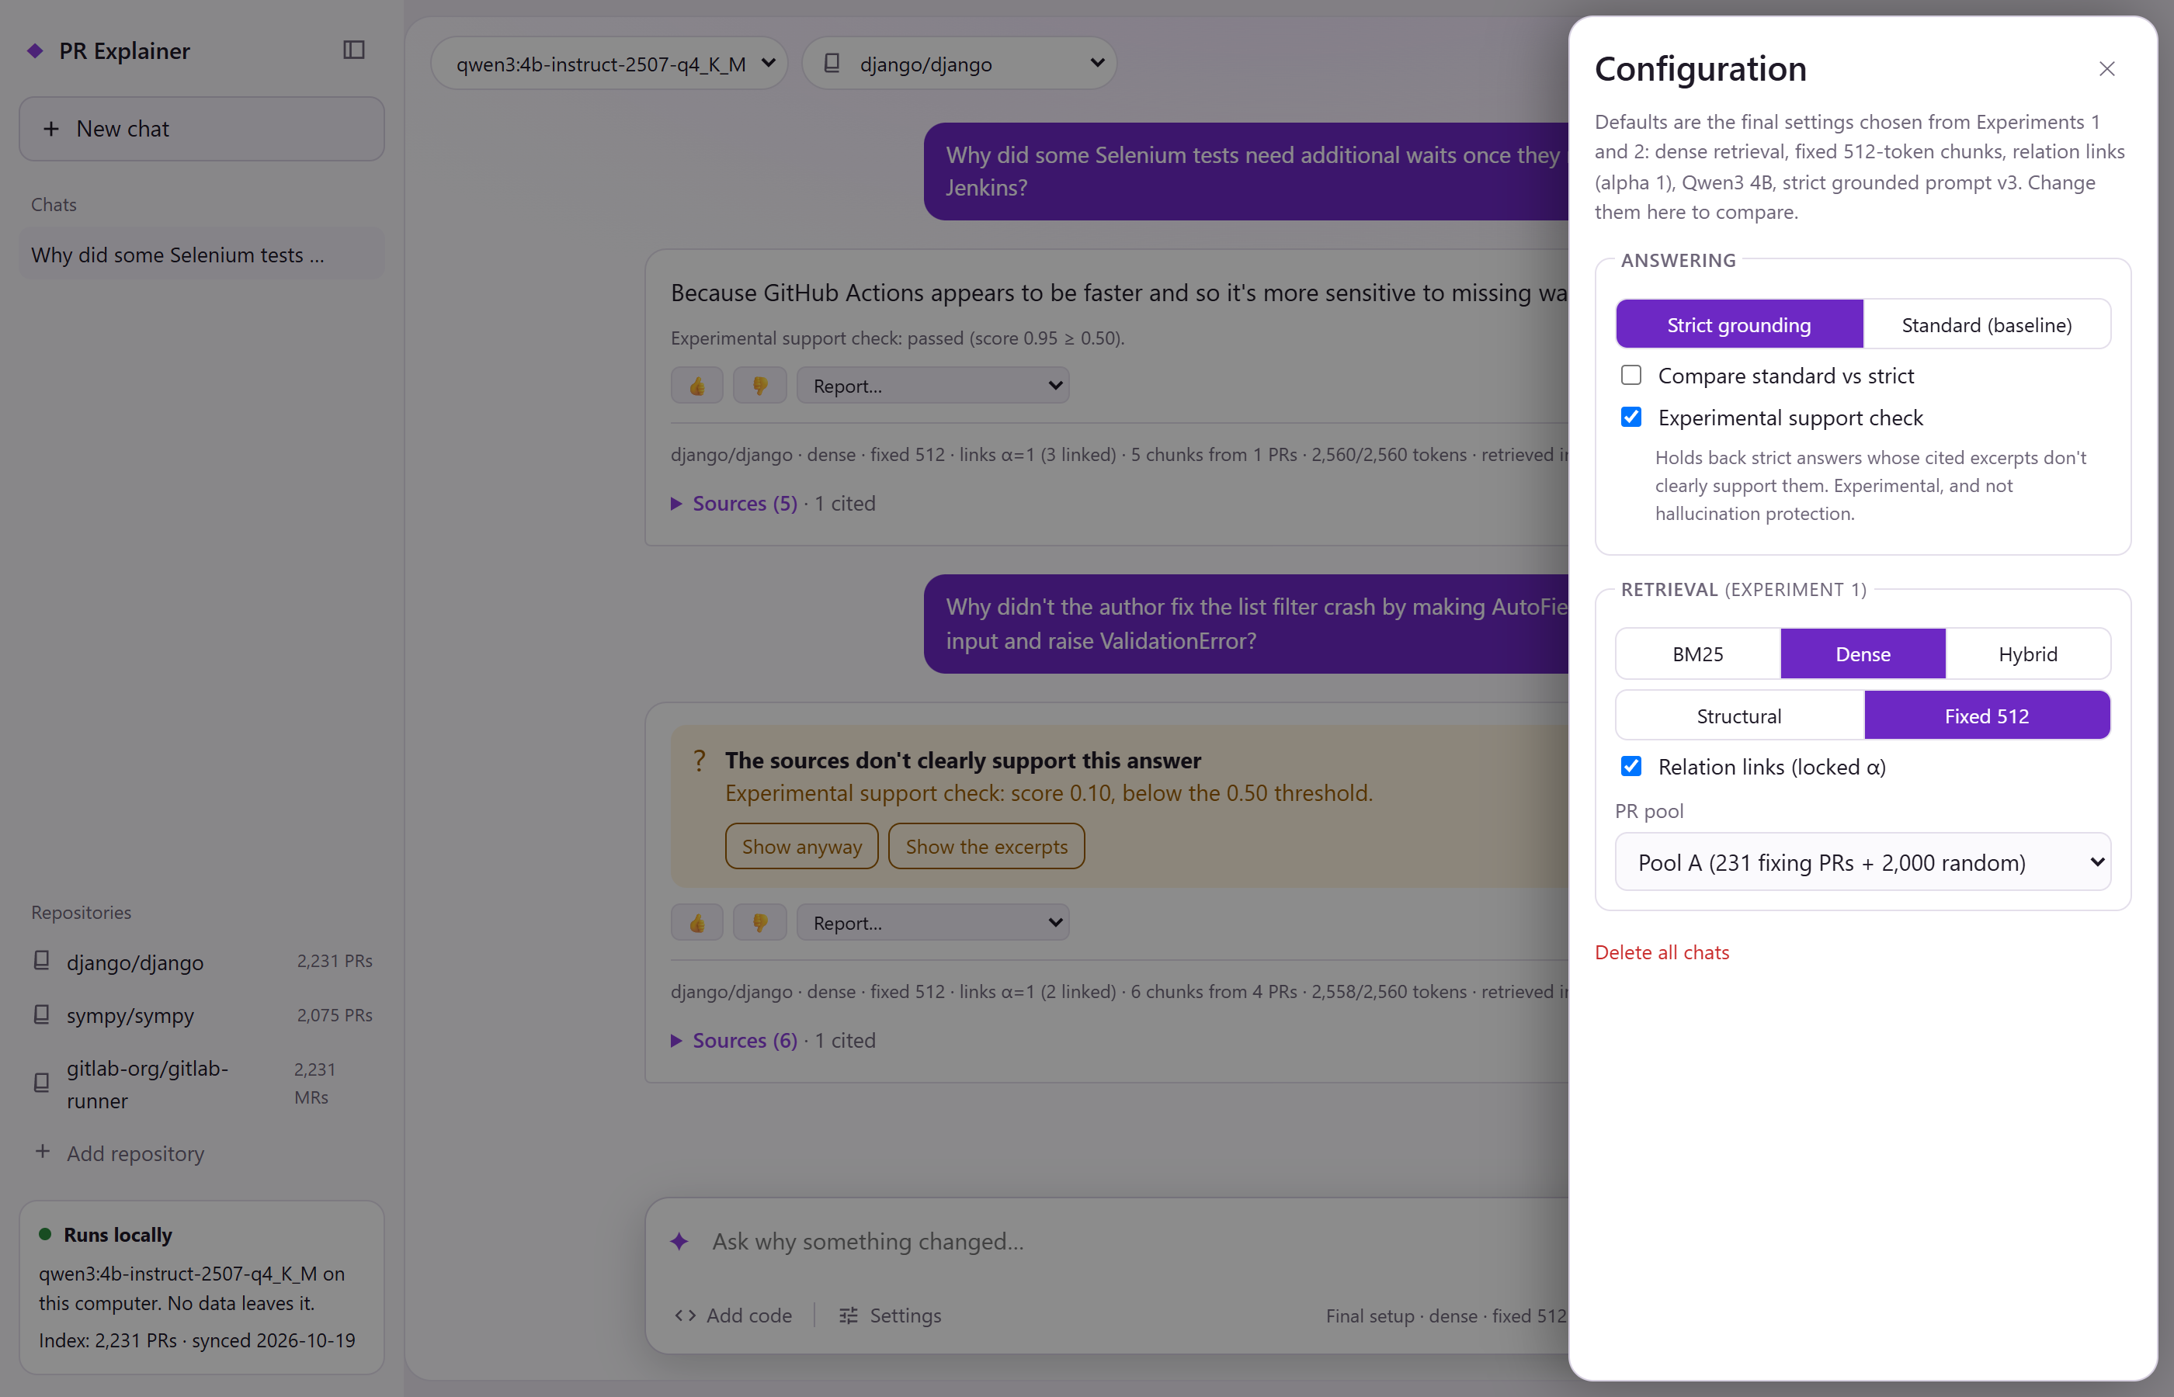
Fig. 8. Configuration panel with the experimental support check switched on, beside an answer that passed (q16966, score 0.95) and one held back with its score (q8596, 0.10) and a “Show anyway” button.

8 Discussion
Retrieval decides what the model sees. Experiment 1 separates the retrievers clearly on bug-report queries: dense retrieval ranks the fixing PR highest in every configuration, and on both Django and SymPy hybrid fusion lowers MRR@5 rather than raising it. Section 4.6 shows that this is largely a property of long, code-heavy queries: on first-line queries the gap shrinks, and on natural-language “why” questions hybrid is numerically ahead, though never significantly. Chunking matters for what reaches the model more than for which PR is ranked first: fixed 512-token chunks deliver the most code within the budget, structural chunks are as good or better at equal size, and links help structural chunks most while risking eviction of the correct PR. Getting the evidence into the context is a precondition for a correct answer: on GitLab Runner the grounded model answered 42 of the 47 questions whose answer span reached the context, and 1 of the 5 where it did not (Section 5.8).
The prompt decides whether the model admits the answer is missing. On GitLab Runner, changing the retriever (H0 vs F0) left the set of answered unanswerable questions exactly unchanged, while changing the prompt with the retrieved context held fixed (F0 vs P0) cut them from 13 to 5 (Section 5.4). Against closed-book answering, grounding is decisive on both axes: the closed-book model was never strictly correct and answered every unanswerable question with a false claim. Against plain RAG with the same context, the grounded prompt was no more often correct on answerable questions (30 vs 30 of 52), gave numerically fewer wrong answers (1 vs 5, not tested) and answered fewer unanswerable questions (pre-registered Holm p 0.023). That last result is fragile: after a blind human read, confident false claims were 3 vs 8, not significant. What the read does show is a change in the kind of error. Plain RAG often used retrieved context to deny a true premise, a failure the grounded prompt did not show. Grounding is therefore best understood as a way to make the model honest about missing evidence, at the cost of declining a few questions it could have answered.
Post hoc checks and steering trade, they do not fix. Both the faithfulness gate and activation steering reduce answers to unanswerable questions only by also removing real answers. For the gate, the cost on GitLab Runner was small (one answer for three hallucinations), but its discrimination on Django was near chance, so it cannot be trusted as a detector. For steering, the vector collapses to a single answer–refuse axis, as the single refusal direction reported by Arditi et al. [31] would predict, so any reduction in hallucination comes with proportionate over-refusal and, at higher strengths, broken citations. Neither makes refusal depend on whether the evidence is present. The most effective interventions we found act before generation (better retrieval) or in the instruction itself (the grounded prompt), not on the generated text or the activations.
Scale, quantisation and model choice. The 8B model answered far more unanswerable questions than the 4B (11–14 vs 2–7 of 17) without being more correct, and prompt v3 helped the 4B but barely changed the 8B. In the other direction, the 4-bit build of the 4B refused five answerable questions that its bf16 version answered correctly (Section 6.3). For a local assistant whose value lies in saying “not found”, a larger model is not automatically safer, and heavier quantisation shifts the balance towards refusing.
Answers to the research questions. Table 15 collects the answer to each question and the status of its evidence; Appendix C gives the status of every result in the report.
Question | Answer | Sections | Evidence
RQ0 Hybrid vs dense | No significant gain in context relevance on any query type; hallucination unchanged (5 vs 5 of 18 unanswerables answered on GitLab Runner) | 4.3, 4.6, 5.9 | Exp 1 pre-registered; follow-ups exploratory (GitLab) or post hoc (Django)
RQ1 Chunking and retriever | Dense retrieval, fixed 512/77 chunks; structural chunks as good or better at equal size | 4.3–4.5 | Pre-registered, uncorrected; structural with links post hoc
RQ2 Grounding | Grounded prompt: same correctness as plain RAG (30 vs 30 of 52), fewer unanswerables answered (5 vs 13 of 18); closed book never strictly correct | 5.4–5.6 | Pre-registered (Holm p 0.023); sensitive to refusal scoring
RQ3 Mitigation | Gate and steering trade correct answers for fewer hallucinated ones | 5.2, 5.7, 6 | Exploratory
RQ4 Deployment | 4B over 8B (fewer unanswerables answered); 4-bit more cautious than bf16 | 5.2, 6.3 | Counts only; quantisation post hoc
Table 15. Answers to the research questions and the status of their evidence.

9 Limitations
Threats to validity. The main threats, in order of importance, are: small question sets with few unanswerable questions, which give low power for hallucination outcomes; questions, gold answers and some label suggestions drafted by LLMs, which may favour explicit, well-documented PRs and anchor human labellers; single human labellers for the GitLab correctness and tagging results; and scoring rules that depend on how a refusal is worded. Each is detailed below with the results it affects.
Data and questions.
- The question sets are small: 50 answerable and 17 unanswerable on Django, 52 and 18 on GitLab Runner, and 15 and 7 on SymPy. With 18 unanswerables, power is low: significance needs about 7 discordant questions all one way.
- Gold answers and questions were written by an LLM (Claude). On Django they were reviewed by Kwek and a second LLM; on GitLab Runner the checks were mostly automated (Codex and DeepSeek, plus Kwek on 11 rows), not done by two people as planned. The sets favour PRs with explicit, rationale-rich discussion and are not a representative sample.
- Four no-reason labels on GitLab Runner are doubtful: nr3177, nr4460, nr1372 and nr1781. The models answered them from the MR text, yet they count as hallucinations in the pre-registered outcome. Without nr3177 and nr4460, F0’s unanswerable answers fall from 5 of 18 to 3 of 16.
- Ten of the 50 Django answerable gold PRs have a same-ticket PR in pool A, which may legitimately contain the reason.
- GitLab Runner’s Experiment 1 labels are closing references, not SWE-bench fixes, so the transfer checks are not like-for-like comparisons with Django.
Labels and judges.
- GitLab Runner correctness has a single labeller (Liu), working from Claude-drafted suggestions. His F0 labels agree only moderately with the earlier provisional labels (κ 0.39; 0.59 for correct vs not).
- Django correctness comes from one LLM judge (Codex), validated against one human rater on 80 rows (κ 0.675). Codex is stricter on correct vs partial. The exploratory W-F and H0 arms were labelled in later Codex sessions, and H0 has no human validation.
- Blinding is imperfect: some citation-stripped answers keep empty brackets, and answer style (for example premise denials) can hint at the arm.
- The post hoc tags and the human read of unanswerables come from one reader each. The two taggers agreed poorly on the kind of dishonesty (κ 0.19).
- Label suggestions drafted by Claude were checked row by row by the human labeller. This speeds labelling but can anchor the labeller towards the suggestion.
Scoring.
- The lenient refusal regex misses free-form refusals (including one in markdown bold), which inflates P0’s and CB’s counts. The broad regex was written after F0’s answers were seen. F0 vs P0 on unanswerables is sensitive to how paraphrased refusals are scored; F0 vs CB is robust.
- P0 and CB answers often hit the 512-token output limit (30 and 45 of 70) and were scored on what was generated.
- The faithfulness measures score sentence-level support, not whether the cited text is the reason. The gate threshold was committed after the faithfulness scores were computed, so all gate results are exploratory, and the gate’s AUROC is near chance on Django (0.54–0.57).
Runs and models.
- All generations use one seed (42) at temperature 0. Ollama output varied slightly between runs (one GitLab F0 answer differed once, then matched), and SymPy answers differed between GPUs for 9 of 22 questions.
- Only Qwen3 4B and 8B were tested, and Experiment 1 used a single embedding model.
- Experiment 1 was not corrected for multiple comparisons, its α choices were fragile, and the dev and test runs were each run once. The 2,560-token budget was never varied, so its effect is untested.
- Hybrid fusion was untuned, equal-weight RRF. Weighted or convex-combination fusion [23] and a cross-encoder reranker were not tested.
- The hybrid follow-ups (Sections 4.6 and 5.9) were run after the main results were known. The GitLab rule was committed before the runs, but the Django tests are post hoc, and H0 correctness on GitLab Runner was not labelled.
- The deployed model is a 4-bit quantisation; its bf16 version answered five more answerable questions correctly (Section 6.3).
Steering.
- Steering was exploratory, on 70 questions from one repository, with provisional question labels and scripted rejected answers.
- It used one seed, and Hugging Face bf16 rather than the Ollama 4-bit model used elsewhere.
- Its correctness labels come from one labeller.
- A single added vector cannot make refusal conditional on the evidence, so the negative result says nothing about methods that change weights.

10 Conclusion and Future Work
We built a fully local assistant that answers “why was this code changed?” from PR and MR histories, with citations or an honest “not found”, and evaluated each design decision on Django, with transfer checks on SymPy and GitLab Runner. For retrieval, dense embedding search ranked the fixing PR highest in every bug-report configuration (Django test, pool A: Hit@5 0.978, MRR@5 0.937). Fixed 512-token chunks delivered the most evidence within a fixed budget, while structure-aware chunks were as good or better at equal size. On the brief’s research question, hybrid search did not significantly improve context relevance on any query type and did not change hallucination: on GitLab Runner it answered exactly the same unanswerable questions as dense retrieval. The instruction mattered more than the retriever. Closed-book answers were never strictly correct, so the assistant’s answers come from retrieval; the grounded prompt was as correct as plain RAG on answerable questions and answered fewer unanswerable questions (pre-registered), although that difference weakens under a human read of paraphrased refusals. A MiniCheck gate and activation steering both reduced hallucinated answers only by also removing real ones.
Future work follows from these limits:
- Evidence-conditional refusal. Fine-tune a local model on reviewed preference pairs (for example DPO), with training PRs from a different repository than the test set, so that refusal depends on whether the evidence is present.
- Tuned fusion and reranking. Test weighted score fusion [23] and a local cross-encoder reranker on “why” questions, where hybrid search was numerically ahead.
- Human-reviewed feedback. Use the app’s feedback log as a reviewed source of regression tests, gate calibration data and retrieval tuning data.
- Better validation. Recruit a second human labeller for correctness, and have two people check the questions.
- A larger unanswerable set, so that hallucination differences can be tested with useful power.
- Rationale cards. Extract verbatim reason sentences per PR and check them by exact match, as a stronger grounding target than chunk citations [4], [19].

11 Contributions
- Liu Ziheng, Clifton:
  - Exp 1 dense and hybrid retrieval, all Exp 1 tuning and test runs;
  - the SymPy transfer check;
  - the activation-steering experiment;
  - blind correctness labels for the GitLab baselines and steering.
- Alyssa Chua Sin Ru:
  - Exp 1 BM25 (code-aware tokenizer) and metrics;
  - the Exp 1 write-up;
  - the human validation labels for the Django correctness judge and the gate-pass tags;
  - SymPy and GitLab pilot labels;
  - the demo app.
- Kwek Tze Xuan, James:
  - Experiment 2 (questions, generation, scoring, faithfulness gate, statistics);
  - the GitLab Runner transfer and baselines;
  - the hybrid follow-up runs (Sections 4.6 and 5.9);
  - running the steering experiment; labels for the SymPy check and the provisional GitLab labels, and tags of the answered GitLab unanswerables;
  - the report draft.

Acknowledgment
We thank Prof Ng Gee Wah and Prof Shen Bingquan for their guidance, in particular the suggestion to show how hallucination can be reduced and not only measured. AI tools were used in this project. Claude (Anthropic) helped write and review code and analysis scripts, ran experiment scripts under the authors’ supervision, drafted the question sets and gold answers, drafted label suggestions that a group member then checked, and helped draft parts of this report. Codex (OpenAI) and DeepSeek ran the automated question checks; Codex also reviewed the methods and produced the LLM-judge labels validated in Section 5.1. Every label used as a result was made or checked by a group member unless stated otherwise. The authors checked all results against the result files and are responsible for the content.
Code and data: https://github.com/ohnoammo/ESP3201A-Group-1.

References
[1] Landbase, “Companies using GitLab in 2026.” Accessed: Oct. 29, 2026. [Online]. Available: https://data.landbase.com/technology/gitlab/
[2] P. Lewis et al., “Retrieval-augmented generation for knowledge-intensive NLP tasks,” in Proc. NeurIPS, 2020.
[3] Y. Tian, Y. Zhang, K.-J. Stol, L. Jiang, and H. Liu, “What makes a good commit message?” in Proc. ICSE, 2022.
[4] M. Sun, A. Saha, N. De Silva, A. Mastropaolo, and O. Chaparro, “Fine-grained multi-document extraction and generation of code change rationale,” arXiv:2604.10345, 2026.
[5] S. Robertson and H. Zaragoza, “The probabilistic relevance framework: BM25 and beyond,” Found. Trends Inf. Retr., vol. 3, no. 4, pp. 333–389, 2009.
[6] Y. Zhang et al., “Qwen3 Embedding: Advancing text embedding and reranking through foundation models,” arXiv:2506.05176, 2025.
[7] G. V. Cormack, C. L. A. Clarke, and S. Büttcher, “Reciprocal rank fusion outperforms Condorcet and individual rank learning methods,” in Proc. SIGIR, 2009.
[8] C. E. Jimenez et al., “SWE-bench: Can language models resolve real-world GitHub issues?” in Proc. ICLR, 2024.
[9] N. Chowdhury et al., “Introducing SWE-bench Verified,” OpenAI, Aug. 2024. [Online]. Available: https://openai.com/index/introducing-swe-bench-verified/
[10] Z. Dai and J. Callan, “Deeper text understanding for IR with contextual neural language modeling,” in Proc. SIGIR, 2019.
[11] B. Efron and R. J. Tibshirani, An Introduction to the Bootstrap. Chapman & Hall, 1993.
[12] Q. McNemar, “Note on the sampling error of the difference between correlated proportions or percentages,” Psychometrika, vol. 12, no. 2, pp. 153–157, 1947.
[13] M. D. Smucker, J. Allan, and B. Carterette, “A comparison of statistical significance tests for information retrieval evaluation,” in Proc. CIKM, 2007.
[14] J. Cohen, “A coefficient of agreement for nominal scales,” Educ. Psychol. Meas., vol. 20, no. 1, pp. 37–46, 1960.
[15] L. Tang, P. Laban, and G. Durrett, “MiniCheck: Efficient fact-checking of LLMs on grounding documents,” in Proc. EMNLP, 2024.
[16] Vectara, “HHEM-2.1-Open (hallucination_evaluation_model),” Hugging Face, 2024. [Online]. Available: https://huggingface.co/vectara/hallucination_evaluation_model
[17] S. Holm, “A simple sequentially rejective multiple test procedure,” Scand. J. Statist., vol. 6, no. 2, pp. 65–70, 1979.
[18] N. Panickssery (Rimsky), N. Gabrieli, J. Schulz, M. Tong, E. Hubinger, and A. M. Turner, “Steering Llama 2 via contrastive activation addition,” in Proc. ACL, 2024.
[19] T. Gao, H. Yen, J. Yu, and D. Chen, “Enabling large language models to generate text with citations,” in Proc. EMNLP, 2023.
[20] H. Huang et al., “Back to the basics: Rethinking issue-commit linking with LLM-assisted retrieval,” in Proc. ICSE, 2026.
[21] V. Karpukhin et al., “Dense passage retrieval for open-domain question answering,” in Proc. EMNLP, 2020.
[22] N. Thakur, N. Reimers, A. Rücklé, A. Srivastava, and I. Gurevych, “BEIR: A heterogeneous benchmark for zero-shot evaluation of information retrieval models,” in Proc. NeurIPS Datasets and Benchmarks Track, 2021.
[23] S. Bruch, S. Gai, and A. Ingber, “An analysis of fusion functions for hybrid retrieval,” ACM Trans. Inf. Syst., vol. 42, no. 1, 2023.
[24] T. Chen et al., “Dense X retrieval: What retrieval granularity should we use?” in Proc. EMNLP, 2024.
[25] N. F. Liu et al., “Lost in the middle: How language models use long contexts,” Trans. Assoc. Comput. Linguist., vol. 12, pp. 157–173, 2024.
[26] J. Chen, H. Lin, X. Han, and L. Sun, “Benchmarking large language models in retrieval-augmented generation,” in Proc. AAAI, 2024.
[27] B. Wen et al., “Know your limits: A survey of abstention in large language models,” Trans. Assoc. Comput. Linguist., vol. 13, 2025.
[28] S. Es, J. James, L. Espinosa-Anke, and S. Schockaert, “RAGAS: Automated evaluation of retrieval augmented generation,” in Proc. EACL (System Demonstrations), 2024.
[29] S. Min et al., “FActScore: Fine-grained atomic evaluation of factual precision in long form text generation,” in Proc. EMNLP, 2023.
[30] L. Zheng et al., “Judging LLM-as-a-judge with MT-Bench and Chatbot Arena,” in Proc. NeurIPS Datasets and Benchmarks Track, 2023.
[31] A. Arditi et al., “Refusal in language models is mediated by a single direction,” in Proc. NeurIPS, 2024.
[32] K. Li, O. Patel, F. Viégas, H. Pfister, and M. Wattenberg, “Inference-time intervention: Eliciting truthful answers from a language model,” in Proc. NeurIPS, 2023.
[33] A. Zou et al., “Representation engineering: A top-down approach to AI transparency,” arXiv:2310.01405, 2023.
[34] Z. Z. Wang et al., “CodeRAG-Bench: Can retrieval augment code generation?” in Findings of NAACL, 2025.
[35] H. Husain, H.-H. Wu, T. Gazit, M. Allamanis, and M. Brockschmidt, “CodeSearchNet challenge: Evaluating the state of semantic code search,” arXiv:1909.09436, 2019.

A Appendix: Prompts and refusal rules
All prompts are given verbatim. {context} is replaced by the packed excerpts, each preceded by its identifier (for example [PR1234-c0]), and {question} by the question. For GitLab Runner and SymPy, “Django” is replaced by the project name. Prompt hashes (SHA-1, first 10 characters) were frozen before the test runs: v2 3a9009c452 and v3 759a5e1219.
Strict grounded prompt v2 (arm prompt “c”).
### SYSTEM
You are an assistant that answers questions about pull requests in the Django project.
### USER
Answer the question using ONLY the pull request excerpts below. Do not use outside knowledge and do not guess.
Rules:
- If the excerpts state the answer, answer in at most three sentences. Then cite, in square brackets, only the id of the excerpt whose text states the reason, for example [PR1234-c0]. This is usually a single excerpt; cite a second one only if the reason is split across two. Never cite an excerpt that does not state the reason.
- If the excerpts do not state the answer, reply with exactly this sentence and nothing else: Not found in the provided PRs
{context}
Question: {question}
Strict grounded prompt v3 (arm prompt “c3”).
### SYSTEM
You are an assistant that answers questions about pull requests in the Django project.
### USER
Answer the question using ONLY the pull request excerpts below. Do not use outside knowledge and do not guess.
Rules:
- The question asks WHY something was done. A reason must be stated in the excerpts in words, for example by an author or reviewer explaining a decision.
- A description of WHAT changed is not a reason. Code changes, titles, commit summaries, tests or release notes that only show what was done do not answer a WHY question. Do not work out a reason yourself from the code.
- If the excerpts state the reason, answer in at most three sentences. Then cite, in square brackets, only the id of the excerpt whose text states the reason, for example [PR1234-c0]. This is usually a single excerpt; cite a second one only if the reason is split across two. Never cite an excerpt that does not state the reason.
- If the excerpts do not state the reason, reply with exactly this sentence and nothing else: Not found in the provided PRs
{context}
Question: {question}
Django plain RAG prompt (development runs only).
### SYSTEM
You are an assistant that answers questions about pull requests in the Django project.
### USER
Use the following excerpts from Django pull requests to answer the question.
{context}
Question: {question}
Answer in at most three sentences.
Django closed-book prompt (development runs only).
### SYSTEM
You are an assistant that answers questions about pull requests in the Django project.
### USER
Question: {question}
Answer in at most three sentences.
GitLab Runner baselines (Section 5.4). P0 used the system prompt “You are a helpful assistant. Use the following context from GitLab Runner merge requests to answer the question.” followed by F0’s context and the question; CB used “You are a helpful assistant. Answer the question about the GitLab Runner project.” followed by the question.
Lenient refusal rule (primary for the baselines). An answer is a refusal if it is empty or if a case-insensitive search of the raw response matches:
not found in the provided|do(es)? not (state|mention|provide|explain|specify|contain|say)|no (information|reason|mention)|not (provided|mentioned|stated|specified)|cannot (be )?determine|unable to determine
Broad refusal rule (sensitivity). A refusal under the lenient rule, or a match of:
(does|do|did)( not|n['’]t)( \w+)? (state|mention|provide|explain|specify|contain|say|include|give)|(is|are|was|were)( not|n['’]t)( \w+)? (provided|mentioned|stated|specified|explained|given|documented)|no (specific |explicit |clear |direct |publicly available )?(information|reason|mention|explanation|details?)|(don['’]t|do not) have (access|information|specific|details)|(cannot|can['’]t|could not|couldn['’]t|unable to) (find|determine|confirm|identify)|not aware of

B Appendix: Hardware and run times
Every stage ran on consumer hardware without any cloud API. Table 16 lists the measured times; index sizes on disk and retrieval latency were not recorded.
Stage | Hardware | Time
Exp 1, pool A development grid (embedding and indexing) | Laptop, RTX 3050 Ti 4 GB, fp16 | about 4 h
Exp 1, pool H development grid (about 150,000 new embeddings) | Laptop, RTX 3050 Ti 4 GB, fp16 | about 13 h
Exp 1, four test runs | Laptop, RTX 3050 Ti 4 GB, fp16 | about 11.5 h
Answer generation, Qwen3-4B 4-bit (Ollama) | Desktop, RTX 5070 12 GB | median 2.9 s per answer
Answer generation, Qwen3-8B (Ollama) | Desktop, RTX 5070 12 GB | median 3.3 s per answer
Prompt length, Django Exp 2 (1,104 generations) | 8,192-token window | median 3,269 tokens (max 3,873)
MiniCheck support check (app) | Desktop, RTX 5070 12 GB | about 0.3 s per answer; 8 s first load
Steering generation, Qwen3-4B bf16 (Hugging Face) | Desktop, RTX 5070 12 GB | median 64 s per answer (unsteered)
H0 generation, 70 GitLab Runner questions | Desktop, RTX 5070 12 GB | about 10 min
Table 16. Hardware and run times.

C Appendix: Status of each result
Table 17 gives the status of every result in the report, using the labels defined in Section 1.
Result | Section | Status
Retriever and chunking comparisons, tuned vs untuned | 4.3–4.4 | Pre-registered; uncorrected
Structural with links vs size-matched with links | 4.4 | Post hoc
GitLab Runner Exp 1, links on vs off | 4.5 | Pre-registered (Holm family of 4)
Dense vs hybrid, first-line bug reports | 4.6 | Secondary; planned runs, tests computed later
Dense vs hybrid on “why” questions, Django | 4.6 | Post hoc
Dense vs hybrid on “why” questions, GitLab Runner | 4.6 | Exploratory; rule committed before the run
Django arms and prompts (primary, contain-cited, correctness) | 5.2 | Pre-declared; scoring fixed after a first count, before any test
Django W-F and H0 arms; MiniCheck gate | 5.2, 5.7 | Exploratory
GitLab Runner F0 vs P0 vs CB | 5.4 | Pre-registered (Holm family of 4)
GitLab Runner correctness | 5.5 | Secondary; unadjusted
Blind read and tags of answered unanswerables | 5.6 | Post hoc
H0 vs F0 generation on GitLab Runner | 5.9 | Exploratory; rule committed before the run
Steering tests | 6.3 | Pre-registered within an exploratory experiment
Paraphrased refusals; bf16 vs 4-bit comparison | 6.3 | Post hoc
Table 17. Status of each result. Pre-registered: rules and tests committed before the data existed; exploratory: rules fixed before the run but outside the pre-declared families; post hoc: chosen after the results were seen.

