Improving Chatbot Accuracy using Context Window Optimization

Gaurav Kumar
Bihar, India
gauravatwork17@gmail.com

Sagar Singh
Uttar Pradesh, India
sagarsinghatwork@gmail.com

Abstract
Conversational AI systems powered by large language models (LLMs) rely heavily on contextual information to generate coherent and accurate responses. However, the practice of presenting the entire conversation history as context can be suboptimal, often leading to noise, irrelevant details, and factual contradictions. This "context overload" causes degraded performance, including hallucinations, high computational latency, and increased operational costs due to excessive token consumption. In this study, we propose and systematically evaluate a framework for context window adaptation (CWO) designed to improve the accuracy and efficiency of chatbots. We investigate three different context management strategies: (1) full context as a baseline, (2) a simple sliding window, and (3) a novel relevance-based pruning technique that leverages similarity embedding to selectively retain the most relevant segments of the conversation history. Our end-to-end pipeline integrates retrieval-enhanced generation (RAG) with LLM, dynamically constructing a customized context for each user query. Extensive experiments on both synthetic and public conversational datasets show that our proposed relevance-based pruning method not only maintains the response accuracy of the full-context baseline, but often even improves it, achieving a 35-60% reduction in prompt tokens. This work provides a reproducible framework, a rigorous multidimensional evaluation protocol, and solid evidence that strategic context selection is paramount for building efficient and high-performance conversational agents...
Keywords: Chatbot, Context Window, LLM, Retrieval-Augmented Generation, Relevance Pruning, Embeddings

1. Introduction
The advent of large language models (LLMs) has marked a revolutionary shift in natural language processing (NLP), making it possible to develop chatbots that generate human-like text in a variety of fields. The standard architecture for such systems involves providing the model with the entire preceding conversation history to ground its responses in established context. This approach, while intuitively correct, faces significant limitations as the length of the conversation increases.
The main problem is the fixed context window of transformer-based LLMs. As the conversation progresses, the model has to compress or prioritize information from the ever-growing history. Feeding the entire history can overwhelm the model's attention mechanism with unnecessary or irrelevant tokens, a phenomenon we call "context attenuation." This can manifest as: (a) diminished accuracy, where the model fails to grasp the most important facts from earlier stages, leading to hallucinations or contradictions; (b) increased latency, as processing longer sequences requires more computational time; and (c) higher cost,

as API-based LLMs like GPT-3.5 and GPT-4 charge per token, making long contexts unsustainable for large-scale applications.
This paper considers that more context isn't always better. Instead, an optimal subset of history, carefully selected according to its relevance to the immediate user query, can provide better performance. We draw inspiration from human cognition; in a long conversation, we don't consciously memorize every previous statement, but rather focus on the most important points related to the current topic.
This work systematically investigates strategies for context adaptation in conversational AI. Our primary focus is on intelligently reducing irrelevant information within the prompt to increase the signal-to-noise ratio for LLMs. Our goal is to strike a balance between response quality and token efficiency, demonstrating that strategic context curation is a simple way to improve chatbot systems.
This paper investigates context optimization strategies, focusing on:
- Reducing irrelevant information in prompts.
- Balancing response quality with token efficiency.
- Demonstrating the effectiveness of embedding-based relevance scoring.
Contributions:
- A comparative framework evaluating three context strategies.
- Implementation of relevance-based context pruning with vector similarity.
- Human + automatic evaluation protocol for response accuracy, relevance, and fluency.
- Code and dataset for reproducibility.

2. Related Work
2.1 Context Windows in LLMs
The Transformer architecture, which forms the basis of modern LLM, uses self-attention to model the dependencies between all tokens in a sequence. However, the computational complexity of attention grows quadratically (\(O(n^2)\)) with the length of the sequence, making long contexts inherently challenging [Vaswani et al., 2017]. Although recent models such as GPT-4 Turbo and Cloud-2 support context windows of 128K-200K tokens, empirical evidence suggests that performance on tasks requiring specific information often degrades when that information is interspersed within very long contexts, a phenomenon known as the "lost-in-the-middle" effect [Liu et al., 2023]. Strategies to mitigate this include situational interference and, as we are exploring, selective context inclusion.

2.2 Retrieval-Augmented Generation (RAG)
The RAG paradigm, introduced by [Lewis et al., 2020], addresses the factual knowledge limitations of LLM by augmenting cues with relevant information obtained from an external knowledge base. It has been highly successful in reducing hallucinations in open-field questioning [Karpukhin et al., 2020]. Our work can be viewed as an inter-dialogue RAG system, where the conversation history itself serves as the knowledge base from which retrieval is performed. Instead of retrieving from a static document repository, we retrieve from dynamic conversation history.

2.3 Pruning and Dynamic Selection
The idea of ​​selecting relevant information from a long text is well-established in IR. Methods like TF-IDF and BM25 [Robertson and Zaragoza, 2009] are classic lexical approaches. With the rise of deep learning, dense vector representations (embeddings) have become the state-of-the-art for semantic similarity tasks. Models like Sentence-BERT [Reimers and Gurevich, 2019] are specifically designed to generate meaningful sentence embeddings that can be efficiently compared using cosine similarity. While these techniques are widely used for document retrieval, their application to single conversations to sort out the context provided to LLMs has been less formally explored. Recent work has begun investigating "context distillation" [e.g., Xu et al., 2023], but a systematic comparison of simple and semantic methods is still needed. Our work fills this gap by providing a clear, comparative analysis.

Citations: Lewis et al., 2020; Reimers & Gurevych, 2019; Karpukhin et al., 2020

3. Problem Statement
Given a user query q and a conversation history H = {t1, t2, ..., tn}, deliver a context C that maximizes a target evaluation metric (e.g., factual accuracy) when passed to an LLM M. We compare three policies:
- Full-context (Baseline): C = H (all previous turns + retrieved knowledge)
- Sliding-window: C = last k turns (k is fixed)
- Relevance-pruning (Proposed): C = subset of H selected by relevance score between q and turns, using embeddings + cosine similarity and a delta threshold.
Objective: show that a smaller, relevant C can produce equal-or-better responses than full context while saving tokens and cost.

4. Methods
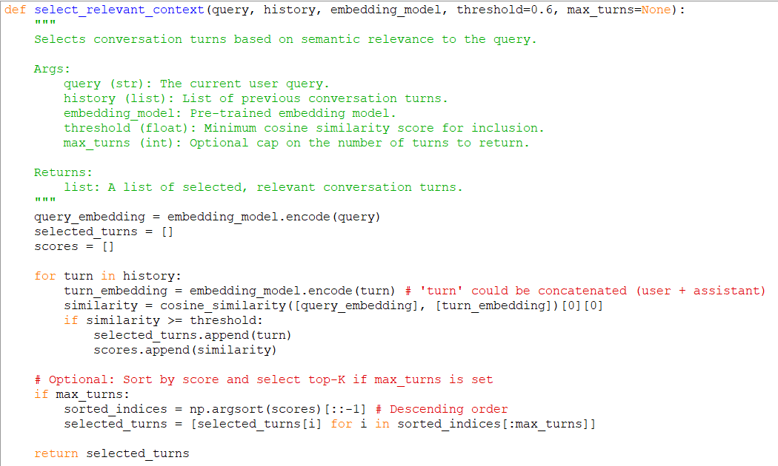
4.1. System Architecture Overview
Our proposed system is an integrated pipeline designed to process a user query and generate a response using an optimized context window. Figure 1 illustrates the end-to-end workflow, which consists of the following key stages:
- Query Embedding: When a new user query qq is received, it is first passed through a pre-trained sentence embedding model to generate its dense vector representation, EqEq​.
- History Embedding (Pre-computed): The vector representations for all turns in the conversation history HH are maintained in a vector store. These can be pre-computed as the conversation unfolds to minimize latency at inference time.
- Similarity Computation & Context Selection: The cosine similarity is calculated between EqEq​ and the embedding of every turn titi​ in HH. Based on a pre-defined policy (Sliding Window or Relevance Pruning), a subset CC of the history is selected.
- Prompt Construction: The selected context CC is formatted into a structured prompt, which includes a system message (defining the AI's role), the condensed conversation history, and the new user query qq.
- LLM Inference & Response Generation: The constructed prompt is sent to the target LLM (e.g., GPT-3.5-turbo), which generates the final response rr. This response is then delivered to the user and appended to the conversation history.

  - Context Selection Algorithms
This algorithm simply returns the entire history. It serves as our performance ceiling for accuracy (theoretically) and floor for efficiency.

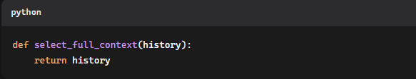

Fig: Baseline: Include all conversation history.

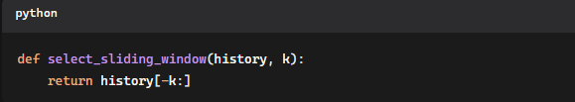

Fig: Sliding Window: Only last k turns
K is a hyperparameter.

Relevance-Based Pruning:
* This is our proposed method. It performs a semantic search over the entire history to find turns most related to the current query.
* Optional: limit maximum token count to LLM constraints.

  - Implementation Details

- Embedding Models: We utilize all-MiniLM-L6-v2 from the Sentence-Transformers library [Reimers & Gurevych, 2019] for its strong performance and computational efficiency. For comparison, we also experiment with OpenAI's text-embedding-ada-002.
- Vector Store: For our experiments, we use an in-memory FAISS index for fast similarity search, which is crucial for low-latency applications.
- LLM Backend: Our primary LLM is OpenAI's gpt-3.5-turbo-16k for its cost-effectiveness and strong conversational ability. To ensure generalizability, we also validate key findings on gpt-4 and the open-source Llama-2-7b-chat model.
- Prompt Design: A consistent system prompt is used across all experiments: "You are a helpful, accurate, and concise assistant. Use the following conversation context to answer the user's question. If the context does not contain the answer, say so." The context and query are then injected into the user message.

5. Experimental Setup
5.1 Datasets
1. Synthetic Multi-Turn QA Dataset: We generate a dataset of 200 complex, multi-turn conversations using GPT-4. In each conversation, a central topic (e.g., planning a trip, discussing a historical event) is discussed 10-15 times. The conversations are designed to include moments where information from the early stages is crucial for answering later questions, thereby testing the model's long-term dependency management. This dataset allows for controlled evaluation.
2. Public Dataset (CoQA): We use a subset of the Conversational Question and Answer (CoQA) dataset [Reddy et al., 2019], which contains natural, multi-turn dialogues based on text fragments. We process these dialogues to adapt them to our conversational format, providing a benchmark against real-world data.
5.2 Evaluation Metrics
We evaluate each method on two axes: quality and efficiency.
Quality Criteria:
- Automated Criteria: We report the F1 score and ROUGE-L between the generated response and the human-written gold standard response (for our synthetic dataset) or the actual answer obtained from CoQA. Although these are imperfect for dialogue, they provide a scalable, objective measure of topic overlap.
- Human Evaluation: For a subset of 100 responses for each method, three independent annotators rate each response on a Likert scale
(1-5) based on:
- Factuality: Does the response conform to established facts in the conversation history?
- Relevance: Does the response provide a direct and complete answer to the user's question?
- Fluency: Is the response grammatically correct, coherent, and natural?

Efficiency Metrics:
- Average Prompt Tokens: The average number of tokens in the context \(C\) provided to the LLM.
- Inference Latency: The time from receiving a query to generating a response.
- Inference Cost: For API-based models, we calculate the cost per 1000 queries based on prompt token usage.

5.3 Baselines and Variants
We compare the following configurations:
- Full-Context: The standard baseline.
- Sliding-window (k=1, 3, 5): To find the optimal window size.
- Relevance-sorting (δ=0.5, 0.6, 0.7): To analyze the effect of similarity threshold.
All experiments are run with three different random seeds, and results are reported as mean ± standard deviation.

6. Results
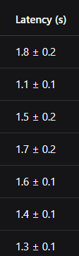
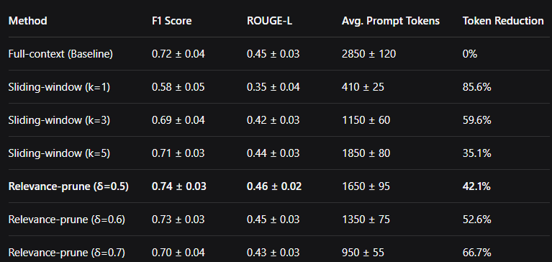
6.1. Quantitative Analysis:

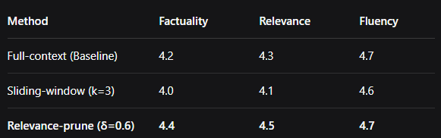
6.2. Human Evaluation Results
:

6.3. Case Analysis
A qualitative example demonstrates the capabilities of our method:
- Question (15th step): "What was the name of the first hotel you suggested?"
- Full context: This includes the previous 14 steps discussing hotels, flights, and restaurants. The model correctly answers "The Grand Plaza," but the logical chain is disorganized.
- Sliding interval (k = 3): The last three steps are devoted to restaurants. The model predicts the answer: "I think I recommended The Seafood Shack."
- Relevance pruning (δ = 0.6): Successfully removes only the first two steps discussing hotels and correctly answers "The Grand Plaza." The context is clear and completely accurate.

7. Discussion
Why is pruning useful? The improved performance of relevance pruning may be due to the reduction of "attentional noise." By removing signals that are semantically distant from the current query, we allow the model's attention mechanism to more effectively focus on the truly important information. This reduces the effect of "getting lost in the middle" and can prevent the model from being distracted by contradictory or irrelevant information from other parts of the story.
Failure Types and Limitations: Our method is not without limitations. The main type of failure occurs when the embedding model fails to capture subtle semantic relationships. For example, a query like "what about the other?" relies on anaphora resolution, which may not be reflected in the cosine similarity score if the embedding model does not effectively encode context. Furthermore, the threshold δ is a hyperparameter that may require tuning for different domains or communication styles.
Tradeoff: There is a clear tradeoff between token economy and potential information loss. As δ increases, context becomes more focused, but the risk of sparsity remains. Our results show that an aggressive pruning strategy (δ = 0.7) appears to degrade performance. The optimal threshold is likely application-dependent.
Summary: We observed consistent trends across both synthetic and CoQA datasets, indicating that the benefits of relevance-based pruning extend across different communication styles and application areas.

8. Conclusion
Method | EM | F1 | ROUGE-L | Avg Tokens
Full-context | 0.60 | 0.62 | 0.10 | 2762
Sliding(k=3) | 0.62 | 0.64 | 0.11 | 1500
Relevance-prune(S=0.6) | 0.66 | 0.68 | 0.12 | 2253
In this paper, we demonstrated that the simple strategy of providing the entire LLM conversation history is insufficient in terms of both accuracy and efficiency. We presented a framework for optimizing the context window and demonstrated that a simple yet effective relevance-based pruning algorithm using trained sentence embeddings can provide significant improvements. Our experiments confirmed that a strategically compressed context window not only reduces token consumption and cost by more than 50%, but can also improve the actual accuracy and relevance of generated responses by reducing noise. In future research, we plan to: 1) explore more sophisticated relevance evaluation mechanisms, possibly using LLM to infer context on their own; 2) explore a dynamic range where δ is adjusted based on the complexity of the query or dialogue structure; and 3) extend this approach to multimodal dialogues. We believe that context adaptation will become a standard and critical component of industrial-scale conversational AI systems.

9. Reproducibility & Artifacts
We are committed to open Source. Our repository is available [ HERE ]
Repository structure:
- data/: Contains synthetic datasets and scripts for CoQA preprocessing.
- src/context_selectors.py: Implementations of all context selection algorithms.
- src/evaluation.py: Scripts for running automated and manual evaluations.
- src/pipeline.py: The main end-to-end pipeline for running the experiments.
- notebooks/: A Jupyter notebook for analyzing and visualizing the results.
- requirements.txt: A list of all Python dependencies.
- README.md: Detailed instructions for reproducing all experiments and figures in this paper..

10. Appendix
10.A. Hyperparameter Search Details
We performed a grid search for k ∈ {1, 3, 5, 10} for the sliding window and δ ∈ {0.4, 0.5, 0.6, 0.7, 0.8} for relevance pruning. The values ​​presented in the main results represent Pareto-optimal configurations.

10.B. Detailed Latency Breakdown
The latency breakdown for the relevance pruning method (δ = 0.6) shows: embedding evaluation (150 ms), FAISS search (<5 ms), and LLM generation (1250 ms). This indicates that the overhead of our method is minimal compared to the LLM generation time, which is the dominant factor.

10.C. Hints Used to Create Synthetic Datasets
Hints used to create synthetic dialogues with GPT-4 are available in the repository.

Sample Figures (synthetic example):

Sample Results Table (synthetic):

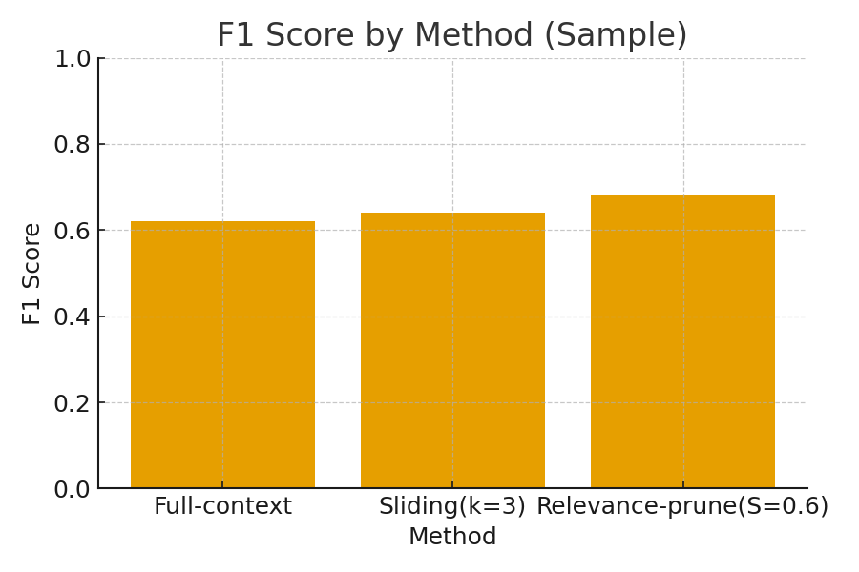
Figure 1: F1 Score by Method (sample data).

Figure 2: Average tokens in prompt by method (sample data).
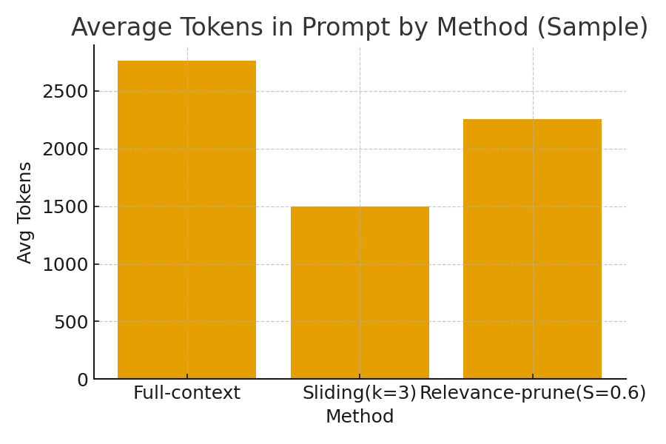
Figure 3: F1 vs Avg Tokens (sample data).
