

**Thank you for choosing the LCM-01 Contact Microphone!**

This microphone is hand-built by Anand Lobo in Fatorda, South Goa.

The LCM-01 microphone unit has 3 parts:

• one (1) piezoelectric disc, ¼ inch TRS female socket

• one (1) 3-meter audio cable, ¼ inch TRS male to XLR male

• one (1) preamplifier module

The preamplifier uses 'phantom power' which is implemented on all

modern professional sound systems; no batteries are required.

**Usage:**

1. Attach the piezoelectric disc to the surface of the instrument you wish to amplify, using the non-marking putty provided.

You may wish to tape the wire down to prevent it from buzzing against the body.

1. Connect the ¼ inch TRS plug of the provided audio cable to the ¼ inch TRS socket of the piezoelectric disc.
2. Connect the XLR plug of the provided audio cable to the XLR socket of the preamplifier module.

**Important**: The microphone will not work without the provided TRS - XLR cable.

1. Connect the preamplifier module to an audio interface or mixer using a standard XLR microphone cable.
2. Turn on phantom power.

**Important**: The microphone will not work without phantom power.

**Troubleshooting:**

If you are experiencing 'mains hum' or related 'buzzing' interference, please ensure that your audio system is properly electrically grounded.

For other issues please contact @ohnoitsalobo_builds on Instagram.

**How does the LCM-01 work?**

The microphone operates using a phenomenon called piezoelectricity – this is the generation of electricity when a material bends or moves. By fixing the piezoelectric disc to a resonant surface, the vibrations of your acoustic instrument are converted into an electrical signal that can be amplified by a PA speaker or mixer.

**What’s special about this microphone?**

Piezoelectric microphones are simple but special devices, such that common sound systems are not designed to handle them directly. As an analogy, think of trying to drive a pickup truck using the engine of a motorcycle; you’ll move, but neither the truck nor the engine are well suited to each other. This incompatibility can be heard when cheap piezoelectric microphones are used in music shows; instruments will tend to sound unnatural, sounding very ‘sharp’ and ‘tinny’ as though they’re being played through a metal box.

Hence, a preamplifier module was designed specifically for this microphone, in order to capture the best possible sound. It acts as a buffer between the microphone and a PA system, preventing any incompatibility and preserving the natural sound of the instrument. The preamplifier requires power to work, which is provided by 48V ‘phantom power’ available on all professional sound systems.

Unlike common instrument pickups, this microphone produces a “balanced” audio signal similar to vocal microphones – in non-technical terms, this means that it is highly resistant to electrical interference or noise, which can often be heard as a ‘buzzing’ or humming sound from typical instrument pickups.

In order to take advantage of this noise immunity, you must use the correct audio cable **and** the preamplifier, which is included with your purchase; a standard instrument cable will not be as resistant to noise.

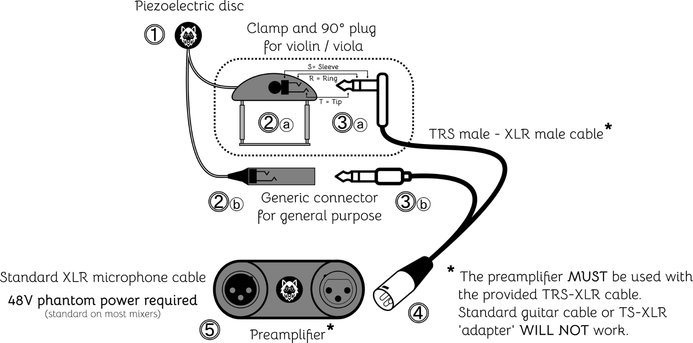

1. Attach the piezoelectric disc ➊ to the instrument or surface you wish to record, using the provided "blue tack" putty **\***.

**\*** Faber-Castell™ "Tack-It" is non-marking and reusable.

1. Secure the connector ➋ to the instrument or surface, such that the wire does not buzz against the surface and does not pull on the piezoelectric disc ➊.

* Mounting clamp ➋ⓐ is provided for violin and viola.
* For other uses, connector ➋ⓑ can be affixed using non-marking tape or other means.

1. Connect the TRS plug ➌ to the piezoelectric disc connector ➋.

* A low-profile 90° plug ➌ⓐ is provided for violin and viola.
* For other uses, a straight plug ➌ⓑ is provided.

1. Connect the XLR plug ➍ to the preamplifier ➎.
2. Using a regular microphone cable (XLR - XLR), connect the preamplifier ➎ to an audio interface or PA mixer.

* Turn on "phantom power" (standard on all professional audio equipment).

The microphone is now ready to use.