Lobo Handcrafted™ Contact Microphone

This microphone is intended to be used primarily on string instruments with a resonating hollow body (instruments such as violin, cello, guitar, ukulele, mandolin, and related instruments) but is not limited to those. It has been used with some success on kalimba, piano, and dulcimer, for example.

It can be attached to any surface to record sounds; attached to a wall, it can detect the sounds of traffic traveling through the earth, or people walking in the next room; attached to a table, it can be used as a pseudo-drum; suitably waterproofed, it could be used as a hydrophone to record sounds underwater.

The microphone unit consists of three parts:

* piezoelectric disc (the ‘pickup’)
* balanced cable (‘stereo’ TRS male – XLR male)
* phantom-powered preamplifier

1. **the pickup**: this is a commonly available piezoelectric disc used typically as a ‘buzzer’ in various electrical appliances. My implementation uses two piezoelectric discs together to create a ‘balanced’ signal, which provides a stronger audio signal and is generally more resistant to electromagnetic interference (EMI).  
   The pickup comes in two functionally identical variants – one with a clamp specifically meant for mounting on violin and viola, and one for practically any other application.

*If desired, this pickup can be used without the cable / preamplifier combo, or with a different commercial preamplifier, at the user’s discretion – with the understanding that the sound quality will be reduced.*

1. **the cable:** this is a custom TRS – XLR cable specifically intended to connect the balanced pickup with the preamplifier built for this purpose. It uses a 6.35mm TRS male connector to connect to the piezoelectric disc on one end, and a common microphone XLR male connector to connect to the preamplifier at the other end.

*This cable is required in order for the piezoelectric disc to work correctly with the preamplifier.*

1. **the preamplifier:** As piezoelectric discs are not naturally compatible with common audio equipment, the preamplifier acts as a ‘buffer’ or ‘impedance matcher’ which enables the audio interface to record the piezoelectric disc accurately. This is something which is not usually addressed by most commercially available piezoelectric instrument pickups.   
   The preamplifier is a custom-designed analog electronic circuit which requires ‘phantom power’ from a professional audio interface in order to function. This is similar to commonly used ‘condenser’ microphones which also do not work without externally applied power.   
   *While the piezo disc 'pickup' can be used with other preamplifiers and audio systems at the user’s discretion, the preamplifier cannot be used with any other pickup.*

**Frequently Asked Questions**

**Q:** Is this an instrument pickup, or a microphone?

**A:** Yes.

**Q:** If this is an instrument pickup, where is my volume / tone control knob?

**A:** Volume and tone controls are in the same place you’d find them on a Shure SM58 microphone.

**Q:** There is a noticeable humming / buzzing noise when I use the microphone. Why?

**A:** The audio system that you are connected to is not electrically grounded, causing what is commonly known as a 'ground loop'. This is not the fault of the microphone and should be checked by a qualified electrician or sound engineer.

This commonly occurs with laptops, and other devices with two-pin power connectors; it should not happen with professional-grade equipment and desktop setup. If you are using a laptop, disconnect from wall power and do your recordings on battery power / USB only.

**Q:** I am performing at a venue that does not have phantom power! What do I do?

**A:** The *preamplifier* will not work without phantom power; however, the *piezoelectric disc* can still be used in a pinch. Just plug in to the piezo disc directly using a standard guitar cable.

It will sound terrible, like a common cheap piezoelectric pickup, but it will work.

Alternatively, if you regularly perform at such venues, you can buy a phantom-power pedal - or perhaps a personal mixer with phantom power - specifically for these situations.

**Q:** Can this be used to capture the sound of percussion instruments?

**A:** Not without some big compromises. For percussion, an ordinary microphone would sound best.

For further questions / clarification, please message @ohnoitsalobo_builds on Instagram.

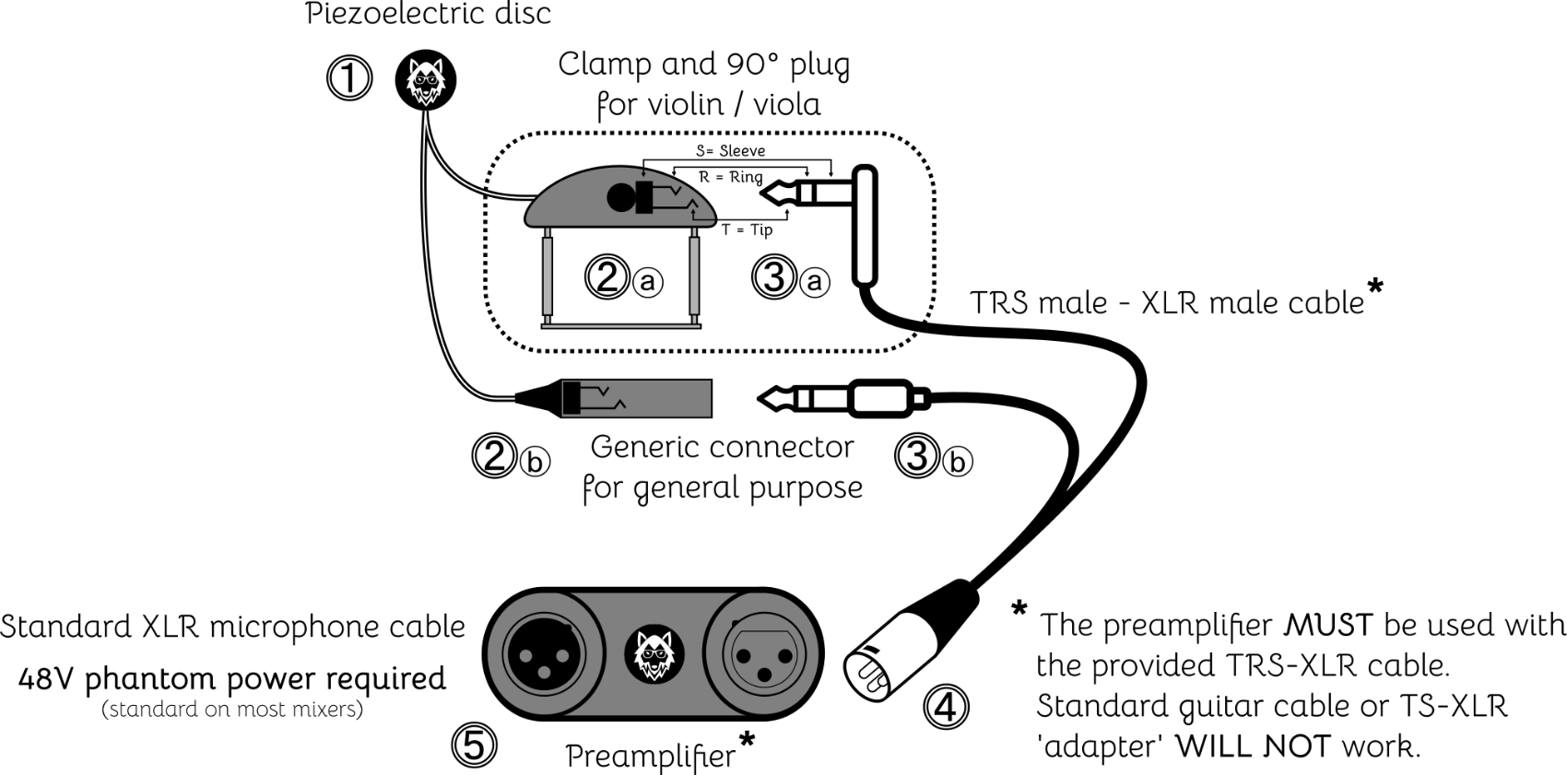**Quick setup**

**1.** Attach the piezoelectric disc ➊ to the instrument or surface you wish to record, using the provided "blue tack" putty **1**.

**1** Faber-Castell™ "Tack-It" is non-marking and reusable.

**2.** Secure the connector ➋ to the instrument or surface, such that the wire does not buzz against the surface and does not pull on the piezoelectric disc ➊.

- Mounting clamp ➋ⓐ is provided for violin and viola.

- For other uses, connector ➋ⓑ can be affixed using non-marking tape or other means.

**3.** Connect the TRS plug ➌ to the piezoelectric disc connector ➋.

- a low-profile 90° plug ➌ⓐ is provided for violin and viola.

- For other uses, a straight plug ➌ⓑ is provided.

**4.** Connect the XLR plug ➍ to the preamplifier ➎.

**5.** Using a regular microphone cable (XLR - XLR), connect the preamplifier ➎ to an audio interface / mixer.

- Turn on "phantom power" (standard on all professional audio equipment).