

**Piezo**phone**™**

phantom-powered contact microphone and preamplifier

**Piezo**phone**™** Quick Setup

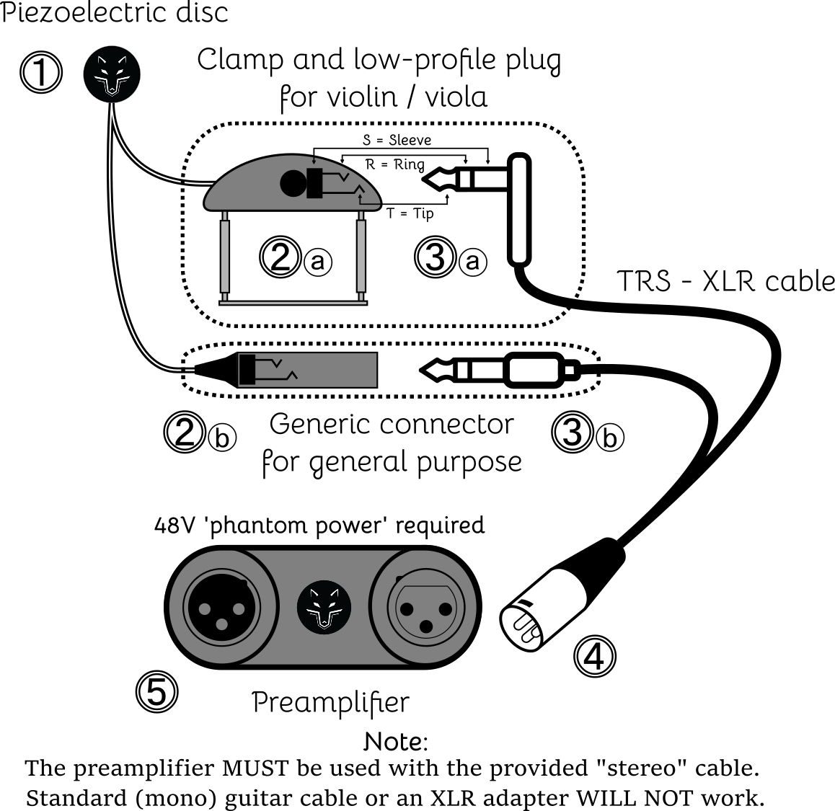

**Note:**

The preamplifier MUST be used with the provided TRS-XLR cable.

Standard (mono) guitar cable or an XLR adapter WILL NOT work.

|  |  |
| --- | --- |
| **1.** | Attach the piezoelectric disc ➊ to the instrument or surface you wish to record, using the provided "blue tack" putty **†**.  **†** Faber-Castell™ "Tack-It" is non-marking and reusable. |
| **2.** | Secure the connector ➋ to the instrument or surface, such that the wire does not buzz against the surface and does not pull on the piezoelectric disc ➊.  - Mounting clamp ➋ⓐ is provided for violin and viola.  - For other uses, connector ➋ⓑ can be affixed using tape or other means. |
| **3.** | Connect the TRS plug ➌ of the provided cable to the piezoelectric disc connector ➋.  - a 'low-profile' plug ➌ⓐ is provided for violin and viola.  - For other uses, a straight plug ➌ⓑ is provided. |
| **4.** | Connect the XLR plug ➍ of the provided cable to the preamplifier ➎. |
| **5.** | Connect the preamplifier ➎ to an audio interface / mixer, using a regular microphone cable (XLR - XLR).  - Turn on "phantom power" (standard on all professional audio equipment). |

Lobo **Piezo**phone**™** Contact Microphone

@ohnoitsalobo_builds

This microphone was originally created for use on bowed string instruments (such as violin, viola, cello), but is not limited to those. It has been successfully used on guitar, ukulele, mandolin, kalimba, piano, and dulcimer, for example.

It can be attached to any surface to record sounds; embedded in a wall, it can detect the sounds of traffic traveling through the earth, or people walking in the next room; attached to a table, it can be used as a pseudo-drum; suitably waterproofed, it could be used as a hydrophone to record sounds underwater.

The microphone unit consists of three parts:

* piezoelectric transducer (the 'pickup')
* balanced cable ('stereo' TRS male – XLR male)
* phantom-powered preamplifier

1. **the pickup** is a commonly available piezoelectric disc used typically as a 'buzzer' in various electrical appliances. This implementation creates a 'balanced' output, which provides a stronger audio signal and is generally more resistant to electromagnetic interference (EMI).  
   The pickup comes in two functionally identical variants – one with a clamp specifically meant for secure mounting on violin and viola, and one for practically any other application.

***Note:*** *If desired, this pickup can be used without the cable / preamplifier combo, or with a different commercial preamplifier, at the user’s discretion – with the understanding that the sound quality will be reduced.*

1. **the cable** is a 'stereo' TRS – XLR cable specifically intended to connect the balanced pickup with the preamplifier built for this purpose. It uses a 6.35mm TRS male connector to connect to the piezoelectric disc on one end, and a common microphone XLR male connector to connect to the preamplifier at the other end.

***Note:*** *This cable is required in order for the piezoelectric disc to work correctly with the preamplifier. Standard 'mono' guitar cable or an XLR adapter WILL NOT work.*

1. **the preamplifier** acts as a 'buffer' or 'impedance matcher' which enables an audio interface to record the piezoelectric disc accurately. This is a known issue which is   
   - not addressed at all by cheaper pickup products, or   
   - sold as an extra product at additional expense by other brands.   
   This preamplifier is a custom-designed analogue electronic circuit which requires *phantom power* from a professional audio interface in order to function. This is similar to commonly used 'condenser' microphones, which also do not work without externally applied power.   
   ***Note:*** *The preamplifier cannot be used with any other piezoelectric pickup, as it has been designed very specifically for this application.*

**Frequently Asked Questions**

**Q:** *Is the* ***Piezo****phone****™*** *an instrument pickup, or a microphone?*

**A:** Yes.

**Q:** *If this is an instrument pickup, where is my volume / tone control knob?*

**A:** The volume and tone controls are the same as a Shure SM58 microphone.

**Q:** *What is the best EQ setting to make this microphone / preamp sound good?*

**A:** The microphone (with the preamplifier) will tend to sound best with a deep, wide cut (-10dB or more) around 2-5kHz ('high-mid' range). Use your ears and a decent audio system for best results and additional adjustments.

Without the preamp, the pickup will not sound good no matter the EQ, due to the loss of lower frequencies in the audio signal.

**Q:** *I am performing at a venue that does not have phantom power! What do I do?*

**A:** The *preamplifier* will not work without phantom power; however, the *piezoelectric disc* can still be used in a pinch. Just plug in to the piezo disc directly using a standard guitar cable.

It will sound like a common cheap piezoelectric pickup, but it will work.

Alternatively, if you regularly perform at such venues without phantom power, you should consider buying a phantom-power pedal - or perhaps a personal mixer with phantom power - specifically for these situations.

**Q:** *There is a noticeable humming / buzzing noise when I use the microphone. Why?*

**A:** The audio system that you are connected to is not electrically grounded, causing what is commonly known as a 'ground loop'. This is not the fault of the microphone and should be checked by a qualified electrician or sound engineer.

This commonly occurs with laptops, and other devices with two-pin power connectors; it should not happen with professional-grade electrically grounded audio equipment and a desktop setup. If you are using a laptop, try disconnecting from wall power and do your recordings on battery power / USB only.

**Q:** *Can this be used to capture the sound of percussion instruments, e.g. drums?*

**A:** Not very effectively. For percussion, a well-placed ordinary microphone would sound best, to capture the actual 'acoustic' sound of the instruments.

For further questions / clarification, please message **@ohnoitsalobo_builds** on Instagram.