PeerNET– Preliminary Report Template
Team: Firestone

Project name: PeerNET

Team members: Paul deGrandis, Brian Vass, Matthew Oyer, Craig Eisenberger

Architectural options

Architectural option 1:
Authored by: Paul deGrandis

Usenet is already distributed and offers much of the same functionality we're targeting. Rather than create an entirely new architecture, I "stood on the shoulders of giants," leveraging the existing design, and used a Peer/SuperPeer concept to allow the system to be fully distributed and peer owned and moderated.
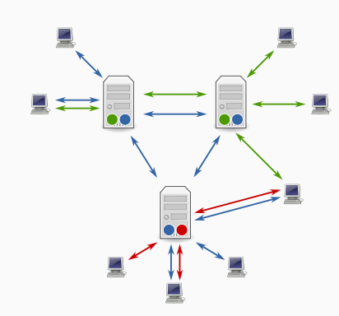
A high level view of the relation between a Peer and a SuperPeer can be found below, and is illustrated as a transition from the original Usenet architecture (wikipedia).

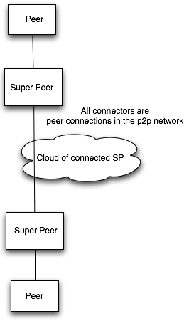

This is a more detailed view the P2P network. You'll notice that SuperPeers make a "backbone" for the P2P network. Internally, the Peer and elevated SuperPeer differ only slightly. They both use an internal C2 architecture. Any Peer can be elected by the P2P system to be elevated to a SuperPeer. SuperPeers help spider searches, send out send messages, help propagate messages peers care about based on tags and metadata. I used the requirements to create a system that achieved all of them while obeying Occam's Razor.

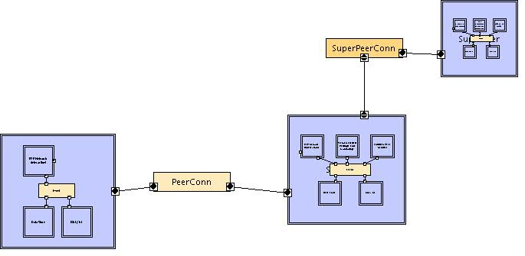

Here is a close view of a Peer. Tags and metadata are stored locally and attached to messages in the Data Store component. All system functionality specified by the requirements from the Project Charter is offered through the UI. Requests for searching, sending, and doing all network actions is passed to the P2P Network Interaction component. Deleting messages, tagging messages are done in the Data Store and are only honored through the UI. This added measure of security and interaction is a major benefit of the C2 architecture.
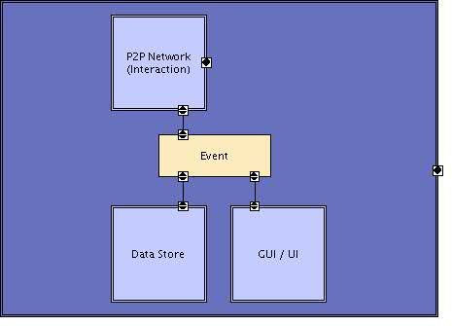

Here is a close view of a SuperPeer. The SuperPeer manages subscriptions (ie: requests for metadata) via a component that does Peer-to-Subscription pairings and monitors messages for metadata. It has a collection of Peer handlers that the SuperPeer is responsible for.
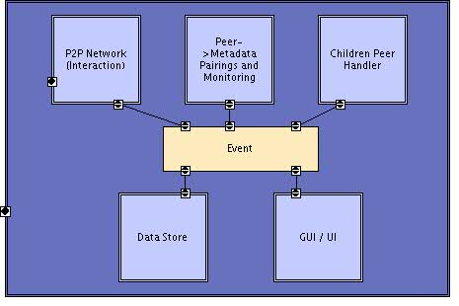

Architectural option 2:
Authored by: Brian Vass
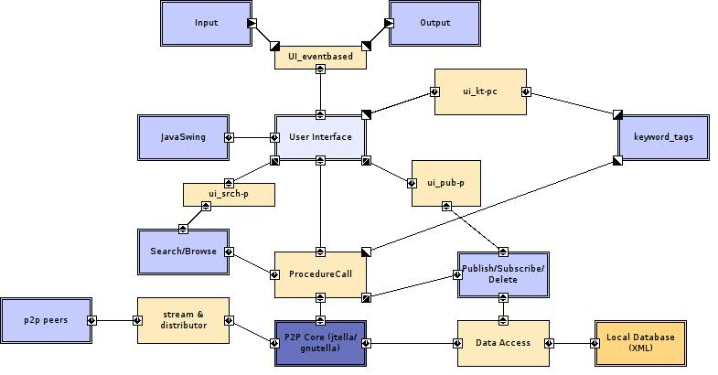
Boxes with double outlines are components, boxes with single outlines are connectors, and arrows indicate direction of information transfer. This diagram was created in arch studio.
Input is handled by the User Interface component, which receives input via the UI_eventbased connector, which is an event-based connector. Output will be displayed to the screen, via the UI_eventbased connectors as well.
The UI will be programmed using the Java Swing library, so I put that there. The interface will mostly be using the ProcedureCall connector to communicate with the P2P core component and receiving updates from it. The P2P core will be implemented by Jtella, a java API for the gnutella P2P core. Information will be distributed out to other peers from the P2P core via a stream and distributor connector.
The P2P core will cache data that has been downloaded by the user via a data access connector in the local database xml. Also, it will transfer information requested by other peers out via that data access connector as well.
To publish a new thread, subscribe to a thread, or delete a thread (on your local machine) users will interact with the Publish/Subscribe/Delete component from the User Interface, via a procedure call connector, ui_pub-p. The Publish/Subscribe/Delete information will then do one of a few things. For everything, it will store (or remove) information via the data access connector in to the local database component. If subscribing or publishing, it will then do a procedure call as well to the P2P core and push or pull the information to or from the peers are required.
To tag a message, users will use the User Interface component which will have a ui_kt-pc procedure call connector, which will interact with the keyword_tags. The keyword_tags component will then interact with the P2P core via a Procedure Call connector, and publish that keyword out to the other peers, as well as have that information updated in its local database.
To search for or browse messages, users will use the User Interface component, which calls the ui_srch-p procedure call to communicate with the Search/Browse component. This then gives a procedure call to the P2P core, which will return results, which will then be printed back to the screen for the user.
In deployment, there should be a network of Peers and “SuperPeers.” SuperPeers will be an intermediary between all of the peers, providing enhanced searching speed and load balancing.

Architectural option 3:
Authored by: Matthew Oyer
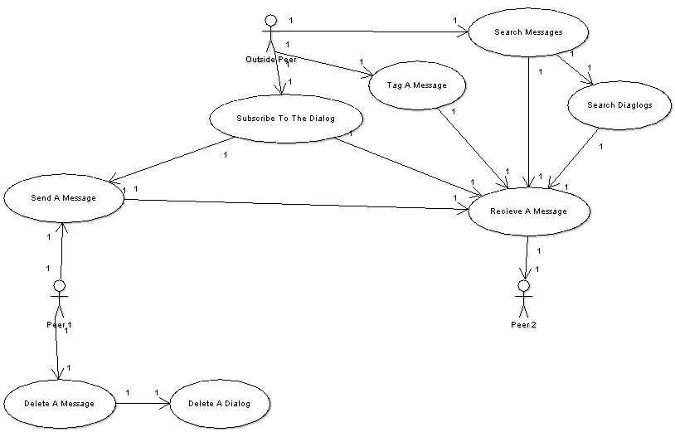

Architectural option 4:
Authored by: Craig Eisenberger
Well so much for getting images done on my laptop. I'll give my plan verbose instead:
As we are seeking to incorporate a P2P architecture, I feel we have two options for the implementation.
One method would have the usenet messaging data stored on all peers and as messages are updated, all peers would have access to all messages. This provides total coverage and ensures that the messages remain in tact. The drawback to such an approach is that as the board gets larger, more and more data is stored in the individual peers. Furthermore there is the issue of attaching files, which I will handle separately.
Another method is to ensure that part of the usenet message data is stored on peers in such a fashion that there is sufficient users connect to be able to generate the complete list on command. In this fashion there is the risk that part of the board may become inoperable if all peers with that section of data disconnect from the network. The advantage here is that there is less data to store on the individual peers systems.
Regarding the attaching of files, these can occur as BitTorrent files, thereby what is shared over the usenet is a Torrent file that would give the user who wants the file the ability to get it via the BitTorrent network. In such an implementation, the exact content of the file is not an issue and Torrent files can be multiple orders of magnitude smaller than the file they represent, therefore space issues of the first method suggested would be mitigated.
Since the space of files is mitigated through use of Torrent files and since the application can support the deleting of messages, I believe that having all messages stored on all client machines is the most efficient way of implementing the system.
I would contend that as a change to the application, we implement a means of users archiveing messages on their own client machines for their own personal use. Thus as a message is deleted, they will still be able to access it, however other peers will not have access unless they archived the message as well.
As a result of this proposed architecture, the message data will be stored on all client machines and as the data is updated, the connect file will be updated, alerting all users who are monitoring the file that new data is available. This data will spread over a P2P network similar to how Torrent files are seeded, however since only the new data needs to be seeded, transfers will be small and quick and as a result should spread fairly quickly across the P2P network.
The Messager part of the application should support write(), read(), deleteMsg(), tag() and delTag(). The Messager operates with write access on the P2P data store. After an operation is performed the Messanger must activate the Updater.
The Updater will alter the attached Torrent file to include the new data, which will then be sent to all Peers who will update their messages. Some design decisions will need to be made with this however. We could implement the Updater to send out data after it has been written, but if there is a lot of activity, there is the possibility that multiple versions of the Torrent will propagate and that data could be lost as a result. To prevent this, the Updater will have to support functionality to see which updates it has performed and which updates are outstanding.
For example if Peer A has three new messages and Peer B has two new messages, then Peer C may get the three messages from A and Peer D may get the two messages from B. Then when Peer C and Peer D attempt to update each other, they will receive an updated version of the file that doesn't include data that they should have. Because of this, the Updater will have to examine the update requests of each and create a new file incorporating both requests and propagate it in the same manner as other requests. In essence then if the overall updated file is spread from C and D containing the five new messages to Peer E, and Peer F receives Peer A's original request of three new messages, Peer E and Peer F's update of Peer G would force G to examine the requests and realize that Peer F's request is completely included in the set of updates from Peer E. As a result Peer F's update is ignored and Peer G will continue to propagate Peer E's update until it receives data to the contrary.
The Search part of the application should support findTag(), findMsg() and archiveMsg() the latter of which will be used after one of the previous two functions are executed. The archiveMsg() function will write messages to the client in a store that functions similar to the P2P data store, but is not part of the network and is only accessible by the client.
The datastore can be implemented as a database readable by the Search portion of the application. This would cut down on file size and allow for cataloguing, however there may be some issues with the writing of updated data to it. However the nature of messages should allow for the database to examine new message being written and determine if in two versions of the database (for example Peer A and Peer B's databases after they update with their three and two messages respectively) can be merged so that the data contained in the resulting database is the full set of data from both existing databases. Thus the updater will have to support checkForOverlap() to identify areas of overlap and mergeData() to examine two databases and identify which data needs to be moved to be accommodated into one database.
In summary a Messager, Search, DataStore and Updater will perform all the work while a P2P network interface will provide the transfer procedures. Messanger will support writing messages and adding tags, Search will hunt down messages and archive ones the user wants, DataStore will hold all the information distributed via the P2P and Updater will check incoming change requests to see how the DataStore needs to be modified to accommodate changes and will send out updates as it deems necessary.

Evaluation and decided architecture

Evaluation results

Paul’s Architecture Critique:
Commenter | Pros | Cons | Favorite Feature
Brian Vass | Your deployment diagram is superb - I think that super-peers are necessary to balance traffic handling. I don't have that modeled in mine but I agree with that. Event bus is a great choice for the intermediate architecture. I chose that as well for the UI/other stuff interaction. Very easy to understand the overall picture. | Lacking a bit of verbosity as far as description for as far as the various Super peer p2p functionality interact/communicate with the other peers. Probably need a bit more detail on the large picture diagram of how the PeerCon and Super Peer connectors actually attach. Is it via the P2P Interaction, or the children peer handler? Maybe a little more detail on the GUI/UI side, but there’s the balance aspect to information explicit and abstracted. | Super-peers.
Craig E
Matt Oyer | Awesome, the super peer method I feel is the best solution for us getting what we want done while keeping things as decentralized as possible. | Doesnt seem to address tagging and or subscription methods. | Super Peers

Brian’s Architecture Critique:
Commenter | Pros | Cons | Favorite Feature
Paul deG | You included all aspects of the system. It's a real arch model | The model becomes confusing points. I feel it's in a little too much detail. You gave focus to tagging, which is something my model didn't do really. I don't think the Data Access is accurately located | Tagging and separation of UI
Craig E
Matt Oyer | Everything we wanted to get done is addressed. | Seems a bit more hardcore than what I thought an architecture needed to be (although I had confused it with a use case so I’m too far in the opposite direction) | Tagging and subscription

Matt’s Architecture Critique:
Commenter | Pros | Cons | Favorite Feature
Brian Vass | This model shows all aspects of the user interaction with the overall system. | This seems more like a use case than an architectural model, as there are no components, connectors, or interfaces. | Tagging a message.
Craig E
Paul deG | This is a model, and shows intent and understanding of how users will interact with the system as well as what actions they should be expected to do. | This is a Use Case. There is no architecture to discuss. Also the multiplicity is incorrect. | Searching

Craig’s Architecture Critique:
Commenter | Pros | Cons | Favorite Feature
Brian Vass | Variety of approaches, and touches upon the SuperPeer idea Paul diagrammed out (a la the gnutella model). | Displaying no images makes comprehension substantially more difficult. If you're talking torrent files, the architecture another bittorrent client. The first idea of implementation (that lends itself to heavy traffic) should be avoided as it poses substantial load problems, as noted. | Storing one's own messages on the local machine, Super-peer-ish network layout.
Paul deG | You have done a good job thoroughly thinking through the problem space and have developed some clear reasoning about the requirements. I like the idea of having a tiered style peer network | Bittorrent is not a good idea or model to think of for the P2P architecture. I feel like some of your ideas stray too far from the USENET architecture. The lack of pictures not only makes your individual assignment, but made it more difficult to decipher exactly what your system intent was in certain cases. | Super-Peers/multi-tier
Matt Oyer | The different pros and cons of methods we could use against this | Bittorrent is more centralized than I though our goal was going for. | Decentralized data storage/super peers

Decision and motivation

After discussion and review of the critique, it became apparent that we should go with a modified version of Paul and Brian’s architecture, as they were essentially the same architecture, modeled at different levels of abstraction. Since there was a consensus between the two diagrams, we proceeded with them. The alternative architectures had a significant number of weaknesses. One architecture was actually a use case, and one was lacking diagrams, making them suboptimal choices.

There are several reasons for deciding on this particular architecture. They include:
- Load balancing – having a network of Peers and SuperPeers allows for redundancy, lighter load on each Peer versus an every peer search every peer connection. It also was the only way to easily achieve all of the desired functionality and requirements specified in the Project Charter
- True P2P – one of the options was to use a “torrent” P2P system like BitTorrent, however that requires an intermediary step, most likely a server, for searching torrents. We chose a model more similar to Gnutella/Limewire.
- The architecture fits – a variety of architectural styles are implemented for various aspects of the system. The architecture models chosen operate largely as an event bus on different levels of the system, including the GUI and the deployment. The Peers and SuperPeers are C2 internally, and the network of them composes what is essentially an event bus. The architecture is simple, modular, and logical for its intended application.

Decided architecture
The motivation and rational for this architecture is provided in section 2.2.

Usenet is already decentralized to some effect. The image below illustrates the current architecture.

Using that deployment view of the architecture as a guide, we can map it directly onto a P2P network, using the notion of peers and super-peers, as illustrated on the right.

What follow are a few images that give a general idea of what a peer and super-peer might look like within this system.

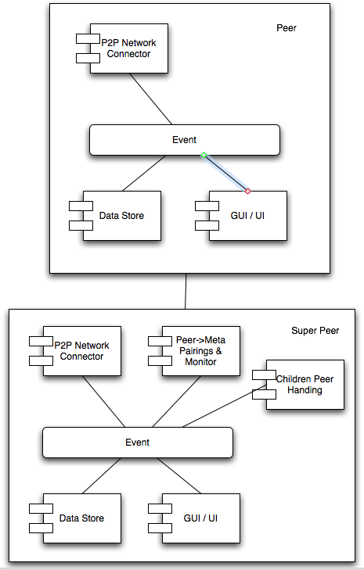

This system, fully realized, would take on a P2P architecture, with connections being an implementation detail. Perhaps streams, but perhaps a P2P network specific protocol.

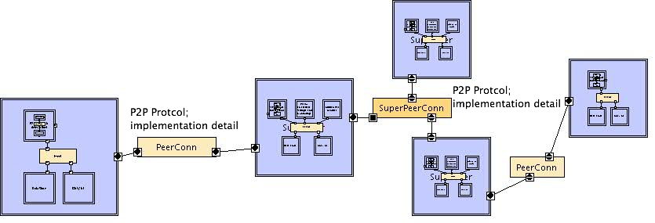

The super-peers manage subscriptions of their peer clusters. In order to achieve the same functionality as the current USENET system, all messages are transported via the super-peers and not via direct connections between peers. In this sense, you can abstract the super-peer part of the network as a gigantic, dynamic event bus.

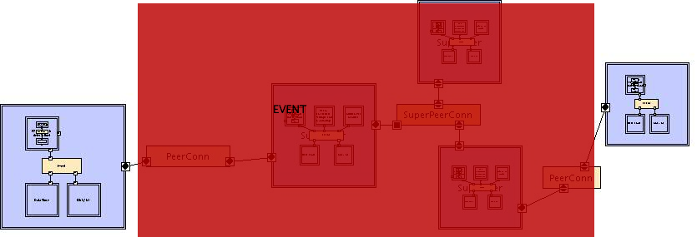

The peer and super-peer components are more or less the same component; however the super peer handles subscriptions. Users tag their OWN messages stored locally in their data store. Searching is a function of the network that asks peers to read into their data store for specific pieces of metadata (including tags). How a search request propagates across the P2P network is an implementation detail of the P2P network infrastructure. The internal architectures of peers and super-peers are based on a C2 architecture. This allows easy systems to be added and security to be implemented and built into the architecture. There is a layered architecture (almost OO in nature) for the P2P interface interaction component. This allows the P2P networking library to have easy and abstracted calls into the local/peer side system, and the local system to easily call into the P2P network.
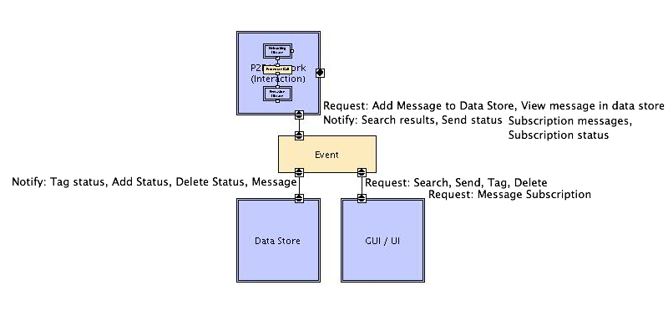

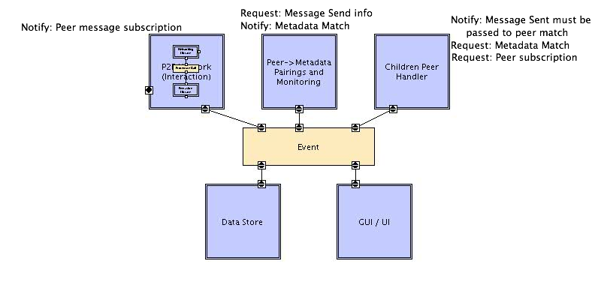

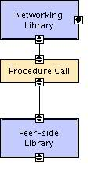

Requests for Change

  - RFC #1:
Title: Cache searches on super-peer
Description: Instead of having each search be performed and then losing the data, we can cache searches on a super-peer for a period of time. This way, frequent searches can be performed quicker and with reduced network load. This will require changes to the super-peer component and the data store. We will have a separate “cached search” section added to the data store, which will save search results for a period of time. Then, the super-peer component will be modified to first look at the cache, and then perform a search as usual. Effort involved in this change should be minimal due to the design of the system.

RFC #2:
Title: Plug-in System
Description: A plug in system will provide a modular way for developers to add in functionality to our system. An example of this could be a chat client or media player. This will require changes to the UI and possibly to the event/C2 bus of peer and super-peer components. We will need to allow the UI to change to accommodate the plug-ins, and have the ability to create new event connectors between the UI and the event bus, which will then interact with the DataStore and Peering components of the system.

RFC #3:
Title: API to the peer functionality
Description: An API will let users interact with the peer functionality of our system, without having to use our UI. We would develop the API as a component, and then have our UI call the API. The API would then connect to the event bus and perform the requested actions. External users would be able to call the API for similar functionality, without needing to use our UI. The API would not require too much work, as it would simply be reorganizing existing code into a new component, which is more accessible to outside interfaces. One example of desired functionality might be a scriptable interface around the API.

