Dataset Airports Data Mart - Business Description

Purpose
The Dataset Airports Data Mart is designed to support comprehensive analysis of flight routes around the world. By integrating data on airlines, airports, countries, and external geographic datasets, the data mart enables users to explore patterns in global air travel. A key objective is to provide actionable insights into route density, airport networks, and route characteristics, not only on a global scale but with a special focus on Europe. This data mart helps answer analytical questions such as:
- Which pairs of airports are connected by the longest flights? This can be explored interactively, including detailed views of individual long-haul routes.
- Which European countries have the densest network of airports?
And furthermore, do these countries also exhibit a high number of flight routes?
To support this analysis, the model incorporates an external dataset with the land area of each European country (source), enabling calculations such as route or airport density per square kilometer and correlation analysis between infrastructure size and geographic scale.

Data Mart Tables and Attributes

1. fact_routes (Fact Table)
Central fact table containing data on flight routes. Each row represents one route.
- airline_id: References the airline operating the route
- source_airport_id: ID of the origin airport
- dest_airport_id: ID of the destination airport
- codeshare: Indicates if the route is a codeshare
- no_stops: Number of stops on the route
- plane: Plane used on the route
- route_length: length of the route in km

2. dim_airlines
Contains airline master data. - name, callsign, IATA/ICAO codes, country_of_origin, active status

3. dim_airports
Contains airport-level details including location and time zone. - name, municipality, country, IATA/ICAO codes, latitude, longitude, elevation, GMT offset, timezone

4. dim_countries
Metadata for countries. - name, ISO code, continent

5. dim_country_area
Imported from Wikipedia; includes country size in square kilometers. - country_name, area_km2

Business Value
This data mart enables comprehensive airline route analysis. It supports dashboards that map flight networks, compare route coverage by country, evaluate airline performance, and normalize metrics using land area. A critical use case is calculating route density per square kilometer.

Answers to Questions

Which pairs of airports are connected by the longest flights?
During the initial analysis, a data inconsistency was discovered: a local airport code from Zambia was mistakenly mapped to Los Alamitos Army Air Field (SLI), which resulted in an artificially inflated flight distance in the dataset. This error skewed the results, making it appear that the longest route involved a Zambian domestic airport and Los Angeles, which is not realistic.
After correcting this mapping issue, the actual longest scheduled commercial flight in the dataset is between Sydney Kingsford Smith Airport (SYD) and Dallas Fort Worth International Airport (DFW). This ultra-long-haul route spans approximately 13 808 kilometers and is operated by Qantas and American Airlines.
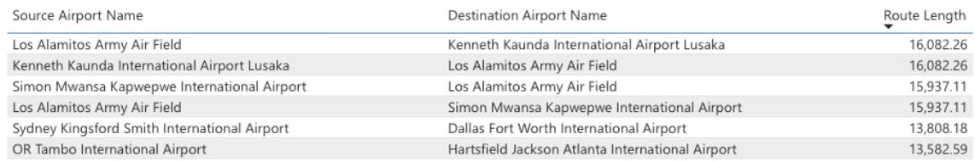

Which European countries have the densest network of airports?
To assess the density of airport networks across Europe, we calculated the number of airports per square kilometer using a combination of airport data from the data mart and land area information sourced from Wikipedia.
The analysis revealed that Malta has the densest airport network in Europe. Although it has a small absolute number of airports, its extremely limited land area results in the highest airport density per km².
Following Malta, Switzerland also ranks highly in terms of density, supported by its robust transportation infrastructure and mountainous geography which necessitates regional air travel. Other countries with similarly high airport densities include Belgium, Germany, Denmark, the United Kingdom, and the Netherlands. These countries share characteristics such as high population density, strong economies, and advanced transportation systems, all of which contribute to a dense and well-distributed network of airports.
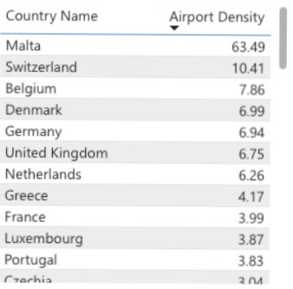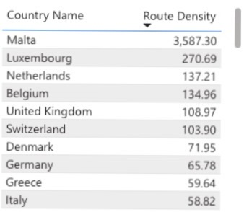
do these countries also exhibit a high number of flight routes?
The results show a consistent trend with airport density, though with some interesting distinctions. Malta once again ranks first — not due to a large number of routes, but because of its extremely small geographic area, which amplifies the ratio.
Luxembourg comes in second, which is somewhat surprising given its modest aviation footprint. However, its strategic location and economic role in Europe contribute to a relatively high number of international connections.
Sharing third place are the Netherlands and Belgium, both compact countries with major international hubs (Amsterdam Schiphol and Brussels Airport) that serve as gateways to Europe.
On shared fifth place are the United Kingdom and Switzerland, both with highly developed aviation infrastructure and a significant number of domestic and international connections, despite their slightly larger land area.
This comparison confirms a strong correlation between airport density and route density in Europe’s smaller and more connected countries.

