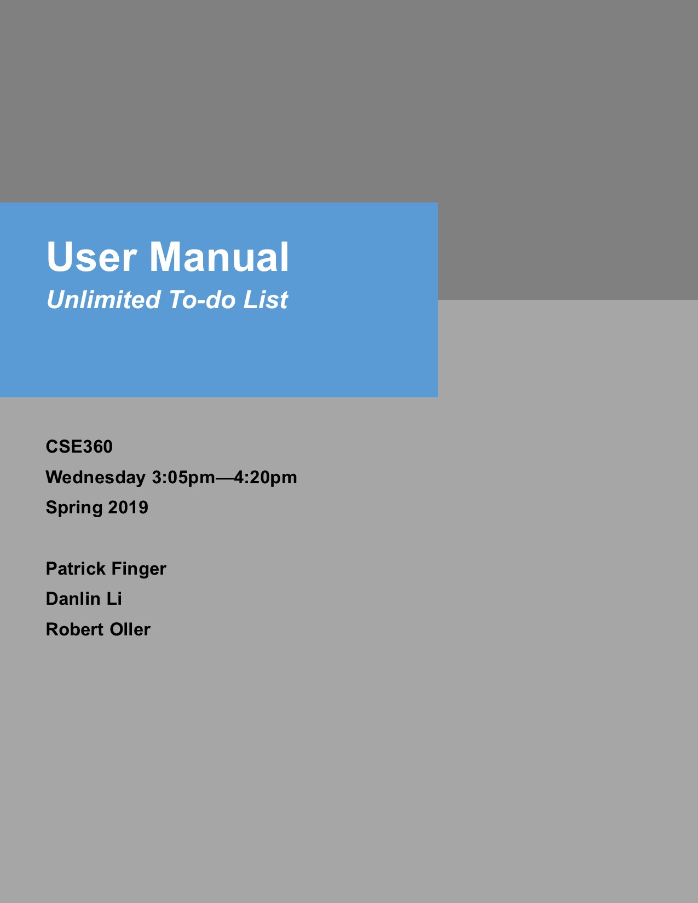





**1**

**2**

**3**

**4**

**6**

**7**

**14**

**15**

**Introduction…………………………………………………………………………….**

**Overview………………………………………………………………………………..**

**Installation……………………………………………………………………………...**

**Getting Started………………………………………………………………………...**

**User Interface………………………………………………………………………….**

**Examples……………………………………………………………………………….**

**Restarting………………………………………………………………………………**

**Exiting…………………………………………………………………………………...**

**Introduction //WIP**

In this user guide, we will be exploring how to use “Unlimited To-do List 2019­­”. First, an overview of To-do List will explore the basic functionalities of the program, including but not limited to what the program is capable of, what To-do List items can possess as properties, etc.

To begin use of the program, an installation guide will walk through the step-by-step process of installing the program on a PC, Mac, or Linux OS. After install is complete, the Getting Started page may be followed on getting familiarized with the program with initial usage. Once setup, the User Interface Overview goes over the user-friendly interface of the program, explaining how to navigate To-do List.

After becoming familiar with how to use To-do List, they may examine or glance at Example Runs section to see what does and does not work with To-do List. This section will go over how the user is expected to operate the program, and the errors which may occur if not properly used.

The Restarting section goes over how to properly save and load a To-do List when restarting the program. After which, Ending the Program section will explain how to safely exit the program.

**Overview //WIP**

The purpose of this program is for the user to have a simple way to prioritize items (tasks) in a To-do list. Each item has a description, priority number, due date, and status. The user has the option to add, remove, re-order, change the description, and display the properties of an item. Along with displaying an item, the user may also display the entirety of the To-do list itself. When the user wants to save or load a To-do list, they have the option to do so as well.

Regarding the items’ properties themselves, the description and priority number of an item must be unique. If the user wishes to enter an item with an existing priority number, the new item will take priority. The status of an item indicates whether the item is not started, in progress, or finished. When displaying the To-do list, each item will be listed in order of ascending priority with priority number, description, due date, and status listed under it.

What the user may *not* do is a number of things. These things include: loading an invalid file, adding an item with a non-sequential priority number, setting a due date in the past, adding or updating an item with an existing description, leaving fields blank when adding an item, etc.

**Installation //WIP**

PC: To install the program, download the .jar file and run the program by either double clicking or right clicking and selecting “open” in the dropdown menu.

Mac: To install the program, download the .jar file and run the program by either double clicking or right clicking and selecting “open” in the dropdown menu.

Linux: To install the program, download the .jar file and run the program by either double clicking or right clicking and selecting “open” in the dropdown menu.

**Getting Started**

To begin using the To-do list, a To-do list text file may be loaded into the application or new To-do list items can be added to the empty list.

To *add* a new item to the list, simply click ‘Add’. This will prompt the user with the Add New Task Dialogue Box. In this dialogue box, the user will be asked to enter a description, date, status, and priority of the new task. Once the fields have been filled out, simply click ‘Okay’ to submit the item into the To-do list.

To *remove* an item in the To-do list, simply click the item to select it, then click ‘Remove’. This will remove the item from the list and automatically update the priority list if necessary.

To *edit* an item from the To-do list, simply click the item to select it, then click ‘Edit’. This will prompt the user with the Edit Task Dialogue Box. In this dialogue box the fields of the item will be pre-filled with the current information of the task. To edit a field, simply select it and modify the data. Next, click ‘Okay’ to submit the changes to the To-do list.

To *save* a list, simply click ‘Save’. This will create or overwrite the file ‘defaultList.txt’ with the To-do list information.

To *load* a list, simply click ‘Load’. This will search for the file ‘defaultList.txt’. The file must be in the same directory as the To-do list application. If the file can be found it will be loaded into the list, otherwise an error will be shown.

To *view a report* of the list, simply click ‘Report’. This will prompt the user with the Report List Dialogue Box. In this dialogue box, the user will be shown a read-only version of the To-do list.

**User Interface**

The user interface contains a master list and five buttons. These buttons grant the user with the functionality previously discussed: add, remove, edit, load, save, and view report. Upon launching the application for the first time the application will display the following:

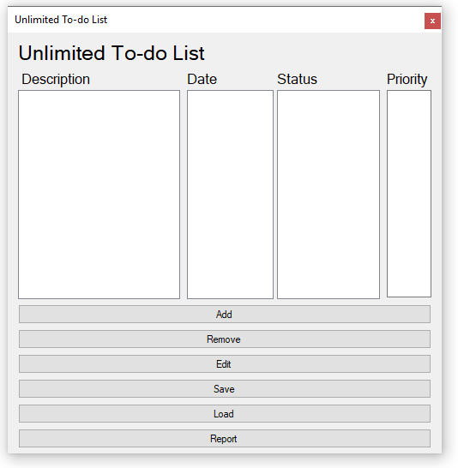

*This is a mock-up image, not the final product*

**Examples**

Adding an item to the list, a common operation, displays a dialogue box and prompts the user to enter information:

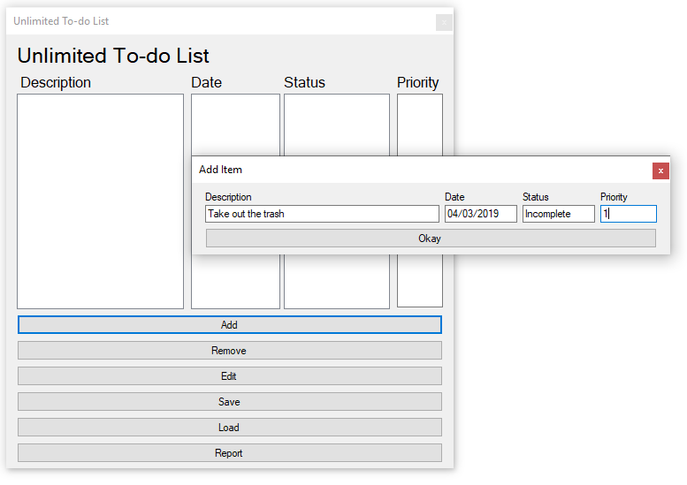

*This is a mock-up image, not the final product*

Upon adding an item to the list, the changes will appear in the application:

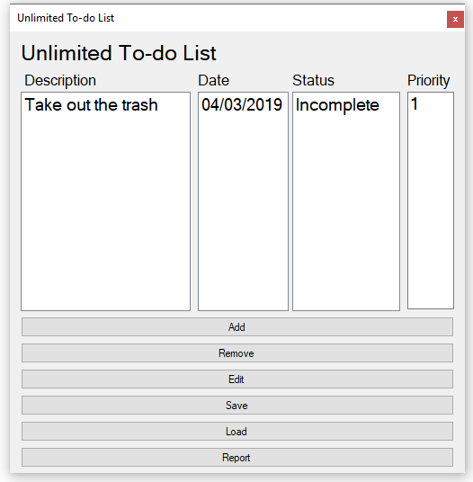

*This is a mock-up image, not the final product*

Clicking ‘Load’ will prompt the user for a file name. The changes will appear after click ‘Okay’:

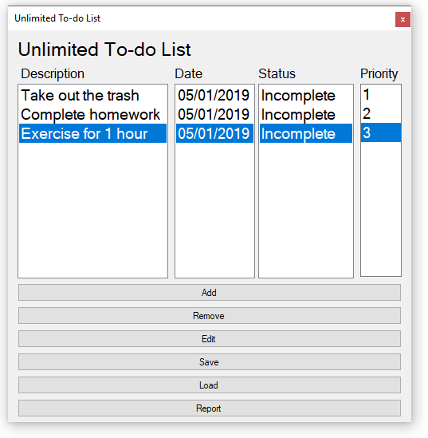

*This is a mock-up image, not the final product*

To edit an existing item, select the item then click edit. In the Edit Item dialogue box, data may be modified:

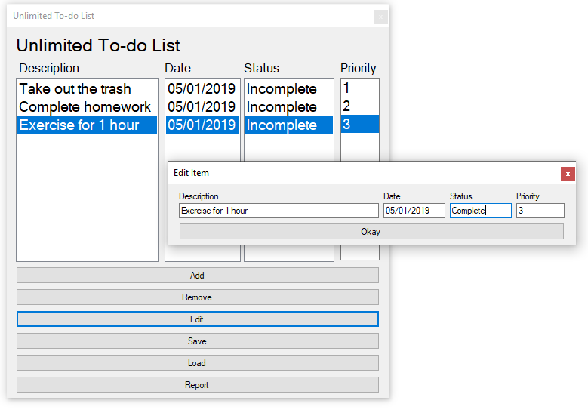

*This is a mock-up image, not the final product*

Upon clicking ‘Okay’ the changes will appear in the list:

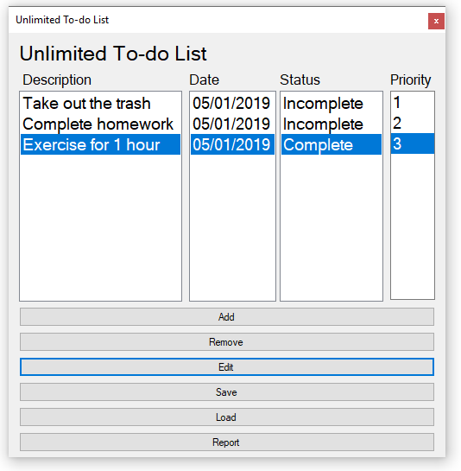

*This is a mock-up image, not the final product*

To remove an item simply select the item, then click ‘Remove’:

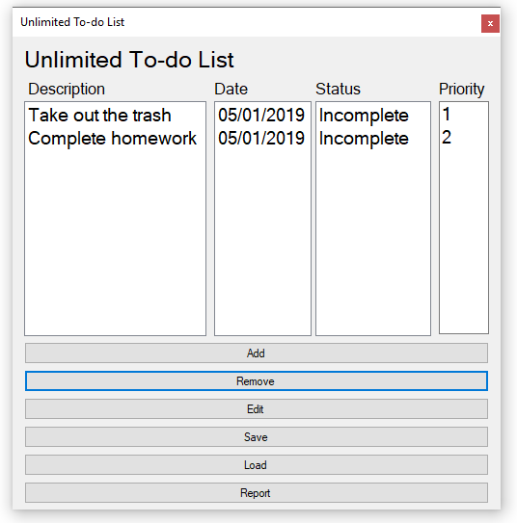

*This is a mock-up image, not the final product*

To view a summary of the list, click on ‘Report’:

**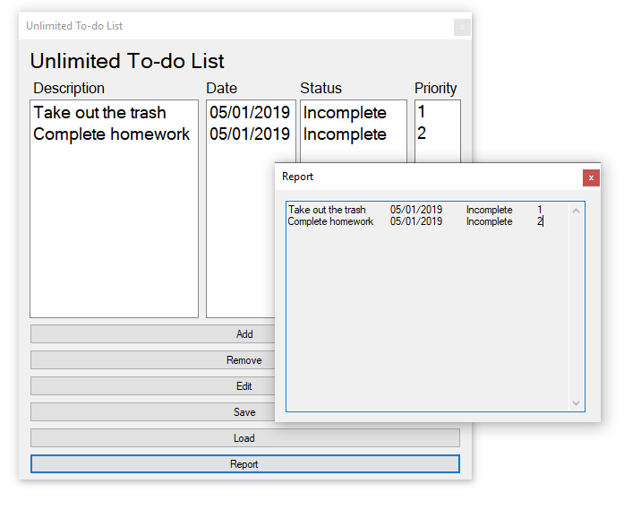***This is a mock-up image, not the final product*

**Restarting //WIP**

To restart the program, all the added or edited description, priority number, due date, and status will be saved automatically to ‘defualtList.txt’. When the program has been started, all of the contents is restored exactly as before the program was terminated. The program will display the first event in the To-do List.

**Termination //WIP**

To end the program, simply click the ‘X’ in the upper right-hand corner. The list will be saved automatically to ‘defaultList.txt’.