TUTORIAL

1. I start with this setting below. Check what the current PATH is in the image. It should be your “EEGWISE-main”. How do you know if you’re in the right PATH? You should be seeing **EEGWISE.mlapp** in the *Current Folder* tap, just like the image below.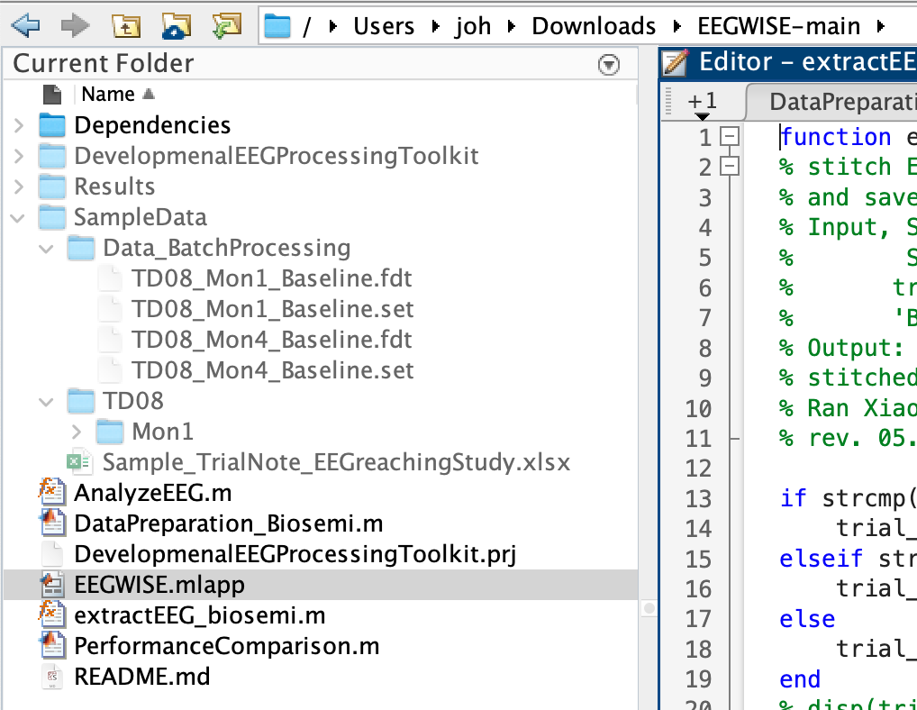
2. This practice will be based on preprocessing TD08_Mon1 data inside the “SampleData” folder. I am done with running **DataPreparation_Biosemi.m**.
3. The setting I used for running EEGWISE app is displayed below. See where the *Data directory* and *Result directory* are. Remember what “.” Stands for? It means the current PATH. So “./Results/” is the same as “/Users/joh/Downloads/EEGWISE-main/Results/”. Your setting will be different, so don’t worry.

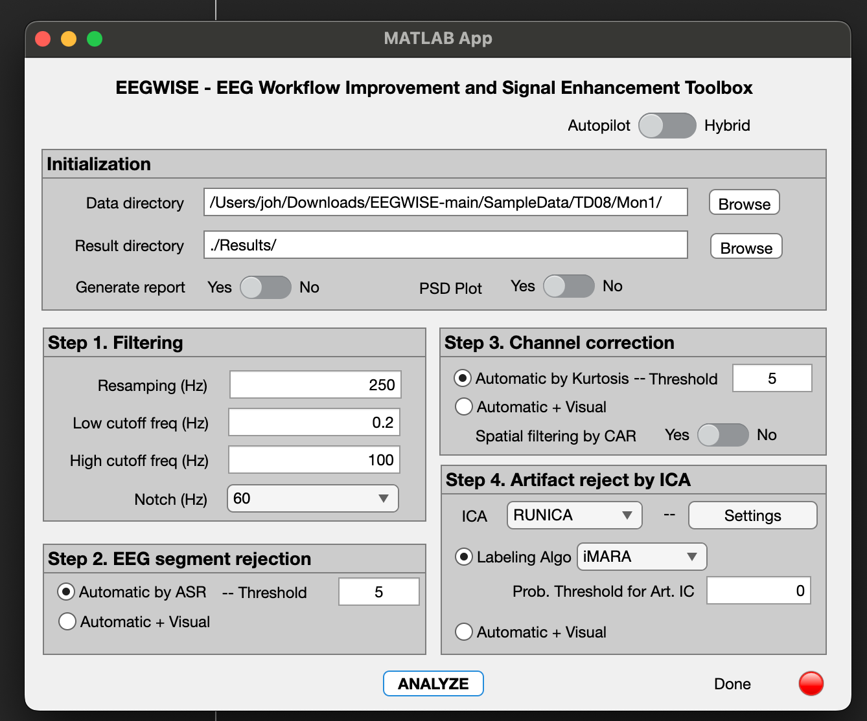

1. Once you’re done, you will have **\*_RelPw.mat** files in your Results directory. ‘*’ means wildcard, so **\*_RelPw.mat** refers to *any* mat file that ends with **_RelPw**.
2. Open **sample_code_jin_v2.m** in MATLAB. Check your PATH. Where are you now??
3. Now try answer the questions… you should eventually be generating these plots: