Create a folder to hold the images you need cropped. You can place the folder anywhere that’s convenient. Here, in the “example” folder, I’ve created a subfolder named “images”:

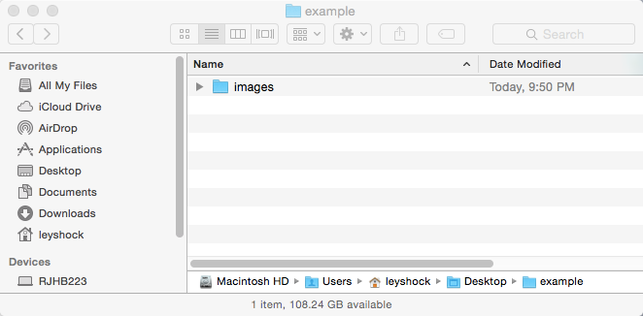

(You don’t need to create a new folder if you already have the images you want to crop in one folder.)

Copy or move all your images into the folder you just created. Here, you’ll see I’ve placed two images into the “images” folder:

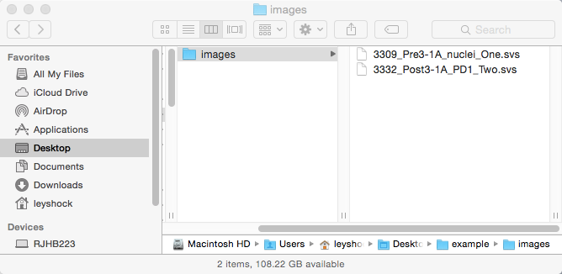

Open up the macro file and configure the

This image cropping tool requires that:

(1) all and only the images to be cropped are placed in this folder:

(2) the “configuration file” is located in this folder:

(3) each line of the configuration file has the following format:

image_file_name,upper_left_x,upper_left_y

Each image to be processed should have a separate line in the configuration file. Here is an example of a configuration file for processing two images

image_1.svs,2003,143

image_2.svs,8301,3339

Before you run the macro, open the macro file and specify how many images are to be processed. Here I’ve specified that two images are to be processed. (Be sure to keep the semicolon after the number!)

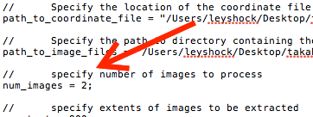

Now, open ImageJ, and go to Plugins -> Macros -> Run. Select the macro, then click open. (Remember, the macro on your computer is found at: )

The macro will process your images and write them to the same folder as the input images. Each cropped image will have the same file name as the input file, except “_cropped.tif” will be appended.