Hyun Taek, Oh (934540212)

Stephen Redfield

CS 271 - 400

Oct. 26, 2023

**Using the Debugger (Lab)**

* **A screen shot of my IDE State**

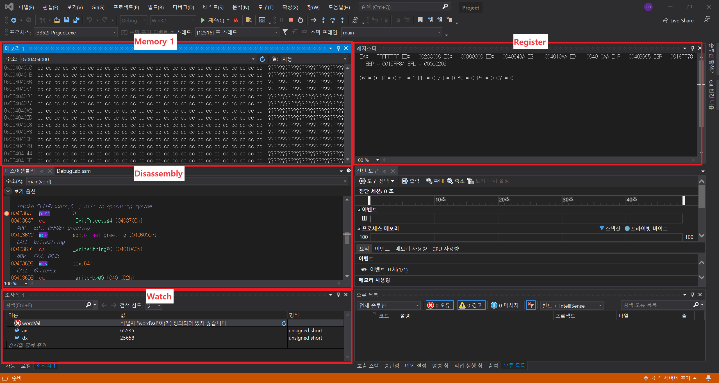

** CPU registers and Flags are in a Register part.

* **Part 1 Questions**

1. What is the current value (in Hex) of the EAX Register?

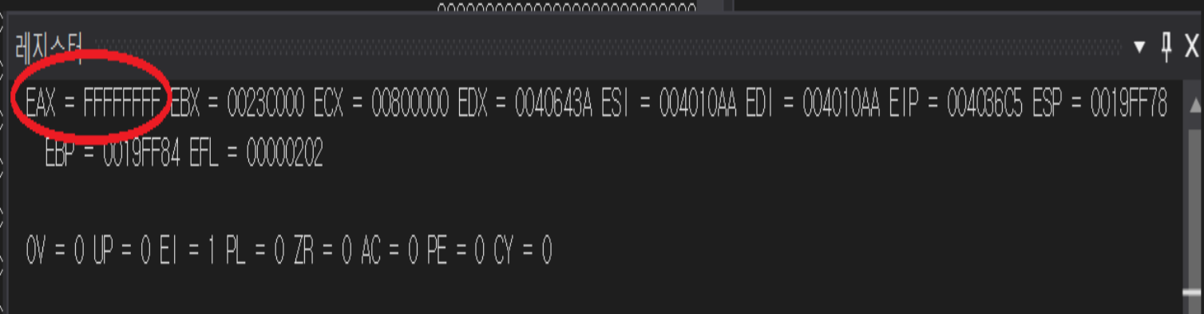

- The current value of the EAX Register is FFFF_FFFFh (in Hex).

1. What is the current state (Set/Clear) of the following flags: Carry, Overflow, Zero, Sign?

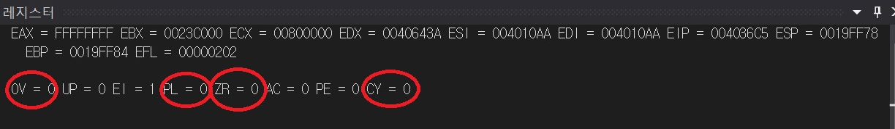

* + Carry flag (CY) is 0.
  + Overflow flag (OV) is 0
  + Sign flag (PL) is 0
  + Zero flag (ZR) is 0
* **Part 2 Questions**

1. (Screenshot of your **User Number** number in Terminal Window and Registers/Editor window in Visual Studio).

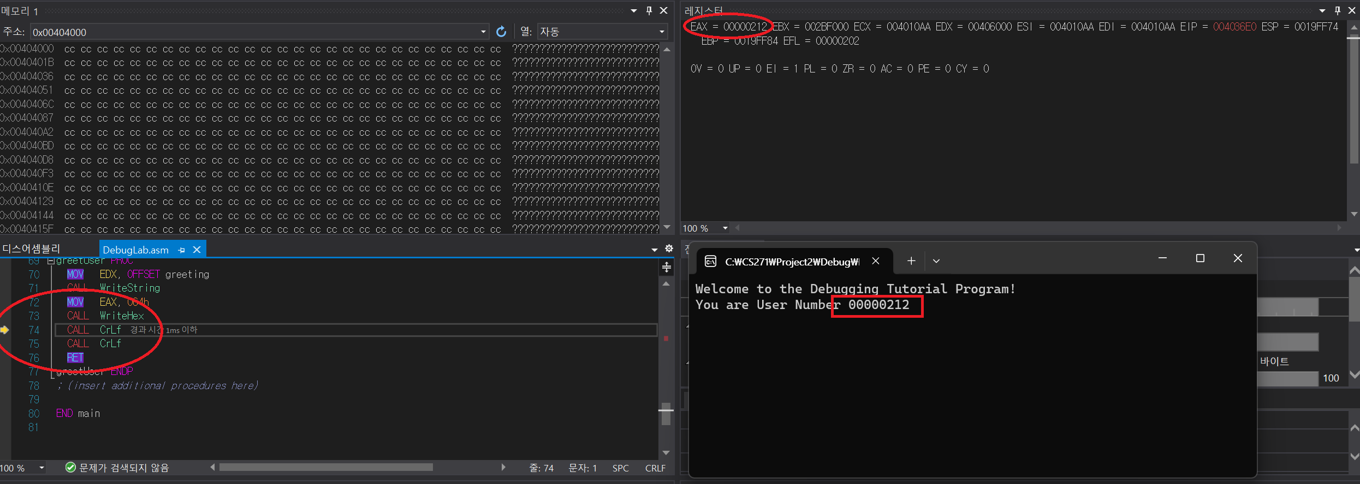

* + My ONID number : 934540212
  + EAX = 0000_0212
* **Part 3 Questions**

1. What instruction (with operands, if any) is located at the **_validName** code label? (Hint: The first instruction after a code label is considered to be "at" that label.)

- The first instruction after **_validName** code label is < MOV EAX, DWORD ptr >

2. What is the *memory address* (in the code segment) of the *instruction* from Question 1 above? (Hint: It will be a hex value to the left of this instruction.) Please **circle this line** on the screenshot attached to this part in your report, including the instruction and operands from Question 1.

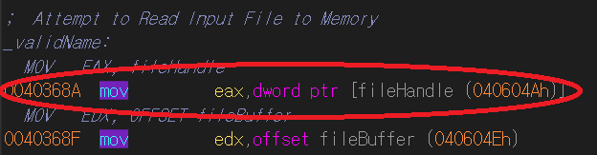

- After **_validName** code label, the memory address is 0x0040_368Ah

3. What is the **significance** of the relationship between the value in EIP (in the Registers window) and the leftmost value on any given line?

- The leftmost value is a current address of instruction being executed. The EIP can be changed by the instruction that has the value of next instruction. It is significant that EIP register has to point to the address of next instruction, and after execution, sometimes the program should come back to the current address like save point to return for next step.

* **Part 4 Questions**

1. Let n = (the last three digits of your OSU ID number).  What is the (n+1)st byte (index n) of **TestText.txt**, interpreted as an ASCII character?

- ‘w’

2. Remember to take a screenshot of the Memory window used to collect this information for inclusion in the lab report. Please circle the value in the address bar and the character in the ASCII portion of the Memory debug window.

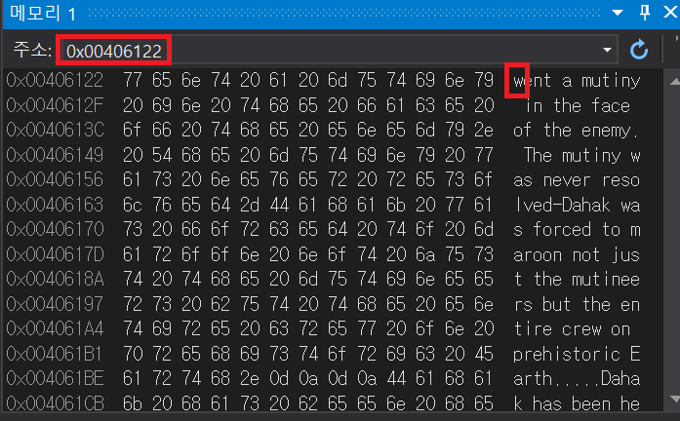

- &fileBuffer = 0x0040_604Eh : ‘m’, My ONID last 3 digits: 212

&fileBuffer + ONID last 3 digits = 0x0040_6122h ${(213)}^{th}$: ‘w’

* **Part 5 Questions**

1. A file handle is reference number supplied by the operating system, and used by a running program to uniquely identify a file. The lab uses the **fileHandle** variable to store this value. What is the file handle of TestText.txt in your execution of the lab program? (This builds on the same watch you used in Step 6 above, but is a *new question*. There are multiple 'watches' which will can get you this value, depending on where you have paused execution.)  
   Please be aware that the handle for a particular file may be different each time you run your program (the operating system state may change between runs), so remember to include a screenshot that shows where you obtained this information, and please circle the value of the file handle on this screenshot.

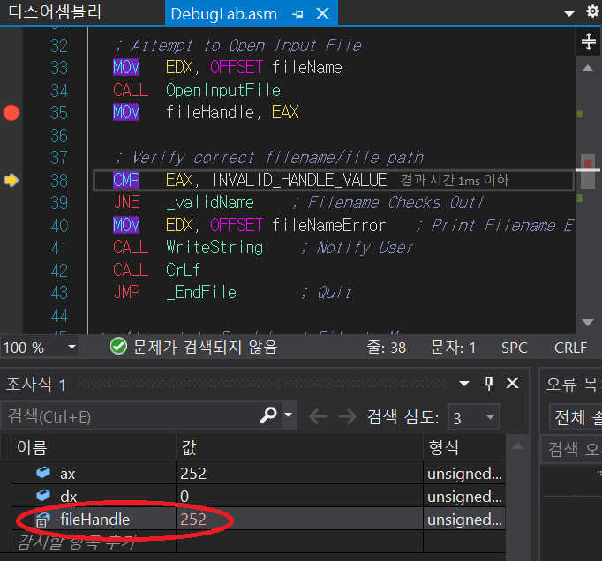

* + In my Lab program, the value of **fileHandle** is 252