**Assignment number:** SUGOCJ-8

**Primary Editor Name*:** Ruelle K



[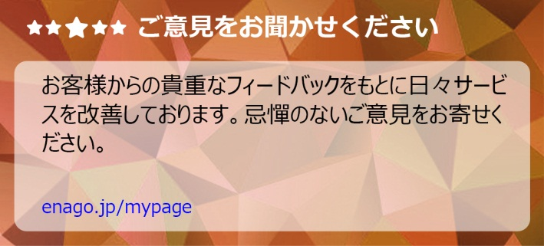](https://my.enago.com/jp-login.aspx?utm_source=editor-message&utm_medium=editor-message-ads&utm_campaign=marketing-block&utm_term=feedback)[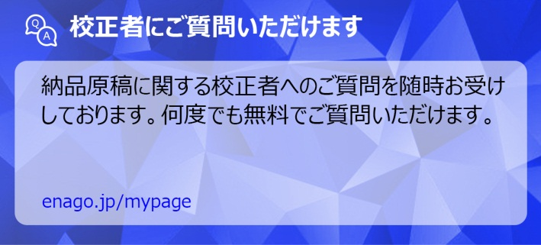](https://my.enago.com/jp-login.aspx?utm_source=editor-message&utm_medium=editor-message-ads&utm_campaign=marketing-block&utm_term=qa)

Dear Author:

Thank you for entrusting us with your document and opting for our ノーマル英文校正サービス. My name is Ruelle K; I have edited your document for language and grammar, from the perspective of fluency, nativity, clarity, and accuracy. Overall, I have made moderate revisions to the document in terms of language and grammar. I hope that the revisions meet your expectations from this service.

As this was a TEX file, we could not make formatting changes. However, essential formatting notes based on the journal guidelines (<https://www.elsevier.com/journals/economics-letters/0165-1765/guide-for-authors#txt900>) have been provided below. Please review these notes for complete adherence to the journal requirements.

Please be assured that I have edited the document to the best of my ability and have clarified relevant changes through remarks. As a step toward successful publication, I suggest that you resolve all the remarks in the file and contact us in case of any clarifications.

I have added a tip on academic writing conventions specific to your document. I hope you find it helpful for future writing.

I wish you good luck for the successful publication of your document and look forward to working with you again.

**Journal Formatting**

*Economics Letters* does not have strict formatting requirements for initial submissions. We have listed the essential guidelines below.

* Note that the manuscript can be of maximum 2000 words.
* Please provide a statement of declarations of interest in the manuscript. Further, disclose competing interests in a separate form for the official record of the journal.
* Authors must disclose the use of generative AI and AI-assisted technologies in the writing process by adding a statement at the end of their manuscript in the core manuscript file before the References list.
* Provide a funding statement and mention sources of funding, if any. Further, add a separate acknowledgements statement to acknowledge any support provided to the study.
* Please submit the names and institutional e-mail addresses of several potential reviewers.
* For initial submissions, there are no strict requirements for reference formatting. References should be presented in any consistent format. The reference style used by the journal will be applied to the accepted article by Elsevier at the proof stage.
* Please ensure that all tables included in the single file are placed next to the relevant text in the manuscript. Note that the journal also accepts the submission of supplementary material such as applications, images and sound clips. Supplementary material must be supplied in separate files.
* Please provide a separate file called “Highlights” with 3–5 bullet points (maximum 85 characters each) conveying the core findings of your research. See example Highlights here: <https://www.elsevier.com/authors/tools-and-resources/highlights>.
* Graphical abstracts are optional for this journal. You may submit a graphical abstract of 531 × 1328 pixels (height × width) using a minimum resolution of 300 dpi. Use Times, Arial, Courier, or Symbol fonts and submit the abstract as a TIFF, EPS, PDF, or MS Office file.
* Elsevier accepts video material and animation sequences to support and enhance your scientific research. Thus, you may submit a video with your submission. Ensure to cite the video in the main text and supply “stills” with the file. More details are available here: <https://www.elsevier.com/authors/policies-and-guidelines/artwork-and-media-instructions>.
* Please check Elsevier’s data visualization options to include interactive data visualizations in your publication and let your readers interact and engage more closely with your research: <https://www.elsevier.com/authors/tools-and-resources/data-visualization>.
* Please provide a data availability statement mentioning where readers can access the data used in this study.
* Authors can publish research objects such as data, methods, protocols, software, and hardware as an additional paper in Research Elements journals. More details are available here: <https://www.elsevier.com/authors/tools-and-resources/research-elements-journals>.

[](https://my.enago.com/jp-login.aspx?utm_source=editor-message&utm_medium=editor-message-ads&utm_campaign=marketing-block&utm_term=myeditors)

[](https://www.enago.jp/vip-editor.htm?utm_source=editor-message&utm_medium=editor-message-ads&utm_campaign=marketing-block)

[](https://www.enago.jp/refer?utm_source=editor-message&utm_medium=editor-message-ads&utm_campaign=marketing-block)