虚拟现实课内实验指导书——补充

2015．9

课内实验一 基本OpenGL应用程序生成
一：课内实验目的
1. 熟悉VC++2010集成开发环境；
2. 熟悉基本OpenGL库的配置方法；
3. 掌握基本OpenGL应用程序生成。
二：课内实验内容
1. 建立基于控制台应用程序的基本OpenGL应用程序；
2. 配置应用程序，添加OpenGL链接库文件；
3. 建立OpenGL的基本环境。
三：课内实验背景知识
OpenGL是一种图形显示软件工具包，它为图形硬件提供软件接口。OpenGL为计算机动画提供由图形生成图像帧的工具。glut库提供了基本的窗口命令和人机交互功能，使用该库可以快速完成图形绘制应用程序的开发。

说明：如果使用的VS2010开发环境，下载OpenGL 安装包所需文件：
http://d.download.csdn.net/down/2560229/ssagnn23
包括：
GL.H GLAUX.H GLU.H glut.h
GLAUX.LIB GLU32.LIB glut32.lib glut.lib OPENGL32.LIB
glaux.dll glu32.dll glut32.dll glut.dll opengl32.dll
VS2010不带 GL.H, GLAUX.h, glu.h, glaux.lib, glu32.lib, opengl32.lib 这些文件。通过上面所给地址下载后，把下载的文件分配放在系统中不同的文件夹下，具体配置方法如下：
(1) 把 glaux.dll、glut32.dll、glut.dll 拷贝到C:\WINDOWS\system32目录下，system32目录下应该已经有 opengl32.dll、glu32.dll了。
(2) 把 GL.H、GLAUX.h、glu.h、glut.h 拷贝到 C:\Program Files\Microsoft Visual Studio 10.0\VC\include\gl
(3) 把 GLAUX.LIB、Glu32.lib、glut32.lib、Opengl32.lib，glut.lib 拷贝到 C:\Program Files\Microsoft Visual Studio 10.0\VC\lib

四：课内实验步骤
- File->New->Project 选择Win32应用程序 输入名称HelloOpenGL

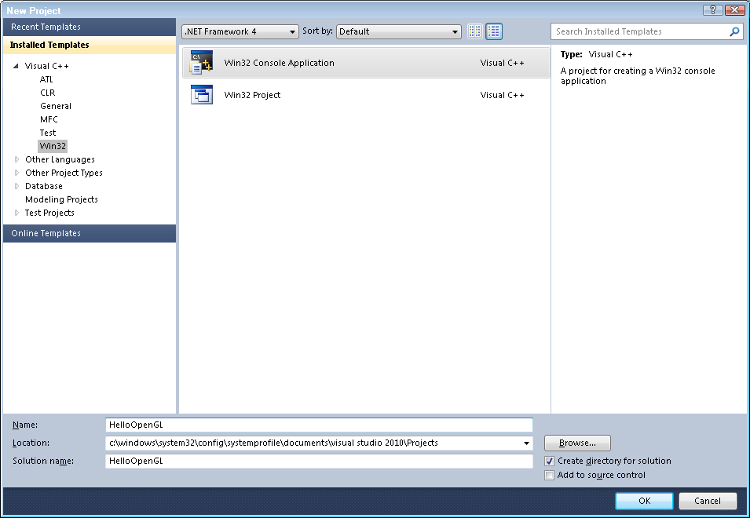
- 点击“OK”后，在后续的对话框中选中Empty project，然后点击Finish。
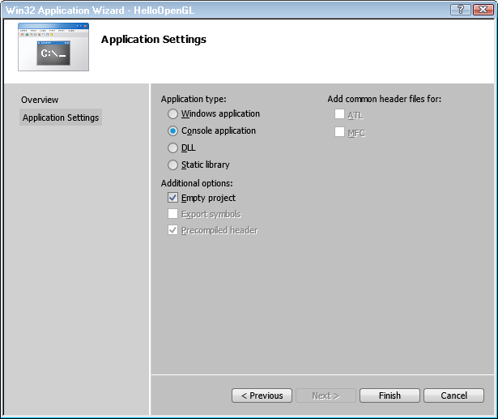
- 右击项目名，选择属性(property)，再选择链接器(Linker)中的输入选项(Input)，附加依赖项(Additional Dependencies):opengl32.lib glu32.lib glaux.lib
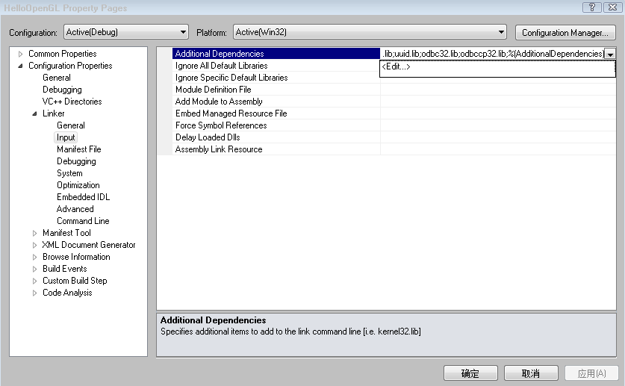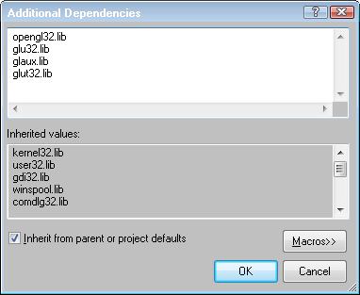
- 右击项目名下的源文件，选择添加(ADD)，再选择新建项 (New Item)，在弹出来的对话框中选择C++ File(.cpp)，输入文件名test,然后点击添加(ADD)，即新建源文件。
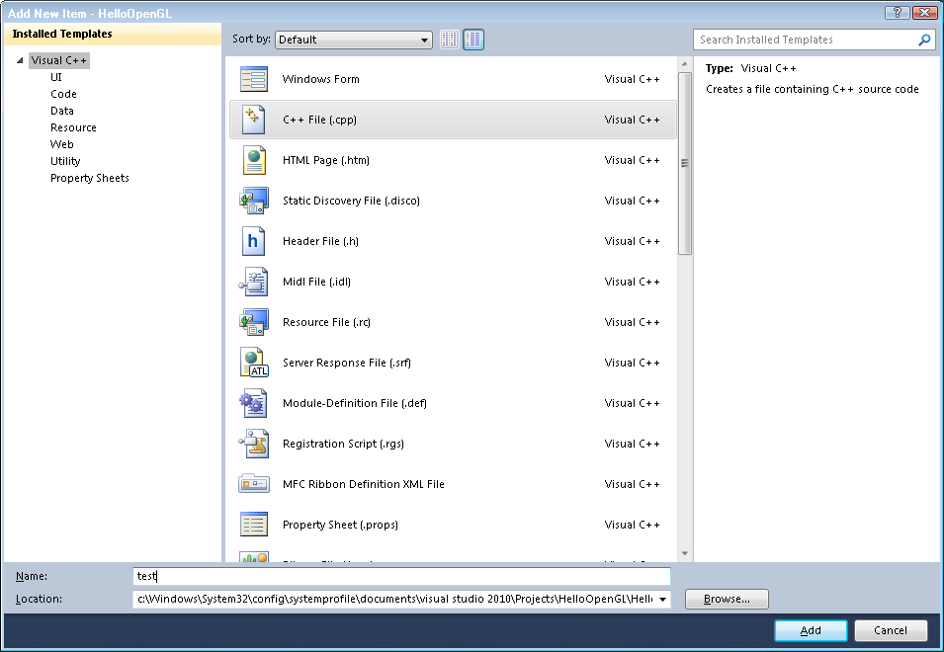

- 在源文件test.cpp中输入如下代码：
#include <GL/glut.h>
#include <stdlib.h>

void display(void)
{
/* 清除颜色缓存 */
glClear (GL_COLOR_BUFFER_BIT);

/* 绘制一个白色多边形，指定四个顶点的坐标
*/
glColor3f (1.0, 1.0, 1.0);
glBegin(GL_POLYGON);
glVertex3f (0.25, 0.25, 0.0);
glVertex3f (0.75, 0.25, 0.0);
glVertex3f (0.75, 0.75, 0.0);
glVertex3f (0.25, 0.75, 0.0);
glEnd();

/* 不等待
* 立即开始处理保存在缓冲区中的OpenGL函数调用。
*/
glFlush ();
}

void init (void)
{
/* 制定清除颜色 */
glClearColor (0.0, 0.0, 0.0, 0.0);

/* 设置投影变换方式 */
glMatrixMode(GL_PROJECTION);
glLoadIdentity();
glOrtho(0.0, 1.0, 0.0, 1.0, -1.0, 1.0);
}

/*
*指定窗口的初始大小和位置以及显示模式（单缓存和RGBA模式）
*打开一个标题为hello的窗口
*调用init函数.
*注册显示函数.
* 进入主循环并处理事件.
*/
int main(int argc, char** argv)
{
glutInit(&argc, argv);
glutInitDisplayMode (GLUT_SINGLE | GLUT_RGB);
glutInitWindowSize (250, 250);
glutInitWindowPosition (100, 100);
glutCreateWindow ("hello");
init ();
glutDisplayFunc(display);
glutMainLoop();
return 0;
}

五：课内实验结果
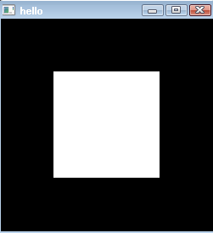

课内实验二OpenGL基本图形元素和模型变换
一：课内实验目的
1. 掌握基本图形元素的绘制函数及其应用方法。
2. 掌握坐标变换函数的使用方法。
二：课内实验内容
1. 学习基本图形元素的绘制函数及其应用方法。
2. 学习OpenGL坐标变换的使用方法。
三：课内实验背景知识
OpenGL提供了基本实体模型的绘制函数及其应用方法。OpenGL绘制的三维形体通过模型视点变换，投影变换和视口变换后显示在窗口中，通过设置不同的矩阵操作完成这些变换。
四：课内实验程序

课内实验步骤1~4与上述课内实验1相同

5在添加的原文件中输入如下代码
#include <GL/glut.h>
#include <stdlib.h>

static int year = 0, day = 0;

void init(void)
{
glClearColor (0.0, 0.0, 0.0, 0.0);
glShadeModel (GL_FLAT);
}

void display(void)
{
glClear (GL_COLOR_BUFFER_BIT);
glColor3f (1.0, 1.0, 1.0);

glPushMatrix();
glutWireSphere(1.0, 20, 16); /* 绘制太阳 */
glRotatef ((GLfloat) year, 0.0, 1.0, 0.0);
glTranslatef (2.0, 0.0, 0.0);
glRotatef ((GLfloat) day, 0.0, 1.0, 0.0);
glutWireSphere(0.2, 10, 8); /* 绘制行星 */
glPopMatrix();
glutSwapBuffers();
}

void reshape (int w, int h)
{
glViewport (0, 0, (GLsizei) w, (GLsizei) h);
glMatrixMode (GL_PROJECTION);
glLoadIdentity ();
gluPerspective(60.0, (GLfloat) w/(GLfloat) h, 1.0, 20.0);
glMatrixMode(GL_MODELVIEW);
glLoadIdentity();
gluLookAt (0.0, 0.0, 5.0, 0.0, 0.0, 0.0, 0.0, 1.0, 0.0);
}

void keyboard (unsigned char key, int x, int y)
{
switch (key) {
case 'd':
day = (day + 10) % 360;
glutPostRedisplay();
break;
case 'D':
day = (day - 10) % 360;
glutPostRedisplay();
break;
case 'y':
year = (year + 5) % 360;
glutPostRedisplay();
break;
case 'Y':
year = (year - 5) % 360;
glutPostRedisplay();
break;
case 27:
exit(0);
break;
default:
break;
}
}

int main(int argc, char** argv)
{
glutInit(&argc, argv);
glutInitDisplayMode (GLUT_DOUBLE | GLUT_RGB);
glutInitWindowSize (500, 500);
glutInitWindowPosition (100, 100);
glutCreateWindow (argv[0]);
init ();
glutDisplayFunc(display);
glutReshapeFunc(reshape);
glutKeyboardFunc(keyboard);
glutMainLoop();
return 0;
}

五：课内实验结果

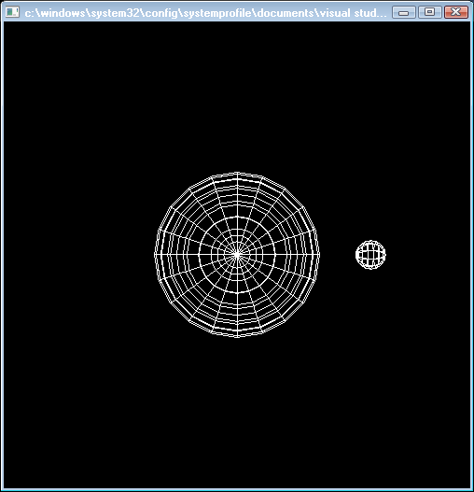

按键盘上的d、D、Y或者y可以观察到三维形体的运动。

六：其它一些范例
1：绘制点画线源代码
#include <GL/glut.h>
#include <stdlib.h>

#define drawOneLine(x1,y1,x2,y2) glBegin(GL_LINES); \
glVertex2f ((x1),(y1)); glVertex2f ((x2),(y2)); glEnd();

void init(void)
{
glClearColor (0.0, 0.0, 0.0, 0.0);
}

void display(void)
{
int i;

glClear (GL_COLOR_BUFFER_BIT);

/* 使用白色绘制所有线段 */
glColor3f (1.0, 1.0, 1.0);

/* 三条线段使用不同的点画模式 */
glEnable (GL_LINE_STIPPLE);

glLineStipple (1, 0x0101); /* dotted */
drawOneLine (50.0, 125.0, 150.0, 125.0);
glLineStipple (1, 0x00FF); /* dashed */
drawOneLine (150.0, 125.0, 250.0, 125.0);
glLineStipple (1, 0x1C47); /* dash/dot/dash */
drawOneLine (250.0, 125.0, 350.0, 125.0);

glDisable (GL_LINE_STIPPLE);
glFlush ();
}

void reshape (int w, int h)
{
glViewport (0, 0, (GLsizei) w, (GLsizei) h);
glMatrixMode (GL_PROJECTION);
glLoadIdentity ();
/* 规定二维视景区域，参数分别为left,right,bottom,top */
gluOrtho2D (0.0, (GLdouble) w, 0.0, (GLdouble) h);
}
int main(int argc, char** argv)
{
glutInit(&argc, argv);
glutInitDisplayMode (GLUT_SINGLE | GLUT_RGB);
glutInitWindowSize (400, 150);
glutInitWindowPosition (100, 100);
glutCreateWindow (argv[0]);
init ();
glutDisplayFunc(display);
glutReshapeFunc(reshape);
glutMainLoop();
return 0;
}
结果：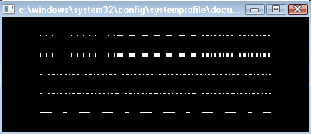

2：绘制点画模式多边形的源文件代码
#include <GL/glut.h>
#include <stdlib.h>

void display(void)
{
GLubyte fly[] = {
0x00, 0x00, 0x00, 0x00, 0x00, 0x00, 0x00, 0x00,
0x03, 0x80, 0x01, 0xC0, 0x06, 0xC0, 0x03, 0x60,
0x04, 0x60, 0x06, 0x20, 0x04, 0x30, 0x0C, 0x20,
0x04, 0x18, 0x18, 0x20, 0x04, 0x0C, 0x30, 0x20,
0x04, 0x06, 0x60, 0x20, 0x44, 0x03, 0xC0, 0x22,
0x44, 0x01, 0x80, 0x22, 0x44, 0x01, 0x80, 0x22,
0x44, 0x01, 0x80, 0x22, 0x44, 0x01, 0x80, 0x22,
0x44, 0x01, 0x80, 0x22, 0x44, 0x01, 0x80, 0x22,
0x66, 0x01, 0x80, 0x66, 0x33, 0x01, 0x80, 0xCC,
0x19, 0x81, 0x81, 0x98, 0x0C, 0xC1, 0x83, 0x30,
0x07, 0xe1, 0x87, 0xe0, 0x03, 0x3f, 0xfc, 0xc0,
0x03, 0x31, 0x8c, 0xc0, 0x03, 0x33, 0xcc, 0xc0,
0x06, 0x64, 0x26, 0x60, 0x0c, 0xcc, 0x33, 0x30,
0x18, 0xcc, 0x33, 0x18, 0x10, 0xc4, 0x23, 0x08,
0x10, 0x63, 0xC6, 0x08, 0x10, 0x30, 0x0c, 0x08,
0x10, 0x18, 0x18, 0x08, 0x10, 0x00, 0x00, 0x08};

GLubyte halftone[] = {
0xAA, 0xAA, 0xAA, 0xAA, 0x55, 0x55, 0x55, 0x55,
0xAA, 0xAA, 0xAA, 0xAA, 0x55, 0x55, 0x55, 0x55,
0xAA, 0xAA, 0xAA, 0xAA, 0x55, 0x55, 0x55, 0x55,
0xAA, 0xAA, 0xAA, 0xAA, 0x55, 0x55, 0x55, 0x55,
0xAA, 0xAA, 0xAA, 0xAA, 0x55, 0x55, 0x55, 0x55,
0xAA, 0xAA, 0xAA, 0xAA, 0x55, 0x55, 0x55, 0x55,
0xAA, 0xAA, 0xAA, 0xAA, 0x55, 0x55, 0x55, 0x55,
0xAA, 0xAA, 0xAA, 0xAA, 0x55, 0x55, 0x55, 0x55,
0xAA, 0xAA, 0xAA, 0xAA, 0x55, 0x55, 0x55, 0x55,
0xAA, 0xAA, 0xAA, 0xAA, 0x55, 0x55, 0x55, 0x55,
0xAA, 0xAA, 0xAA, 0xAA, 0x55, 0x55, 0x55, 0x55,
0xAA, 0xAA, 0xAA, 0xAA, 0x55, 0x55, 0x55, 0x55,
0xAA, 0xAA, 0xAA, 0xAA, 0x55, 0x55, 0x55, 0x55,
0xAA, 0xAA, 0xAA, 0xAA, 0x55, 0x55, 0x55, 0x55,
0xAA, 0xAA, 0xAA, 0xAA, 0x55, 0x55, 0x55, 0x55,
0xAA, 0xAA, 0xAA, 0xAA, 0x55, 0x55, 0x55, 0x55};

glClear (GL_COLOR_BUFFER_BIT);
glColor3f (1.0, 1.0, 1.0);

/* 先绘制一个纯色填充的矩形, */
/* 然后绘制两个点画矩形 */
glRectf (25.0, 25.0, 125.0, 125.0);
glEnable (GL_POLYGON_STIPPLE);
glPolygonStipple (fly);
glRectf (125.0, 25.0, 225.0, 125.0);
glPolygonStipple (halftone);
glRectf (225.0, 25.0, 325.0, 125.0);
glDisable (GL_POLYGON_STIPPLE);

glFlush ();
}

void init (void)
{
glClearColor (0.0, 0.0, 0.0, 0.0);
glShadeModel (GL_FLAT);
}

void reshape (int w, int h)
{
glViewport (0, 0, (GLsizei) w, (GLsizei) h);
glMatrixMode (GL_PROJECTION);
glLoadIdentity ();
gluOrtho2D (0.0, (GLdouble) w, 0.0, (GLdouble) h);
}

int main(int argc, char** argv)
{
glutInit(&argc, argv);
glutInitDisplayMode (GLUT_SINGLE | GLUT_RGB);
glutInitWindowSize (350, 150);
glutCreateWindow (argv[0]);
init ();
glutDisplayFunc(display);
glutReshapeFunc(reshape);
glutMainLoop();
return 0;
}

结果： 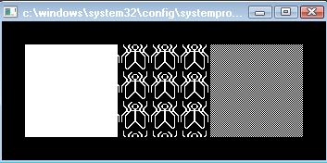
3．经过变换的立方体
#include <GL/glut.h>
#include <stdlib.h>

void init(void)
{
glClearColor (0.0, 0.0, 0.0, 0.0);
glShadeModel (GL_FLAT);
}

void display(void)
{
glClear (GL_COLOR_BUFFER_BIT);
glColor3f (1.0, 1.0, 1.0);
glLoadIdentity (); /* 设置单位阵 */
gluLookAt (0.0, 0.0, 5.0, 0.0, 0.0, 0.0, 0.0, 1.0, 0.0); /* 设置视点 */
glScalef (1.0, 2.0, 1.0); /* 设置模型变换矩阵 */
glutWireCube (1.0); /* 绘制线框立方体 */
glFlush ();
}

void reshape (int w, int h)
{
glViewport (0, 0, (GLsizei) w, (GLsizei) h); /* 设置视口信息 */
glMatrixMode (GL_PROJECTION); /* 选择投影矩阵 */
glLoadIdentity ();
glFrustum (-1.0, 1.0, -1.0, 1.0, 1.5, 20.0); /* 设置透视投影变换矩阵 */
glMatrixMode (GL_MODELVIEW); /* 选择模型视点矩阵 */
}

int main(int argc, char** argv)
{
glutInit(&argc, argv);
glutInitDisplayMode (GLUT_SINGLE | GLUT_RGB);
glutInitWindowSize (500, 500);
glutInitWindowPosition (100, 100);
glutCreateWindow (argv[0]);
init ();
glutDisplayFunc(display);
glutReshapeFunc(reshape);
glutMainLoop();
return 0;
}
结果：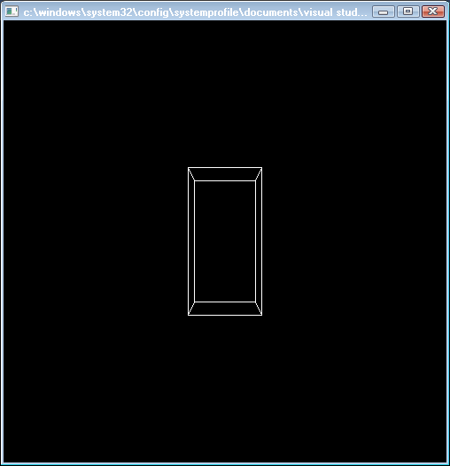

课内实验三 光照与材质

一：课内实验目的：
1. 掌握利用OpenGL编写绘制具有真实感效果的图形方法。
2. 掌握添加光源和设置颜色材料属性的方法。

二：课内实验内容：
1. 掌握添加光源的实现方法。
2. 掌握设置颜色和材料属性的方法。

三：课内实验要求
通过本课内实验，掌握添加光源和设置颜色材料属性的方法，利用OpenGL编写绘制具有真实感效果的图形。

四：课内实验程序
课内实验步骤1~4与上述课内实验1相同
5在添加的原文件中输入如下代码
#include <GL/glut.h>
#include <stdlib.h>

void init(void)
{
GLfloat mat_specular[] = { 1.0, 1.0, 1.0, 1.0 };
GLfloat mat_shininess[] = { 50.0 };
GLfloat light_position[] = { 1.0, 1.0, 1.0, 0.0 };

glClearColor (0.0, 0.0, 0.0, 0.0);
glShadeModel (GL_SMOOTH);

glMaterialfv(GL_FRONT, GL_SPECULAR, mat_specular);
glMaterialfv(GL_FRONT, GL_SHININESS, mat_shininess);
glLightfv(GL_LIGHT0, GL_POSITION, light_position);

glEnable(GL_LIGHTING);
glEnable(GL_LIGHT0);
glEnable(GL_DEPTH_TEST);
}

void display(void)
{
glClear (GL_COLOR_BUFFER_BIT | GL_DEPTH_BUFFER_BIT);
glutSolidSphere (1.0, 20, 16);
glFlush ();
}

void reshape (int w, int h)
{
glViewport (0, 0, (GLsizei) w, (GLsizei) h);
glMatrixMode (GL_PROJECTION);
glLoadIdentity();
if (w <= h)
glOrtho (-1.5, 1.5, -1.5*(GLfloat)h/(GLfloat)w,
1.5*(GLfloat)h/(GLfloat)w, -10.0, 10.0);
else
glOrtho (-1.5*(GLfloat)w/(GLfloat)h,
1.5*(GLfloat)w/(GLfloat)h, -1.5, 1.5, -10.0, 10.0);
glMatrixMode(GL_MODELVIEW);
glLoadIdentity();
}

void keyboard(unsigned char key, int x, int y)
{
switch (key) {
case 27:
exit(0);
break;
}
}

int main(int argc, char** argv)
{
glutInit(&argc, argv);
glutInitDisplayMode (GLUT_SINGLE | GLUT_RGB | GLUT_DEPTH);
glutInitWindowSize (500, 500);
glutInitWindowPosition (100, 100);
glutCreateWindow (argv[0]);
init ();
glutDisplayFunc(display);
glutReshapeFunc(reshape);
glutKeyboardFunc(keyboard);
glutMainLoop();
return 0;
}

五：课内实验结果
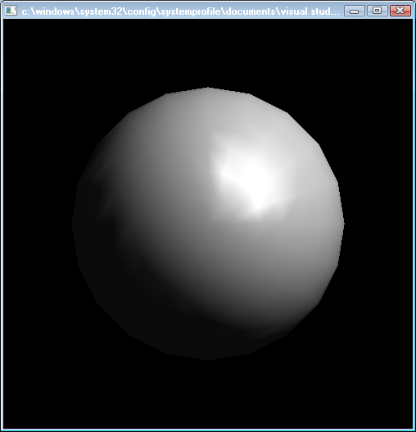

六：其它一些范例
1：使用光滑着色模式绘制一个三角形
#include <GL/glut.h>
#include <stdlib.h>

void init(void)
{
glClearColor (0.0, 0.0, 0.0, 0.0);
glShadeModel (GL_SMOOTH);
}

void triangle(void)
{
glBegin (GL_TRIANGLES);
glColor3f (1.0, 0.0, 0.0);
glVertex2f (5.0, 5.0);
glColor3f (0.0, 1.0, 0.0);
glVertex2f (25.0, 5.0);
glColor3f (0.0, 0.0, 1.0);
glVertex2f (5.0, 25.0);
glEnd();
}

void display(void)
{
glClear (GL_COLOR_BUFFER_BIT);
triangle ();
glFlush ();
}

void reshape (int w, int h)
{
glViewport (0, 0, (GLsizei) w, (GLsizei) h);
glMatrixMode (GL_PROJECTION);
glLoadIdentity ();
if (w <= h)
gluOrtho2D (0.0, 30.0, 0.0, 30.0 * (GLfloat) h/(GLfloat) w);
else
gluOrtho2D (0.0, 30.0 * (GLfloat) w/(GLfloat) h, 0.0, 30.0);
glMatrixMode(GL_MODELVIEW);
}

void keyboard(unsigned char key, int x, int y)
{
switch (key) {
case 27:
exit(0);
break;
}
}

int main(int argc, char** argv)
{
glutInit(&argc, argv);
glutInitDisplayMode (GLUT_SINGLE | GLUT_RGB);
glutInitWindowSize (500, 500);
glutInitWindowPosition (100, 100);
glutCreateWindow (argv[0]);
init ();
glutDisplayFunc(display);
glutReshapeFunc(reshape);
glutKeyboardFunc (keyboard);
glutMainLoop();
return 0;
}
结果：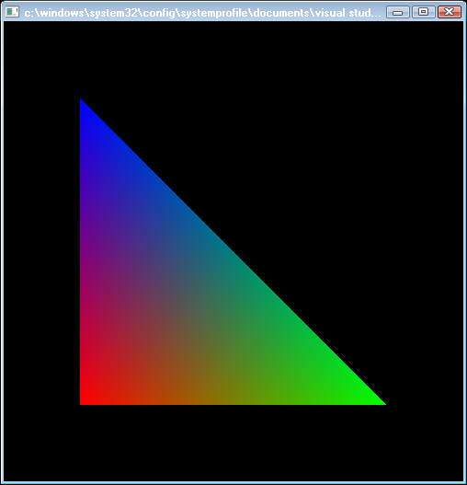

2：绘制两个三角形，查看启用和不启用深度缓存的效果
#include <GL/glut.h>
#include <stdlib.h>
void display(void)
{
glClearColor(0.0f,0.0f,0.0f,0.0f);
glClear (GL_COLOR_BUFFER_BIT );
//glClearDepth(1.0);
//glClear (GL_COLOR_BUFFER_BIT | GL_DEPTH_BUFFER_BIT);
//绘制一个红色三角形，z轴位置为-1.0f
glColor3f (1.0, 0.0, 0.0);
glBegin(GL_POLYGON);
glVertex3f(-0.5f, -0.3f,-1.0f);
glVertex3f(0.5f, -0.3f,-1.0f);
glVertex3f(0.0f, 0.4f,-1.0f);
glEnd();
//绘制一个蓝色的倒立三角形，z轴位置为-2.0f
glColor3f (0.0, 0.0, 1.0);
glBegin(GL_POLYGON);
glVertex3f(-0.5f, 0.3f,-2.0f);
glVertex3f(0.0f, -0.4f,-2.0f);
glVertex3f(0.5f, 0.3f,-2.0f);
glEnd();
glFlush ();
}
void reshape (int w, int h)
{
glViewport (0, 0, (GLsizei) w, (GLsizei) h);
glMatrixMode (GL_PROJECTION);
glLoadIdentity ();
glOrtho(-1.0, 1.0, -1.0, 1.0,0.0, 10.0);
}
int main(int argc, char** argv)
{
glutInit(&argc, argv);
glutInitDisplayMode (GLUT_SINGLE | GLUT_RGB| GLUT_DEPTH);
glutInitWindowSize (400, 400);
glutInitWindowPosition (100, 100);
glutCreateWindow (argv[0]);
//glEnable(GL_DEPTH_TEST) ;//启用深度测试
glutDisplayFunc(display);
glutReshapeFunc(reshape);
glutMainLoop();
return 0;
}
不启用深度测试：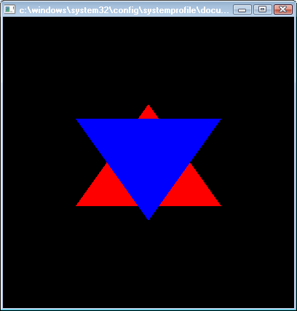
启用深度测试：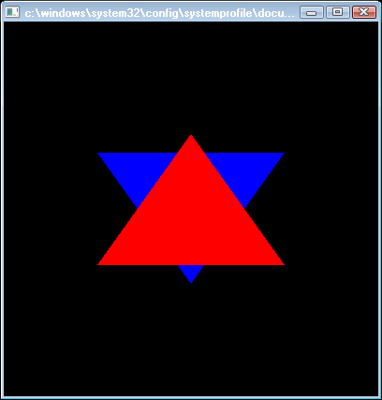

3：使用模型变换来移动光源
#include <GL/glut.h>
#include <stdlib.h>

static int spin = 0;

/* Initialize material property, light source, lighting model,
* and depth buffer.
*/
void init(void)
{
glClearColor (0.0, 0.0, 0.0, 0.0);
glShadeModel (GL_SMOOTH);
glEnable(GL_LIGHTING);
glEnable(GL_LIGHT0);
glEnable(GL_DEPTH_TEST);
}

/* Here is where the light position is reset after the modeling
* transformation (glRotated) is called. This places the
* light at a new position in world coordinates. The cube
* represents the position of the light.
*/
void display(void)
{
GLfloat position[] = { 0.0, 0.0, 1.5, 1.0 };

glClear (GL_COLOR_BUFFER_BIT | GL_DEPTH_BUFFER_BIT);
glPushMatrix ();
gluLookAt (0.0, 0.0, 5.0, 0.0, 0.0, 0.0, 0.0, 1.0, 0.0);

glPushMatrix ();
glRotated ((GLdouble) spin, 1.0, 0.0, 0.0);
glLightfv (GL_LIGHT0, GL_POSITION, position);

glTranslated (0.0, 0.0, 1.5);
glDisable (GL_LIGHTING);
glColor3f (0.0, 1.0, 1.0);
glutWireCube (0.1);
glEnable (GL_LIGHTING);
glPopMatrix ();

glutSolidTorus (0.275, 0.85, 8, 15);
glPopMatrix ();
glFlush ();
}

void reshape (int w, int h)
{
glViewport (0, 0, (GLsizei) w, (GLsizei) h);
glMatrixMode (GL_PROJECTION);
glLoadIdentity();
gluPerspective(40.0, (GLfloat) w/(GLfloat) h, 1.0, 20.0);
glMatrixMode(GL_MODELVIEW);
glLoadIdentity();
}

void mouse(int button, int state, int x, int y)
{
switch (button) {
case GLUT_LEFT_BUTTON:
if (state == GLUT_DOWN) {
spin = (spin + 30) % 360;
glutPostRedisplay();
}
break;
default:
break;
}
}

void keyboard(unsigned char key, int x, int y)
{
switch (key) {
case 27:
exit(0);
break;
}
}

int main(int argc, char** argv)
{
glutInit(&argc, argv);
glutInitDisplayMode (GLUT_SINGLE | GLUT_RGB | GLUT_DEPTH);
glutInitWindowSize (500, 500);
glutInitWindowPosition (100, 100);
glutCreateWindow (argv[0]);
init ();
glutDisplayFunc(display);
glutReshapeFunc(reshape);
glutMouseFunc(mouse);
glutKeyboardFunc(keyboard);
glutMainLoop();
return 0;
}
结果：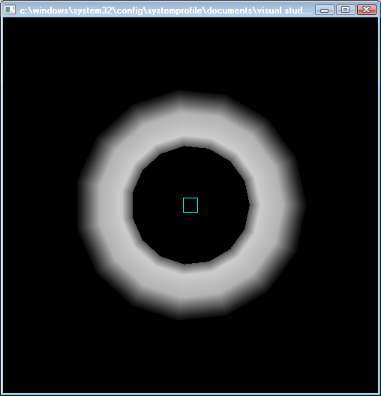点击鼠标可以发现光源位置在移动。
4：使用不同的材质属性
void display(void)
{
GLfloat no_mat[] = { 0.0, 0.0, 0.0, 1.0 };
GLfloat mat_ambient[] = { 0.7, 0.7, 0.7, 1.0 };
GLfloat mat_ambient_color[] = { 0.8, 0.8, 0.2, 1.0 };
GLfloat mat_diffuse[] = { 0.1, 0.5, 0.8, 1.0 };
GLfloat mat_specular[] = { 1.0, 1.0, 1.0, 1.0 };
GLfloat no_shininess[] = { 0.0 };
GLfloat low_shininess[] = { 5.0 };
GLfloat high_shininess[] = { 100.0 };
GLfloat mat_emission[] = {0.3, 0.2, 0.2, 0.0};

glClear(GL_COLOR_BUFFER_BIT | GL_DEPTH_BUFFER_BIT);

/* draw sphere in first row, first column
* diffuse reflection only; no ambient or specular
*/
glPushMatrix();
glTranslatef (-3.75, 3.0, 0.0);
glMaterialfv(GL_FRONT, GL_AMBIENT, no_mat);
glMaterialfv(GL_FRONT, GL_DIFFUSE, mat_diffuse);
glMaterialfv(GL_FRONT, GL_SPECULAR, no_mat);
glMaterialfv(GL_FRONT, GL_SHININESS, no_shininess);
glMaterialfv(GL_FRONT, GL_EMISSION, no_mat);
glutSolidSphere(1.0, 16, 16);
glPopMatrix();

/* draw sphere in first row, second column
* diffuse and specular reflection; low shininess; no ambient
*/
glPushMatrix();
glTranslatef (-1.25, 3.0, 0.0);
glMaterialfv(GL_FRONT, GL_AMBIENT, no_mat);
glMaterialfv(GL_FRONT, GL_DIFFUSE, mat_diffuse);
glMaterialfv(GL_FRONT, GL_SPECULAR, mat_specular);
glMaterialfv(GL_FRONT, GL_SHININESS, low_shininess);
glMaterialfv(GL_FRONT, GL_EMISSION, no_mat);
glutSolidSphere(1.0, 16, 16);
glPopMatrix();

/* draw sphere in first row, third column
* diffuse and specular reflection; high shininess; no ambient
*/
glPushMatrix();
glTranslatef (1.25, 3.0, 0.0);
glMaterialfv(GL_FRONT, GL_AMBIENT, no_mat);
glMaterialfv(GL_FRONT, GL_DIFFUSE, mat_diffuse);
glMaterialfv(GL_FRONT, GL_SPECULAR, mat_specular);
glMaterialfv(GL_FRONT, GL_SHININESS, high_shininess);
glMaterialfv(GL_FRONT, GL_EMISSION, no_mat);
glutSolidSphere(1.0, 16, 16);
glPopMatrix();

/* draw sphere in first row, fourth column
* diffuse reflection; emission; no ambient or specular reflection
*/
glPushMatrix();
glTranslatef (3.75, 3.0, 0.0);
glMaterialfv(GL_FRONT, GL_AMBIENT, no_mat);
glMaterialfv(GL_FRONT, GL_DIFFUSE, mat_diffuse);
glMaterialfv(GL_FRONT, GL_SPECULAR, no_mat);
glMaterialfv(GL_FRONT, GL_SHININESS, no_shininess);
glMaterialfv(GL_FRONT, GL_EMISSION, mat_emission);
glutSolidSphere(1.0, 16, 16);
glPopMatrix();

glFlush();
}
结果：