Driver Installation for your VGA card

The Setup CD has done its best to make it as easy as possible to install your VGA card’s driver, but thers are still some issues you should be noted. Following are the procedures for driver installation:

Step 1: Install your VGA card properly (refer to hardware installation guide).

Step 2: Power on your PC.

Step 3: If it is the first time you install this VGA card, by the Plug and Play feature of Windows 95, Windows 95 will find a new hardware and ask for the driver.
In this case, please insert the Setup CD into CD-ROM.
(Assume your CD-ROM drive is on drive D:,if it is not, change D: to other drive letter.)
then input the driver source as

D:\S3TRIOV (if you install a S3 Trio64V+ card) or
D:\S3TRIOV2 (if you install a S3 Trio64V2 card) or
D:\S3VIRGE (if you install a S3 ViRGE or ViRGE/DX/GX card) or
D:\ET6000 (if you install a Tseng Lab ET6000 card) or
D:\PerMedia (if you install a 3Dlabs Permedia card) or
D:\Voodoo (if you install a HELIOS 3D-Voodoo card) or
D:\Rush (if you install a HELIOS 3D-Voodoo Rush card) or
D:\VIRGEGX2 (if you install a S3 ViRGE/GX2 card) or
D:\INTEL740 (if you install a Intel 740)

then Windows will copy the driver files and ask you to restart Windows,
you need to choose 'OK' to restart Windows so that the new driver will take effect.

Step 4: Insert the Setup CD into your CD-ROM drive. The Setup CD will auto-launch the Setup program on Windows 95 and Windows NT 4.0, if you are on other platform or the Setup program does not auto-run, please double click the MSSETUP.EXE on the root of the Setup CD yourself. Then a Setup Window will appear, the Setup program will detect your Windows version and your VGA chipset and display a specific setup window which you can install the driver and releated softwares conveniently. Please follow the on-screen instruction to complete the installation.

The following window is a example Setup Window for S3 ViRGE, other chipset has similiar picture, when Windows prompt you to restart Windows, please click YES to restart your system.

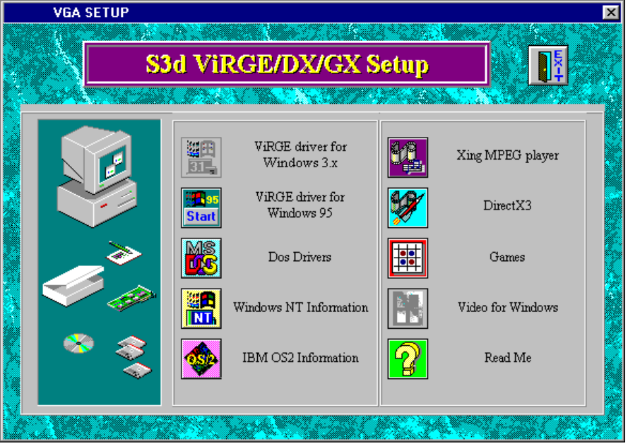

How to Launch Media Pro
After install the drivers for Windows 3.x and 95 and restarting the Windows, a  icon will display at the left bottom of your screen (the taskbar tray icon area). Left Click(on Windows 3.x) or Right Click(on Windows 95) this icon, and then select the 'Diaplay Control Panel' menu item, or double click the 'Display Control Panel' icon on the new installed program group, the 'Diaplay Control Panel' program will be opened. The main window of the 'Diaplay Control Panel' is showed as following, please refer to Help or user manual for optional guide.
