1. To begin, go to phonegap.com and click on install.

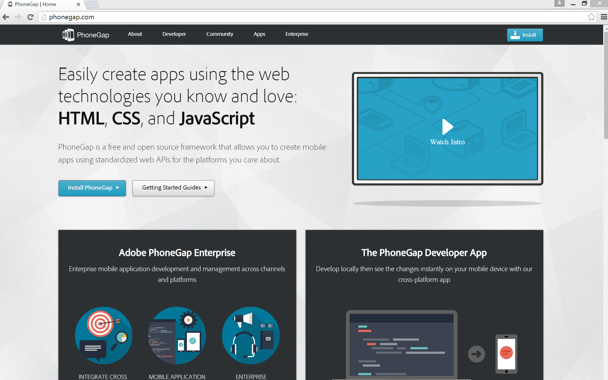

1. It will bring you to the “Install PhoneGap” page. On this page, it will tell you to install NodeJS. Click the link.

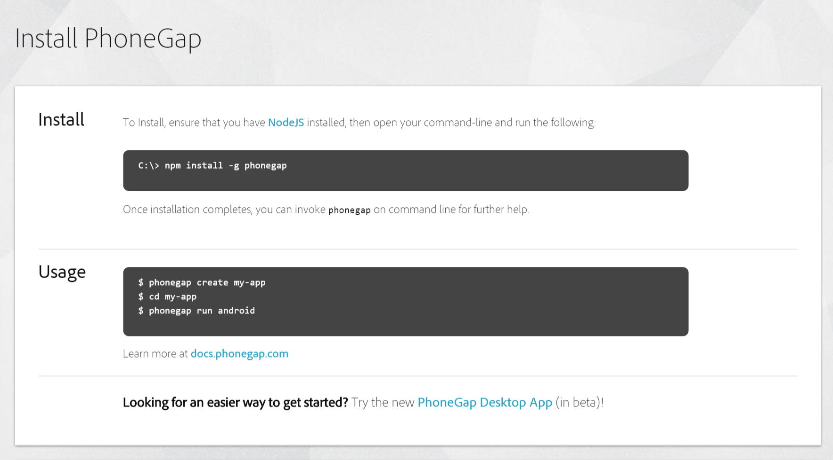

1. Once you click the link, it will bring you to this page. Click install and download the proper version.

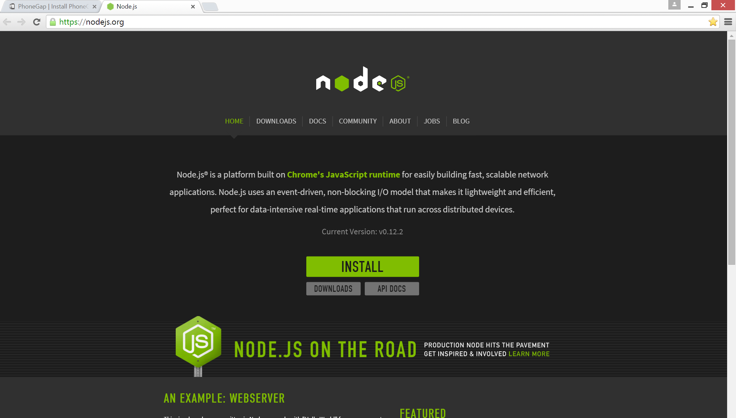

1. After you install Node.JS. Open up the Node.JS Command prompt and run enter:

npm install -g phonegap

You should get a display similar to this.

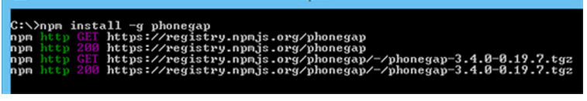

1. After you Node.JS you will need to install JDK. Go to this link. Download the correct version.

http://www.oracle.com/technetwork/java/javase/downloads/jdk8-downloads-2133151.html

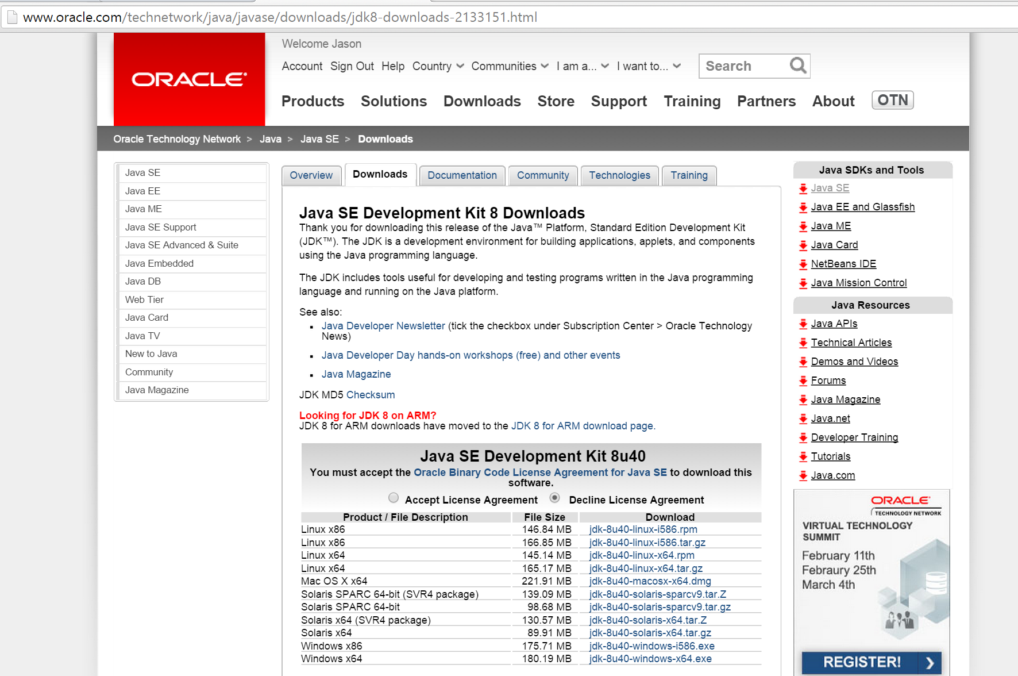

1. You will need to install Eclipse. This is the IDE that will be used to configure and emulate the Android application. Select the correct version and download and install the IDE.

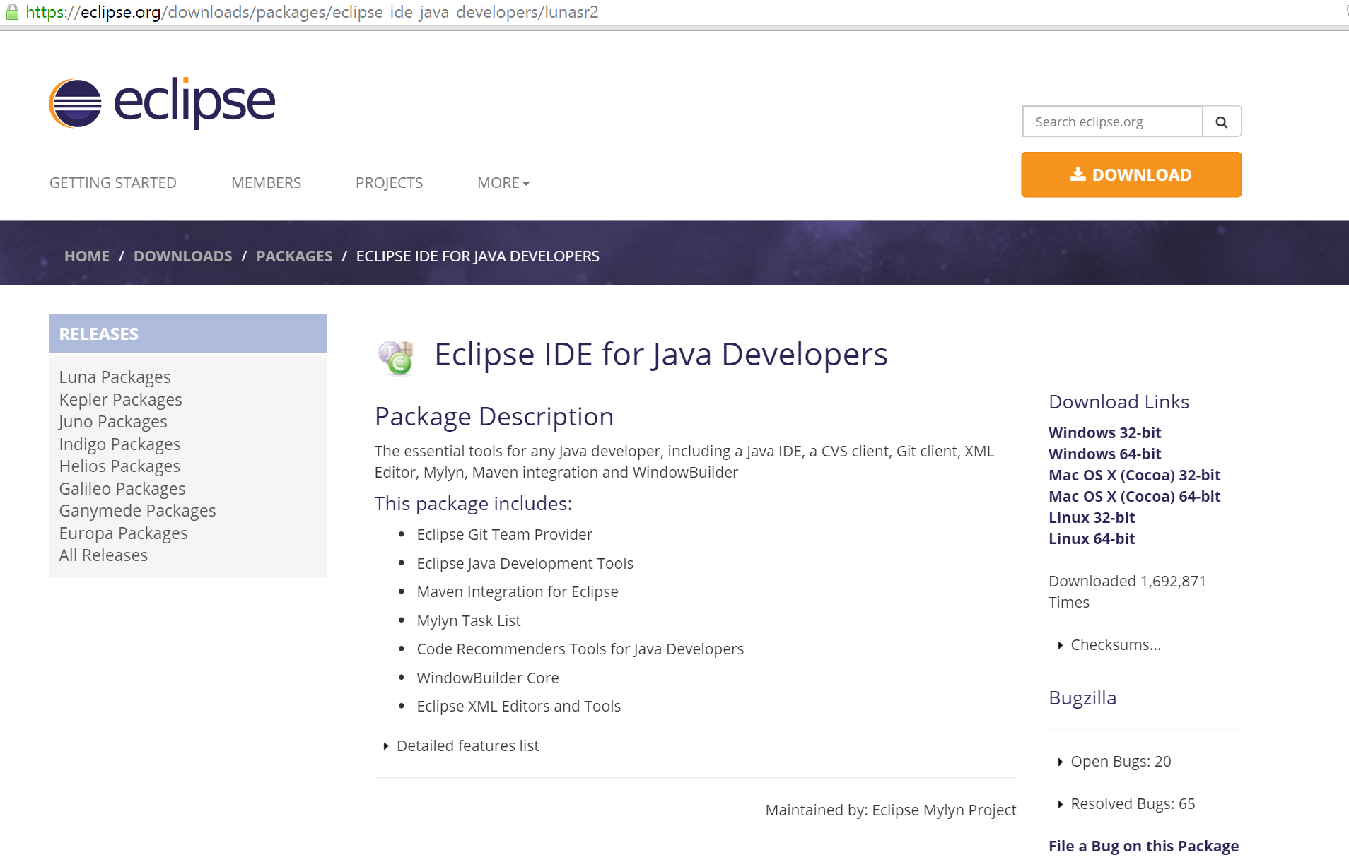

1. You will need to install the ADT plugin after you install Eclipse.

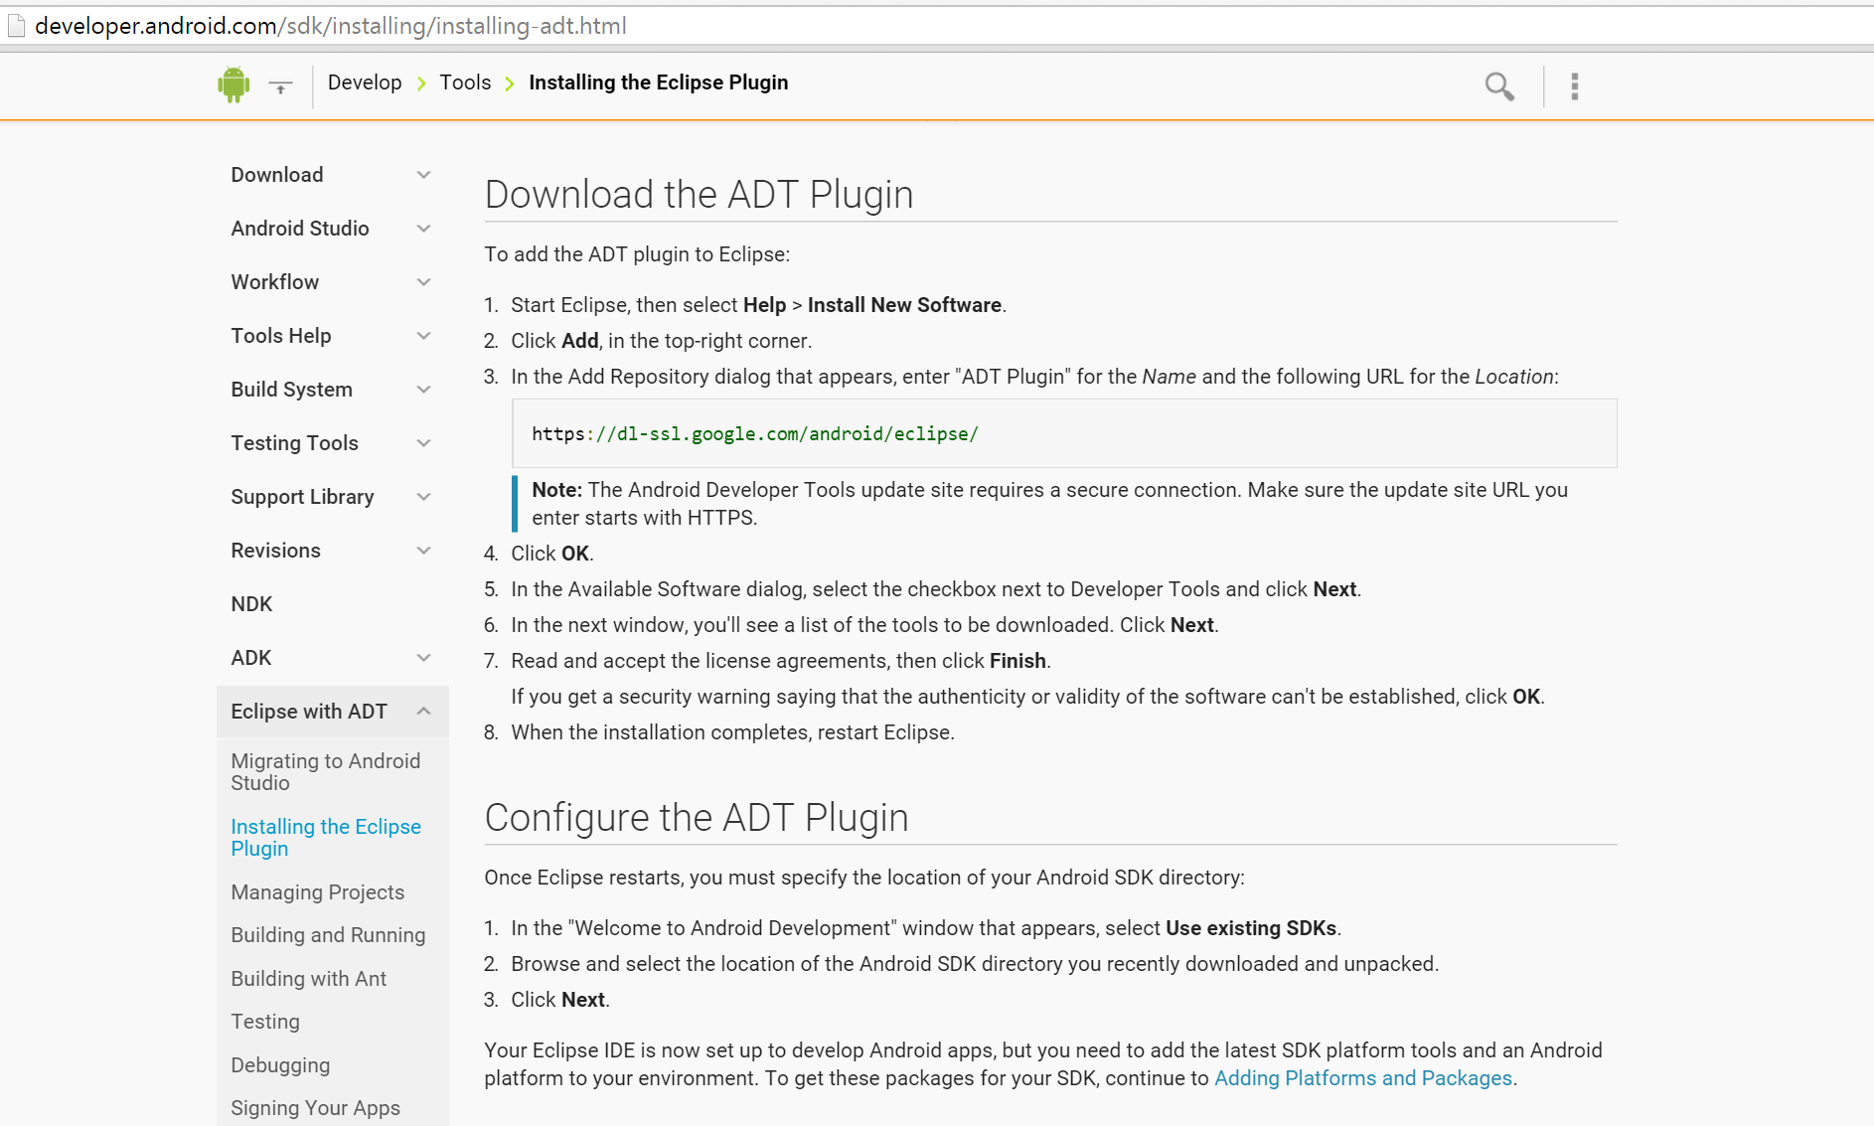

1. This is how the Java Eclipse IDE looks like.

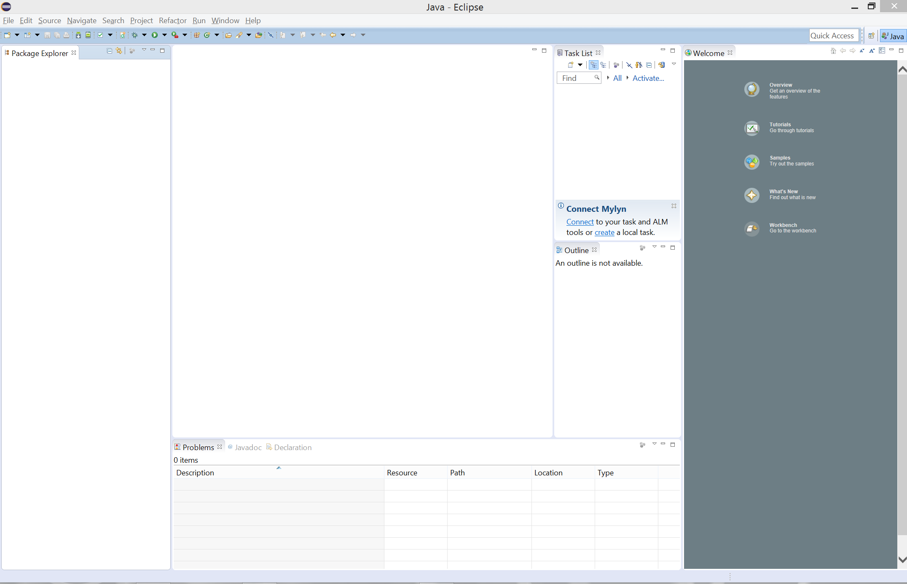

1. After you have Eclipse installed, you will need to download tools and updates from the Android SDK Manager. Go to Window > Android SDK Manager. e

