(4)

首先用R package算出f(x)=x^(-1/3)+x/10從0到1的積分值=1.55

我們利用Monte Carlo method with U(0,1) ,得到一個估計量I_U ,

(e.g樣本數10000下估計值=1.54964)

接下來 ,重複生成1000次 ,建構95%信賴區間=[ 1.54362 1.551501 ]

|  |
| --- |
| f<-function(x){x^(-1/3)+x/10} #積分f(x)=x^(-1/3)+x/10  a<-0;b<-1;n<-1e04;N<-1000 #從0到1  I<-integrate(f,0,1)$value #用R算出積分值為1.55  #Monte Carlo method  F_u<-function(n){ (b-a)/n*sum(f(runif(n,0,1))) }  I_U<-F_u(n) #利用U(0,1)算出的積分= 1.54964  confi.of.I_U<-function(N,alpha){  x<-rep(0,N)  for(i in 1:N){ x[i]<-x[i]+F_u(n) }  I.bar<-sum(x)/N  I.sd<-sd(x)  cat("The 95% confidence interval for estimating I is [",  I.bar-I.sd/sqrt(N)*qnorm(1-alpha),"",  I.bar+I.sd/sqrt(N)*qnorm(1-alpha),"]","\n")}  confi.of.I_U(100,0.05)  #建構 95% confidence interval for estimating I is [ 1.54362 1.551501 ] |

(5)

比較兩個不同的p(x)對於Monte Carlo method 估計量的sample variance ,

1.對於p_1(x) ~ U(0,1) ,理論上的variance=0.0007208333 ,

樣本數1000利用S^2估計得sample variance=0.00078835

2.對於p_2(x)=2/3*x^(-1/3) ,理論上的var=1.99999999999978e-06 ,

樣本數1000利用S^2估計得sample variance=1.77499754521021e-06

|  |
| --- |
| #p_1(x) ~ U(0,1)  var1<-(3+3/25+1/300-(31/20)^2)/n  x1<-rep(0,N)  for(i in 1:N){ x1[i]<-x1[i]+F_u(n)}  var.hat1<-sd(x1)^2;rm(x1) #理論上的var=0.72/n  利用S^2估計得var.hat=0.603/n  #p_2(x)=2/3*x^(-1/3)  var2<-(9/4+3/20+9/2000-(31/20)^2)/n  F_2<-function(n){ sum(3/2+3/20*(runif(n,0,1))^(4/3))/n }  I_2<-F_2(n) #利用p_2(x)算出的積分= 1.565765  x2<-rep(0,N)  for(i in 1:N){ x2[i]<-x2[i]+F_2(n)}  var.hat2<-sd(x2)^2;rm(x2) #理論上的var=0.002/n  利用S^2估計得var.hat= 0.0020029/n |

(7)

利用monte carlo估計E(X^4) ,X~N(0,1) ,由R package算出E(X^4)=3 ,

1. with p(x)~U(0,1) , 選擇b=10使得目標f函數值 < 1e-19

重複生成100次 ,得到算出積分= 2.987094 ,建構95%信賴區間為[ 2.9586575 3.015532 ]

1. with p(x)~exp(1), 重複生成100次 ,得到算出積分= .006623499 ,建構95%信賴區間為[ 2.99874603 3.01450096 ]

|  |
| --- |
| #est. E(X^4) by monte carlo  f<-function(x){ 1/sqrt(2*pi)*(x^4)*exp(-x^2/2) }  I<-integrate(f,-Inf,Inf)$value #利用R算出積分=3  plot(x=seq(0.01,5,0.01),y=f(seq(0.01,5,0.01)))  #with U(0,1)  n<-1e04;b<-10 #integrate(f,10,Inf)  I_Muni<-2*sum(f(runif(n,0,b)))*b/n  confi.of.I_Muni<-function(N,alpha){  x<-rep(0,N)  for(i in 1:N){ x[i]<-x[i]+2*sum(f(runif(n,0,b)))*b/n }  I.bar<-sum(x)/N  I.sd<-sd(x)  cat("The 95% confidence interval for estimating I is [",  I.bar-I.sd/sqrt(N)*qnorm(1-alpha),"",  I.bar+I.sd/sqrt(N)*qnorm(1-alpha),"]","\n",I.bar)  }  confi.of.I_Muni(100,0.05)  #with exp(1)  n<-1e04;lambda<-1  Exp<-function(n,lambda){  X<--log(runif(n,0,1))/lambda  return(X)  }  fex<-function(x){f(x)/exp(-x) }  I_Mexp<-2*sum(fex(Exp(n,1)))/n  confi.of.I_Mexp<-function(N,alpha){  x<-rep(0,N)  for(i in 1:N){ x[i]<-x[i]+2*sum(fex(rexp(n,1)))/n }  I.bar<-sum(x)/N  I.sd<-sd(x)  cat("The 95% confidence interval for estimating I is [",  I.bar-I.sd/sqrt(N)*qnorm(1-alpha),"",  I.bar+I.sd/sqrt(N)*qnorm(1-alpha),"]","\n")  }  confi.of.I_Mexp(100,0.05) |

1. with p(x)~N(0,1),

(a)首先生成N(0,1) by rejection sampling N(0,1) with g(x)~exp(1) ,

e(x)=c*g(x) with g(x)=exp(-x) 且選擇c=2 使得e(x)>p(x) (如下圖)

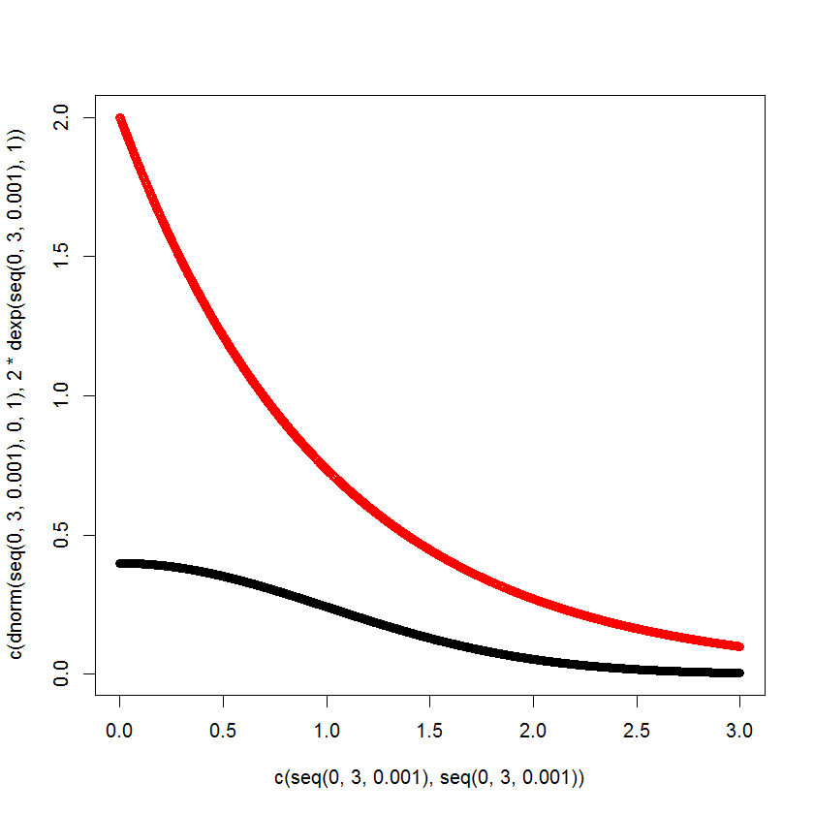 (黑色為N(0,1) ;紅色為2*exp(1) )

接著成功生成10000個隨機變數~N(0,1) , 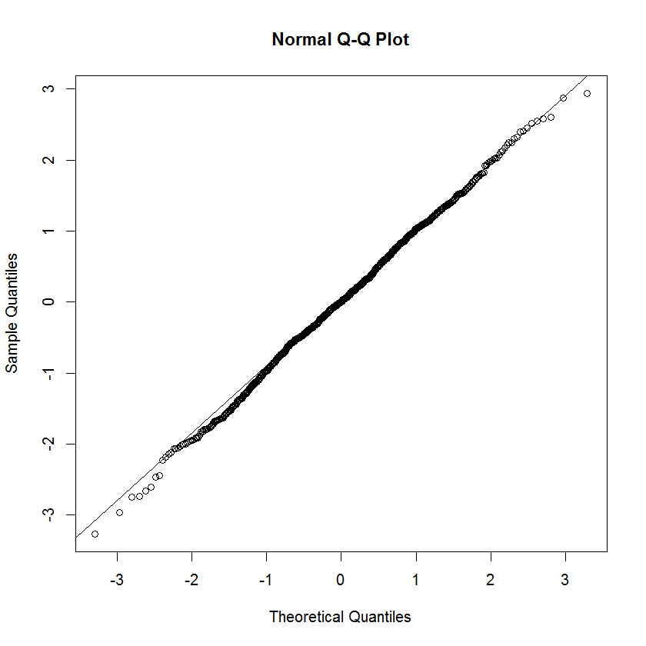 (由QQ-plot判斷生成的N(0,1) )

(b) 重複生成100次 ,得到算出積分= 3.017778408 ,建構95%信賴區間為 [ 3.00298434 3.032572474 ]