Exercise 1.

For non-parametric density estimation , by kernel method

我們有 $MISE=E\left(ISE\right)=E\left({\int{\left(\hat{f}-f\right)}}^{2}dx\right)=\int{Var\left(\hat{f}\right)}dx+\int{Bias{\left(\hat{f}\right)}^{2}dx}$

$$=\frac{b_{n}^{4}u_{2}^{2}}{4}R\left(f^{''}\right)+\frac{1}{nb_{n}}R\left(k\right)+o\left(\frac{1}{nb_{n}}\right)$$

$$with optimal bandwith b_{n}^{*}={\left(\frac{R\left(k\right)}{nu_{2}^{2}R\left(f^{''}\right)}\right)}^{\frac{1}{5}}, where u_{2}=\int{xk^{2}\left(x\right)dx}$$

$, R\left(k\right)=\int{k^{2}(x)dx} , R\left(f^{''}\right)=\int{f^{''}{\left(x\right)}^{2}dx}$.

這裡選擇Eparechinlcov kernel,

$$k\left(x\right)=\frac{3}{4}\left(1-x^{2}\right) , -1<x<1$$

經過計算(附錄), $u_{2}^{2}=\frac{1}{25} , R\left(f^{''}\right)=0.2115626 , R\left(k\right)=\frac{3}{5}$, 代入MISE中,

得到不同樣本數 $n_{1}=10 , {MISE}_{1}=0.2735451$

$$n_{2}={10}^{2}, {MISE}_{2}=0.04335398$$

$$n_{3}={10}^{3}, {MISE}_{3}=0.006871143$$

$$n_{4}={10}^{6}, {MISE}_{4}=0.00002735451$$

$$n_{5}={10}^{7} , {MISE}_{5}=0.000004335398$$

$$n_{6}={10}^{8} , {MISE}_{6}=0.0000006871143$$

觀察到, $\frac{MISE_{1}}{MISE_{4}}=\frac{0.2735451}{0.00002735451}={10}^{4} as n_{4}={10}^{5}n_{1}$, 同樣 $\left(n_{2},n_{5}\right)和(n_{3},n_{6})$ 如上

故, $as n→∞ ,AMISE=O\left(n^{-\frac{4}{5}}\right).$

Exercise 2.

Data “faithful” 為黃石公園的噴泉噴發時間(X1)與等待時間(X2)，我們想要找到X1和X2的邊際密度函數 $g_{X_{1}}(x_{1}),g_{X_{2}}(x_{2})$ 和聯合密度函數 $g_{{X_{1}X}_{2}}(x_{1},x_{2})$.

利用kernel method, 這裡選擇Eparechinlcov kernel,

$$k\left(x\right)=\frac{3}{4}\left(1-x^{2}\right) , -1<x<1$$

For $g_{X_{1}}(x_{1})$,

(i)我們有 ${ X}_{1},X_{2},…,X_{272} \sim g_{X_{1}}$, 考慮估計量 $f_{n}\left(x\right)=\frac{1}{nb_{n}}\sum_{i=1}^{n}{k\left(\frac{x-X_{i}}{b_{n}}\right)} 取 n=272, take b_{n}=\left(0.05 , 0.1 , 0.5 , 1\right)$, 對於不同的 $b_{n}$ 估計畫圖如下:

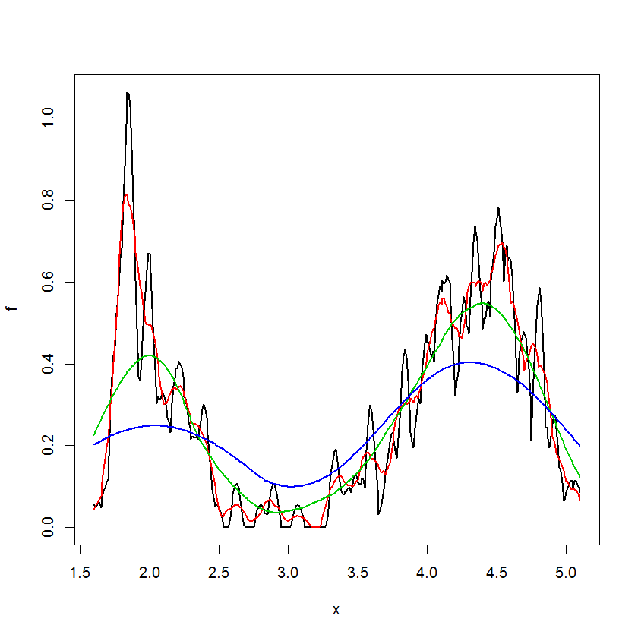

(黑色 $b_{n}=0.05$;紅色 $b_{n}=0.1$;綠色 $b_{n}=0.5$;藍色 $b_{n}=1$)

發現 $b_{n}$ 愈小則圖形越曲折複雜, $b_{n}$ 愈大則圖形越平滑.

(ii)Choose $b_{n}$ by peseudo likelihood,

考慮 $b_{n}^{*}=argmax_{b_{n}}p\left(b_{n}\right)=\prod_{i=1}^{n}{{\hat{f}}_{-i}(x_{i})}=0.21,$ 畫圖入下:

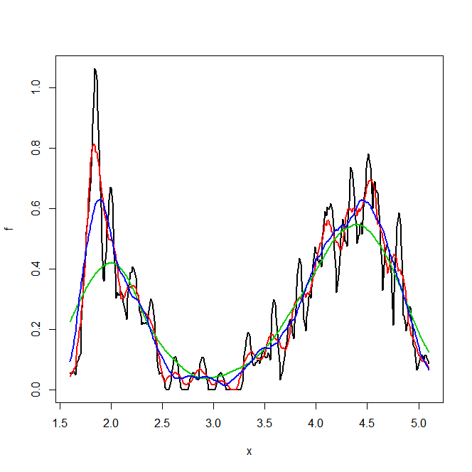

(黑色為 $b_{n}=0.05$, 紅色為 $b_{n}=0.1,$ 綠色為 $b_{n}=0.5$, 藍色為 $b_{n}=0.21$)

For $g_{X_{2}}(x_{2})$,

我們有 ${ X}_{1},X_{2},…,X_{272} \sim g_{X_{2}}$, 考慮估計量 $f_{n}\left(x\right)=\frac{1}{nb_{n}}\sum_{i=1}^{n}{k\left(\frac{x-X_{i}}{b_{n}}\right)} with n=272, take b_{n}=\left(1 , 2 , 3 , 4\right)$, 對於不同的 $b_{n}$ 估計畫圖如下:

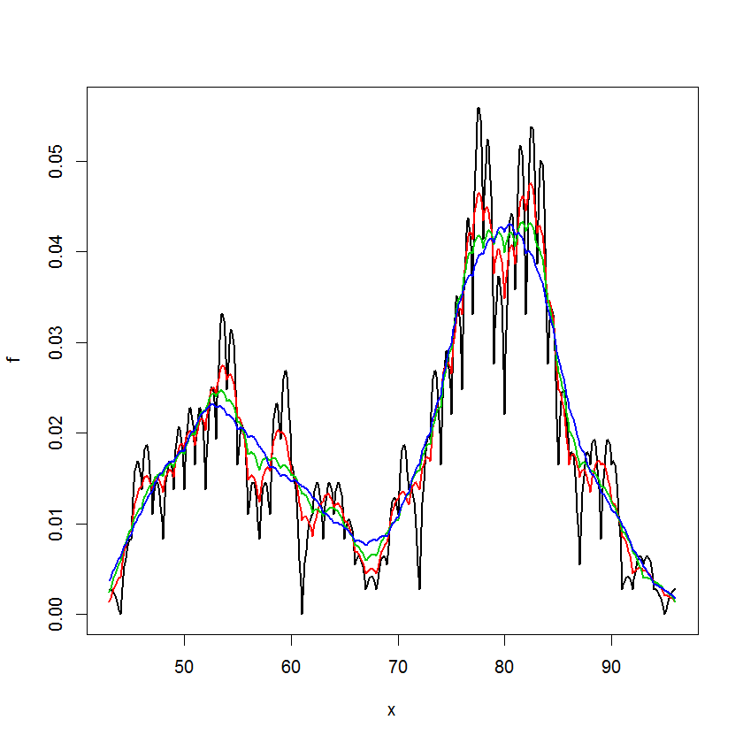

(黑色 $b_{n}=1$;紅色 $b_{n}=2$;綠色 $b_{n}=3$;藍色 $b_{n}=4$)

發現當 $b_{n}=4$ 圖形才比較平滑, 應該是原始資料X2等待時間的尺度和X1噴發時間不同, 可以看到不同樣本的等待時間差異較大. 故對於bandwith的選擇數字相對要大一些才趨於平滑.

For $g_{{X_{1}X}_{2}}(x_{1},x_{2})$,

有 $\left(X_{11},X_{12}\right),\left(X_{21},X_{22}\right),\left(X_{31},X_{32}\right),…,\left(X_{272,1},X_{272,2}\right) \sim g_{{X_{1}X}_{2}}$, 考慮估計量

$$f_{n}\left(x\right)=\frac{1}{n}\sum_{i=1}^{n}{\prod_{j=1}^{p}{\frac{1}{b_{nj}}k\left(\frac{x_{j}-X_{ij}}{b_{nj}}\right) }}, with n=272$$

$,take b_{n}=\left(b_{n1},b_{n2}\right)=(0.5 , 2)$, 畫出的3維圖如下:

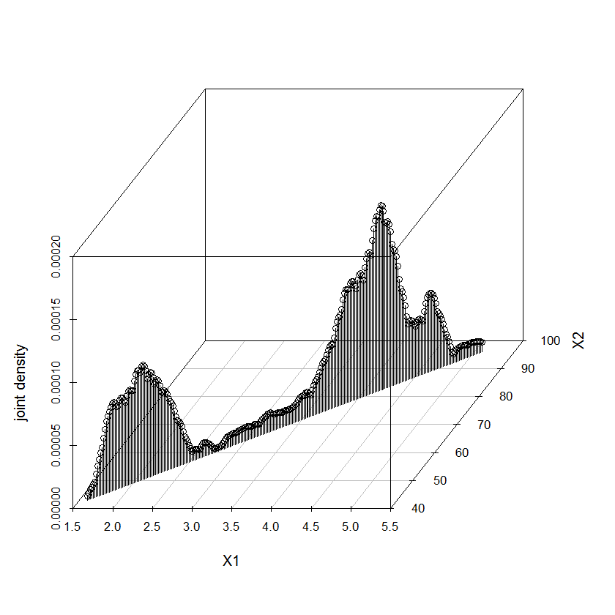

(只畫出 $\left(X_{1},X_{2}\right)$ 對角線部分的 $g_{{X_{1}X}_{2}}$)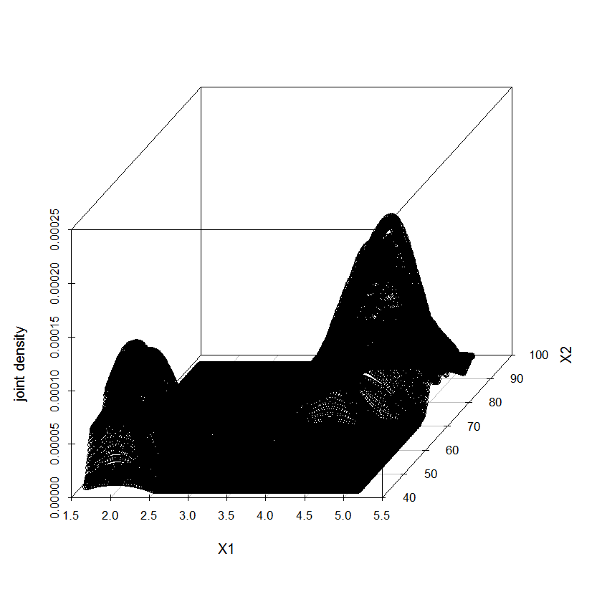

(所有的 $\left(X_{1},X_{2}\right)$ 的 $g_{{X_{1}X}_{2}}$)

#Exercise 1.

|  |
| --- |
| #non-parametric density est of kernal method  #R(f'')  R_f<-function(x){ 1/pi* (x^2-1)^2 *exp(-x^2) }  I_Simpson<-function(a,b,l){  #a<-0;b<-20;l<-50  h<-seq(a,b,(b-a)/l)  if(l%%2==0){  z1<-0;z2<-0  for(i in 2:(l/2)){ z1<-z1+2*R_f(h[2*i-1]) }  for(i in 1:(l/2)){ z2<-z2+4*R_f(h[2*i]) }  I_S<-(R_f(h[1])+R_f(h[l+1])+z1+z2)*(b-a)/l/3  } else {print("n need to be even")} }  Rf<-I_Simpson(0,20,50)  #R(k) with Eparechinlcov kernal  Rk<-3/5  #optimal bandwith b_n  bandwidth<-function(n){ ( Rk / n *(1/25) *Rf )^(1/5) }  #MISE  MISE<-function(n){ bandwidth(n)^4 *(1/25) *Rf /4 + 1/(n*bandwidth(n)) *Rk }  a<-MISE(10^6) |

#Exercise 2.

|  |
| --- |
| #Eparechinlcov kernel  K<-function(x){ if(x>-1 && x<1){ return(3/4*(1-x^2)) }else{ return(0) } }  #Triangle kernel  K<-function(x){ if(x>-1 && x<1){ return(1-abs(x)) }else{ return(0) } }  #Uniform kernel  K<-function(x){ if(x>-1 && x<1){ return(1/2) }else{ return(0) } }  #Normal kernel  K<-function(x){ return(1/sqrt(2*pi)*exp(-x^2/2)) }  #g1 density  data<-faithful  n<-length(data[,1])  b_n<-c(0.05,0.1,0.5,1)  for(k in 1:length(b_n)){  x<-seq(min(data[,1]),max(data[,1]),0.01)  f<-rep(0,length(x))  for(l in 1:length(x)){  y<-rep(0,n)  for(i in 1:n){  y[i]<-K( (x[l]-data[i,1]) /b_n[k] ) /n /b_n[k]  f[l]<-sum(y)  }  }  if(k==1){ windows();plot(x,f,type = "l",lwd=2) }  else{ lines(x,f,col= k,lwd=2) }  }  #g2 density  data<-faithful  n<-length(data[,2])  b_n<-c(1,2,3,4)  for(k in 1:length(b_n)){  x<-seq(min(data[,2]),max(data[,2]),0.1)  f<-rep(0,length(x))  for(l in 1:length(x)){  y<-rep(0,n)  for(i in 1:n){  y[i]<-K( (x[l]-data[i,2]) /b_n[k] ) /n /b_n[k]  f[l]<-sum(y)  }  }  if(k==1){ windows();plot(x,f,type = "l",lwd=2) }  else{ lines(x,f,col= k,lwd=2) }  }  #g(x1,x2) density  data<-faithful  n<-272  #j=1  b_n1<-0.5  x1<-seq(min(data[,1]),max(data[,1]), (max(data[,1])-min(data[,1]))/n )  #j=2  x2<-seq(min(data[,2]),max(data[,2]), (max(data[,2])-min(data[,2]))/n )  b_n2<-2  #g(x1,x2) density 對角線部分  n<-272  x<-cbind(x1,x2)  f<-rep(0,length(x[,1]))  for(l in 1:length(x[,1])){  y<-rep(0,n)  for(i in 1:n){  y[i]<-K( (x[l,1]-data[i,1]) /b_n1 ) /b_n1 /n *K( (x[l,2]-data[i,2]) /b_n2 ) /b_n2 /n  f[l]<-sum(y)  }  }  windows();plot(x[,1],f,type = "l",lwd=2)  windows();plot(x[,2],f,col = 2,type = "l",lwd=2)  library(scatterplot3d)  windows();scatterplot3d(x1,x2,f,color = ,type = "h",  xlab = "X1",  ylab = "X2",  zlab = "joint density")  library(plotly)  plot_ly(data.frame(x=x1 ,y=x2 ,z=f)  , x = ~x ,y = ~y, z = ~z,color = , colors = ) %>%  add_markers() %>%  layout(scene = list(xaxis = list(title = "X1"),  yaxis = list(title = "X2"),  zaxis = list(title = "joint density")))  #3維圖全部  n<-272  f<-matrix(0,length(x2),length(x1))  for(k in 1:length(x1)){  for(l in 1:length(x2)){  y<-rep(0,n)  for(i in 1:n){  y[i]<-K( (x1[k]-data[i,1]) /b_n1 ) /b_n1 /n *K( (x2[l]-data[i,2]) /b_n2 ) /b_n2 /n  f[k,l]<-sum(y)  }  }  }  plot(x=1:9,y=matrix(11:19,3,3))  B<-c()  for(i in 1:273){  A<-cbind(x1,x2[i])  B<-rbind(B,A)  }  windows();scatterplot3d(B[,1],B[,2],f,color = ,type = "p",  xlab = "X1",  ylab = "X2",  zlab = "joint density")  plot_ly(data.frame(x=B[,1] ,y=B[,2] ,z=as.vector(f) )  , x = ~x ,y = ~y, z = ~z,color = , colors = ) %>%  add_markers() %>%  layout(scene = list(xaxis = list(title = "X1"),  yaxis = list(title = "X2"),  zaxis = list(title = "joint density"))) |