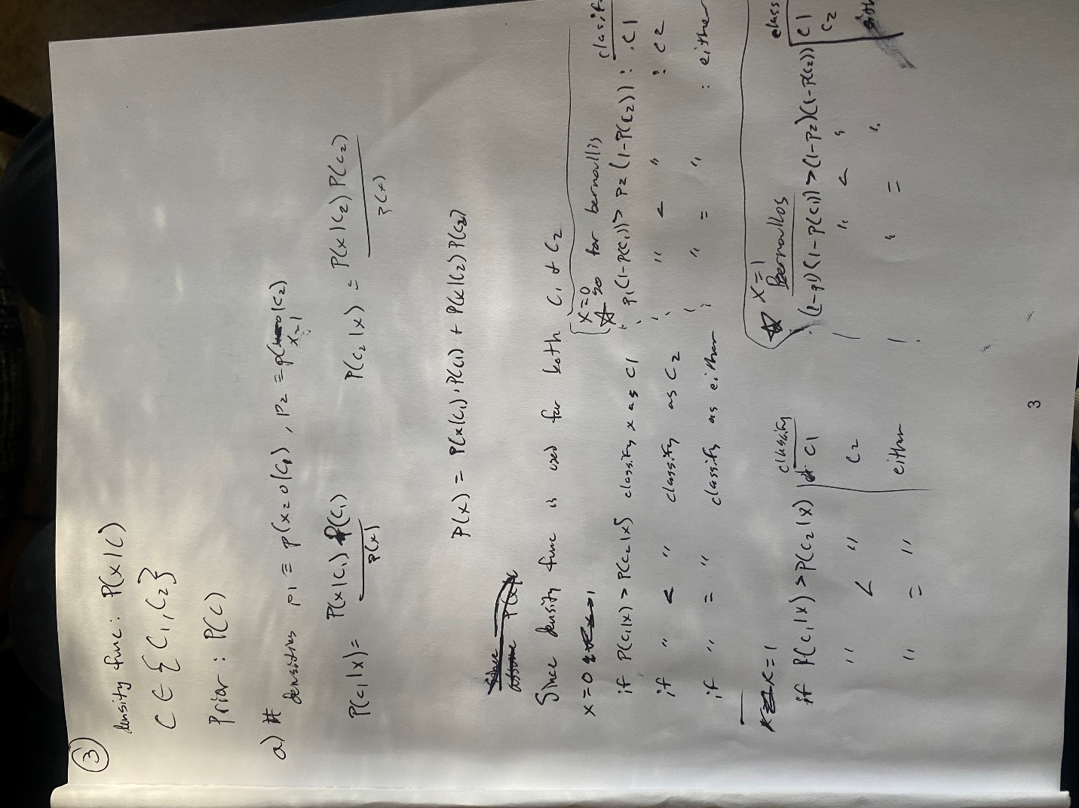

3c:

x = (0, 0): P(C1|x) = nan, P(C2|x) = nan

x = (0, 1): P(C1|x) = nan, P(C2|x) = nan

x = (1, 0): P(C1|x) = nan, P(C2|x) = nan

x = (1, 1): P(C1|x) = 0.2, P(C2|x) = 0.8

Priors: P(C1) = 0.6, P(C2) = 0.4

x = (0, 0): P(C1|x) = nan, P(C2|x) = nan

x = (0, 1): P(C1|x) = nan, P(C2|x) = nan

x = (1, 0): P(C1|x) = nan, P(C2|x) = nan

x = (1, 1): P(C1|x) = 0.6, P(C2|x) = 0.4000000000000001

Priors: P(C1) = 0.8, P(C2) = 0.19999999999999996

x = (0, 0): P(C1|x) = nan, P(C2|x) = nan

x = (0, 1): P(C1|x) = nan, P(C2|x) = nan

x = (1, 0): P(C1|x) = nan, P(C2|x) = nan

x = (1, 1): P(C1|x) = 0.8, P(C2|x) = 0.19999999999999993

[see code problem3c.py]

4: Table of Error Rates:

Prior Value Error Rate

0.000010 0.540000

0.000100

0.540000

0.001000 0.540000

0.010000 0.540000

0.100000 0.510000

1.000000 0.515000

2.000000 0.455000

3.000000 0.460000

4.000000 0.460000

5.000000 0.460000

6.000000 0.460000

The error rate with the best prior on the test is: 0.44499999999999995