Cash Flow and Cumulative Savings Analysis
Initial Investment: ₹30.09 lakh
Annual Net Savings: ₹1.558 lakh/year
Project Life: 25 years
Battery Replacement: ₹13.44 lakh in Years 10 and 20.

Annual Cash Flow Graph
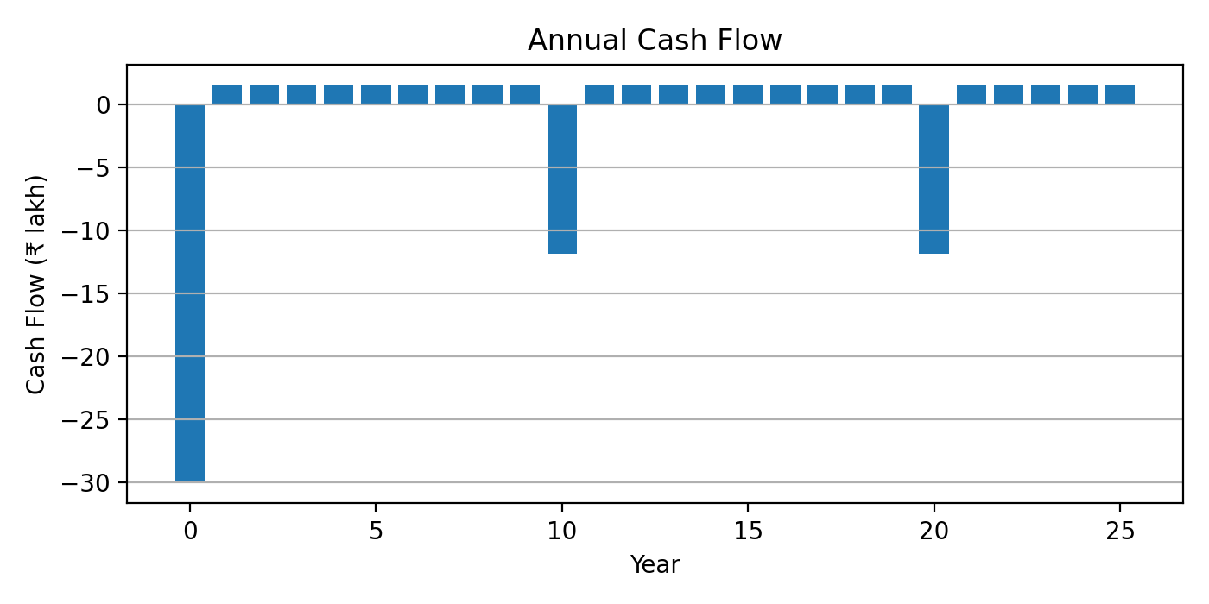

Cumulative Cash Flow Graph
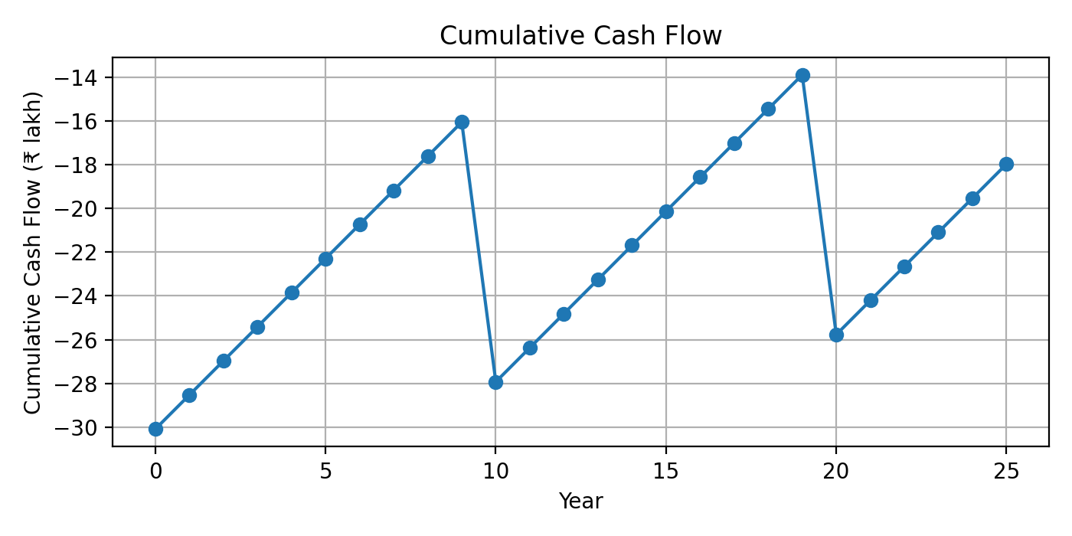

Engineering Observation
With lead-acid sealed gel batteries and two complete battery replacements over a 25-year project life, the cumulative cash flow remains negative under the assumed electricity tariff of ₹8.5/kWh. This reflects the economics of many off-grid systems where energy independence and reliability are the primary objectives rather than short-term financial returns.

