**Programming Assignment #4**

0611031 資工 10 謝至恆

**目標:**

使用random forests實作supervised learning，這次只要做分類問題的learning，

先實作decision tree，要包括induction part( 使用training data 建構tree)，和inference part (也就是驗算用的samples)，只使用real-valued attribute，使用CART方法來建構tree。

**解題思路:**

根據不同的attribute分離node，我們使用Gini’s impurity(將經過attribute後分類的資料，2邊分別套入公式，全部相加後跟其他attribute比較)來檢查哪個node可以把資料分的最乾淨，優先選擇這個attribute來做上層的分類，就可以越快分類完成，使用這個方法一直循環下去就可以得到一個decision tree。

接下來就要build a forest，Random Forests(簡單來說, 也就是利用bagging隨機【抽出後放回再繼續抽】的方式，建構一些decision tree，最後再從這些trees中取平均，因為是抽出再放回，所以有可能會重複抽取，也比較不會出現完全一樣的組合，這樣一來就可以在現有的資料裡面創造出更多的資料組合也就是dataset，這樣一來再learning上就有很大的優勢(增加training的數量)，希望可以得到一個比較折衷，且較正確的結果)，並使用tree bagging( random select samples)和attribute bagging(random select attribute)來觀察forest的結果。

**CART:**a.決策樹生成：基於訓練數據生成決策樹，決策樹盡量大

(使用gini係數來求得)  
b.決策樹剪枝：用驗證數據集對已生成的樹進行剪枝並選擇最優子樹，用損失函數最小作為剪枝的標準

採用CCP（代價複雜度）剪枝方法。代價複雜度選擇節點表面誤差率增益值最小的非葉子節點，刪除該非葉子節點的左右子節點，若有多個非葉子節點的表面誤差率增益值相同小，則選擇非葉子節點中子節點數最多的非葉子節點進行剪枝。

**實作:**

這次的作業我是使用python來做，因為這方面的code我比較不熟悉，上網查了許多資料，發現python的資料最豐富也比較詳細，加上普遍code比較短衣些，所以我也就用python了，我是使用-鳶尾花iris的dataset，(聽說這個比較簡單?)

裡面有3種不同的鳶尾花，裡面有150筆資料，4種特徵(分別為 萼片(sepal)之長與寬以及花瓣(petal)之長與寬)。

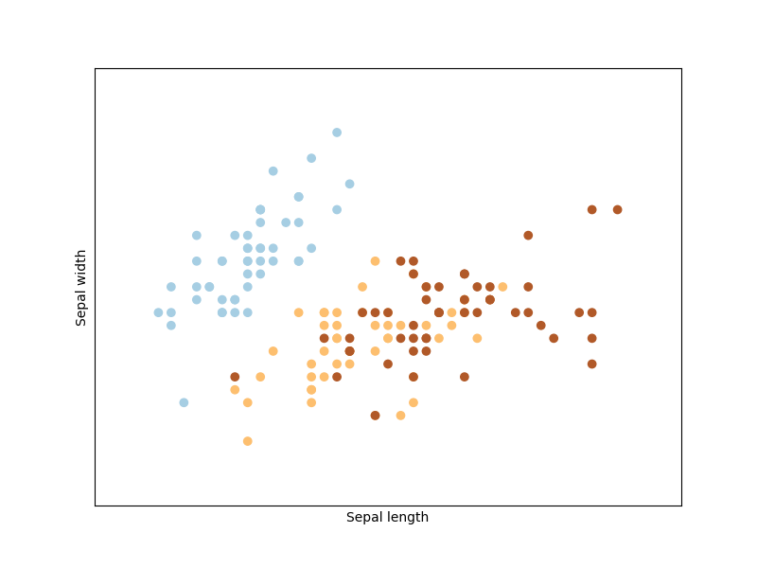

根據上網查到的source code來做改寫。

先將data load進來，取前120做traing data，30個做validation data，用來剪枝。

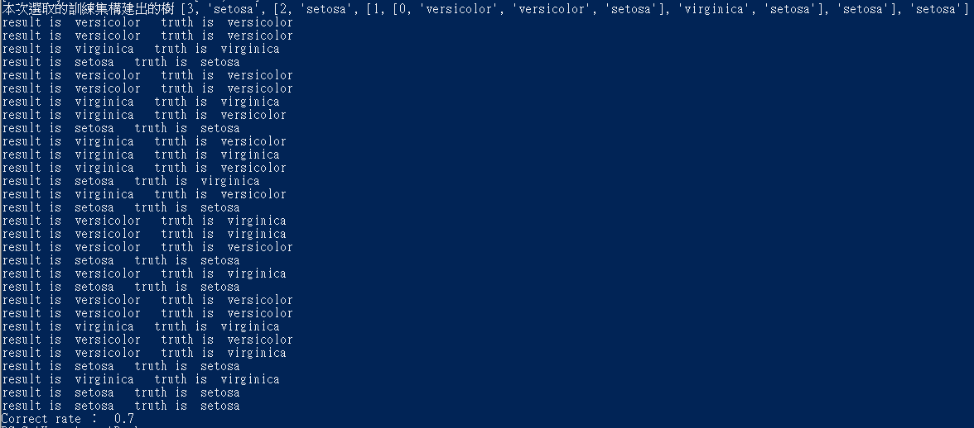

把每個attribute使用Gini方式計算出的資料給予的資訊量，選取最大的來做劃分，以此類推來得到decision tree。

Random forest的部分，採用tree bagging的方式就是先從所有資料隨機抽取120個資料(有可能選到重複的資料)做training data，再抽30個validation data，來建構decision tree，取30個深度為3的tree，做平均來得到一個tree。Attribute bagging就是隨機抽1個attribute來生成trees再求平均，這樣就可以得到一個學到比較少noise但又可以保證signal趨於大部分sample的tree。

**程式結果**

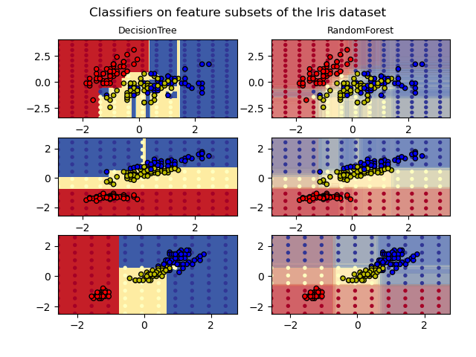

在第一行中，僅使用萼片寬度和長度特徵構建分類器，在第二行中僅使用花瓣長度和萼片長度構建分類器，在第三行中僅使用花瓣寬度和花瓣長度構建分類器。可以看出 第3行>第2行>第1行的分類結果

**心得；**

這次作業的觀念實際上在課堂上就大部分都已經了解了，不過要實作還是有點不知道該怎麼下手，上網查了很多資料，這次的作業比較難的部分我覺得是將上網查的code看懂並改成作業要求的形式。不過看到最後結果有跑出來還蠻有成就感的，decision tree的部分本身不難，random forest的實作就比較複雜了，雖然書上原理好像蠻簡單的，但實際要做的程式碼我看了蠻久才比較了解。

這次作業讓我更加理解上課的內容，任我對Learning的辦法了解了更多。

**參考資料**

**決策樹- Cart + iris數據集+ python實現**

<https://blog.csdn.net/weixin_43909872/article/details/86027350>

# 演算法-隨機森林分類(RandomForestClassifier)

<http://www.taroballz.com/2019/05/25/ML_RandomForest_Classifier/>

# The iris 鳶尾花資料集

<https://machine-learning-python.kspax.io/datasets/ex3_the_iris_dataset>

Plot the decision surfaces of ensembles of trees on the iris dataset

<https://scikit-learn.org/stable/auto_examples/ensemble/plot_forest_iris.html>

# 决策树分类鸢尾花数据集python实现

<https://blog.csdn.net/zhoulei124/article/details/88994445?utm_medium=distribute.pc_relevant.none-task-blog-BlogCommendFromMachineLearnPai2-1.nonecase&depth_1-utm_source=distribute.pc_relevant.none-task-blog-BlogCommendFromMachineLearnPai2-1.nonecase>

**Decision Tree 實作和 Random Forest(觀念)**

<https://medium.com/@jacky308082/machine-learning%E4%B8%8B%E7%9A%84decision-tree%E5%AF%A6%E4%BD%9C%E5%92%8Crandom-forest-%E8%A7%80%E5%BF%B5-%E4%BD%BF%E7%94%A8python-3a94cef2ce6f>

Code:

from sklearn import datasets

import math

import numpy as np

def getInformationEntropy(arr,leng):

return -(arr[0]/leng*math.log(arr[0]/leng if arr[0]>0 else 1)+ arr[1]/leng*math.log(arr[1]/leng if arr[1]>0 else 1)+ arr[2]/leng*math.log(arr[2]/leng if arr[2]>0 else 1))

def discretization(index):

feature1 = np.array([iris.data[:,index],iris.target]).T

feature1 = feature1[feature1[:,0].argsort()]

counter1 = np.array([0,0,0])

counter2 = np.array([0,0,0])

resEntropy = 100000

for i in range(len(feature1[:,0])):

counter1[int(feature1[i,1])] = counter1[int(feature1[i,1])] + 1

counter2 = np.copy(counter1)

for j in range(i+1,len(feature1[:,0])):

counter2[int(feature1[j,1])] = counter2[int(feature1[j,1])] + 1

if i != j and j != len(feature1[:,0])-1:

sum = (i+1)*getInformationEntropy(counter1,i+1) + (j-i)*getInformationEntropy(counter2-counter1,j-i) + (length-j-1)*getInformationEntropy(np.array(num)-counter2,length-j-1)

if sum < resEntropy:

resEntropy = sum

res = np.array([i,j])

res_value = [feature1[res[0],0],feature1[res[1],0]]

print(res,resEntropy,res_value)

return res_value

def getRazors():

a = []

for i in range(len(iris.feature_names)):

print(i)

a.append(discretization(i))

return np.array(a)

#隨機抽取120的training data set和30的validation data set

def divideData():

completeData = np.c_[iris.data,iris.target.T]

np.random.shuffle(completeData)

trainData = completeData[range(int(length*0.8)),:]

testData = completeData[range(int(length*0.8),length),:]

return [trainData,testData]

def getEntropy(counter):

res = 0

denominator = np.sum(counter)

if denominator == 0:

return 0

for value in counter:

if value == 0:

continue

res += value/denominator * math.log(value/denominator if value>0 and denominator>0 else 1)

return -res

def findMaxIndex(dataSet):

maxIndex = 0

maxValue = -1

for index,value in enumerate(dataSet):

if value>maxValue:

maxIndex = index

maxValue = value

return maxIndex

def recursion(featureSet,dataSet,counterSet):

if(counterSet[0]==0 and counterSet[1]==0 and counterSet[2]!=0):

return iris.target_names[2]

if(counterSet[0]!=0 and counterSet[1]==0 and counterSet[2]==0):

return iris.target_names[0]

if(counterSet[0]==0 and counterSet[1]!=0 and counterSet[2]==0):

return iris.target_names[1]

if len(featureSet) == 0:

return iris.target_names[findMaxIndex(counterSet)]

if len(dataSet) == 0:

return []

res = 1000

final = 0

for feature in featureSet:

i = razors[feature][0]

j = razors[feature][1]

set1 = []

set2 = []

set3 = []

counter1 = [0,0,0]

counter2 = [0,0,0]

counter3 = [0,0,0]

for data in dataSet:

index = int(data[-1])

if data[feature]< i :

set1.append(data)

counter1[index] = counter1[index]+1

elif data[feature] >= i and data[feature] <=j:

set2.append(data)

counter2[index] = counter2[index]+1

else:

set3.append(data)

counter3[index] = counter3[index]+1

a =( len(set1)*getEntropy(counter1) + len(set2)*getEntropy(counter2) + len(set3)*getEntropy(counter3) )/ len(dataSet)

if a<res :

res = a

final = feature

#返回被選中的特徵的下標

#sequence.append(final)

featureSet.remove(final)

child = [0,0,0,0]

child[0] = final

child[1] = recursion(featureSet,set1,counter1)

child[2] = recursion(featureSet,set2,counter2)

child[3] = recursion(featureSet,set3,counter3)

return child

def judge(data,tree):

root = "unknow"

while(len(tree)>0):

if isinstance(tree,str) and tree in iris.target_names:

return tree

root = tree[0]

if(isinstance(root,str)):

return root

if isinstance(root,int):

if data[root]<razors[root][0] and tree[1] != [] :

tree = tree[1]

elif tree[2] != [] and (tree[1]==[] or (data[root]>=razors[root][0] and data[root]<=razors[root][1])):

tree = tree[2]

else :

tree = tree[3]

return root

if __name__ == '__main__':

iris = datasets.load_iris()

num = [0,0,0]

for row in iris.data:

num[int(row[-1])] = num[int(row[-1])] + 1

length = len(iris.target)

[trainData,testData] = divideData()

razors = getRazors()

tree = recursion(list(range(len(iris.feature_names))), trainData,[np.sum(trainData[:,-1]==0), np.sum(trainData[:,-1]==1),np.sum(trainData[:,-1]==2)])

print("本次選取的訓練集構建出的樹",tree)

index = 0

right = 0

for data in testData:

result = judge(testData[index],tree)

truth = iris.target_names[int(testData[index][-1])]

print("result is ",result ," truth is ",truth)

index = index + 1

if result == truth:

right = right + 1

print("Correct rate ： ",right/index)

print(__doc__)

import numpy as np

import matplotlib.pyplot as plt

from matplotlib.colors import ListedColormap

from sklearn.datasets import load_iris

from sklearn.ensemble import (RandomForestClassifier)

from sklearn.tree import DecisionTreeClassifier

# Parameters

n_classes = 3

n_estimators = 30

cmap = plt.cm.RdYlBu

plot_step = 0.02 # fine step width for decision surface contours

plot_step_coarser = 0.5 # step widths for coarse classifier guesses

RANDOM_SEED = 13 # fix the seed on each iteration

# Load data

iris = load_iris()

plot_idx = 1

models = [DecisionTreeClassifier(max_depth=None),

RandomForestClassifier(n_estimators=n_estimators),

]

for pair in ([0, 1], [0, 2], [2, 3]):

for model in models:

# We only take the two corresponding features

X = iris.data[:, pair]

y = iris.target

# Shuffle

idx = np.arange(X.shape[0])

np.random.seed(RANDOM_SEED)

np.random.shuffle(idx)

X = X[idx]

y = y[idx]

# Standardize

mean = X.mean(axis=0)

std = X.std(axis=0)

X = (X - mean) / std

# Train

model.fit(X, y)

scores = model.score(X, y)

# Create a title for each column and the console by using str() and

# slicing away useless parts of the string

model_title = str(type(model)).split(

".")[-1][:-2][:-len("Classifier")]

model_details = model_title

if hasattr(model, "estimators_"):

model_details += " with {} estimators".format(

len(model.estimators_))

print(model_details + " with features", pair,

"has a score of", scores)

plt.subplot(3, 2, plot_idx)

if plot_idx <= len(models):

# Add a title at the top of each column

plt.title(model_title, fontsize=9)

# Now plot the decision boundary using a fine mesh as input to a

# filled contour plot

x_min, x_max = X[:, 0].min() - 1, X[:, 0].max() + 1

y_min, y_max = X[:, 1].min() - 1, X[:, 1].max() + 1

xx, yy = np.meshgrid(np.arange(x_min, x_max, plot_step),

np.arange(y_min, y_max, plot_step))

# Plot either a single DecisionTreeClassifier or alpha blend the

# decision surfaces of the ensemble of classifiers

if isinstance(model, DecisionTreeClassifier):

Z = model.predict(np.c_[xx.ravel(), yy.ravel()])

Z = Z.reshape(xx.shape)

cs = plt.contourf(xx, yy, Z, cmap=cmap)

else:

# Choose alpha blend level with respect to the number

# of estimators

# that are in use (noting that AdaBoost can use fewer estimators

# than its maximum if it achieves a good enough fit early on)

estimator_alpha = 1.0 / len(model.estimators_)

for tree in model.estimators_:

Z = tree.predict(np.c_[xx.ravel(), yy.ravel()])

Z = Z.reshape(xx.shape)

cs = plt.contourf(xx, yy, Z, alpha=estimator_alpha, cmap=cmap)

# Build a coarser grid to plot a set of ensemble classifications

# to show how these are different to what we see in the decision

# surfaces. These points are regularly space and do not have a

# black outline

xx_coarser, yy_coarser = np.meshgrid(

np.arange(x_min, x_max, plot_step_coarser),

np.arange(y_min, y_max, plot_step_coarser))

Z_points_coarser = model.predict(np.c_[xx_coarser.ravel(),

yy_coarser.ravel()]

).reshape(xx_coarser.shape)

cs_points = plt.scatter(xx_coarser, yy_coarser, s=15,

c=Z_points_coarser, cmap=cmap,

edgecolors="none")

# Plot the training points, these are clustered together and have a

# black outline

plt.scatter(X[:, 0], X[:, 1], c=y,

cmap=ListedColormap(['r', 'y', 'b']),

edgecolor='k', s=20)

plot_idx += 1 # move on to the next plot in sequence

plt.suptitle("Classifiers on feature subsets of the Iris dataset", fontsize=12)

plt.axis("tight")

plt.tight_layout(h_pad=0.2, w_pad=0.2, pad=2.5)

plt.show()