**Week12_Discussion_0611031**

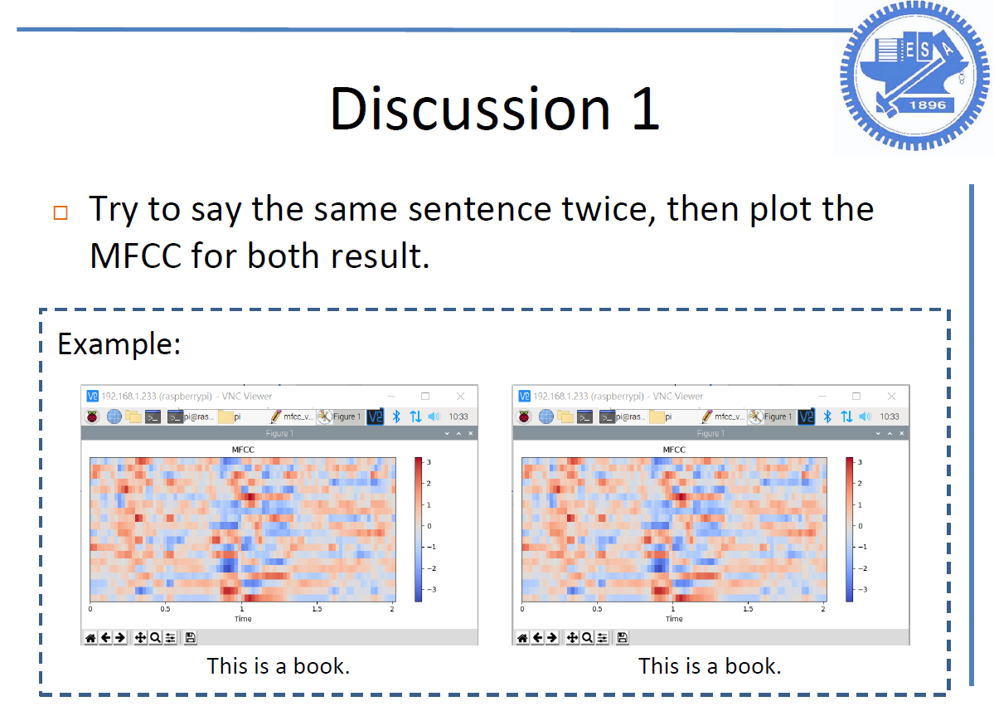

I speak “This is a book.”,too.

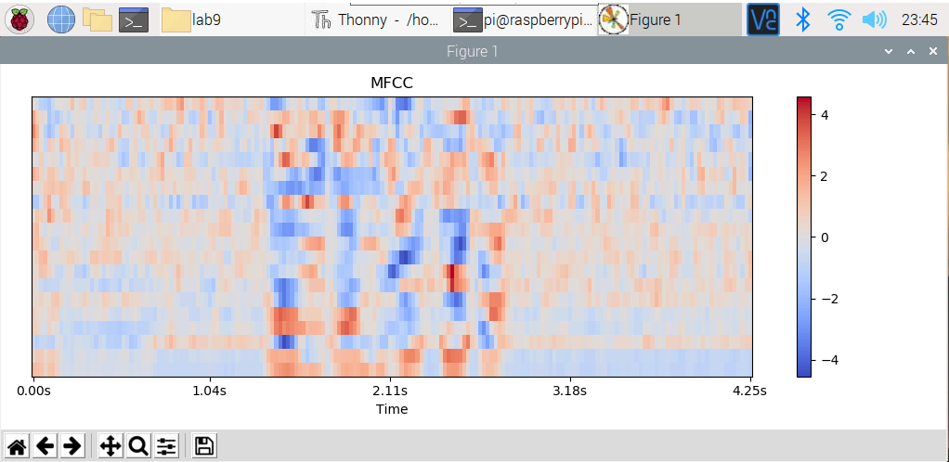

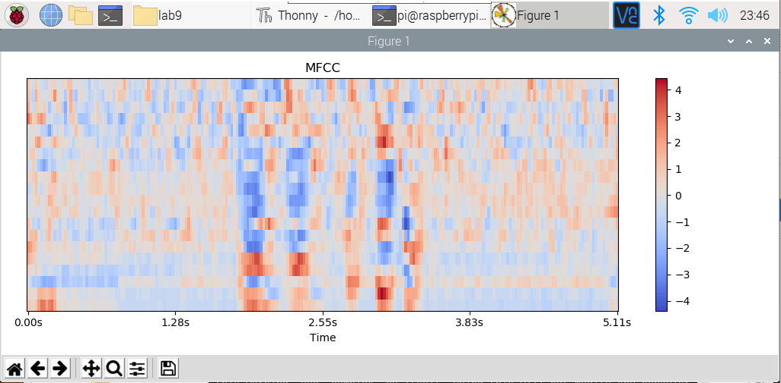

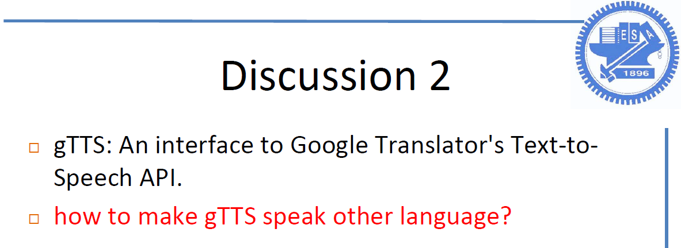

更改gTTs(text=’想要說的語言的詞’, lang=’想要的語言’)

Code:

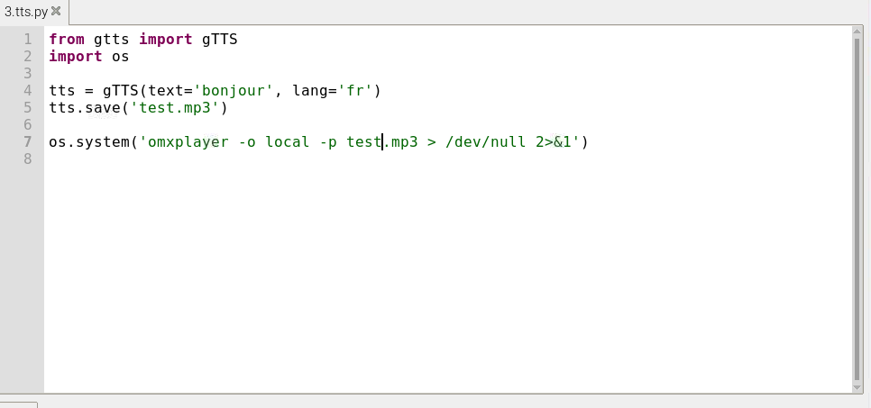

即可聽到法語的bonjour