Preliminary
LED Current Sink Driver IC | AQ06
LED Current Sink Driver IC | 6-Channel

General Description
The AQ06 is a compact and white package IC featuring 6-channel input voltage-based low side current sink control driver optimized for LED lighting solution.
The self-protection features include thermal regulation, temperature protection and LED short monitoring output.

Feature
- All-in-1 package (Dimming control, LED current sink FET, Headroom voltage low detection, LED open & short and thermal-protection mechanism)
- Independent dimming control for each channel in a package
- Maximum 80V headroom voltage for serial connection of multiple LEDs
- Maximum 40 mA sink current per channel for linearity
- 4.5V ~ 5.5V IC operating voltage range
- Multiplexed analog voltage input with gate sampling
- Headroom voltage control signal FB for power supply voltage control
- Fail-safe FB output when LED open detected
- Thermal regulation & over temperature protection
- LED short sensing monitor output
- Low power consumption
- Latch-up Immunity I_{LATCH}: JEDEC JESD78D Nov 2011: ±100mA
- ESD_{HBM} protection (Norm: MIL 883 E Method 3015 Human Body Model): ±2kV
- The optimized pin-out of the AQ06 allows for a dense layout and a compact total solution size
- Small and white color package (QFN2020-16H) for lighting solution

Application
- TV Display
- LED lighting with dimming control
Block Diagram Pin Diagram

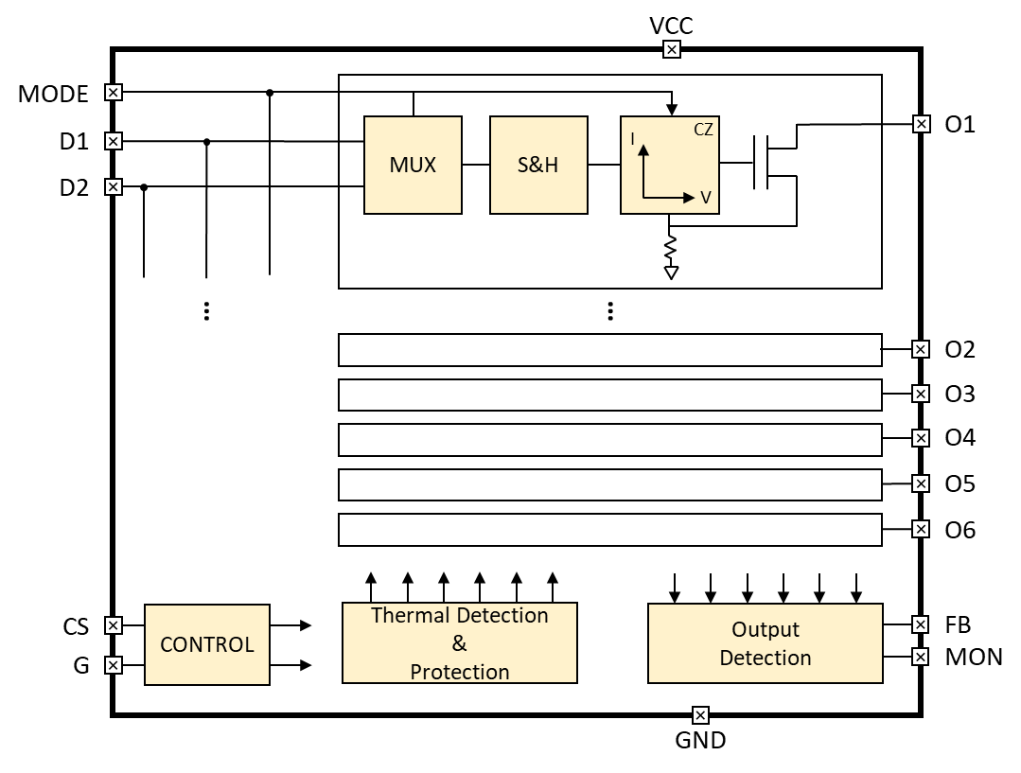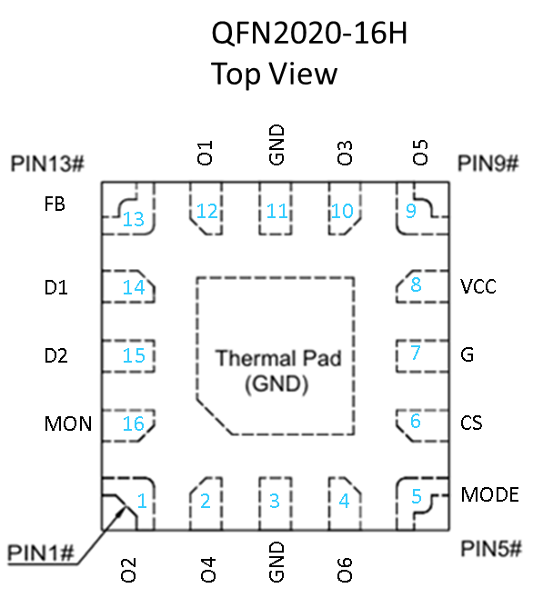

Pin description
Pin Name | Pin No. | I/O | Type | Description | If pins unused, the levels to be
O2 | 1 | Out | Current load | Current Sink 2 | GND ¹⁾
O4 | 2 | Out | Current load | Current Sink 4 | GND ¹⁾
GND | 3 | - | GND | Ground | -
O6 | 4 | Out | Current load | Current Sink 6 | GND ¹⁾
MODE | 5 | In | Digital input | Mode Control | -
CS | 6 | In | Digital input | Chip Select | -
G | 7 | In | Digital input | Gate enable | GND
VCC | 8 | - | Supply voltage | IC operation | +5V (Vcc)
O5 | 9 | Out | Current load | Current Sink 5 | GND ¹⁾
O3 | 10 | Out | Current load | Current Sink 3 | GND ¹⁾
GND | 11 | - | GND | Ground | GND
O1 | 12 | Out | Current load | Current Sink 1 | GND ¹⁾
FB | 13 | Out | Open drain | Headroom voltage low detection | GND
D1 | 14 | In | Analog input | Analog Dimming input 1 | GND
D2 | 15 | In | Analog input | Analog Dimming input 2 | GND
MON | 16 | Out | Open drain | Headroom voltage high detection | GND
TPAD | Bottom | - | Thermal Pad | Internally connected to GND | GND

Note: 1) Unused "Ox" (x=1,2,3,4,5,6) output pin connected to GND for reliable operation

Equivalent Circuits of Individual Pins
PAD Name | I/O | Internal Circuit | Description
VCC | - | 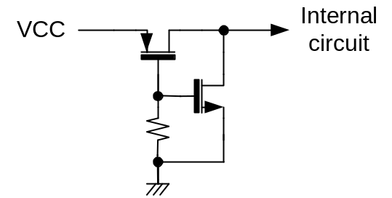 | Supply Voltage input
FB,  MON | O | 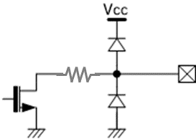 | Headroom voltage low detection
Ox | O | 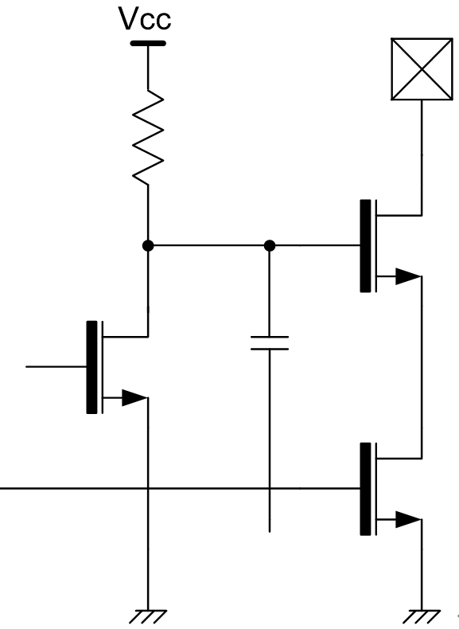 | Current sink drive output
CS,  G | I | 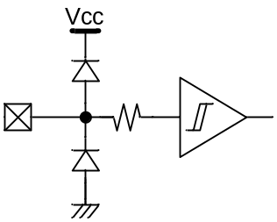 | Gate enable
D,  MODE | I | 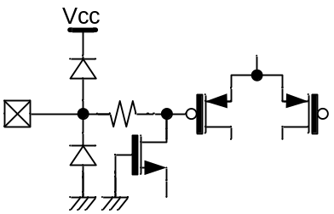 | Analog Dimming input
MON | O |  | Headroom voltage high detection

Maximum Absolute ratings (Ta=25°C unless otherwise specified)
Parameter | Symbol | Value | Unit
Supply voltage | V_{CC} | -0.3 ~ 7.0 | V
Maximum output pin voltage  ; Io_{(BR)} 1mA | V_{O} | 100 | V
MODE, D to GND voltage | V_{MODE}, V_{D} | -0.3 ~ Vcc+0.3 | V
CS, G to GND voltage | V_{CS}, V_{G} | -0.3 ~ Vcc+0.3 | V
FB to GND voltage | V_{FB} | -0.3 ~ Vcc+0.3 | V
MON to GND voltage | V_{MON} | -0.3 ~ Vcc+0.3 | V
FB to GND current | I_{FB} | 5 | mA
MON to GND current | I_{MON} | 5 | mA
Thermal Resistance (Junct. to Amb.) | R_{θJA} | 300 ²⁾ | ℃/W
Thermal Resistance (Junct. to Case) | R_{θJC} | 3 ²⁾ | ℃/W
Power Dissipation on package ²⁾ | P_{TOT} | 1 | W
Junction temperature | T_{J} | -20 ~ 150 | ℃
Storage temperature | T_{STG} | -45 ~ 150 | ℃
Relative Humidity(non-condensing) | RH_{NC} | 5 ~ 85 | %
Moisture Sensitivity | MSL | Maximum floor life time of 168h | 3
Stresses beyond those listed under Absolute Maximum Ratings may cause permanent damage to the device
Note: 2) Surface mounted on FR-4 substrate PC Board 1” x 1” inch 2-oz copper plate

Electrostatic Discharge
Parameter | Symbol | Value | Unit | Remark
Electrostatic Discharge HBM  ; Contact | ESDHBM | ±2k | V | C=100 pF, R=1.5 kΩ3015 Human Body Model
Electrostatic Discharge CDM  ; Contact | ESDCDM | ±500 | V | R=1 Ω  JESD22-A115C

Electrical Characteristics
VCC = 5.0V, Ta=25.0℃ Unless otherwise noted, x=1,2,3,4
Characteristics | Symbol | Condition | Value |  |  | Unit
Characteristics | Symbol | Condition | min | typ | max | Unit
Supply
Operating voltage | V_{CC} ³⁾ |  | 4.5 | - | 5.5 | V
Quiescent current | I_{Q_5V} | Dx=0V, Gx=0V  Vhd=0.7V, Vcc=5V | - | - | 300 | uA
Operating Current at MODE 4 | I_{CC4} | O1=O2=O3=O4=O5=O6=32mA | - | - | 7 | mA
Operating Current at MODE 3 | I_{CC3} | O1=O2=O3=O4=O5=O6=24mA | - | - | 5.3 | mA
Operating Current at MODE 2 | I_{CC2} | O1=O2=O3=O4=O5=O6=16mA | - | - | 3.7 | mA
Operating Current at MODE 1 | I_{CC1} | O1=O2=O3=O4=O5=O6=8mA | - | - | 2 | mA
Input
Data Input voltage | V_{D} ⁴⁾ | Dx: Analog input for dimming control | 0.23 | - | 4.5 | V
Data hold time | t_{DH} | 25ºC; Io=20mA   Io=19.5mA | 1 | - | - | Sec
Input current | I_{D}, I_{MODE}  I_{CS}, I_{G} | MODE, D=3.5V CS, G=5V | 0 | - | 1 | uA
Cs, G | V_{IL}  V_{IH} | Logic low level | - | - | 1.0 | V
Cs, G | V_{IL}  V_{IH} | Logic high level | 1.7 | - | - | V
Cs, G | V_{IHYS} | Vcc=5.0V | 20m | 0.6 | - | V
Gate enable Time | t_{G}⁵⁾ | 25ºC; D:(30mA) | 3 | - | - | uS
Output
Current load voltage | V_{O} | Headroom voltage for normal operation | 0.23 | - | 80 | V
Headroom voltage | V_{HD30} | I_{OX}=32mA | 450 | - | - | mV
Current load off current | I_{OFF1} | D=0V, Gx=0V, Vox=80V |  |  | 200 | nA
Output Current max. | I_{MODE4~1} | 40 mA, 32 mA, 24 mA, 16 mA | 16 |  | 40 | mA
Output Current Accuracy | Acc_{IO%} | 400uA @ MODE 4  100uA @ MODE 1 | 3% | - | +3%
Control
“FB active” threshold voltage | V_{FBA} | Logically ORed for 6-channels | 630 | 700 | 770 | mV
“FB release” threshold voltage | V_{FBR} | Logically ORed for 6-channels | 670 | 760 | 880 | mV
“FB” sensing hysteresis voltage | V_{FBH} | Logically ORed for 6-channels | 40 | 60 | 110 | mV
“FB release” by LOE | V_{LOE} | By LED Open Error | 140 | 200 | 250 | mV
FB sink voltage | V_{FBL} | I_{FB}= 2mA (Open Drain) | - | - | 0.2 | V
MON sink voltage | V_{MON} | I_{MON}=2mA (Open Drain) | - | - | 0.2 | V
FB detect delay | T_{FBD} | High - > Low | - | - | 1 | uS
FB low duration | T_{FBHLD} | Minimum low duration | 12 | - | - | uS
MON low output | T_{MONL} | Synchronized to Gate input high pulse width | - | - | - | uS
Protection and Detection
Automatic Thermal Regulation Range @T_{j} | T_{ATR} | Io@125℃  ~ Io/3@150℃ | 125 | - | ≈150 | ℃
Thermal shut down temperature @T_{j} | T_{OTP} | I_{O} off | - | 150 | - | ℃
Thermal shut down hysteresis @Tj | T_{HYS} | - | 24 | 30 | 36 | ℃
LED short detect voltage threshold | V_{LSD}⁶⁾ |  | 26 | 32 | 38 | V
LED short release voltage threshold | V_{LSR} |  | 23 | 28 | 34 | V

Note:
3) The operation at Vcc below 5V will limit a maximum LED current sinking.
4) The D input voltage above 3.5V may not guarantee a good linearity in current sinking.
5) Based on internal circuit simulation result.
6) LED short detection logic circuit will not cut off LED current sinking when it is detected.

ATR (Automatic Thermal Regulation) and OTP (Over Temperature Protection)
The junction temperature of the IC must not exceed the maximum limit. Overtemperature protection is activated at 150°C, causing the IC to stop regulating immediately. Overheat protection helps prevent catastrophic failure due to accidental device overheating. If the junction temperature drops below 150°C, the channel will still stop regulating the LED current. When the junction temperature drops below 125°C (typical hysteresis = 30°C), the IC resumes current driving.

Connection Diagram (Single LED block and pin recommendation for display matrix)

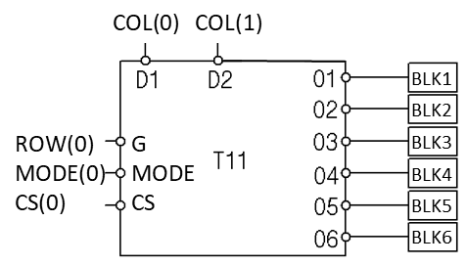

Output Current Control by “MODE” Signal Level

For each output port of the AQ06 IC, the gain of converting the D input voltage to the output current can vary depending on the voltage input level of the MODE pin.

Max. Drive Current Control Table
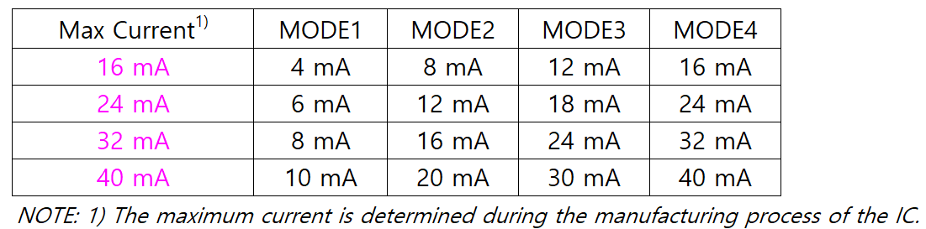

Application Block Diagram

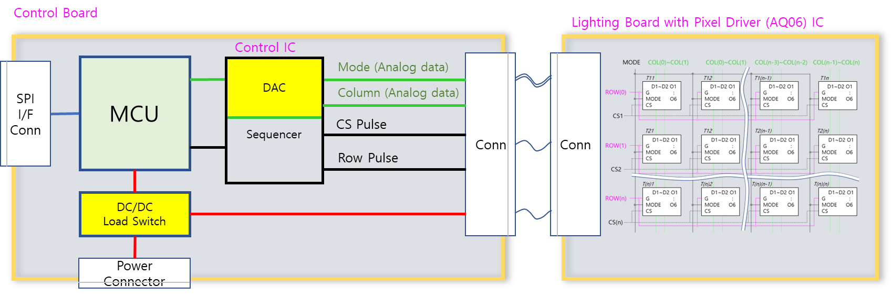
Control IC: GT's CQ24 goes well with the AQ06.

Interface Diagram

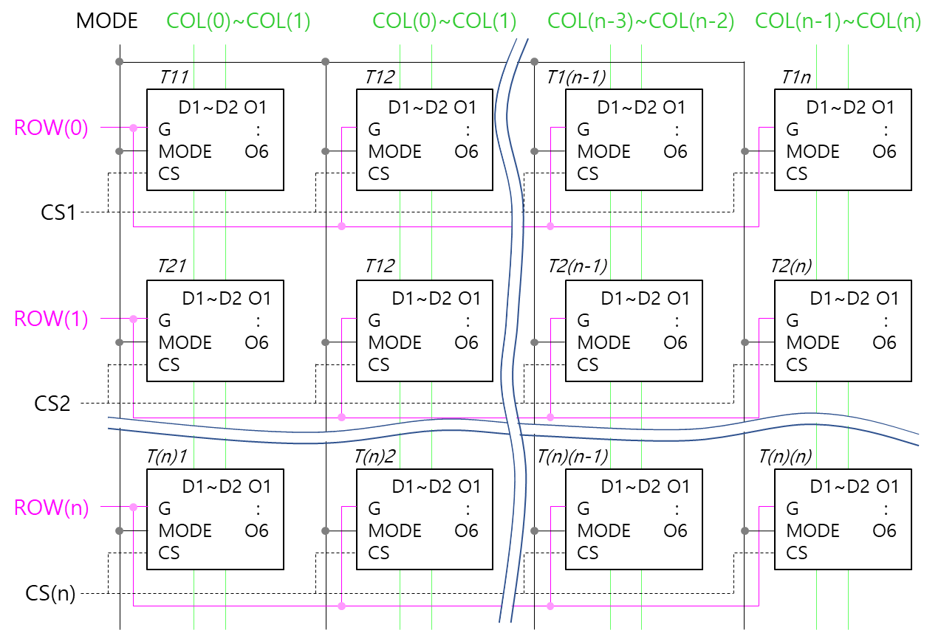

Physical Dimensions

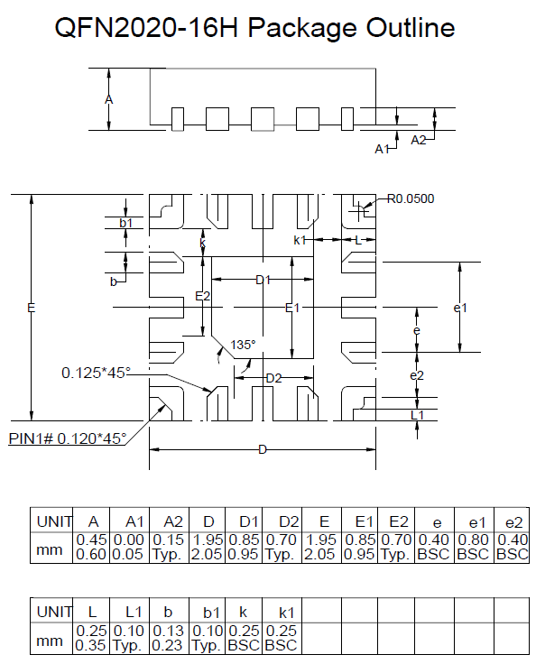

Suggested Footprint – QFN2020-16H

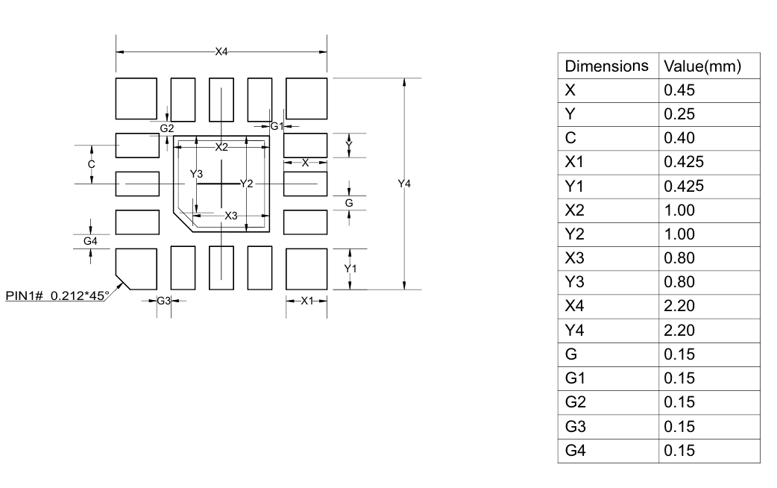

Note: The reflow peak soldering temperature is peak 260°C and it is specified based on IPC/JEDEC J-STD-020 “Moisture/Reflow Sensitivity Classification for Non-Hermetic Solid State Surface Mount Devices”

Global Technologies and are trademarks of Solution Korea Company or its subsidiaries in the Republic of Korea and/or other countries. The products of Global Technologies reserve the right to make changes without further notice to any products herein. Global Technologies makes no warranty, representation or guarantee regarding the suitability of its products for any particular purpose, nor does Global Technologies assume any liability arising out of the application or use of any product or circuit, and specifically disclaims any and all liability, including without limitation special, consequential or incidental damages. Global Technologies does not convey any license under its patent rights nor the rights of others.
Global Technologies and are trademarks of Solution Korea Company or its subsidiaries in the Republic of Korea and/or other countries. Global Technologies owns the rights to a number of patents, trademarks, copyrights, trade secrets, and other intellectual property. Global Technologies reserves the right to make changes without further notice to any products herein. Global Technologies makes no warranty, representation or guarantee regarding the suitability of its products for any particular purpose, nor does Global Technologies assume any liability arising out of the application or use of any product or circuit, and specifically disclaims any and all liability, including without limitation special, consequential or incidental damages. Buyer is responsible for its products and applications using Global Technologies products, including compliance with all laws, regulations and safety requirements or standards, regardless of any support or applications information provided by Global Technologies. “Typical” parameters which may be provided in Global Technologies data sheets and/or specifications can and do vary in different applications and actual performance may vary over time. All operating parameters, including “Typical” must be validated for each customer application by customer’s technical experts. Global Technologies does not convey any license under its patent rights nor the rights of others. Global Technologies products are not designed, intended, or authorized for use as a critical component in life support systems or any FDA Class 3 medical devices or medical devices with a same or similar classification in a foreign jurisdiction or any devices intended for implantation in the human body. Should Buyer purchase or use Global Technologies products for any such unintended or unauthorized application, Buyer shall indemnify and hold Global Technologies and its officers, employees, subsidiaries, affiliates, and distributors harmless against all claims, costs, damages, and expenses, and reasonable attorney fees arising out of, directly or indirectly, any claim of personal injury or death associated with such unintended or unauthorized use, even if such claim alleges that Global Technologies was negligent regarding the design or manufacture of the part. Global Technologies is an Equal Opportunity/Affirmative Action Employer. This literature is subject to all applicable copyright laws and is not for resale in any manner.

