Features  - ISO 26262 Compliant (Up to ASIL-B)  - AEC-Q100 Qualified for Automotive Applications  - Grade 1: 125°C Ambient Operating Temperature  - Support Flexible R/GB pad mapping for various LED pixel configuration  - Bi-directional 1-wire daisy chain (max 31 serial) connection with configurable data rate  - Support Interface CRC check function  - 12-channel output sink drivers with programmable max. current 64mA  - 12-bit global brightness control  - Configurable 12-bit PWM or 14-bit PWM  - Support internal OSC frequency spread function for EMI rejection  - Programmable output headroom voltage detection for VLED voltage optimization  - Configurable dimming directions, head shift lighting and tail shift lighting  - Sync controllability between daisied devices via command or wire  - Optimal IC pin configuration allows for single layer PCB  - Supply voltage 3.0 ~ 5.5V  - Maximum 24V output driver working (headroom) voltage  - Fault events support of driver function  - Shorted or Open LEDs  - Thermal Warning / Shutdown  - Overvoltage/Undervoltage Detection on All Supplies  - Digital Input/Output Control Signal Monitoring  - Built-in-Self-Test for Internal Fault Detection Comparators  - Compact QFN3030-24 pin package |  | Applications  - RGB Backlight for Automotive Display.  (Cluster, Center Information, Entertainment)  - RGB LED Backlight for TV and Monitor.  General Description  The ID601 is a 12-channel constant current sink RGB LED driver for display backlight systems.  While conventional RGB backlight systems require separate three channels for red, green, and blue LED pixels, the ID601 achieves multiplexed driving for full-color RGB backlight pixels with one or two channels.  This approach allows single-layer BLU implementation, significantly reducing PCB layers.  Each channel supports up to 64mA of output current and a maximum output voltage of 24V and can time-share up to three LEDs per channel.  This device can support max 14-bit PWM dimming resolution and a 12-bit DAC global brightness resolution.  To ensure stable, flicker-free RGB time-sequential operation, the device features optimized subframe timing control and precise current regulation to effectively suppress flickering caused by rapid color transitions.  Integrated self-protection features include LED open/short detection and overheating shutdown. is also included to optimize the VLED voltage feedback control function during LED operation, improving power efficiency.  The ID601 can be controlled with several commands through a IC603 controller or directly by a MCU. Multiple ID601 devices can be daisy-chained and controlled via a serial interface from a single IC603, enabling scalable, high-channel-count RGB LED backlight systems for large-area displays. The ID601 is ASIL-B compliant.  Ordering Information
  Product ID | Package | Body Size
  ID601 | QFN3030-24L | 3.0x3.0x0.55mm

ID601 (12-channel RGB LED Current Sink Driver IC)
Revision History

Date  (YYYY-MM-DD) | Ver. | Editor | Contents
2026/06/01 | 0.1 | Songhyeon Kim | Released with:  - Preliminary datasheet

Contents
1. Block Diagram 5
2. Pin Configuration 6
2.1. Pin Configuration 6
2.2. Pin Description 7
2.3. Equivalent Circuits of individual pins 8
3. General Product Characteristics 9
3.1. Absolute Maximum Rating 9
3.2. Recommended Operating Condition 9
3.3. Thermal Information 9
3.4. Electrical Characteristic 11
3.5. Power Sequence 13
4. Functional Description 14
4.1. Overview 14
4.2. PWM Dimming 14
4.2.1. TYPE-1 (RGB) 14
4.2.2. TYPE-2 (R/GB, 6CH) 15
4.3. Communication 17
4.3.1. Overview 17
4.3.2. 17
4.3.3. Message Frame Format 17
4.3.4. Message Fault Handling 19
4.3.5. Communication Watchdog 22
4.4. Fault Detection and Protection 23
4.4.1. Internal Power Source Monitoring 24
4.4.2. DAC Reference Voltage Monitoring 24
4.4.3. Vsync missing 25
4.4.4. Channel Control Mismatch 25
4.4.5. Channel Open / Short Detection 25
4.4.6. Over Temperature Detection 26
4.5. OSC Frequency Locked Loop 26
4.6. VHD (VLED Headroom Voltage) Feedback Function 27
4.7. Built-In Self Test (BIST) 27
5. REGISTER MAP 27
5.1.1. RESET / ID 27
5.1.2. LD CONTROL 28
5.1.3. LD SIZE 29
5.1.4. FPWM DIVIDER 29
5.1.5. CHANNEL ENABLE 30
5.1.6. FAULT CONTROL 30
5.1.7. FAULT LEVEL 31
5.1.8. FAULT STATUS0 32
5.1.9. FAULT STATUS1 32
5.1.10. FAULT STATUS2 33
5.1.11. FAULT STATUS3 33
5.1.12. MAX CURRENT LEVEL 34
5.1.13. MAX CURRENT VREF 34
5.1.14. CHx_LD_TYPE 34
5.1.15. DELAY CH 35
5.1.16. FAULT CONFIGURATION 35
5.1.17. BIST 36
5.1.18. SERIALIZER OUTPUT BAUDRATE 36
5.1.19. V_MASK 37
5.1.20. SV_MASK 37
5.1.21. RSTCNT 37
5.1.22. TIMEOUT 38
5.1.23. FLL CONTROL 38
5.1.24. WR_PROTECT 38
5.1.25. NF_CONTROL 39
5.1.26. CHOP_EN 39
5.1.27. OFS_TEMP_ETC 40
5.1.28. OSC FLL MANUAL 40
5.1.29. SPREAD 41
5.1.30. TEST MODE0 41
5.1.31. TEST MODE1 42
6. Application Information 43
7. PACKAGE OUTLINE DRAWING 44
8. Tape and Reel information 45
Block Diagram
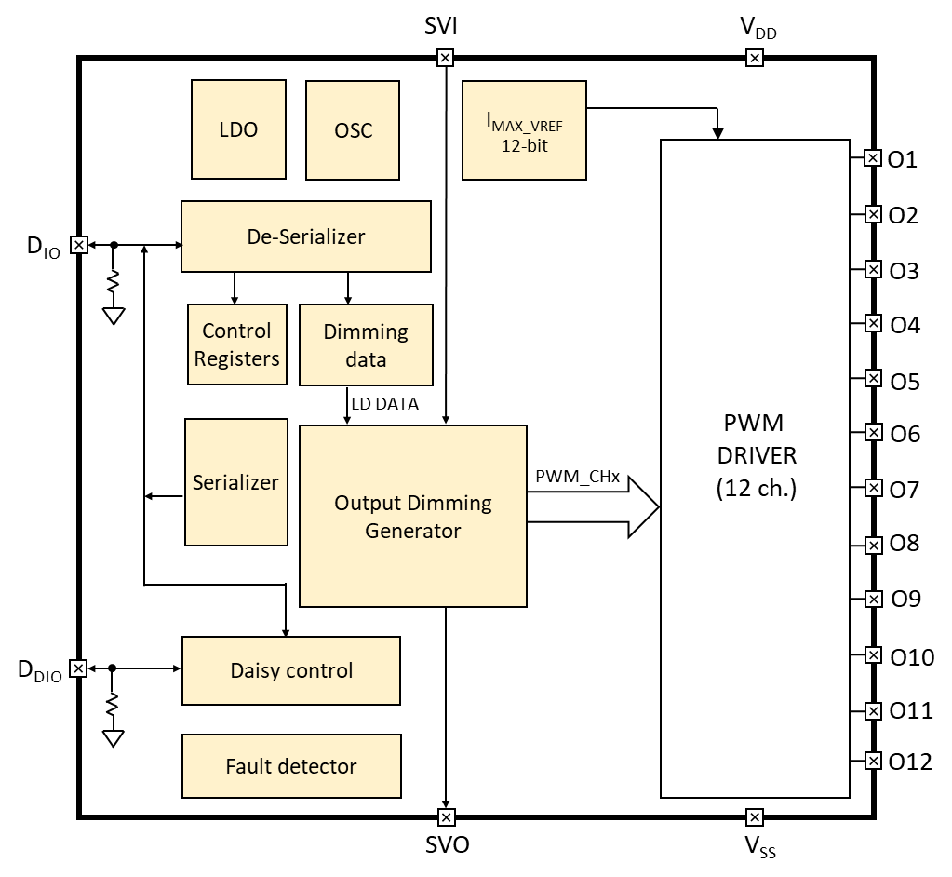
Figure 1. Functional Block diagram

Pin Configuration

Pin Configuration
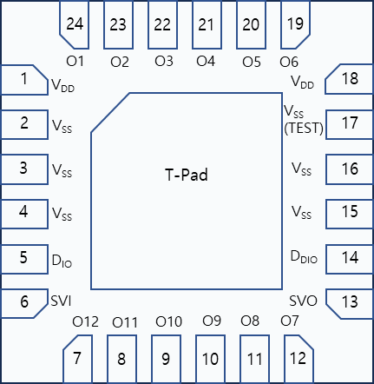
Figure 2. Top-View Pin Map

Pin Description
Pin No | Pin Name | I/O | Description
1 | V_{DD} | - | Supply voltage
2 | V_{SS} | - | Ground
3 | V_{SS} | - | Ground
4 | V_{SS} | - | Ground
5 | D_{IO} | I/O | Data In/Out. Internal PD, 48KΩ.
6 | SVI | I | External sync. Input. External svsync (+vsync).
7 | O12 | O | Current Sink 12. If unused, connect to GND.
8 | O11 | O | Current Sink 11. If unused, connect to GND.
9 | O10 | O | Current Sink 10. If unused, connect to GND.
10 | O9 | O | Current Sink 9. If unused, connect to GND.
11 | O8 | O | Current Sink 8. If unused, connect to GND.
12 | O7 | O | Current Sink 7. If unused, connect to GND.
13 | SVO | O | External sync. Output. External svsync (+vsync).
14 | D_{DIO} | I/O | Daisied Data In/Out. Internal PD, 48KΩ.
15 | V_{SS} | - | Ground
16 | V_{SS} | - | Ground
17 | V_{SS} | - | Ground
18 | V_{DD} | - | Supply voltage
19 | O6 | O | Current Sink 6. If unused, connect to GND.
20 | O5 | O | Current Sink 5. If unused, connect to GND.
21 | O4 | O | Current Sink 4. If unused, connect to GND.
22 | O3 | O | Current Sink 3. If unused, connect to GND.
23 | O2 | O | Current Sink 2. If unused, connect to GND.
24 | O1 | O | Current Sink 1. If unused, connect to GND.

Equivalent Circuits of individual pins
Pad Name | I/O | Internal Circuit | Description
D_{IO} | I/O | 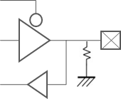 | Data In/Out
D_{DIO} | I/O |  | Daisied Data In/Out
O1 ~ O12 | Current  Sink | 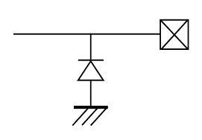 | Current Load
VDD | - | 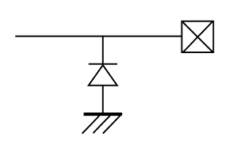 | Supply voltage
VSS | - | 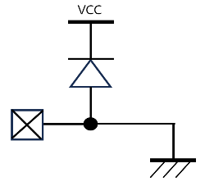  V_{DD} | GND
SVI | I |  | Schmit trigger
SVO | O |  | TTL output

General Product Characteristics

Absolute Maximum Rating
(Ta = 25℃ unless otherwise noted)
- 1) Surface mounted on FR-4 substrate PC Board 1” x 1” inch 2-oz copper plate, V_{HD} = 2.0V I_{OUT}= 64mA T_{A} = 55℃
- 2) Stresses beyond the Maximum Absolute ratings may cause permanent damage to the device
- 3) Exposure to absolute maximum rating conditions for extended periods may affect device reliability.
Parameter | Pin | MIN | MAX | UNIT
Supply voltage | V_{DD} | -0.3 | 6.0 | V
Sink output pin voltage | V_{O} | -0.3 | 24 | V
Sink output current | I_{O} | - | 64 | mA
D_{IO} to GND | V_{DIO} | -0.3 | VDD+0.3 | V
D_{DIO} to GND | V_{DDIO} | -0.3 | VDD+0.3 | V
SVI to GND | V_{SVI} | -0.3 | VDD+0.3 | V
SVO to GND | V_{SVO} | -0.3 | VDD+0.3 | V
Storage temperature, T_{stg} |  |  | 165 | °C
Reflow Temperature |  |  | 260 | °C
ESD | HBM⁽¹⁾ | ±2000 |  | V
ESD | CDM⁽²⁾ | ±500 |  | V
ESD | CDM⁽²⁾ (corner pins) | ±750 |  | V
Note:
- AEC Q100-002
- AEC Q100-011

Recommended Operating Condition
Symbol | Parameter | Min. | Max. | Unit
VDD | VDD supply voltage range | 4.5 | 5.5 | V
T_{A} | Operating ambient temperature | -40 | 125 | °C
T_{J} | Operating junction temperature | -40 | 150 | °C

Thermal Information
Symbol | Thermal Metric |  | Unit
R_{θJA} | Junction to Ambient thermal resistance | 68 ⁽¹⁾ | °C/W
R_{θJC(TOP)} | Junction to Case(Top) thermal resistance | 4.0 ⁽¹⁾ | °C/W
P_{TOT} | Power Dissipation on package | 1.0 ⁽¹⁾ | W
T_{A} | Ambient temperature | -40 ~ 125 | ℃
T_{J} | Junction temperature | -40 ~ 150 | ℃
T_{STG} | Storage temperature | -45 ~ 150 | ℃
RH_{NC} | Relative Humidity (non-condensing) | 5 ~ 85 | %
MSL | Moisture Sensitivity Level | 3⁽²⁾ | level
Note:
- Surface mounted on FR-4 substrate PC Board 1” x 1” inch 2-oz copper plate, V_{HD} = 2.0V I_{OUT}= 64mA T_{A} = 55℃
- Maximum Floor Life-time of 168 hr

Electrical Characteristic
(V_{DD} =3.3V, Ta=25.0℃ unless otherwise noted)

Characteristics | Symbol | Condition | Value |  |  | Unit
Characteristics | Symbol | Condition | min | typ | max | Unit
Supply voltage
Operating voltage | V_{DD}¹⁾ |  | 3.0 | - | 5.5 | V
Supply current
Quiescent Current | I_{s} | Standby state, No LED current | - | 2.00 | - | mA
Operating Current | I_{DD} | All output 100% Independent of duty sink | - | 3.00 | - | mA
Oscillator
Internal MCLK²⁾ | f_{OSC} |  | 40 | - | 60 | MHz
In/Out
D_{IO}, D_{DIO} | V_{IL}  V_{IH} | Input logic low level | - | - | 0.7 | V
D_{IO}, D_{DIO} | V_{IL}  V_{IH} | Input logic high level | 2.5 | - | V_{DD} | V
D_{IO}, D_{DIO} | V_{OL}  V_{OH} | Output logic low level @ 4mA | - | - | 0.5 | V
D_{IO}, D_{DIO} | V_{OL}  V_{OH} | Output logic high level @ 4mA | V_{DD}*0.8 | - | V_{DD} | V
D_{IO}, D_{DIO} | R_{PD} | Internal pull-down resistance | - | 22 | - | KΩ
Logic long time ³⁾ | T_{1H}, T_{0L} | as a receiver | 6 | - | 63 | MCLK
Logic short time ³⁾ | T_{1L}, T_{0H} | as a receiver | 3 | - | 32 | MCLK
Propagation delay | T_{D_DS} | Downstream (D_{IO} to D_{DIO}) | - | 9.0 | 14 | ns
Propagation output skew⁴⁾ | T_{DSKEW_DS} | D_{DDIO} T_{1H}=T_{1H}-T_{DSKEW_DS} @downstrm | - | 1.5 | 2.6 | ns
Propagation delay | T_{D_US} | Upstream (D_{DIO} to D_{IO}) | - | 9.5 | 14.5 | ns
Propagation output skew⁴⁾ | T_{DSKEW_US} | D_{DIO} T_{1H}=T_{1H}-T_{DSKEW_US} @upstream | - | 1.4 | 2.3 | ns

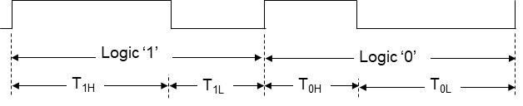

Note : 1) The operation below VDD, 3.3V will limit a maximum LED sinking current and affect a current variation.
2) Oscillator frequency tolerance can be controlled by FLL within 2%.
3) The conditions, ①T1H ≥ T0H* 2 ② T0L ≥ T1L* 2 ③ (T1H +T0H) = (T0L+T1L) < 90 are normally
recommended.
However, the value depends on the baud-rate of the IC603.

4) On downstreaming (or upstreaming), the T1H of DDDIO (or T1H of DDIO) is shorted as many as TDSKEW_DS (or TDSKEW_US), but the total of 1 bit cycle will remain the same.
So, the proper value for T1H and T0L must be carefully determined based on the daisy size.

Characteristics | Symbol | Condition | Value |  |  | Unit
Characteristics | Symbol | Condition | min | typ | max | Unit
Output
Driving voltage | V_{O} | Headroom voltage V_{HD} :  0.35V@ I_{O} 4mA, 0.40V@ I_{O} 8mA  0.44V@ I_{O} 12mA, 0.49V@ I_{O} 16mA  0.54V@ I_{O} 20mA, 0.59V@ I_{O} 24mA  0.64V@ I_{O} 28mA, 0.69V@ I_{O} 32mA  0.74V@ I_{O} 36mA, 0.79V@ I_{O} 40mA  0.85V@ I_{O} 44mA, 0.89V@ I_{O} 48mA  0.96V @ I_{O} 52mA, 1.00V @ I_{O} 56mA  1.10V@ I_{O} 60mA, 1.15V@ I_{O} 64mA | V_{HD} | - | 24 | V
Short detection voltage ⁴⁾ | V_{SD} | Short detection level V_{SD} :  3b’000=3.5V, 3b’001=6.5V  3b’010=9.5V, 3b’011=12.5V  3b’100=16.5V, 3b’101=16.5V  3b’110=16.5V, 3b’111=16.5V | - | V_{SD} | - | V
Short detection hysteresis voltage | V_{SDH} |  | - | 0.65 | - | V
Open detection voltage ⁴⁾ | V_{OD} |  | - | - | 0.35 | V
Open detection hysteresis voltage | V_{ODH} |  | - | 0.075 | - | V
Sink current | I_{O} | Device max current level : I_{O}  4’b0000 = 4mA, 4’b0001 = 8mA  4’b0010 = 12mA, 4’b0011 = 16mA  4’b0100 = 20mA, 4’b0101 = 24mA  4’b0110 = 28mA, 4’b0111 = 32mA  4’b1000 = 36mA, 4’b1001 = 40mA  4’b1010 = 44mA, 4’b1011 = 48mA  4’b1100 = 52mA, 4’b1101 = 56mA  4’b1110 = 60mA, 4’b1111 = 64mA | - | - | 64 | mA
Current accuracy ⁵⁾ | % | @ a trimmed point  (Room temperature at 25℃) | -1.5 | - | +1.5 | %
Current dynamic range | % |  | 5 |  | 95 | %
LED off current | I_{OFF} | Vo = 24V | - | - | 300 | nA
Feedback
FB threshold voltage  (Logically ORed for 12-ch) | V_{FBA} | FB level V_{FBA} :  3’b000 = 0.4V, 3’b001 = 0.5V  3’b010 = 0.6V, 3’b011 = 0.7V  3’b100 = 0.85V, 3’b101 = 1.0V  3’b110 = 1.15V, 3’b111 = 1.3V | - | V_{FBA} | - | V
FB hysteresis voltage | V_{FBH} |  | - | 60 | - | mV
Thermal protection
Thermal cut off @T_{J} | ^{T}CUT |  | 150 | - | - | ℃
Thermal cut off hysteresis @T_{J} | ^{T}HYS |  | - | 20 | - | ℃

Note : 4) If LED open or short event is happened, the corresponding channel will be turned-off under the function
enabled. If the thermal is happened, all channels output will be turned-off under the function enabled.
5) Under satisfying the power dissipation specification.
Characteristics | Symbol | Condition | Value |  |  | Unit
Characteristics | Symbol | Condition | min | typ | max | Unit
V_{DD} Ramp up
V_{DD} Ramp up time | T_{VDD} | from 0 to stable 3.3V | - | - | 2.0 | ms
Initialization after V_{DD}, 3.3V stable
Internal Initial time | T_{INIT} | from stable 3.3V | 100 | - | - | ms
Allowed 1st command | T_{FCMD} | after T_{INIT} is completed | 5 | - | - | ms
VSYNC daisy out @ SYNCMODE = 1
VSYNCO delay | T_{VSOD} | from VSYNCI to VSYNCO | - | 5.0 | 9.0 | ns

Power Sequence

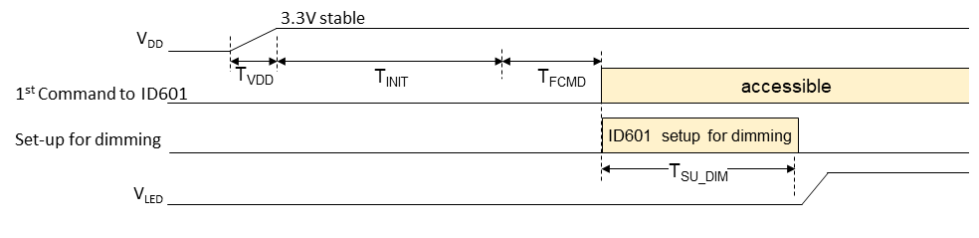
Figure 3. Power up sequence and Ramp-up time

Functional Description

Overview
작성 필요

PWM Dimming

TYPE-1 (RGB)
The ID601 supports three LEDs(red, green, blue) dimming. Type-1 allows for time-division drive of three LEDs(red, green, blue) per channel. The three LEDs can be configured for different RGB colors, and the IC603 sets the time-division drive times for each RGB LED within a frame and transmits them to the ID601 as SVI signals.
The ID601 can independently control the current of each RGB LED by driving VREF1/2/3 at separate SVI intervals. Meanwhile, the IC603 provides external VLED selection signals (GATE1/2/3) for time-division drive.

LD_TYPE | LED Type | No. ch. per pixel | No. pixel per IC | Full-time driving | Time sequential driving
1 | RGB or BGB | 1 | 12 | - | LED1/LED2/LED3
2 | R-GB | 2 | 6 | LED1 | LED2/LED3
3 | GB | 1 | 12 | - | LED3/LED3

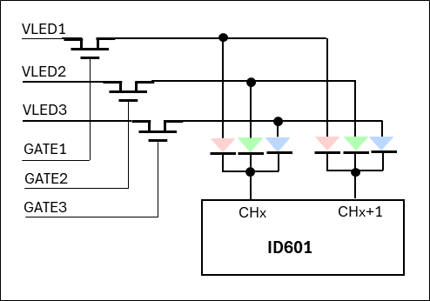
Figure 4. PWM Dimming sequence @ LD_DIR = 1, SYNCMODE = 0, TYPE-1

TYPE-2 (R/GB, 6CH)
The ID601 supports three LEDs(red, green, blue) dimming. In Type-2 mode, odd channels independently drive one LED(red), while even channels support brightness control by time-divisionally driving two LEDs(green, blue).
Brightness control for odd channels is implemented within a single frame, regardless of the SVI value, while brightness control for even channels is implemented within two SVI intervals for two LEDs within a single frame.
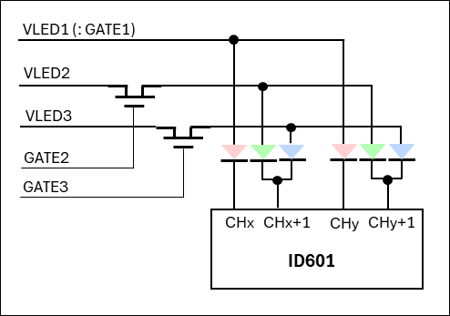
Figure 5. PWM Dimming sequence @ LD_DIR = 1, SYNC_MODE = 0, TYPE-2

As shown in Table 8, the ID601 enables flexible channel mapping between time-division channels and non-time-division channels.
In the TYPE-1 case, all channels output time-division PWM regardless of CHx_LD_TYPE.

CHx_LD_TYPE  (register) |  | 0 | 1 | 0 | 1 | 0 | 1 | 0 | 1 | 0 | 1 | 0 | 1
LD transmit sequence |  | 1 | 2 | 4 | 5 | 7 | 8 | 10 | 11 | 13 | 14 | 16 | 17
LD_SIZE(register)  = 18 |  |  | 3 |  | 6 |  | 9 |  | 12 |  | 15 |  | 18
CHx_LD_TYPE  (register |  | 0 | 1 | 1 | 0 | 1 | 0 | 0 | 1 | 0 | 1 | 1 | 0
LD transmit sequence |  | 1 | 2 | 4 | 6 | 7 | 9 | 10 | 11 | 13 | 14 | 16 | 18
LD_SIZE(register)  = 18 |  |  | 3 | 5 |  | 8 |  |  | 12 |  | 15 | 17
CHx_LD_TYPE  (register |  | 0 | 1 | 1 | 0 | 1 | 0 | 0 | 1 | 0 | 1 | x | x
LD transmit sequence |  | 1 | 2 | 4 | 6 | 7 | 9 | 10 | 11 | 13 | 14
LD_SIZE (register)  = 15 |  |  | 3 | 5 |  | 8 |  |  | 12 |  | 15
 |  |  |  |  |  |  |  |  |  |  | x means the CHx_EN=0

Communication

Overview
One wire serial 통신에 대한 설명, Daisy 통신 방식 등 설명 필요
Downstream: Consume-and-Bypass
Upstream: Pass-and-Append

Message Frame Format
가능한 명령별 Format 설명

Example of Communication Waveforms
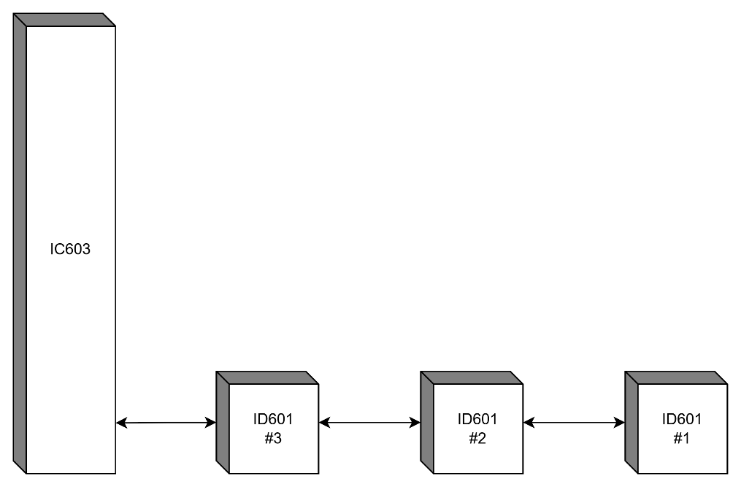

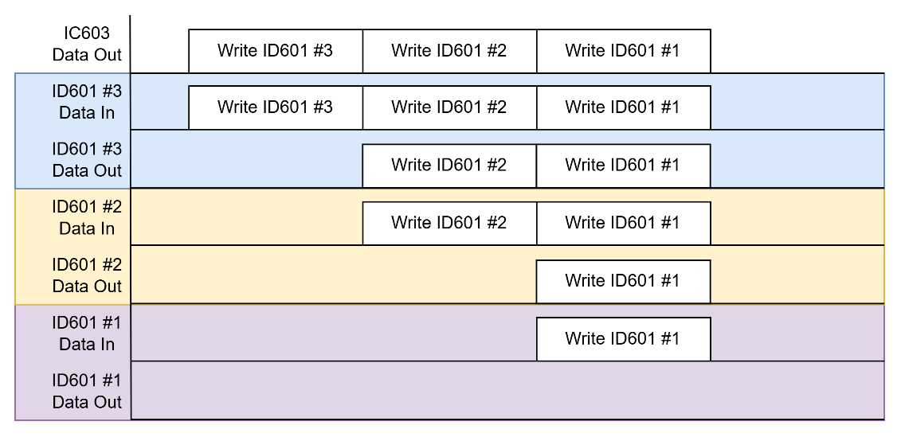
Write / Local Read / Fault Read에 대한 파형 첨부
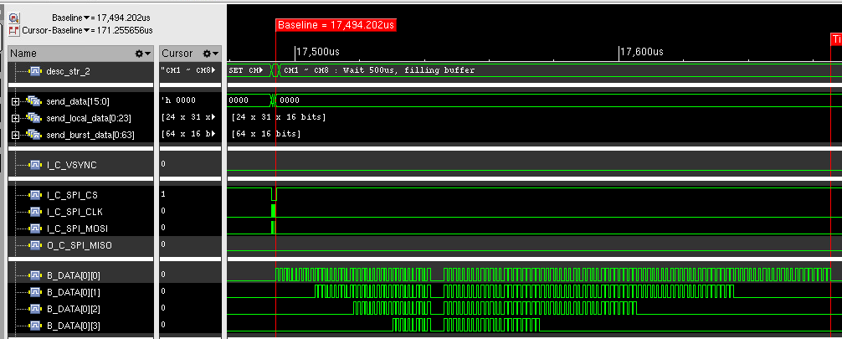

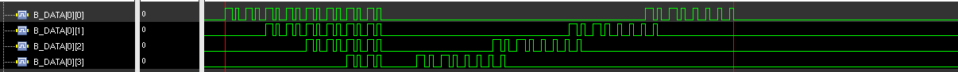

Message Fault Handling

Cyclic Redundancy Check (CRC)
ID601 supports CRC-based error detection for serial communication. When the CRC_EN configuration is enabled, a CRC field is appended to serial communication frames on a per-ID601 basis. On downstream transmission, the controller device generates and appends a CRC for each driver device's command data. On upstream reception, each ID601 generates and appends a CRC to its own response data, and the controller device verifies the CRC for each ID601. The CRC is calculated over the corresponding data portion of the frame, excluding the CRC field itself. The CRC algorithm used for serial communication is CRC-8/SAE J1850, defined by the polynomial:
CRC(x)=x8+x4+x3+x2+1

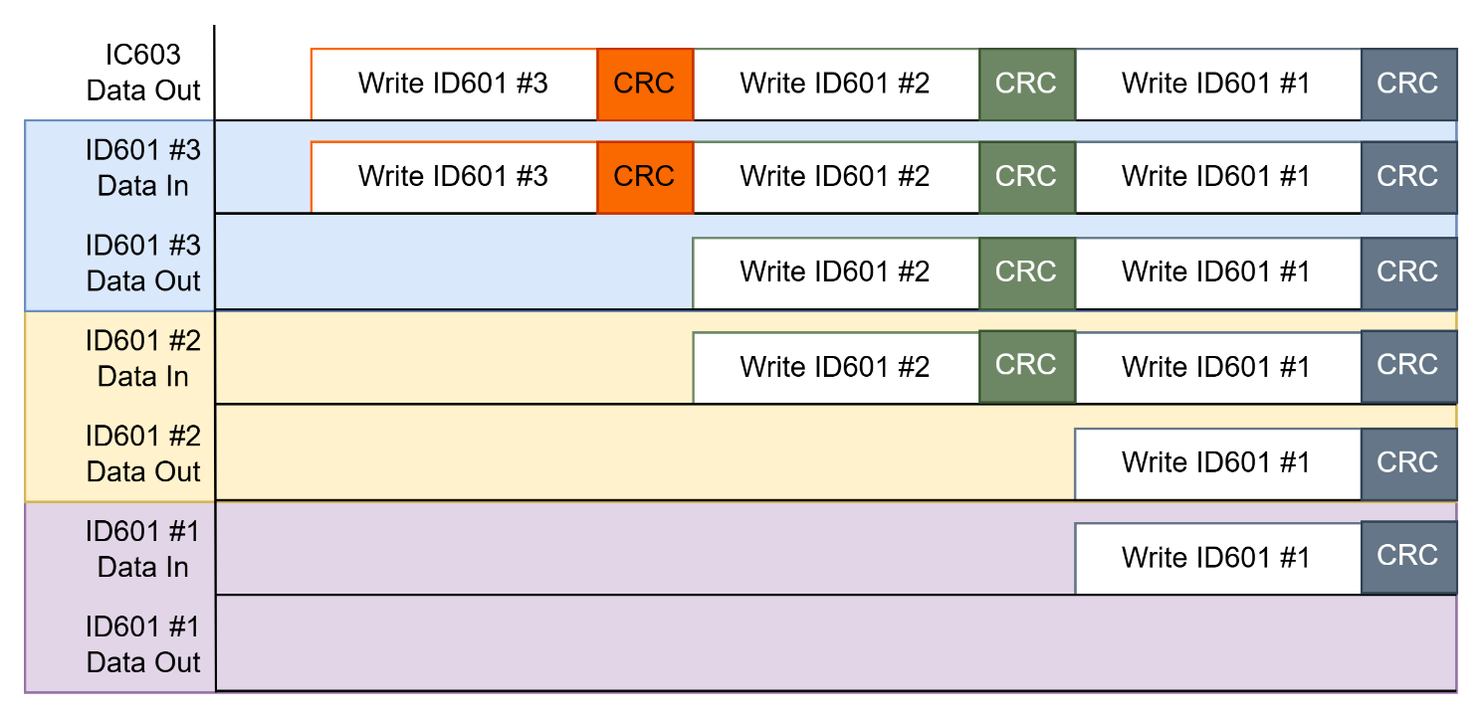
Figure 6 Serial communication protocol with CRC

Downstream operation
On a downstream transaction, the controller device constructs a command stream containing the command and corresponding CRC for each ID601 in the daisy chain. Each ID601 extracts the command and CRC intended for itself according to its position in the chain and bypasses the remaining bitstream to the next device. CRC verification is performed after the complete command bitstream has been received.

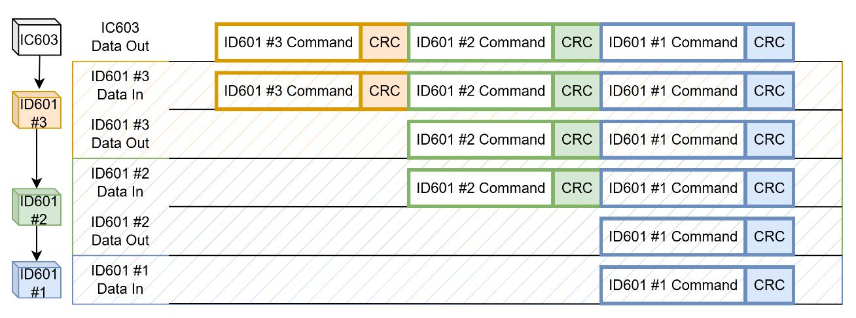

Upstream Operation (Local Read)
On a local read transaction, the last ID601 in the daisy chain (DEV_ID = 1) initiates the response by transmitting its response data followed by the corresponding CRC. Each preceding device forwards the received response stream and appends its own response data and CRC, resulting in a continuous response bitstream transmitted back to the controller device. During this process, each ID601 does not perform CRC verification on the forwarded response stream. The controller device receives the complete response stream and performs CRC verification independently for each ID601’s response.

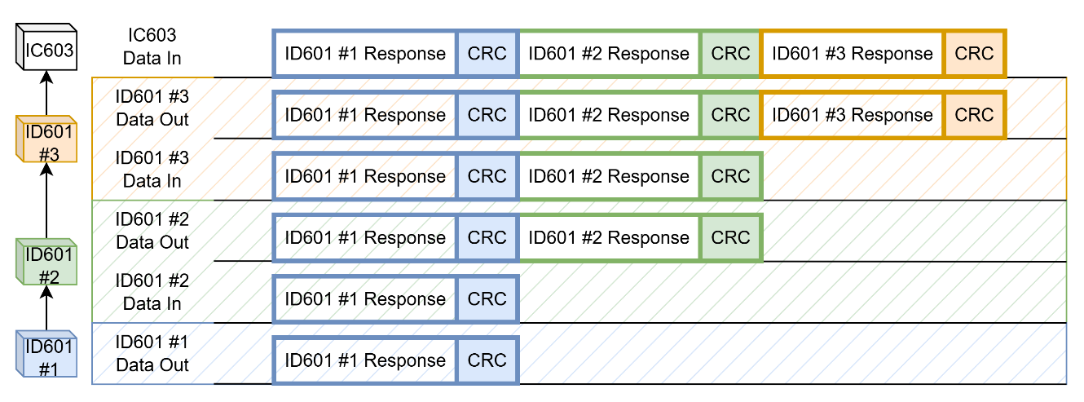

Upstream Operation (Fault Read/Fault Auto Read)
On a fault read transaction, the last ID601 in the daisy chain (DEV_ID = 1) initiates the response by transmitting its fault data followed by the corresponding CRC. Each preceding device receives the response from the downstream device, performs CRC verification, combines the received fault data with its own fault information using a logical OR operation, calculates a new CRC over the updated data, and forwards the modified response upstream. The controller device receives a single aggregated response from the first ID601 in the chain and performs CRC verification on the response.

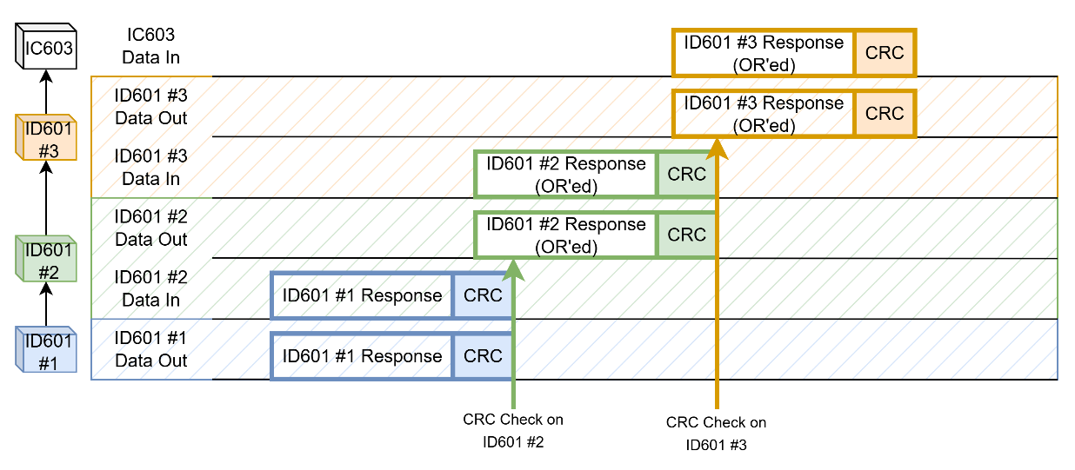

Communication Timeout
ID601 implements a timeout detection mechanism for serial communication during read operations.
After receiving a local read or fault (auto) read command, an internal counter starts running based on a clock divided from MCLK (MCLK/64).
When the counter value exceeds the threshold defined in the TIMEOUT register, the device sets the RESP_ERR flag in the FAULT STATUS1 register, while the CRC_EN configuration is enabled. After timeout expiration, the internal communication logic returns to the initial state, allowing a new command transaction.

Communication Errors
Command error
After receiving a command frame, ID601 checks the integrity and format of the received data. The device detects a command error condition in the following cases:
- Command CRC error when CRC_EN configuration is enabled
- Start bit and command code error
- Command protocol bit count error¹⁾
- Bit broken error when BBKN_EN configuration is enabled
- When the number of received data blocks in an LD command is less than the configured LD_SIZE

When a command error is detected, the CMD_ERR flag in the FAULT STATUS1 register is set, while CRC_EN configuration is enabled. A command error occurring during an LD data transfer command only sets the CMD_ERR flag and does not affect the ongoing LD transfer. For all other command types, when a command error is detected at the end of the transmission, ID601 ignores the corresponding command and does not execute it.
Note:
- the total number of received bits must be an integer multiple of the command frame length defined by the protocol. A bit count error is detected if this condition is not met.

Response error
During a read response operation, ID601 detects a response error in the following cases:
- Start bit and command code error in the first response frame
- Timeout

During a fault (auto) read operation, the device checks the integrity and format of the received data from the next daisied ID601. The device detects a response error in the following cases:
- CRC error
- Start bit and command code error
- Timeout

When a response error is detected, the RESP_ERR flag in the FAULT STATUS1 register is set, while CRC_EN configuration is enabled. If a response CRC error is detected during fault (auto) read, ID601 continues the response transmission but the read response is invalidated by overwriting the CRC field with 0x00.

Communication Watchdog
ID601 detects a watchdog timeout condition when no valid command frame is received within the configured timeout period, while the WD_EN configuration is enabled. The timeout period is defined by an internal counter, and its threshold is configured by the WD_TIMECFG setting.
Upon detection of this condition, the WD_TIMEOUT flag in the FAULT STATUS1 register is set. If the WD_DIMM_EN configuration is enabled, all enabled channel PWM outputs are forced to be HIGH. In this case, the MAX_CURR_VREF1/2/3 output is also fixed according to the VREF_FIX1/2/3 register setting. The output control action is released only when the WD_TIMEOUT flag is cleared.

Fault Detection and Protection

Fault | Detection  Configuration | Reaction  Configuration | Channel PWM Reaction | Related  Register Bit
LDO Overvoltage | LDO_OVUV_EN | - | - | LDO_OV
LDO Undervoltage | LDO_OVUV_EN | - | - | LDO_UV
OSC_LDO Overvoltage | OSC_LDO_OVUV_EN | - | - | OSC_LDO_OV
OSC_LDO Undervoltage | OSC_LDO_OVUV_EN | - | - | OSC_LDO_UV
VREF Overvoltage | VREF_OVUV_EN | VREF_OVUV_OFF_EN | OFF | VREF_OV
VREF Undervoltage | VREF_OVUV_EN | VREF_OVUV_OFF_EN | OFF | VREF_UV
VSYNC missing | VS_MISS_EN | VS_MISS_DIMM_EN | ON with 100% duty cycle | VS_MISS
Channel Control Mismatch | CH_CTRL_MISMATCH_EN | - | - | CH_CTRL_MISMATCH
Channel Open | O_DET_E | O_OFF_E | OFF | OPEN  OPEN_CHx
Channel Short | S_DET_E | S_OFF_E | OFF | SHORT  SHORT_CHx
Over Temperature | T_DET_E | T_OFF_E | OFF | THERMAL
Communication Watchdog Timeout | WD_EN | WD_DIMM_EN | ON with 100% duty cycle | WD_TIMEOUT
Table 1 Fault detection and reaction

Internal Power Source Monitoring
LDO Overvoltage
ID601 detects an LDO overvoltage condition when the OSC LDO comparator output remains HIGH for longer than 2,048 cycles of MCLK/2, while the LDO_OVUV_EN configuration is enabled. Upon detection of this condition, the LDO_OV flag in the FAULT STATUS1 register is set.

LDO undervoltage
ID601 detects an LDO undervoltage condition when the LDO undervoltage comparator output remains HIGH for longer than 2,048 cycles of MCLK/2, while the LDO_OVUV_EN configuration is enabled.
Upon detection of this condition, the LDO_UV flag in the FAULT STATUS1 register is set.

OSC_LDO Overvoltage
ID601 detects an OSC LDO overvoltage condition when the OSC LDO comparator output remains HIGH for longer than 2,048 cycles of MCLK/2, while the OSC_LDO_OVUV_EN configuration is enabled.
Upon detection of this condition, the OSC_LDO_OV flag in the FAULT STATUS1 register is set.

OSC_LDO Undervoltage
ID601 detects an OSC LDO undervoltage condition when the OSC LDO comparator output remains HIGH for longer than 2,048 cycles of MCLK/2, while the OSC_LDO_OVUV_EN configuration is enabled. Upon detection of this condition, the OSC_LDO_UV flag in the FAULT STATUS1 register is set. The OSC_LDO_UV flag is cleared by both fault (auto) read and register read operations.

DAC Reference Voltage Monitoring
VREF Overvoltage
ID601 detects a VREF overvoltage condition when the VREF overvoltage comparator output remains HIGH for longer than 2,048 cycles of MCLK/2, while the VREF_OVUV_EN configuration is enabled.
Upon detection of this condition, the VREF_OV flag in the FAULT STATUS1 register is set. If the VREF_OVUV_OFF_EN configuration is enabled, all channel PWM outputs are forced LOW during this condition. The forced PWM LOW state is released, when the fault condition is cleared.

VREF Undervoltage
ID601 detects a VREF undervoltage condition when the VREF undervoltage comparator output remains HIGH for longer than 2,048 cycles of MCLK/2, while the VREF_OVUV_EN configuration is enabled.
Upon detection of this condition, the VREF_UV flag in the FAULT STATUS1 register is set. If the VREF_OVUV_OFF_EN configuration is enabled, all channel PWM outputs are forced LOW during this condition. The forced PWM LOW state is released, when the fault condition is cleared.

Vsync missing
ID601 detects a VSYNC missing condition when no valid VSYNC or SVSYNC signal is received for 32,627 MCLK/64 time, while the VS_MISS_EN configuration is enabled. Upon detection of this condition, the VS_MISS flag in the FAULT STATUS1 register is set. If the VS_MISS_DIMM_EN configuration is enabled, all enabled channel PWM outputs are forced HIGH. In this case, the MAX_CURR_VREF1/2/3 output is also fixed according to the VREF_FIX1/2/3 register setting. The output control action is released when valid sync input is restored and VS_MISS flag is cleared.

Channel Control Mismatch
ID601 includes readback paths that internally route digital channel enable signals and PWM control outputs back into the logic for monitoring. The device detects a channel control mismatch condition when a difference between the channel outputs and the corresponding readback inputs persists for longer than 512 MCLK cycles, while the CH_CTRL_MISMATCH_EN configuration is enabled. Upon detection of this condition, the CH_CTRL_MISMATCH flag in the FAULT STATUS1 register is set. The condition is released when the mismatch between the output signals and the readback inputs is removed.

Channel Open / Short Detection
PWM Channel Open
ID601 detects an OPEN condition when the OPEN comparator input remains HIGH before the rising edge of the PWM output, while the O_DET_EN configuration is enabled. Upon detection of this condition, the OPEN flag in the FAULT STATUS0 register is set, and the corresponding bit in the per-channel OPEN_CHx register is also set. If the O_OFF_EN configuration is enabled, the affected channel PWM output is forced LOW. The forced PWM LOW state is released when the OPEN flag in the FAULT STATUS0 register is cleared.

PWM Channel Short
ID601 detects a SHORT condition when the SHORT comparator input is remains HIGH before the falling edge of the PWM output, while the S_DET_EN configuration is enabled. Upon detection of this condition, the SHORT flag in the FAULT STATUS0 register is set, and the corresponding bit in the per-channel SHORT_CHx register is also set. If the S_OFF_EN configuration is enabled, the affected channel PWM output is forced LOW. The forced PWM LOW state is released when the SHORT flag in the FAULT STATUS0 register is cleared.
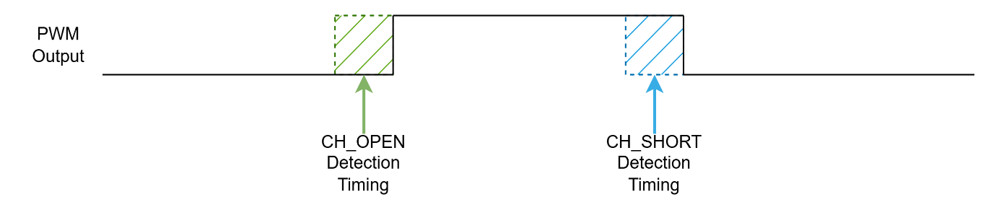

Over Temperature Detection
ID601 detects an over temperature condition when the THERMAL comparator input remains HIGH, while the T_DET_EN configuration is enabled. Upon detection of this condition, the THERMAL flag in the FAULT STATUS0 register is set. If the T_OFF_E configuration is enabled, all channel PWM outputs are forced LOW. The forced PWM LOW state is released, when the fault condition is cleared.

OSC Frequency Locked Loop
The FLL continues to calibrate the MCLK frequency to exactly match the PWM frequency with the time of one frame.

FLL 관련 레지스터와 동작 Scheme 설명 / 사용법 등의 정보 포함 필요

Transition a frame frequency without a flicker.
Figure . PWM 12-bit

Figure . PWM 14-bit

VHD (VLED Headroom Voltage) Feedback Function
This is a function that allows monitoring of each major fault.

Built-In Self Test (BIST)
ID601 includes a Built-In Self Test (BIST) controller to verify the operational integrity of the analog
comparator circuits associated with fault detection. The BIST is triggered by the system through a register write. The BIST verifies comparator functionality by applying internal stimulus to the comparator inputs and observing their responses. ID601 alternates the comparator input conditions and samples the outputs. The sampled results before and after each stimulus change are compared. If any comparator output does not toggle as expected, ID601 determines the BIST result as a failure. Otherwise, the test is considered successful.

REGISTER MAP
설명

전체 레지스터맵 추가 필요

RESET / ID

Acc | Addr |  | Default |  | B11 |  | B10 | B9 | B8 | B7 | B6 | B5 | B4 | B3 | B2 | B1 | B0
R/W | 0x00 |  | 0x100 |  | RST |  | VS_RST | E_RST | LKG_E | x | x | x | ID [4:0]
Bits |  | Fields |  |  |  | Descriptions
11 |  | RST |  | 0  1 |  | NOP  All internal logics are initialized to a default state and this bit will be auto-cleared after internal initialization.
10 |  | VS_RST |  | 0  1 |  | NOP  If this bit is set, then the serializer and de-serializer of ID601 will be initialized to a default state at every vsync. This bit set does not affect all internal registers and buffers. This bit can’t be set at the same time as the E_RST bit.
9 |  | E_RST |  | 0  1 |  | NOP  If this bit is set, then the serializer and de-serializer of ID601 will be initialized to a default state at the last third pwm clock. This function starts from the first vsync input. So, it is careful that the ID601 access at the back of the frame should be avoided for proper operation. This bit set does not affect all internal registers and buffers. This bit can’t be set at the same time as the VS_RST bit.
8 |  | LKG_E |  | 0  1 |  | NOP  Enable leakage current mode for driver protection to prevent the VLED voltage from being directly applied to the driver output node
4:0 |  | ID |  |  |  | These bits are read only. If the ID601 will receive the ID-Gen command from the IC603 controller, then the ID value is automatically generated. The ID value is needed for proper reading, so, the ID-Gen command must be firstly executed by the IC603 controller before executing any commands. If all ID601 drivers daisied will receive the ID-Gen command, the last-located device will have the first number of ID, and the first located device will have the last number of ID, that is, the number of daisied devices. The ID value can not be written by a Host.

LD CONTROL

Acc |  | Addr |  | Default | B11 | B10 |  | B9 | B8 | B7 | B6 | B5 | B4 | B3 | B2 | B1 | B0
R/W |  | 0x01 |  | 0x000 | SV_NO [5:0] |  |  |  |  |  |  | LD_TYPE | DELAY_CH_EN | SYNCMODE | PWM_RES | LD_DIR | LD_MODE
 | Bits |  | Fields |  |  |  | Descriptions
 |  |  |  |  |  |  | This register determines the dimming sequence. Even if the LD_MODE and LD_DIR value will be changed in the middle of the current frame, the value will affect the dimming sequence from the next frame after completing the current frame process.
 | 11:6 |  | SV_NO |  |  |  | This bit determines sub-frame NO. in 1-frame.  4 : #4 sub-frames  8 : #8 sub-frames  16 : #16 sub-frames  32 : #32 sub-frames  Other register values ​​are unused.
 | 5 |  | LD_TYPE |  |  |  | These bits determine the RGB PWM Dimming (LED1/2/3 PWM Dimming)  0 TYPE-2/3  1 TYPE-1
 | 4 |  | DELAY_CH_EN |  |  |  | This bit determine the Ch. Delay value for LD_MODE  0 Ch. delay value in normal mode  1 Ratio of Ch. delay value in normal mode  (Normal mode SVSYNC = 16, 1/2 of the set Ch. delay value)
 | 3 |  | SYNCMODE |  |  |  | This value determines VSYNC input.  0 command  1 SVI
 | 2 |  | PWM_RES |  |  |  | This bit determines the PWM resolution.  0 12-bit PWM resolution (max steps 4,095)  1 14-bit PWM resolution (max steps 16,383)
 | 1 |  | LD_DIR |  |  |  | This bit determines the direction of modulated edge with increasing on time from a vsync.  0 Head Shift Lighting  1 Tail Shift Lighting
 | 0 |  | LD_MODE |  |  |  | This bit determines the x8 mode.  0 Normal mode  1 x8 mode.

LD SIZE

Acc |  | Addr |  | Default | B11 |  | B10 | B9 | B8 | B7 | B6 | B5 | B4 | B3 | B2 | B1 | B0
R/W |  | 0x02 |  | 0x000 | x |  | x | x | x | x | x | LD_SIZE [5:0]
 | Bits |  | Fields |  |  | Descriptions
 | 5:0 |  | LD_SIZE |  |  | This value determines how many LD data will be transmitted for one time. This value is not needed to match with the number of enabled channels in the CHANNEL ENABLE register. It keeps in mind that the LD data to be transmitted will be mapped sequentially from channel 1 to channel n regardless of the corresponded CHx_EN bit activation.

FPWM DIVIDER

Acc | Addr | Default | B11 | B10 | B9 | B8 | B7 | B6 | B5 | B4 | B3 | B2 | B1 | B0
R/W | 0x03 | 0x000 | FPWM_DIV2 [3:0] |  |  |  | FPWM_DIV1 [7:0]
R/W | 0x04 | 0x000 | FPWM_DIV3 [7:0] |  |  |  | FPWM_DIV2[7:4]

Bits | Fields | Descriptions
11:0  11:0 | FPWM_DIV1/2/3 | These registers determine the PWM reference clock. The PWM reference clock can be created by dividing the MCLK frequency by the setting value + 1. Even if the setting value will be changed in the middle of the frame, the value will be applied immediately from the next vsync assertion. Refer to the Tabel 6. for other relevant sets.  FPWM_DIV1[7:0] : PWM reference clock for RED LED ( LED1 )  FPWM_DIV2[7:0] : PWM reference clock for GREEN LED ( LED2 )  FPWM_DIV3[7:0] : PWM reference clock for BLUE LED ( LED3 )

CHANNEL ENABLE

Acc | Addr | Default | B11 | B10 | B9 | B8 | B7 | B6 | B5 | B4 | B3 | B2 | B1 | B0
R/W | 0x05 | 0x000 | CH12_EN | CH11_EN | CH10_EN | CH9_EN | CH8_EN | CH7_EN | CH6_EN | CH5_EN | CH4_EN | CH3_EN | CH2_EN | CH1_EN

Bits | Fields | Descriptions
11:0 | CHx_EN | These bits should be set if the corresponding channels are to be used. The number of enabled channels in these registers does not need to match the LD_SIZE value. It is careful that the number of enabled channels should be the same as the LD_SIZE value, but the number can be smaller than the LD_SIZE value like the special mapping below.  the number of  enabled channels = 5  the amount of LD data to be transmitted for one time  LD_SIZE = 7  wherein, the LD data of the disabled channels, CH2 and CH5, can be any value

FAULT CONTROL

Acc |  | Addr |  | Default | B11 | B10 |  | B9 | B8 | B7 | B6 | B5 | B4 | B3 | B2 | B1 | B0
R/W |  | 0x06 |  | 0x000 | x | FT_MODE[1:0] |  |  | FB_MODE[1:0] |  | O_FB_E | T_DET_E | S_DET_E | O_DET_E | T_OFF_E | S_OFF_E | O_OFF_E
 | Bits |  | Fields |  |  |  | Descriptions
 | 10:9 |  | FT_MODE |  |  |  | This bit determines for various faults ( open, short, fb, thermal etc )  00 FAULT = ERR || short_all || open_all  01 FAULT = open_all  10 FAULT = short_all  11 FAULT = ERR  *ERR = THERMAL | LDO_OV | LDO_UV | VREF_OV | VREF_UV | OSC_LDO_OV |  OSC_LDO_UV | RESP_ERR | CMD_ERR | VS_MISS | WD_TIMEOUT |  CH_CTRL_MISMATCH
 | 8:7 |  | FB_MODE |  |  |  | This bit  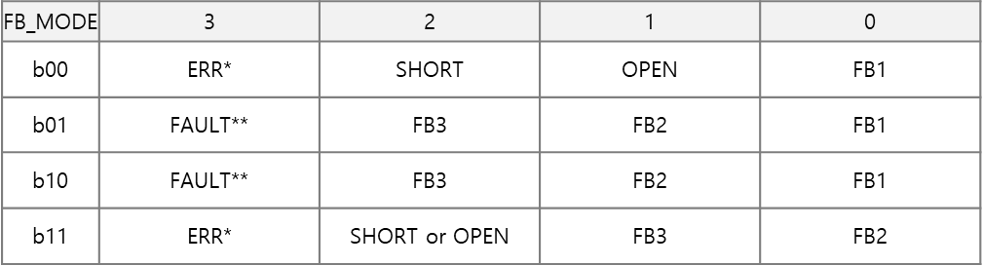
 | 6 |  | O_FB_E |  |  |  | This bit enables to detect the FB Open event.
 | 5 |  | T_DET_E |  |  |  | This bit enables to detect the THERMAL event.
 | 4 |  | S_DET_E |  |  |  | This bit setting enables to detect the SHORT event, and the event can be detected in only case the corresponding channel’s PWM output is ON status and its channel’s headroom is above the set value in the SHORT_LEVEL register.
 | 3 |  | O_DET_E |  |  |  | Setting this bit will allow the OPEN event to be detected at the point where the PWM on that channel transitions from On to Off. This event will only be detected when the headroom for that channel is less than 0.25V.
 | 2 |  | T_OFF_E |  |  |  | This bit setting makes all channels’ output be off in case the THERMAL event happens, and all channels will be activated again after the THERMAL event is cleared.
 | 1 |  | S_OFF_E |  |  |  | This bit setting makes the SHORTed channel’s output be off in case the SHORT event happens.
 | 0 |  | O_OFF_E |  |  |  | This bit setting makes the OPENed channel’s output be off in case the OPEN event happens.

FAULT LEVEL

Acc |  | Addr |  | Default | B11 | B10 |  | B9 | B8 | B7 | B6 | B5 | B4 | B3 | B2 | B1 | B0
R/W |  | 0x07 |  | 0x000 | x | x |  | x | FB3_LEVEL [2:0] |  |  | FB2_LEVEL [2:0] |  |  | FB1_LEVEL [2:0]
R/W |  | 0x08 |  | 0x000 | x | x |  | x | SHORT3_LEVEL [2:0] |  |  | SHORT2_LEVEL [2:0] |  |  | SHORT1_LEVEL [2:0]
 | Bits |  | Fields |  |  |  | Descriptions
 | 8:0 |  | FB1/2/3_LEVEL |  |  |  | The FB_LEVEL determines the level at which a FB event occurs.  3b’000 : < 0.45V 3b’001 : < 0.55V 3b’010 : < 0.65V 3b’011 : < 0.75V  3’b100 : < 0.90V 3’b101 : < 1.05V 3’b110 : < 1.20V 3b’111 : < 1.35V  FB1_LEVEL : FB LEVEL for LED1  FB2_LEVEL : FB LEVEL for LED2  FB3_LEVEL : FB_LEVEL for LED3
 | 8:0 |  | SHORT1/2/3_LEVEL |  |  |  | The SHORT_LEVEL determines the level at which a SHORT event occurs.  3b’000 : > 3.5V 3b’001 : > 4.5V 3b’010 : > 6.5V 3b’011 : > 9.0V  3b’100 : > 13.5V 3b’101 : > 17.5V 3b’110 : > 26.0V 3b’111 : > 32.0V  SHORT1_LEVEL : SHORT LEVEL for LED1  SHORT2_LEVEL : SHORT LEVEL for LED2  SHORT3_LEVEL : SHORT_LEVEL for LED3

FAULT STATUS0

Acc |  | Addr |  | Default | B11 |  | B10 | B9 | B8 | B7 | B6 | B5 | B4 | B3 | B2 | B1 | B0
RO |  | 0x09 |  | 0x000 | x |  | x | x | x | x | x | x | SHORT | OPEN | FB3 | FB2 | FB1
 | Bits |  | Fields |  |  | Descriptions
 | 4 |  | SHORT |  |  | The SHORT bit indicates whether the SHORT event happens. The event can be detected in case some channel’s headroom goes above the set value in the SHORT_LEVEL of FAULT LEVEL register and its channel’s PWM out is ON status. If the S_OFF_E bit of the FAULT CONTROL register is set, the output of the channels in which the event occurs is turned off. This bit is auto-cleared after readout but set again as long as the event is not cleared.
 | 3 |  | OPEN |  |  | The OPEN bit indicates whether the OPEN event happens. The event can be detected in case some channel’s headroom goes below 0.25V and its channel’s PWM out is OFF status. If the O_OFF_E bit of the FAULT CONTROL register is set, the output of the channels in which the event occurs is turned off. This bit is auto-cleared after readout but set again as long as the event is not cleared.
 | 2:0 |  | FB1/2/3 |  |  | The FB bit indicates whether the output channels’ headroom voltage is below the value set by FB_LEVEL of the FAULT LEVEL register due to insufficient VLED. This bit is set whenever the FB event occurs in even one of the activated channels and will be auto-cleared after readout this register. This bit will be set again after readout as long as the FB condition is still valid.  If the O_FB_E of FAULT CONTROL register is set, the FB event will happen in case the OPEN event is not asserted.  FB1 : FB signal for LED1  FB2 : FB signal for LED2  FB3 : FB signal for LED3

FAULT STATUS1

Acc |  | Addr |  | Default | B11 | B10 |  |  | B9 | B8 | B7 | B6 | B5 | B4 | B3 | B2 | B1 | B0
RO |  | 0x0A |  | 0x000 | RESP_ERR | CMD_ERR |  |  | WD_TIMEOUT | VS_MISS | CH_CTRL_MISMATCH | VREF_OV | VREF_UV | OSC_LDO_OV | OSC_LDO_UV | LDO_OV | LDO_UV | THERMAL
 | Bits |  | Fields |  |  |  |  | Descriptions
 | 11 |  | RESP_ERR |  |  |  |  | This bit shows whether a timeout during read/fault response or CRC check failure during fault response have been occurred when CRC_EN configuration is enabled. This bit is cleared by a read operation and not cleared by fault (auto) read operation.
 | 10 |  | CMD_ERR |  |  |  | This bit shows whether a CRC error or invalid bit error in the command frame event have been occurred when CRC_EN configuration is enabled. This bit is cleared by a read operation and not cleared by fault (auto) read operation.
 | 9 |  | WD_TIMEOUT |  |  |  | Flag for TIMEOUT. This bit shows whether a watchdog timeout event has been occurred. This bit is cleared by a read operation and not cleared by fault (auto) read operation.
 | 8 |  | VS_MISS |  |  |  | Flag for Vsync missing
 | 7 |  | CH_CTRL_MISMATCH |  |  |  | Flag for CH_CTRL_MISMATCH. This bit shows whether a logic mismatch in channel control output event has been occurred. This bit is cleared by a read operation.
 | 6 |  | VREF_OV |  |  |  | Flag for VREF Over-Voltage. This bit shows whether a VREF OV event has been occurred. This bit is cleared by a read operation.
 | 5 |  | VREF_UV |  |  |  | Flag for VREF Under-Voltage. This bit shows whether a VREF UV event has been occurred. This bit is cleared by a read operation.
 | 4 |  | OSC_LDO_OV |  |  |  | This bit shows whether a OSC_LDO_OV event has been occurred. This bit is cleared by a read operation.
 | 3 |  | OSC_LDO_UV |  |  |  | This bit shows whether a OSC_LDO_UV event has been occurred. This bit is cleared by a read operation.
 | 2 |  | LDO_OV |  |  |  | Flag for LDO Over-Voltage
 | 1 |  | LDO_UV |  |  |  | Flag for LDO Under-Voltage
 | 0 |  | THERMAL |  |  |  | The THERMAL bit indicates whether the THERMAL event due to overheating happens, and this bit will keep asserted as long as the THERMAL event is not cleared. The event threshold can be set by the OFS_TEMP in the TEMP register. If the T_OFF_E bit of the FAULT CONTROL register is set, all output sink drivers will be turned-off as long as the event is asserted, and turned-on again after internal temperature goes down below the set level of the OFS_TEMP. This bit involves other fault events in the readout information, MISS_VS, OV15 and 15 at the FAULT_(AUTO)_READ transaction.

FAULT STATUS2

Acc | Addr | Default | B11 | B10 | B9 | B8 | B7 | B6 | B5 | B4 | B3 | B2 | B1 | B0
RO | 0x0B | 0x000 | OPEN_CH12 | OPEN_CH11 | OPEN_CH10 | OPEN_CH9 | OPEN_CH8 | OPEN_CH7 | OPEN_CH6 | OPEN_CH5 | OPEN_CH4 | OPEN_CH3 | OPEN_CH2 | OPEN_CH1

Bits | Fields | Descriptions
11:0 | OPEN_CHx | This bit indicates whether the OPEN event each Ch.

FAULT STATUS3

Acc | Addr | Default | B11 | B10 | B9 | B8 | B7 | B6 | B5 | B4 | B3 | B2 | B1 | B0
RO | 0x0B | 0x000 | SHORT_  CH12 | SHORT_  CH11 | SHORT_  CH10 | SHORT_CH9 | SHORT_CH8 | SHORT_CH7 | SHORT_CH6 | SHORT_CH5 | SHORT_CH4 | SHORT_CH3 | SHORT_CH2 | SHORT_CH1

Bits | Fields | Descriptions
11:0 | SHORT_CHx | This bit indicates whether the SHORT event each Ch.

MAX CURRENT LEVEL

Acc | Addr | Default | B11 | B10 | B9 | B8 | B7 | B6 | B5 | B4 | B3 | B2 | B1 | B0
R/W | 0x0D | 0x000 | MAX_CURR_LEVEL3 [3:0] |  |  |  | MAX_CURR_LEVEL2 [3:0] |  |  |  | MAX_CURR_LEVEL1 [3:0]

Bits | Fields | Descriptions
11:0 | MAX_CURR_  LEVEL3/2/1 | The MAX_CURR_LEVEL determines the physical maximum current level of the device. The max dimming sink-current set by the MAX_CURR_VREF can not be beyond the MAX_CURR_LEVEL.

MAX CURRENT VREF

Acc | Addr | Default | B11 | B10 | B9 | B8 | B7 | B6 | B5 | B4 | B3 | B2 | B1 | B0
R/W | 0x0E | 0x000 | MAX_CURR_VREF1[11:0]
R/W | 0x0F | 0x000 | MAX_CURR_VREF2[11:0]
R/W | 0x10 | 0x000 | MAX_CURR_VREF3[11:0]

Bits | Fields | Descriptions
11:0 | MAX_CURR_VREF1/2/3 | The MAX_CURR_VREF1/2/3 determines the maximum current value of a frame to be dimmed. If the max current level is set to 8mA, then the MAX_CURR_VREF value is proportional to the max current level, and so this value decides the max current reference of all blocks being dimmed for a frame. The setting value will come into effect at the next vsync assertion even if the value is set during current dimming frame earlier than the next vsync.  MAX_CURR_VREF1 : MAX_CURR_VREF for LED1  MAX_CURR_VREF2 : MAX_CURR_VREF for LED2  MAX_CURR_VREF3 : MAX_CURR_VREF for LED3

CHx_LD_TYPE

Acc |  | Addr |  | Default | B11 |  | B10 | B9 | B8 | B7 | B6 | B5 | B4 | B3 | B2 | B1 | B0
R/W |  | 0x11 |  | 0x000 | CH12_LD  _TYPE |  | CH11_LD  _TYPE | CH10_LD  _TYPE | CH9_LD  _TYPE | CH8_LD  _TYPE | CH7_LD  _TYPE | CH6_LD  _TYPE | CH5_LD  _TYPE | CH4_LD  _TYPE | CH3_LD  _TYPE | CH2_LD  _TYPE | CH1_LD  _TYPE
 | Bits |  | Fields |  |  | Descriptions
 | 11:0 |  | CHx_LD_TYPE |  |  | This bit determines whether it is time-sharing data or non-sharing data each CH.  0 non-sharing data  1 time-sharing data

DELAY CH

Acc | Addr |  | Default | B11 |  | B10 | B9 | B8 | B7 | B6 | B5 | B4 | B3 | B2 | B1 | B0
R/W | 0x12 |  | 0x000 | x |  | x | DELAY_CH2 [4:0] |  |  |  |  | DELAY_CH1 [4:0]
R/W | 0x13 |  | 0x000 | x |  | x | DELAY_CH4 [4:0] |  |  |  |  | DELAY_CH3 [4:0]
R/W | 0x14 |  | 0x000 | x |  | x | DELAY_CH6 [4:0] |  |  |  |  | DELAY_CH5 [4:0]
R/W | 0x15 |  | 0x000 | x |  | x | DELAY_CH8 [4:0] |  |  |  |  | DELAY_CH7 [4:0]
R/W | 0x16 |  | 0x000 | x |  | x | DELAY_CH10 [4:0] |  |  |  |  | DELAY_CH9 [4:0]
R/W | 0x17 |  | 0x000 | x |  | x | DELAY_CH12 [4:0] |  |  |  |  | DELAY_CH11 [4:0]
Bits |  | Fields |  |  | Descriptions
9:0 |  | DELAY_CHx |  |  | The DELAY_CHx determines from which PWM position the dimming out starts. If this is set to n, then the dimming out starts at (n+1)^{th} PWM position. Normally, the setting value can not exceed the max PWM resolution.

FAULT CONFIGURATION

Acc | Addr | Default | B11 | B10 | B9 | B8 | B7 | B6 | B5 | B4 | B3 | B2 | B1 | B0
R/W | 0x18 | 0x31F | CRC_EN | WD_DIMM  _EN | WD_TIMECFG  [1:0] |  | WD_EN | VS_MISS_  DIMM_EN | VS_MISS_EN | CH_CTRL_  MISMATCH_EN | VREF_OVUV  _OFF_EN | VREF_  OVUV_EN | OSC_LDO_  OVUV_EN | LDO_  OVUV_EN

Bits | Fields | Descriptions
11 | CRC_EN | This bit enables to detect the THERMAL event.
10 | WD_DIMM_EN | This bit enables the PWM dimming HIGH function in the watchdog timeout event
9:8 | WD_TIMCFG | This bit configures the watchdog timeout threshold  2’b00: 8,191 MCLK/64  2’b01: 16,383 MCLK/64  2’b10: 65,635 MCLK/64  2’b11: 262,143 MCLK/64 (default)
7 | WD_EN | This bit enables the watchdog timer function.
6 | VS_MISS_DIMM_EN | This bit enables the PWM dimming HIGH function in the vsync missing event.
5 | VS_MISS_EN | This bit enables the detection of vsync missing event.
4 | CH_CTRL_MISMATCH_EN | This bit enables the detection of mismatch between channel control input and output.
3 | VREF_OVUV_OFF_EN | This bit setting makes all channels’ output be off in case the VREF_OV or VREF_UV event happens, and all channels will be activated again after the event is cleared.
2 | VREF_OVUV_EN | This enables the detection of OV and UV of the VREF output
1 | OSC_LDO_OVUV_EN | This enables the detection of OV and UV of the OSC LDO output
0 | LDO_OVUV_EN | This enables the detection of OV and UV of the LDO output

BIST

Acc | Addr | Default | B11 | B10 | B9 | B8 | B7 | B6 | B5 | B4 | B3 | B2 | B1 | B0
R/W  (R/O) | 0x19 | 0x000 | BIST_START | x | x | x | x | x | x | x | x | BIST_BUSY  (R/O) | BIST_DONE  (R/O) | BIST_ERR  (R/O)

Bits | Fields | Descriptions
11 | BIST_START | When this bit is written to 1, it triggers the Comparator OV/UV Built-In Self test. This bit is automatically cleared after written.
2 | BIST_BUSY  (R/O) | This bit shows whether BIST sequence is ongoing. This bit is automatically cleared after BIST is done.
1 | BIST_DONE  (R/O) | This bit shows whether BIST sequence has been completed.
0 | BIST_ERR  (R/O) | This bit shows whether a failure in BIST test has been occurred.

SERIALIZER OUTPUT BAUDRATE

Acc | Addr | Default | B11 | B10 | B9 | B8 | B7 | B6 | B5 | B4 | B3 | B2 | B1 | B0
R/W | 0x1C | 0x318 | SERIAL_CLK_LOW [5:0] |  |  |  |  |  | SERIAL_CLK_HIGH [5:0]

Bits | Fields | Descriptions
8:0 | SERIAL_LAT | This determines the interval time between the successive data packets incoming from the IC603. That means the interval time between the last bit of n^{th} ID601 device’s data packet and the first bit of (n+1)^{th} ID601 device’s data packet incoming from the XC. The setting value should be larger than the 1-bit serial data length time at which the IC603 is sending to the daisied ID601 s. So, the proper value depends on the serial baudrate of the IC603 and can be set between (1-bit time + 3 MCLKs) and (1-bit time + 5 MCLKs). If the proper value will be set, then the serial data value will be broken.  It is careful that this register value should be changed to the proper value firstly in case that the Serializer Output Baudrate of IC603 is changed to slow down.

V_MASK

Acc | Addr | Default | B11 | B10 | B9 | B8 | B7 | B6 | B5 | B4 | B3 | B2 | B1 | B0
R/W | 0x1E | 0x000 | x | x | V_MASK [9:0]

Bits | Fields | Descriptions
9:0 | V_MASK | The V_MASK determines internal VSYNC position. This register is only valid under (syncmode = 1). Refer the picture Figure 12 below. (unit MCLK/2)
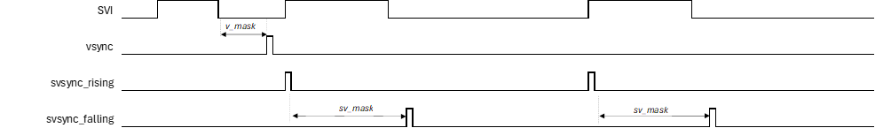

Figure . Timing Diagram for VSYNC / SVSYNC generation ( @SYNC_MODE = 1)

SV_MASK

Acc | Addr | Default | B11 | B10 | B9 | B8 | B7 | B6 | B5 | B4 | B3 | B2 | B1 | B0
R/W | 0x1F | 0x000 | SV_MASK_EN | x | SV_MASK [9:0]

Bits | Fields | Descriptions
11 | SV_MASK_EN | The SV_MASK_EN determines SV_MASK function enable or disable.  0 disable, 1 enable
9:0 | SV_MASK | The SV_MASK determines internal SVSYNC rising / falling position. (unit MCLK/2)

RSTCNT

Acc | Addr | Default | B11 | B10 | B9 | B8 | B7 | B6 | B5 | B4 | B3 | B2 | B1 | B0
R/W | 0x20 | 0x000 | x | x | RSTCNT [9:0]

Bits | Fields | Descriptions
9:0 | RSTCNT | The RSTCNT determines RESET position for interface (decoder/encoder)  The RSTCNT is counted by a MCLK/64 from a last svsync, reset at every vsync.  (unit MCLK/64)

TIMEOUT

Acc | Addr | Default | B11 | B10 | B9 | B8 | B7 | B6 | B5 | B4 | B3 | B2 | B1 | B0
R/W | 0x21 | 0x3FF | x | TIMEOUT[10:0]

Bits | Fields | Descriptions
10:0 | TIMEOUT | The TIMEOUT is the READOUT output waiting time. If no readout is input for more than TIMEOUT, the read operation is stopped. (unit MCLK/64)

FLL CONTROL

Acc | Addr | Default | B11 | B10 | B9 | B8 | B7 | B6 | B5 | B4 | B3 | B2 | B1 | B0
R/W | 0x22 | 0x000 | FLLCNT [11:0]
R/W | 0x23 | 0xC32 | FLL_EN | FLL_RANGE[1:0] |  | x | FLLCNT[19:12]

Bits | Fields | Descriptions
11:0  7:0 | FLLCNT | This determines the FLL target frequency value.  The FLLCNT is counted by an MCLK/64
11 | FLL_EN | This bit enables the FLL function. The FLL continues to calibrate the MCLK frequency to exactly match the PWM frequency with the time of one frame.  1 Enable FLL function (= The MCLK is unlocking, so calibrated to the target frequency)  0 Disable FLL function (= The MCLK is locking at the current frequency)  It is needed that this bit should be set to 0 just before the first vsync starts to be entered to the ID601 and set to 1 just before the vsync is not asserted if the vsync will be not supplied any more to the ID601 .
10:9 | FLL_RANGE | It is recommended to use the default value.

WR_PROTECT

Acc |  | Addr |  | Default | B11 |  | B10 | B9 | B8 | B7 | B6 | B5 | B4 | B3 | B2 | B1 | B0
R/W |  | 0x24 |  | 0x555 | WR_PROTECT[11:0]
 | Bits |  | Fields |  |  | Descriptions
 | 11:0 |  | WR_PROTECT |  |  | These bits are used REGISTER write enable.  The purpose of WR_PROTECT is to prevent registers from being unintentionally written.  1. write-protect1 = 0xAAA : PWMCLK_DIV1/2/3, MAX_CURR_VREF1/2/3 writable  2. write-protect2 = 0xCCC : MAX_CURR_VREF1/2/3 writable  3. Other values : writable

NF_CONTROL

Acc | Addr | Default | B11 | B10 | B9 | B8 | B7 | B6 | B5 | B4 | B3 | B2 | B1 | B0
R/W | 0x25 | 0x000 | BBKN_TH[5:0] |  |  |  |  |  | EMI_REJ_EN | SGRJT_  EN2 | SGRJT_  EN1 | BBKN_  EN | DGRJT_EN2 | DGRJT_EN1

Bits | Fields | Descriptions
11:6 | BBKN_TH | The BBKN_TH is a register for detecting short DIN pulses.  It is recommended to set BBKN_TH to the max. DIN that should be filtered.  The BBKN_TH DIN pulses shorter than this register are not recognized as DIN pulses internally, and the corresponding command is ignored.
5 | EMI_REJ_EN | The EMI_REJ_EN determinant EMI rejection enable.  This register is used to improve EMI by spreading the SVSYNC signal in 1-mclk unit.  0 disable  1 enable
4 | SGRJT_EN2 | The SGRJT_EN2 determinant SVI glitch within 4-MCLK rejection enable.  0 disable  1 enable
3 | SGRJT_EN1 | The SGRJT_EN1 determinant SVI glitch within 3-MCLK rejection enable.  0 disable  1 enable
2 | BBKN_EN | The BBKN_TH determinant BBKN_EN function enable.  0 disable  1 enable
1 | DGRJT_EN2 | The DGRJT_EN2 determinant DIN glitch within 4-MCLK rejection enable.  0 disable  1 enable
0 | DGRJT_EN1 | The DGRJT_EN1 determinant DIN glitch within 3-MCLK rejection enable.  0 disable  1 enable

CHOP_EN

Acc | Addr | Default | B11 | B10 | B9 | B8 | B7 | B6 | B5 | B4 | B3 | B2 | B1 | B0
R/W | 0x26 | 0x000 | x | x | x | x | x | x | CHOP_EN | CHOP_DRV_EN | CHOP_OSCLDO_EN | CHOP_OSC_EN | CHOP_DAC_EN | CHOP_BGR_EN

Bits | Fields | Descriptions
5 | CHOP_EN | Enable for the chopping clock generator
4 | CHOP_DRV_EN | The CHOP_DRV_EN is determinant DRIVER CHOPPING function.  0 disable  1 enable
3 | CHOP_OSCLDO_EN | The CHOP_OSCLDO_EN is determinant OSC LDO CHOPPING function.  0 disable  1 enable
2 | CHOP_OSC_EN | The CHOP_OSC_EN determinant OSC CHOPPING enable.  0 disable  1 enable
1 | CHOP_DAC_EN | The CHOP_DAC_EN determinant DAC CHOPPING enable.  0 disable  1 enable
0 | CHOP_BGR_EN | The CHOP_BGR_EN determinant BGR CHOPPING enable.  0 disable  1 enable

OFS_TEMP_ETC

Acc | Addr | Default | B11 | B10 | B9 | B8 | B7 | B6 | B5 | B4 | B3 | B2 | B1 | B0
R/W | 0x27 | 0x829 | OFS_TEMP [3:0] |  |  |  | OV_SWAP_EN | DAC_RNG | FLT_CTL [1:0] |  | O_SLEW[1:0] |  | FLT_GAIN [1:0]

Bits | Fields | Descriptions
11:8 | OFS_TEMP | This determines the temperature level at which the thermal event occurs. The thermal threshold temperature may vary slightly from the set value. The thermal event threshold temperature according to the OFS_TEMP value is mapped as follows.  93/ 99/ 103/ 109/ 113/ 117/ 123/ 127/ 133(default) / 137/ 143/ 147/ 151/ 157/ 161/ 165℃
7 | OV_SWAP_EN | Enable for comparator self-test
6 | DAC_RNG | It is recommended to use the default value.
5:4 | FLT_CTL | It is recommended to set to 1.
3:2 | O_SLEW | This bit determines slew control for PWM drivers.  It is recommended to use the default value
1:0 | FLT_GAIN | It is recommended to use the default value.

OSC FLL MANUAL

Acc | Addr | Default | B11 | B10 | B9 | B8 | B7 | B6 | B5 | B4 | B3 | B2 | B1 | B0
R/W | 0x28 | 0x000 | OSC_FLL_MAN [11:0]
R/W | 0x29 | 0x808 | OSC_MAN_EN | x | x | x | x | x | OSC_FLL_ERR  _RANGE[1:0] |  | OSC_FLL_MAN [15:12]

Bits | Fields | Descriptions
11:0  3:0 | OSC_FLL_MAN | This bit determines the FLL target frequency value in manual mode.
11 | OSC_MAN_EN | Enable the manual mode of the FLL module. It is careful that this bit must be cleared during the initialization after POR.
5:4 | OSC_FLL_ERR_RANGE | It is recommended to use the default value.

SPREAD

Acc | Addr | Default | B11 | B10 | B9 | B8 | B7 | B6 | B5 | B4 | B3 | B2 | B1 | B0
R/W | 0x2A | 0x000 | SPRD_EN | x | x | x | x | SPRD_SPD[2:0] |  |  | x | SPRD_GAIN[2:0]

Bits | Fields | Descriptions
11 | SPRD_EN | This determines SPREAD function enable.  0 disable  1 enable
6:4 | SPRD_SPD | This determines SPREAD step.  ('000' :128 clock, '001' :64 clock, '010' : 32 clock, '011' : 16 clock  '100’ : 8 clock, '101’ : 4 clock, '110’ : 2 clock, '111’ : 1 clock)
2:0 | SPRD_GAIN | This determines SPREAD gain.  (‘000' : calculated value/8, ‘001' : calculated value/4,  ‘010’ : calculated value/2, ‘011' : calculated value,  ‘100’ : calculated value*2, ‘101’ : calculated value*4,  ‘110’ : calculated value*8, ‘111’ : calculated value*16)

TEST MODE0

Acc | Addr | Default | B11 | B10 | B9 | B8 | B7 | B6 | B5 | B4 | B3 | B2 | B1 | B0
R/W | 0x1A | 0x000 | x | x | x | x | AMUX_SEL[3:0] |  |  |  | DMUX_SEL[3:0]

Bits | Fields | Descriptions
7:4 | AMUX_SEL | Analog mux en/signal selection bits
3:0 | DMUX_SEL | Digital mux en/signal selection bits

TEST MODE1

Acc | Addr | Default | B11 | B10 | B9 | B8 | B7 | B6 | B5 | B4 | B3 | B2 | B1 | B0
R/W | 0x1B | 0x000 | x | x | x | x | TM_OSC_  STUCK_HIGH | TM_OSC_  STUCK_LOW | TM_OVUVTEST  _BGR | TM_UVOTEST  _LDO_1P5 | TM_LDO_OK | TM_UVOVTEST  _DAC_1P5 | TM_ANA_DIM  _FIX_MAN | TM_ANA_DIM  _FIX_DIS

Bits | Fields | Descriptions
7 | TM_OSC_STUCK_HIGH
6 | TM_OSC_STUCK_LOW
5 | TM_OVOVTEST_BGR
4 | TM_UVOTEST_LDO_1P5
3 | TM_LDO_OK
2 | TM_UVOVTEST_DAC_1P5
1 | TM_ANA_DIM_FIX_MAN
0 | TM_ANA_DIM_FIX_DIS

Application Information

Figure 14 shows a typical application with

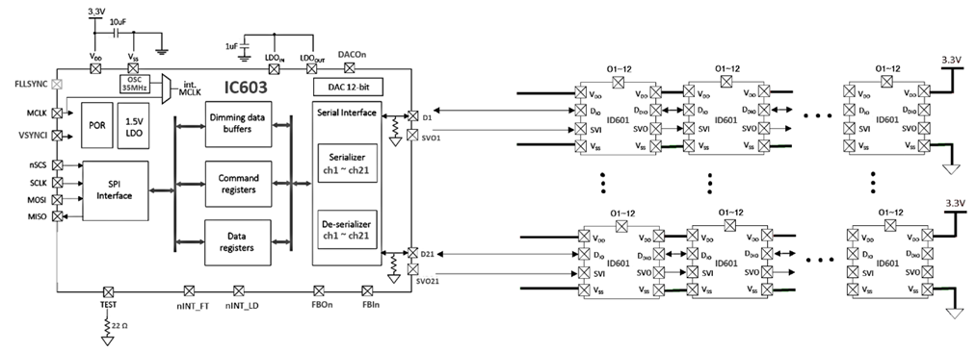
Figure 14 : ID601 Application schematic

PACKAGE OUTLINE DRAWING

TBD

Tape and Reel information
TBD
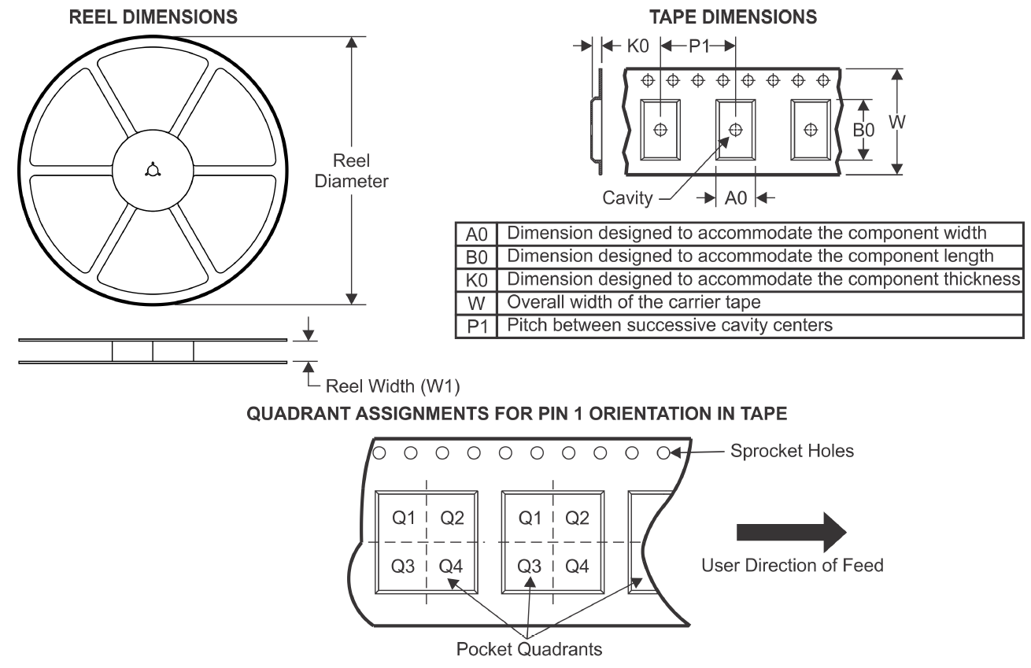

Device | Package | Pin | SPQ | Reel Diameter (mm) | Reel Width W1 (mm) | A0  (mm) | B0  (mm) | K0  (mm) | P1  (mm) | W  (mm) | Pin1
ID601

