Spring Data JPA Hands-On Exercises

1. Spring Data JPA - Quick Example
Objective: Demonstrate the implementation of DML using Spring Data JPA on a single database table. For this exercise, a lightweight H2 in-memory database was used to rapidly test the configuration and data retrieval without needing an external MySQL server. Implementation: A Spring Boot application was generated containing Spring Data JPA and H2 database dependencies. The project was configured to automatically create an in-memory database and populate it via a data.sql script. A Country entity, CountryRepository, and CountryService were implemented to fetch records, and the results were logged using SLF4J from the main application class.
src/main/resources/application.properties
Properties
# H2 Database configuration
spring.datasource.url=jdbc:h2:mem:ormlearn;DB_CLOSE_ON_EXIT=FALSE
spring.datasource.driverClassName=org.h2.Driver
spring.datasource.username=sa
spring.datasource.password=
spring.jpa.database-platform=org.hibernate.dialect.H2Dialect

# Hibernate configuration & Logging
spring.jpa.hibernate.ddl-auto=create-drop
spring.jpa.show-sql=true
spring.jpa.defer-datasource-initialization=true
logging.level.org.hibernate.SQL=trace
logging.level.org.springframework=info
logging.level.com.cognizant=debug
src/main/resources/data.sql
SQL
insert into country values ('IN', 'India');
insert into country values ('US', 'United States of America');
src/main/java/com/cognizant/ormlearn/model/Country.java
Java
package com.cognizant.ormlearn.model;

import javax.persistence.Column;
import javax.persistence.Entity;
import javax.persistence.Id;
import javax.persistence.Table;

@Entity
@Table(name="country")
public class Country {
@Id
@Column(name="co_code")
private String code;

@Column(name="co_name")
private String name;

public String getCode() { return code; }
public void setCode(String code) { this.code = code; }
public String getName() { return name; }
public void setName(String name) { this.name = name; }

@Override
public String toString() {
return "Country [code=" + code + ", name=" + name + "]";
}
}
src/main/java/com/cognizant/ormlearn/repository/CountryRepository.java
Java
package com.cognizant.ormlearn.repository;

import org.springframework.data.jpa.repository.JpaRepository;
import org.springframework.stereotype.Repository;
import com.cognizant.ormlearn.model.Country;

@Repository
public interface CountryRepository extends JpaRepository<Country, String> {
}
src/main/java/com/cognizant/ormlearn/service/CountryService.java
Java
package com.cognizant.ormlearn.service;

import java.util.List;
import javax.transaction.Transactional;
import org.springframework.beans.factory.annotation.Autowired;
import org.springframework.stereotype.Service;
import com.cognizant.ormlearn.model.Country;
import com.cognizant.ormlearn.repository.CountryRepository;

@Service
public class CountryService {
@Autowired
private CountryRepository countryRepository;

@Transactional
public List<Country> getAllCountries() {
return countryRepository.findAll();
}
}
src/main/java/com/cognizant/ormlearn/OrmLearnApplication.java
Java
package com.cognizant.ormlearn;

import java.util.List;
import org.slf4j.Logger;
import org.slf4j.LoggerFactory;
import org.springframework.boot.SpringApplication;
import org.springframework.boot.autoconfigure.SpringBootApplication;
import org.springframework.context.ApplicationContext;
import com.cognizant.ormlearn.model.Country;
import com.cognizant.ormlearn.service.CountryService;

@SpringBootApplication
public class OrmLearnApplication {
private static final Logger LOGGER = LoggerFactory.getLogger(OrmLearnApplication.class);
private static CountryService countryService;

public static void main(String[] args) {
ApplicationContext context = SpringApplication.run(OrmLearnApplication.class, args);
countryService = context.getBean(CountryService.class);
testGetAllCountries();
}

private static void testGetAllCountries() {
LOGGER.info("Start");
List<Country> countries = countryService.getAllCountries();
LOGGER.debug("countries={}", countries);
LOGGER.info("End");
}
}
Test Execution & Result:

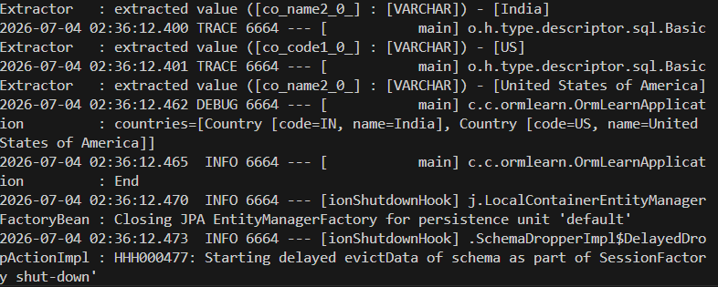

2. Difference between JPA, Hibernate and Spring Data JPA
Java Persistence API (JPA)
- JPA is the JSR 338 Specification used for persisting, reading, and managing data from Java objects.
- It acts strictly as a set of rules and does not contain a concrete implementation of the specification.
Hibernate
- Hibernate is an Object-Relational Mapping (ORM) tool.
- It serves as one of the concrete implementations for the JPA specification.
Spring Data JPA
- Spring Data JPA provides another level of abstraction over a JPA implementation provider like Hibernate.
- It does not have its own JPA implementation, but it drastically reduces boilerplate code and automatically manages transactions.

Code Comparison
Standard Hibernate Implementation: Standard Hibernate requires manually handling sessions, transactions, commits, and rollbacks.
Java
public Integer addEmployee(Employee employee){
Session session = factory.openSession();
Transaction tx = null;
Integer employeeID = null;

try {
tx = session.beginTransaction();
employeeID = (Integer) session.save(employee);
tx.commit();
} catch (HibernateException e) {
if (tx != null) tx.rollback();
e.printStackTrace();
} finally {
session.close();
}
return employeeID;
}
Spring Data JPA Implementation: Spring Data JPA abstracts the session management entirely, allowing developers to extend JpaRepository and use the @Transactional annotation.
Java
// Repository
public interface EmployeeRepository extends JpaRepository<Employee, Integer> {
}

// Service
@Autowired
private EmployeeRepository employeeRepository;

@Transactional
public void addEmployee(Employee employee) {
employeeRepository.save(employee);
}

