Week 5 Hands-on: Frontend Development with React

Document 1: 1. ReactJS-HOL

Exercise 1: Create a React Application
Description: Set up a new React environment using create-react-app named myfirstreact. Modified the main application component to display a specific welcome heading.
Source Code (src/App.js):
JavaScript
import React from 'react';
import './App.css';

function App() {
return (
<div className="App">
<h1>welcome to the first session of React</h1>
</div>
);
}

export default App;
Output / Screenshot:

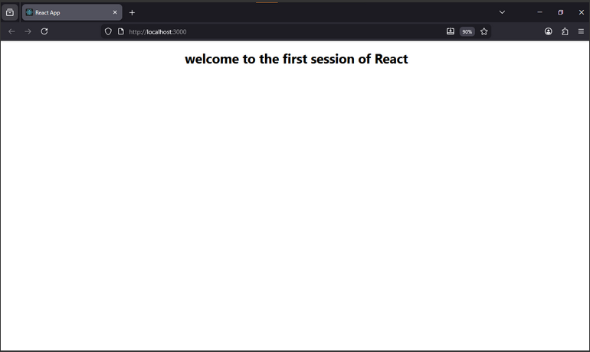Document 2: 2. ReactJS-HOL

Exercise 2: Create Multiple Components
Description: Created a React app for a Student Management Portal. Built three separate functional components (Home, About, and Contact) and invoked all three sequentially within the main App.js file.
Source Code:
src/Components/Home.js
JavaScript
import React from 'react';

function Home() {
return (
<div>
<h3>Welcome to the Home page of Student Management Portal</h3>
</div>
);
}
export default Home;
src/Components/About.js
JavaScript
import React from 'react';

function About() {
return (
<div>
<h3>Welcome to the About page of the Student Management Portal</h3>
</div>
);
}
export default About;
src/Components/Contact.js
JavaScript
import React from 'react';

function Contact() {
return (
<div>
<h3>Welcome to the Contact page of the Student Management Portal</h3>
</div>
);
}
export default Contact;
src/App.js
JavaScript
import React from 'react';
import './App.css';
import Home from './Components/Home';
import About from './Components/About';
import Contact from './Components/Contact';

function App() {
return (
<div className="App">
<Home />
<About />
<Contact />
</div>
);
}
export default App;
Output / Screenshot:

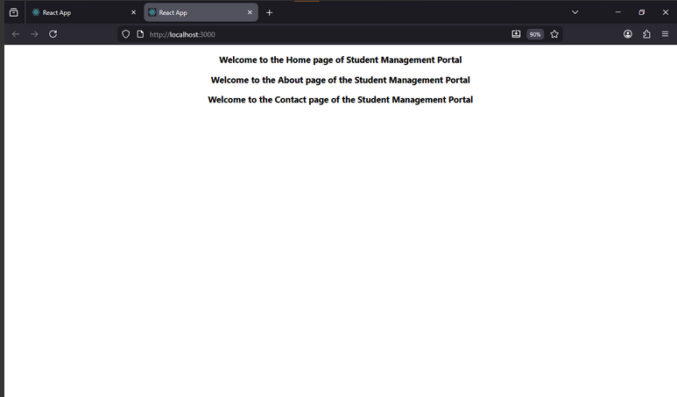Document 3: 3. ReactJS-HOL

Exercise 3: Function Component and Styling
Description: Created a function component CalculateScore that accepts props (Name, School, Total, and Goal) to calculate a student's average score. Applied custom CSS styling to format the output into an organized card.
Source Code:
src/Components/CalculateScore.js
JavaScript
import React from 'react';
import '../Stylesheets/mystyle.css';

function CalculateScore({ Name, School, Total, Goal }) {
const average = Total / Goal;
return (
<div className="formatstyle">
<h2>Student Details:</h2>
<div className="details">
<p><b>Name:</b> <span>{Name}</span></p>
<p><b>School:</b> <span>{School}</span></p>
<p><b>Total Marks:</b> <span>{Total}</span></p>
<p><b>Total Subjects (Goal):</b> <span>{Goal}</span></p>
<p><b>Average Score:</b> <span>{average.toFixed(2)}%</span></p>
</div>
</div>
);
}
export default CalculateScore;
src/App.js
JavaScript
import React from 'react';
import './App.css';
import CalculateScore from './Components/CalculateScore';

function App() {
return (
<div className="App">
<CalculateScore
Name="Steeve"
School="DNV Public School"
Total={284}
Goal={3}
/>
</div>
);
}
export default App;
Output / Screenshot:

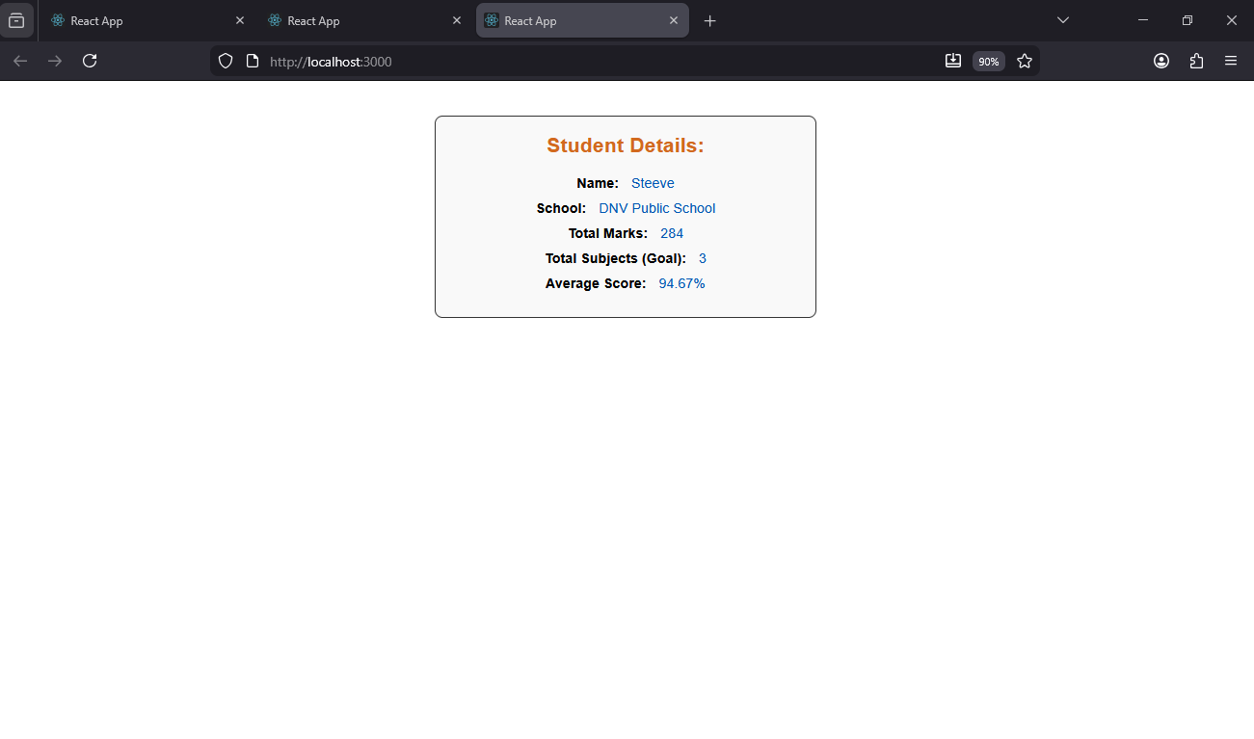Document 4: 4. ReactJS-HOL

Exercise 4: Component Life Cycle
Description: Implemented a class component using the componentDidMount() lifecycle hook to fetch post data from an external REST API (JSONPlaceholder). Implemented the componentDidCatch() hook to gracefully handle and alert rendering errors.
Source Code (src/Posts.js):
JavaScript
import React, { Component } from 'react';

class Posts extends Component {
constructor(props) {
super(props);
this.state = { posts: [] };
}

componentDidMount() {
this.loadPosts();
}

loadPosts = () => {
fetch('https://jsonplaceholder.typicode.com/posts')
.then(response => response.json())
.then(data => this.setState({ posts: data.slice(0, 3) }));
}

componentDidCatch(error, info) {
alert("An error occurred: " + error.message);
}

render() {
return (
<div>
<h2>Blog Posts</h2>
{this.state.posts.map(post => (
<div key={post.id} className="post">
<h3>{post.title}</h3>
<p>{post.body}</p>
</div>
))}
</div>
);
}
}

export default Posts;
Output / Screenshot:

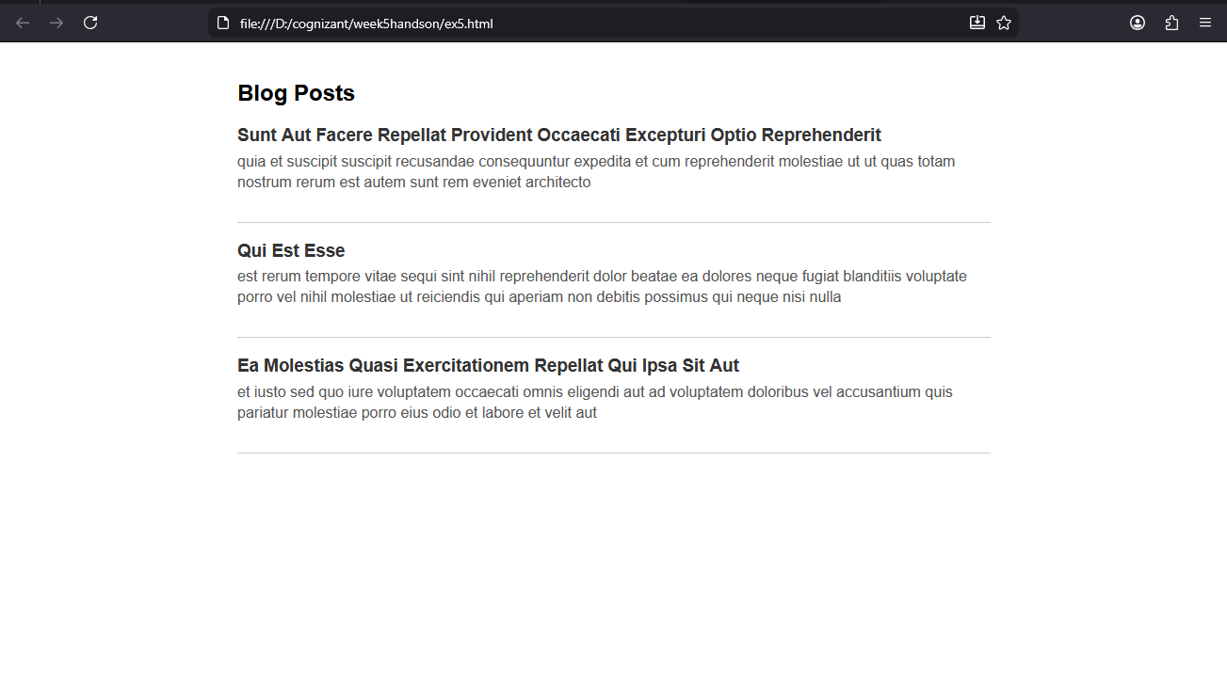Document 5: 5. ReactJS-HOL

Exercise 5: Styling with CSS Modules
Description: Created a dashboard component displaying ongoing and completed cohorts. Utilized CSS Modules for scoped container styling and applied dynamic inline styles via JavaScript expressions to change the text color to green or blue based on the cohort's status.
Source Code (src/CohortDetails.js):
JavaScript
import React from 'react';
import styles from './CohortDetails.module.css';

function CohortDetails({ name, start, end, status }) {
const titleStyle = status === 'ongoing' ? { color: 'green' } : { color: 'blue' };

return (
<div className={styles.box}>
<h3 style={titleStyle}>Cohort: {name}</h3>
<dl>
<dt>Start Date</dt><dd>{start}</dd>
<dt>End Date</dt><dd>{end}</dd>
<dt>Status</dt><dd>{status}</dd>
</dl>
</div>
);
}

export default CohortDetails;
Output / Screenshot:
