Document 3: 1. Git-HOL

Exercise: Git Configuration
Description: Configured global Git variables for user name and email. Configured Notepad++ as the default global core editor. Verified configurations using git config --list.
Output:

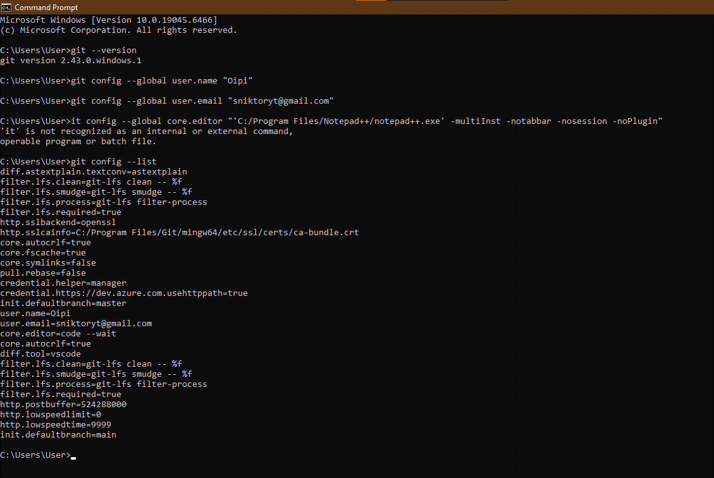

Document 4: 2. Git-HOL

Exercise: Git Ignore
Description: Created a local repository containing a log directory and .log files. Created a .gitignore file to exclude *.log and log/. Verified using git status that the ignored files were no longer tracked by Git.
Output:

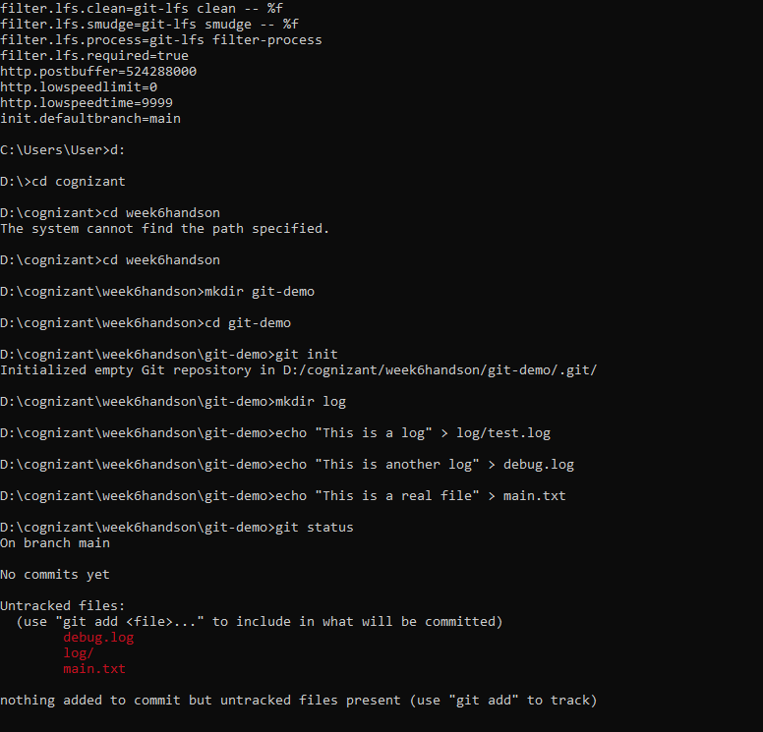

Document 5: 3. Git-HOL

Exercise: Branching and Merging
Description: Created a new branch GitNewBranch, added a new file, and committed the changes to the branch. Switched back to the master branch and successfully merged GitNewBranch into master. Verified the commit history using the graph log and deleted the merged branch.
Output:
