Week 6 Hands-on: React and GIT

Document 1: 9. ReactJS-HOL

Exercise: ES6 Features (Map, Filter, Destructuring)
Description: Created an application that uses ES6 .map() to render a list of players, .filter() to find players with a score below 70, and demonstrated array destructuring and the spread operator to merge arrays.
Source Code (App.js):
JavaScript
import React, { useState } from 'react';
import './App.css';

const players = [
{ name: 'Mr. Sachin', score: 80 }, { name: 'Mr. Virat', score: 95 },
{ name: 'Mr. Dhoni', score: 100 }, { name: 'Mr. Rohit', score: 85 },
{ name: 'Mr. Rahul', score: 75 }, { name: 'Mr. Dhawan', score: 90 },
{ name: 'Mr. Bumrah', score: 65 }, { name: 'Mr. Shami', score: 60 },
{ name: 'Mr. Ashwin', score: 55 }, { name: 'Mr. Jadeja', score: 50 },
{ name: 'Mr. Pant', score: 45 }
];

const T20players = ['Virat', 'Rohit', 'Rahul'];
const RanjiTrophyPlayers = ['Pant', 'Jadeja'];

function ListofPlayers() {
const lowScores = players.filter(p => p.score < 70);
return (
<div>
<h1>List of Players</h1>
<ul>{players.map((p, i) => <li key={i}>{p.name} - {p.score}</li>)}</ul>
<hr/>
<h3>Players with score below 70</h3>
<ul>{lowScores.map((p, i) => <li key={i}>{p.name} - {p.score}</li>)}</ul>
</div>
);
}

function IndianPlayers() {
const [odd, even] = players;
const mergedTeams = [...T20players, ...RanjiTrophyPlayers];
return (
<div>
<h3>Destructuring:</h3>
<p>First Player: {odd.name}</p>
<p>Second Player: {even.name}</p>
<h3>Merged Teams:</h3>
<ul>{mergedTeams.map((p, i) => <li key={i}>{p}</li>)}</ul>
</div>
);
}

function App() {
const [flag, setFlag] = useState(true);
return (
<div className="App">
<button onClick={() => setFlag(!flag)}>Toggle View</button>
{flag ? <ListofPlayers /> : <IndianPlayers />}
</div>
);
}

export default App;

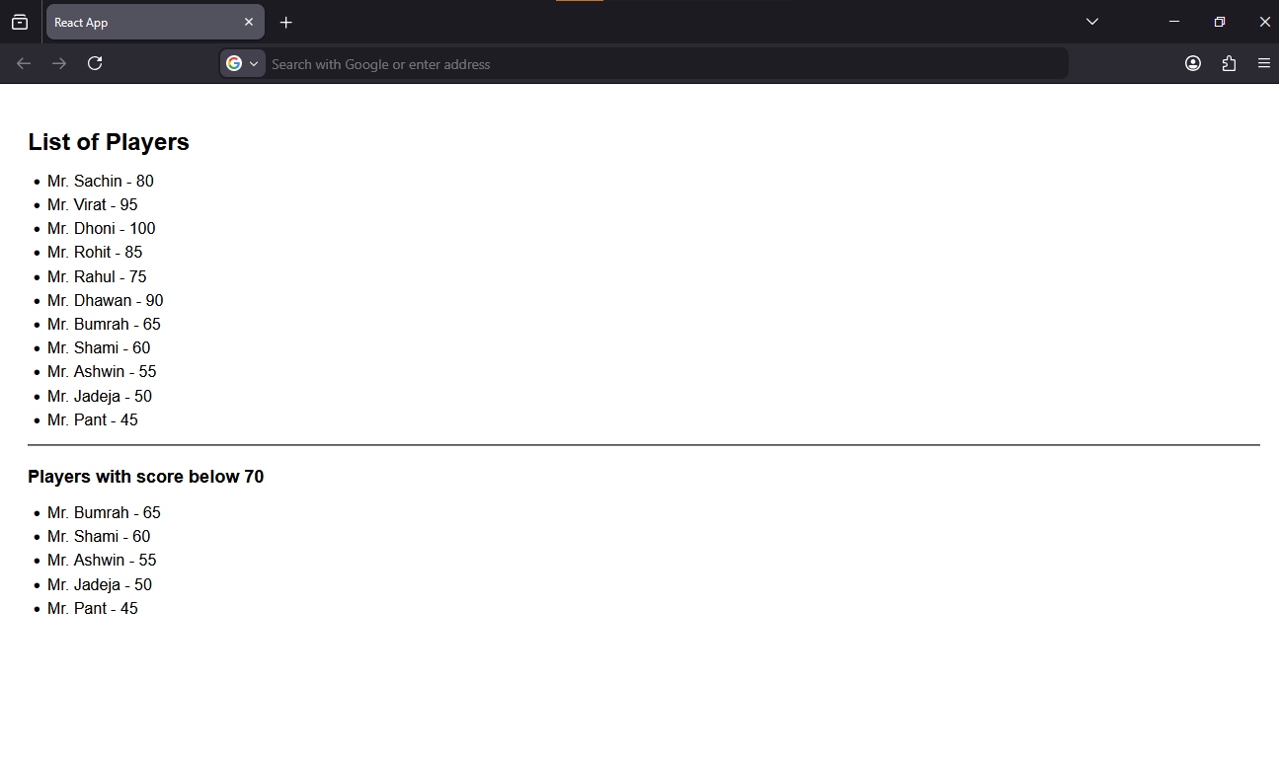Document 2: 10. ReactJS-HOL

Exercise: Office Space Rental App (JSX & Expressions)
Description: Created an application to display office space details. Utilized JSX to render elements and loop through an array of objects. Applied dynamic inline CSS using JavaScript expressions to change the rent text color based on its value.
Source Code (App.js):
JavaScript
import React from 'react';
import officeImg from './office.jpg';

const offices = [
{ id: 1, name: 'Tech Hub', rent: 45000, address: '123 Innovation Dr, Silicon Valley' },
{ id: 2, name: 'Startup Garage', rent: 65000, address: '456 Founder Ave, New York' },
{ id: 3, name: 'Enterprise Plaza', rent: 85000, address: '789 Corporate Blvd, Chicago' }
];

function App() {
return (
<div style={{ maxWidth: '600px', margin: '0 auto', padding: '20px' }}>
<h1 style={{ textAlign: 'center' }}>Office Space Rental</h1>
<img src={officeImg} alt="Office Space" style={{ display: 'block', margin: '0 auto', maxWidth: '400px', border: '1px solid #ccc', padding: '5px' }} />

<h2>Available Locations:</h2>
<ul style={{ listStyleType: 'none', padding: 0 }}>
{offices.map(office => (
<li key={office.id} style={{ backgroundColor: '#f4f4f4', margin: '10px 0', padding: '15px', borderRadius: '5px' }}>
<p><strong>Name:</strong> {office.name}</p>
<p><strong>Rent:</strong>
<span style={{ color: office.rent < 60000 ? 'red' : 'green' }}>
${office.rent.toLocaleString()}
</span>
</p>
<p><strong>Address:</strong> {office.address}</p>
</li>
))}
</ul>
</div>
);
}

export default App;
Output: 