Week 4 Hands-on: Spring Security and JWT

Document 1: 5. JWT-handson

Exercise 1: Securing RESTful Web Services with Spring Security
Description: Added the Spring Security starter dependency to the project to lock down all REST endpoints. Configured a SecurityFilterChain bean to require authentication for all requests.
Source Code:
pom.xml (Addition)
XML
<dependency>
<groupId>org.springframework.boot</groupId>
<artifactId>spring-boot-starter-security</artifactId>
</dependency>
Output / Screenshot:

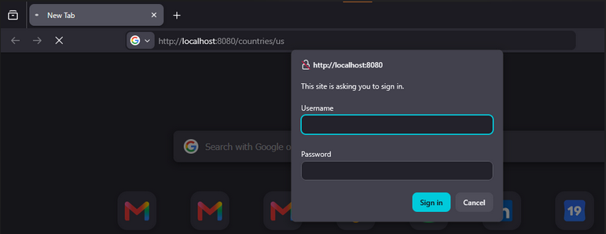Exercise 2: Creating Users and Roles in Spring Security
Description: Created in-memory users (user and admin) with specific roles and encrypted passwords using InMemoryUserDetailsManager and BCryptPasswordEncoder. Configured authorization rules to restrict the /countries endpoints to the USER role.
Source Code:
src/main/java/com/cognizant/spring_learn/security/SecurityConfig.java
package com.cognizant.spring_learn.security;

import org.slf4j.Logger;
import org.slf4j.LoggerFactory;
import org.springframework.context.annotation.Bean;
import org.springframework.context.annotation.Configuration;
import org.springframework.security.config.annotation.web.builders.HttpSecurity;
import org.springframework.security.config.annotation.web.configuration.EnableWebSecurity;
import org.springframework.security.core.userdetails.User;
import org.springframework.security.core.userdetails.UserDetails;
import org.springframework.security.core.userdetails.UserDetailsService;
import org.springframework.security.crypto.bcrypt.BCryptPasswordEncoder;
import org.springframework.security.crypto.password.PasswordEncoder;
import org.springframework.security.provisioning.InMemoryUserDetailsManager;
import org.springframework.security.web.SecurityFilterChain;
import org.springframework.security.web.authentication.UsernamePasswordAuthenticationFilter;

@Configuration
@EnableWebSecurity
public class SecurityConfig {

private static final Logger LOGGER = LoggerFactory.getLogger(SecurityConfig.class);

@Bean
public UserDetailsService userDetailsService() {
UserDetails user = User.builder()
.username("user")
.password(passwordEncoder().encode("pwd"))
.roles("USER")
.build();

UserDetails admin = User.builder()
.username("admin")
.password(passwordEncoder().encode("pwd"))
.roles("ADMIN")
.build();

return new InMemoryUserDetailsManager(user, admin);
}

@Bean
public PasswordEncoder passwordEncoder() {
return new BCryptPasswordEncoder();
}

@Bean
public SecurityFilterChain filterChain(HttpSecurity http) throws Exception {
LOGGER.info("START: Configuring SecurityFilterChain");

http.csrf(csrf -> csrf.disable())
.cors(cors -> cors.disable())
.authorizeHttpRequests(auth -> auth
.requestMatchers("/countries/**").hasRole("USER")
.requestMatchers("/authenticate").hasAnyRole("USER", "ADMIN")
.anyRequest().authenticated()
)
// Inject our new OncePerRequestFilter before the standard auth filter
.addFilterBefore(new JwtAuthorizationFilter(), UsernamePasswordAuthenticationFilter.class)
.httpBasic(basic -> {});

LOGGER.info("END: Configuring SecurityFilterChain");
return http.build();
}
}
Output / Screenshot:

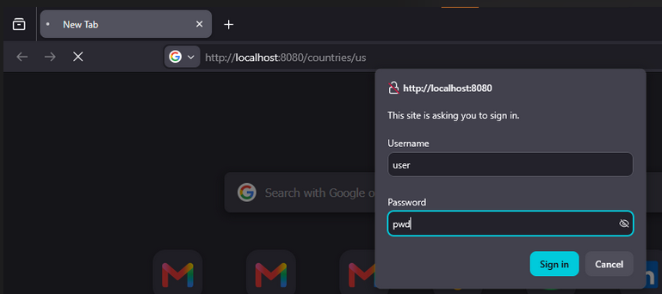

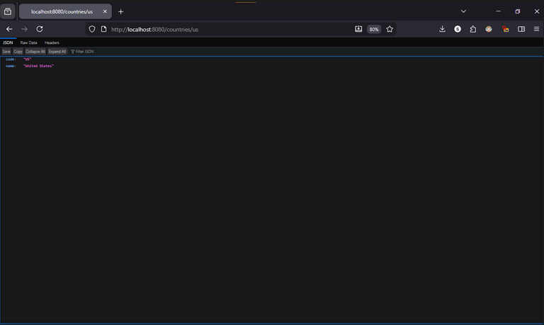

Exercise 3: Create Authentication Service that Returns JWT
Description: Created a new /authenticate endpoint that accepts Basic Authentication credentials, decodes the Base64 header, and generates a JSON Web Token (JWT) using the jjwt library. The token is configured to expire in 20 minutes and is signed with a secret key.
Source Code:
src/main/java/com/cognizant/spring_learn/controller/AuthenticationController.java
package com.cognizant.spring_learn.controller;

import java.util.Base64;
import java.util.Date;
import java.util.HashMap;
import java.util.Map;

import org.slf4j.Logger;
import org.slf4j.LoggerFactory;
import org.springframework.web.bind.annotation.GetMapping;
import org.springframework.web.bind.annotation.RequestHeader;
import org.springframework.web.bind.annotation.RestController;

import io.jsonwebtoken.JwtBuilder;
import io.jsonwebtoken.Jwts;
import io.jsonwebtoken.SignatureAlgorithm;

@RestController
public class AuthenticationController {

private static final Logger LOGGER = LoggerFactory.getLogger(AuthenticationController.class);

@GetMapping("/authenticate")
public Map<String, String> authenticate(@RequestHeader("Authorization") String authHeader) {
LOGGER.info("START authenticate");
LOGGER.debug("Auth Header: {}", authHeader);

// Extract the username from the header
String user = getUser(authHeader);

// Generate the token
String token = generateJwt(user);

// Return the token in a Map (Spring converts this to JSON automatically)
Map<String, String> map = new HashMap<>();
map.put("token", token);

LOGGER.info("END authenticate");
return map;
}

private String getUser(String authHeader) {
// The header comes in as "Basic dXNlcjpwd2Q=" (Base64 encoded)
// We strip the first 6 characters ("Basic ") to get just the encoded string
String encodedCredentials = authHeader.substring(6);

// Decode it back to "user:pwd"
byte[] decodedBytes = Base64.getDecoder().decode(encodedCredentials);
String decodedString = new String(decodedBytes);

// Split by colon and grab the first part (the username)
return decodedString.split(":")[0];
}

private String generateJwt(String user) {
JwtBuilder builder = Jwts.builder();
builder.setSubject(user);

// Set the token issue time as current time
builder.setIssuedAt(new Date());

// Set the token expiry as 20 minutes from now (1,200,000 milliseconds)
builder.setExpiration(new Date((new Date()).getTime() + 1200000));

// Sign the token with a secret key
builder.signWith(SignatureAlgorithm.HS256, "secretkey");

return builder.compact();
}
}
Output / Screenshot:

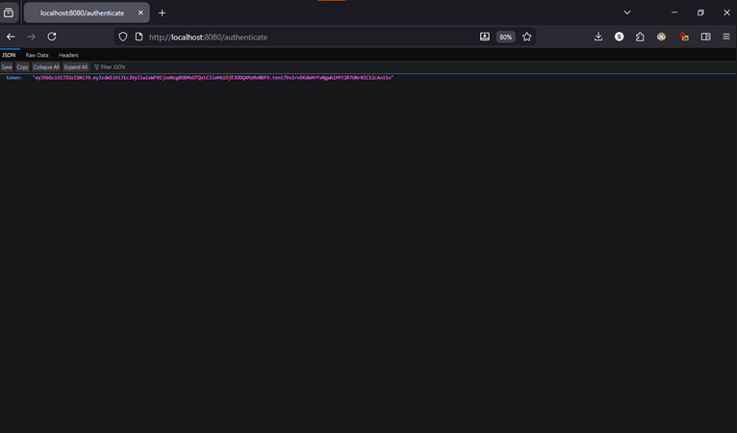

Exercise 4: Authorize Based on JWT
Description: Created a custom JwtAuthorizationFilter extending OncePerRequestFilter to intercept requests, extract the Bearer token from the Authorization header, validate it using the secret key, and explicitly grant the ROLE_USER authority. Configured the SecurityFilterChain to apply this filter to incoming requests.
Source Code:
src/main/java/com/cognizant/spring_learn/security/JwtAuthorizationFilter.java
package com.cognizant.spring_learn.security;

import java.io.IOException;
import java.util.Collections;

import jakarta.servlet.FilterChain;
import jakarta.servlet.ServletException;
import jakarta.servlet.http.HttpServletRequest;
import jakarta.servlet.http.HttpServletResponse;

import org.slf4j.Logger;
import org.slf4j.LoggerFactory;
import org.springframework.security.authentication.UsernamePasswordAuthenticationToken;
import org.springframework.security.core.authority.SimpleGrantedAuthority;
import org.springframework.security.core.context.SecurityContextHolder;
import org.springframework.web.filter.OncePerRequestFilter;

import io.jsonwebtoken.Claims;
import io.jsonwebtoken.Jws;
import io.jsonwebtoken.JwtException;
import io.jsonwebtoken.Jwts;

public class JwtAuthorizationFilter extends OncePerRequestFilter {

private static final Logger LOGGER = LoggerFactory.getLogger(JwtAuthorizationFilter.class);

@Override
protected void doFilterInternal(HttpServletRequest request, HttpServletResponse response, FilterChain chain)
throws IOException, ServletException {
LOGGER.info("START doFilterInternal");
String header = request.getHeader("Authorization");

if (header == null || !header.startsWith("Bearer ")) {
chain.doFilter(request, response);
return;
}

UsernamePasswordAuthenticationToken authentication = getAuthentication(request);
if (authentication != null) {
SecurityContextHolder.getContext().setAuthentication(authentication);
}

chain.doFilter(request, response);
LOGGER.info("END doFilterInternal");
}

private UsernamePasswordAuthenticationToken getAuthentication(HttpServletRequest request) {
String token = request.getHeader("Authorization");
if (token != null) {
try {
Jws<Claims> jws = Jwts.parser()
.setSigningKey("secretkey")
.parseClaimsJws(token.replace("Bearer ", ""));

String user = jws.getBody().getSubject();
LOGGER.debug("User from token: {}", user);

if (user != null) {
// CRITICAL FIX: We must grant the ROLE_USER authority so Spring Security allows access!
return new UsernamePasswordAuthenticationToken(user, null,
Collections.singletonList(new SimpleGrantedAuthority("ROLE_USER")));
}
} catch (JwtException ex) {
LOGGER.error("JWT Parsing Error: {}", ex.getMessage());
return null;
}
}
return null;
}
}
Output / Screenshot:

