Mockito Hands-On Exercises: Mandatory Tasks

Project Configuration & Setup
To enable JUnit 5 and Mockito in the environment, the following dependencies and compiler properties were configured in the Maven pom.xml file:
XML
<project xmlns="http://maven.apache.org/POM/4.0.0"
xmlns:xsi="http://www.w3.org/2001/XMLSchema-instance"
xsi:schemaLocation="http://maven.apache.org/POM/4.0.0 http://maven.apache.org/xsd/maven-4.0.0.xsd">
<modelVersion>4.0.0</modelVersion>

<groupId>com.deepskilling</groupId>
<artifactId>mockito-exercises</artifactId>
<version>1.0-SNAPSHOT</version>

<properties>
<maven.compiler.source>21</maven.compiler.source>
<maven.compiler.target>21</maven.compiler.target>
<project.build.sourceEncoding>UTF-8</project.build.sourceEncoding>
</properties>

<dependencies>
<dependency>
<groupId>org.junit.jupiter</groupId>
<artifactId>junit-jupiter</artifactId>
<version>5.10.0</version>
<scope>test</scope>
</dependency>
<dependency>
<groupId>org.mockito</groupId>
<artifactId>mockito-core</artifactId>
<version>5.5.0</version>
<scope>test</scope>
</dependency>
<dependency>
<groupId>org.mockito</groupId>
<artifactId>mockito-junit-jupiter</artifactId>
<version>5.5.0</version>
<scope>test</scope>
</dependency>
</dependencies>
</project>

Prerequisites: Dummy Service Classes
Before writing the tests, the following base classes were created to represent the external dependency and the main service being tested.
ExternalApi.java
Java
package com.deepskilling;

public class ExternalApi {
public String getData() {
return "Real Data";
}
}
MyService.java
Java
package com.deepskilling;

public class MyService {
private ExternalApi api;

public MyService(ExternalApi api) {
this.api = api;
}

public String fetchData() {
return api.getData();
}
}

Exercise 1: Mocking and Stubbing
Scenario: Test a service that depends on an external API by using Mockito to mock the external API and stub its methods.
Test Implementation (MyServiceTest.java):
Java
package com.deepskilling;

import static org.mockito.Mockito.*;
import static org.junit.jupiter.api.Assertions.assertEquals;
import org.junit.jupiter.api.Test;
import org.mockito.Mockito;

public class MyServiceTest {

@Test
public void testExternalApi() {
// 1. Create a mock object for the external API
ExternalApi mockApi = Mockito.mock(ExternalApi.class);

// 2. Stub the method to return predefined values
when(mockApi.getData()).thenReturn("Mock Data");

// 3. Write a test case that uses the mock object
MyService service = new MyService(mockApi);
String result = service.fetchData();

assertEquals("Mock Data", result);
}
}
Test Execution & Result:

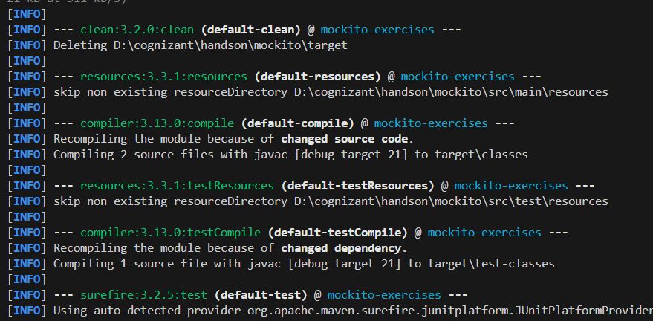Exercise 2: Verifying Interactions
Scenario: Ensure that a specific method is called on the mocked dependency during the execution of the service.
Test Implementation (MyServiceTest.java):
Java
package com.deepskilling;

import static org.mockito.Mockito.*;
import org.junit.jupiter.api.Test;
import org.mockito.Mockito;

public class MyServiceTest {

@Test
public void testVerifyInteraction() {
// 1. Create a mock object
ExternalApi mockApi = Mockito.mock(ExternalApi.class);
MyService service = new MyService(mockApi);

// 2. Call the method
service.fetchData();

// 3. Verify the interaction
verify(mockApi).getData();
}
}
Test Execution & Result:
