JUnit Basic Testing Exercises
Exercise 1: Setting Up JUnit
Exercise 3: Assertions in JUnit
Exercise 4: Arrange-Act-Assert (AAA) Pattern, Test Fixtures, Setup and Teardown Methods

Exercise 1 Code Screenshot
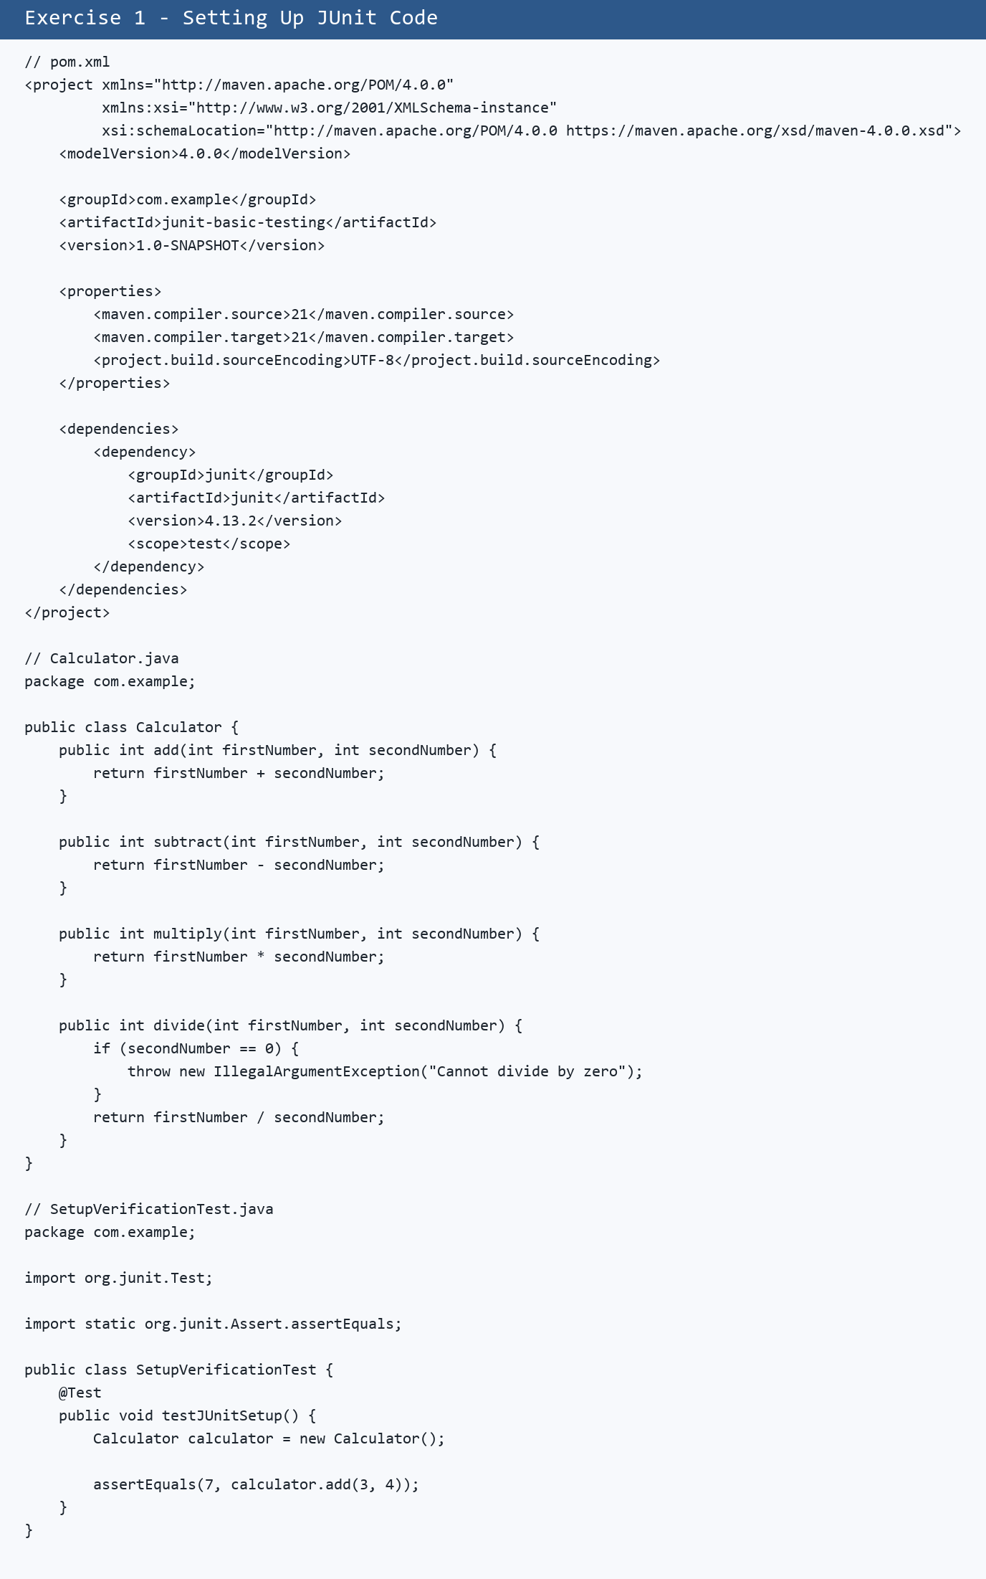

Exercise 3 Code Screenshot
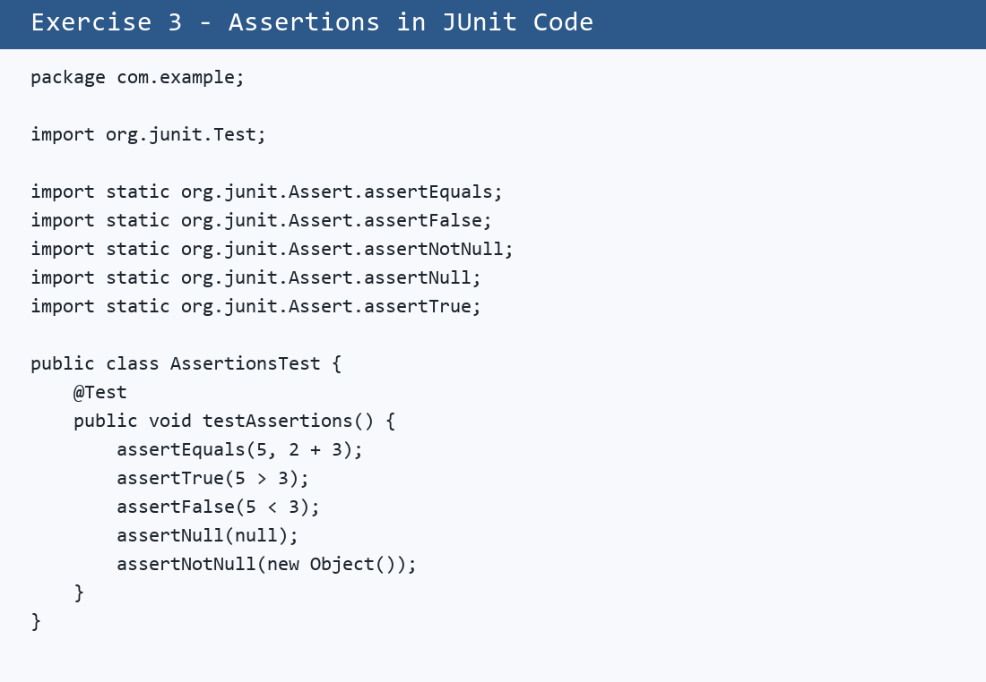

Exercise 4 Code Screenshot
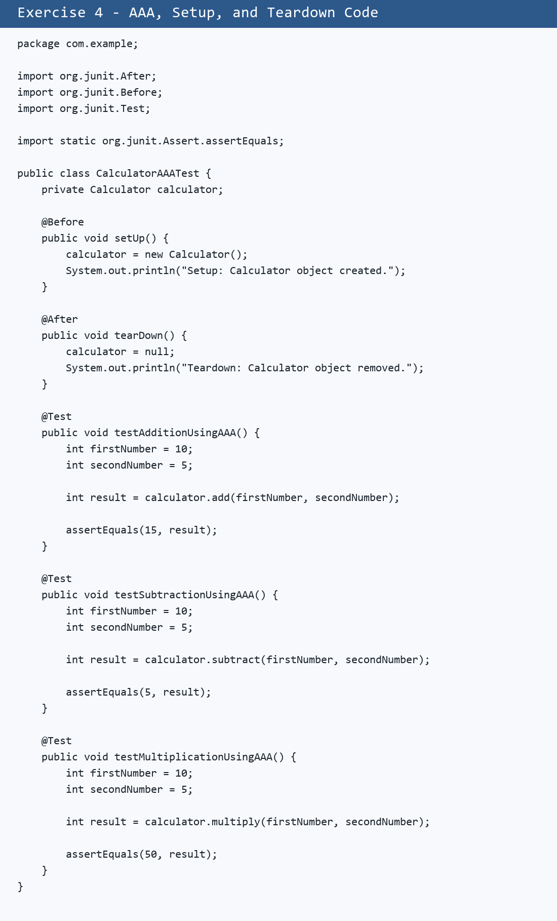

JUnit Output Screenshot
