Algorithms and Data Structures
Exercise 2: E-commerce Platform Search Function
Exercise 7: Financial Forecasting

Exercise 2 Code Screenshot
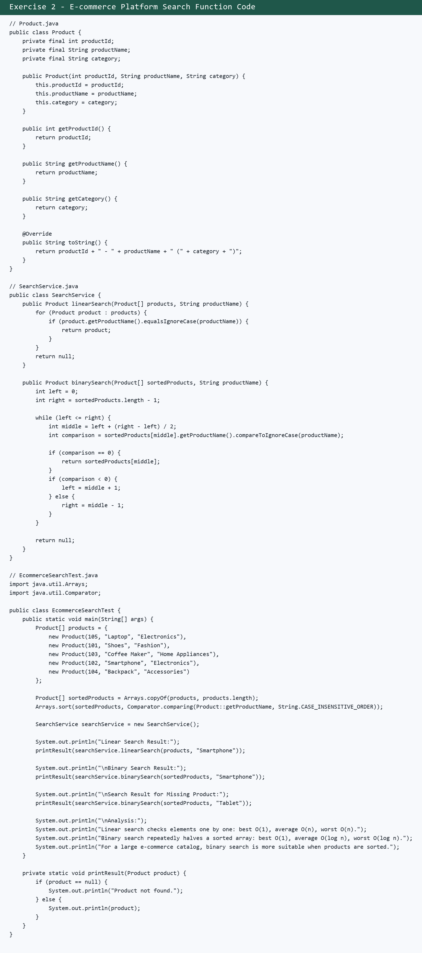

Exercise 2 Output Screenshot
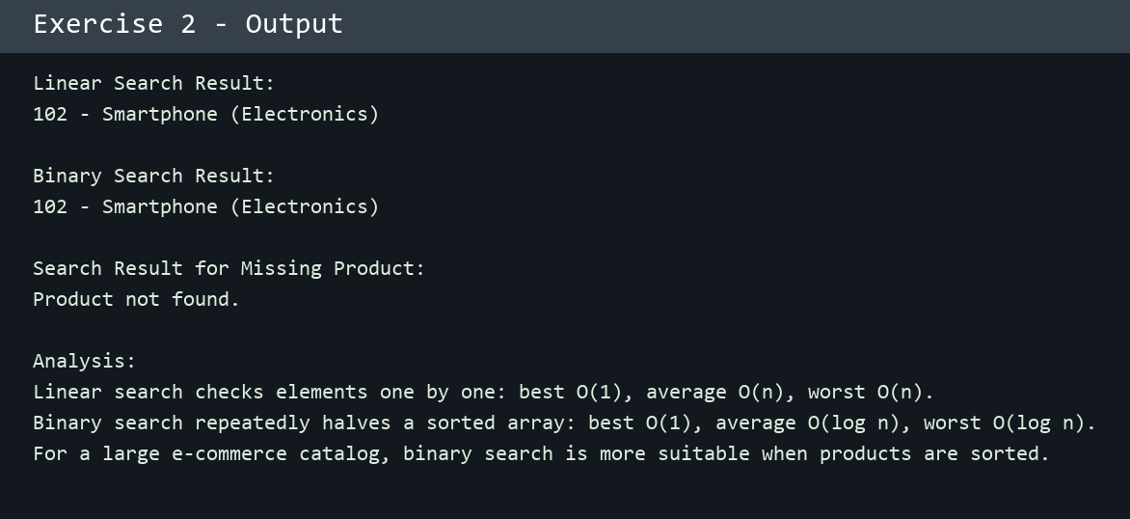

Exercise 7 Code Screenshot
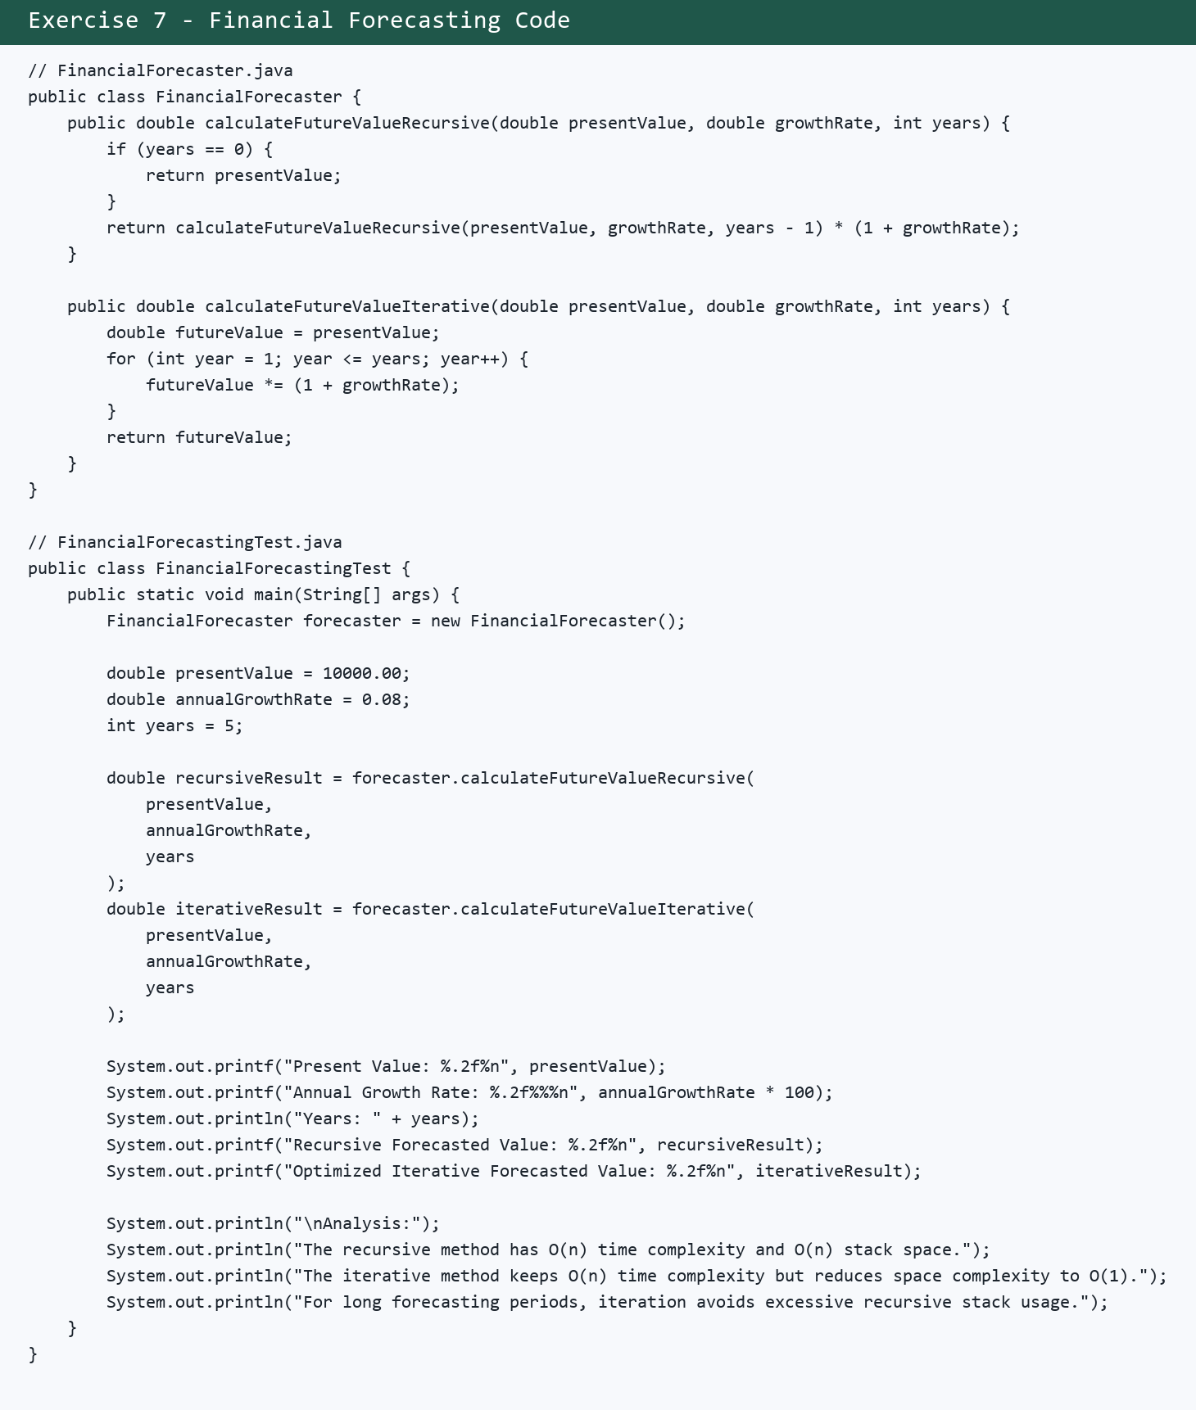

Exercise 7 Output Screenshot
