Design Patterns and Principles
Exercise 1: Implementing the Singleton Pattern
Exercise 2: Implementing the Factory Method Pattern

Exercise 1 Code Screenshot
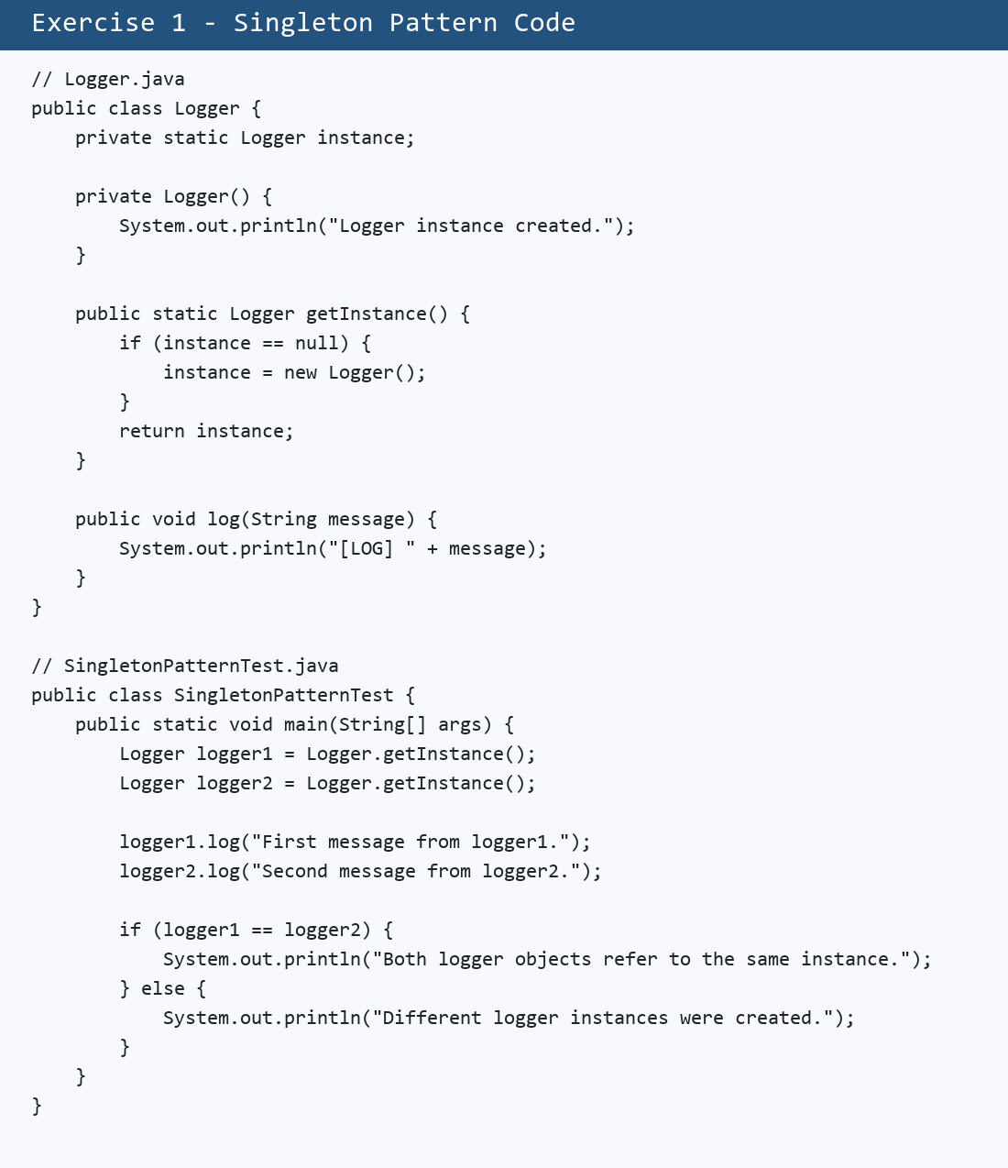

Exercise 1 Output Screenshot
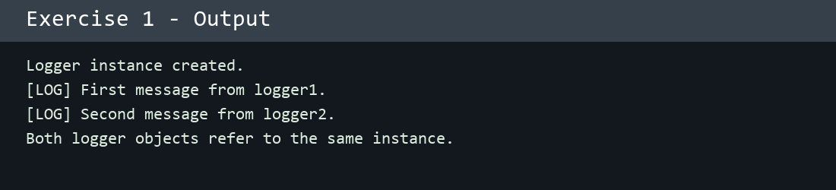

Exercise 2 Code Screenshot
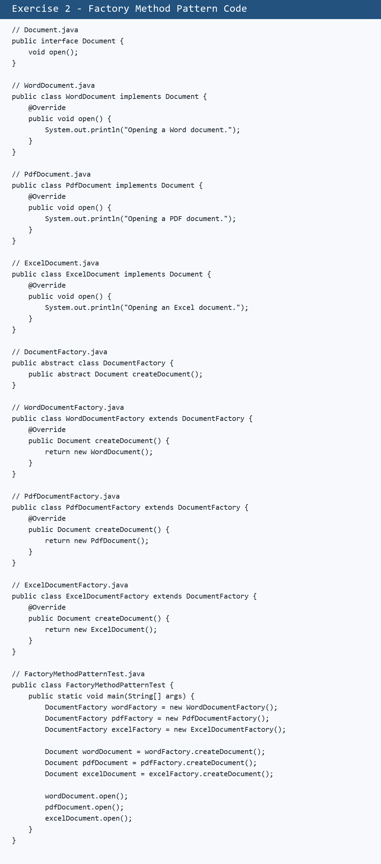

Exercise 2 Output Screenshot
