PL/SQL Programming Exercises
Exercise 1: Control Structures
Exercise 3: Stored Procedures

Exercise 1 Code Screenshot
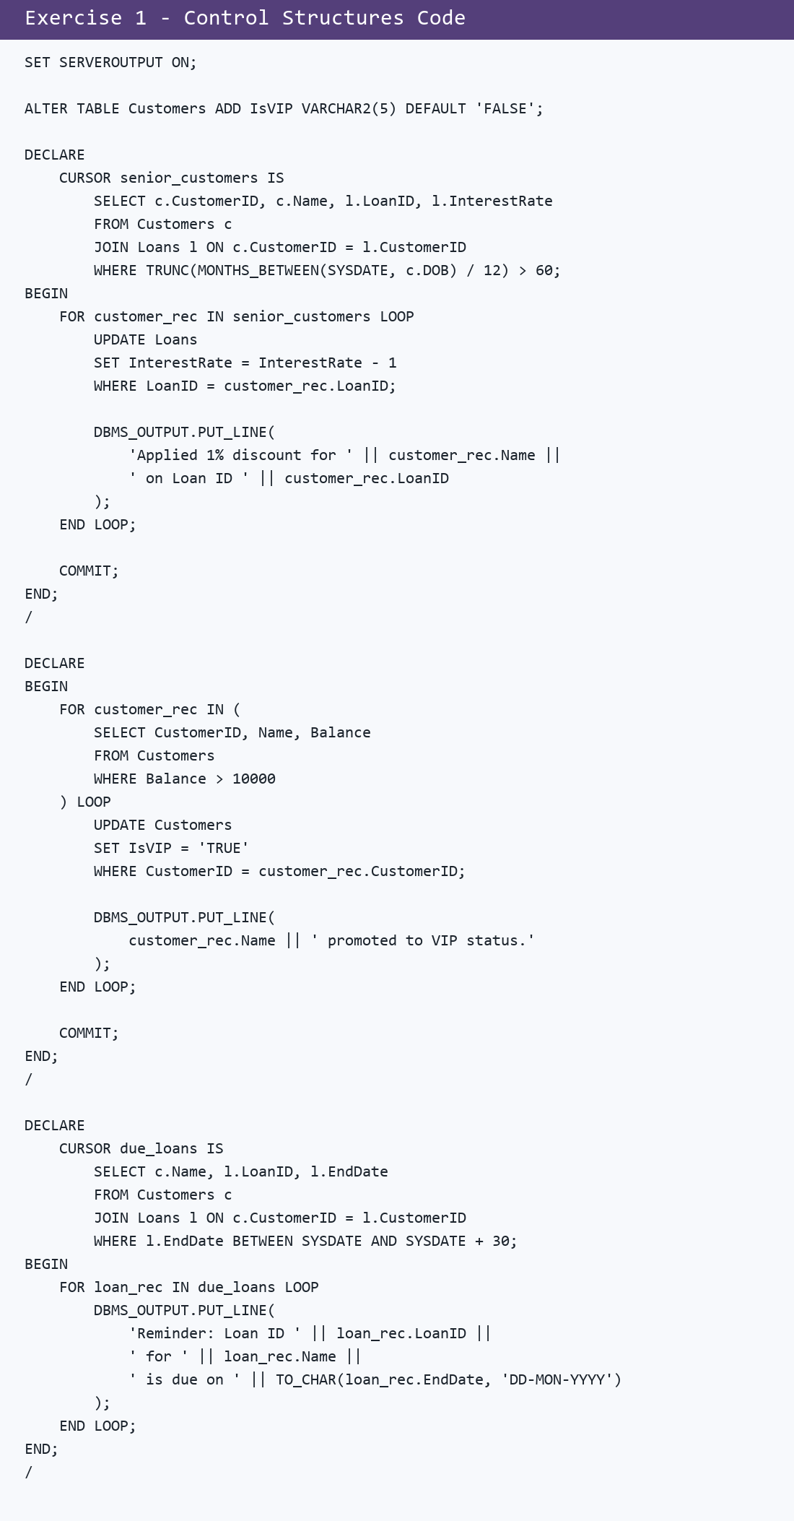

Exercise 1 Output Screenshot
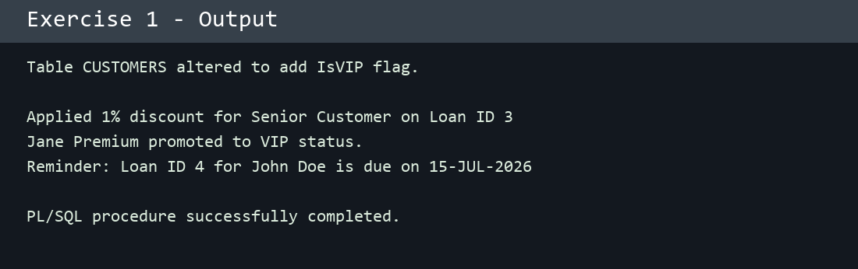

Exercise 3 Code Screenshot
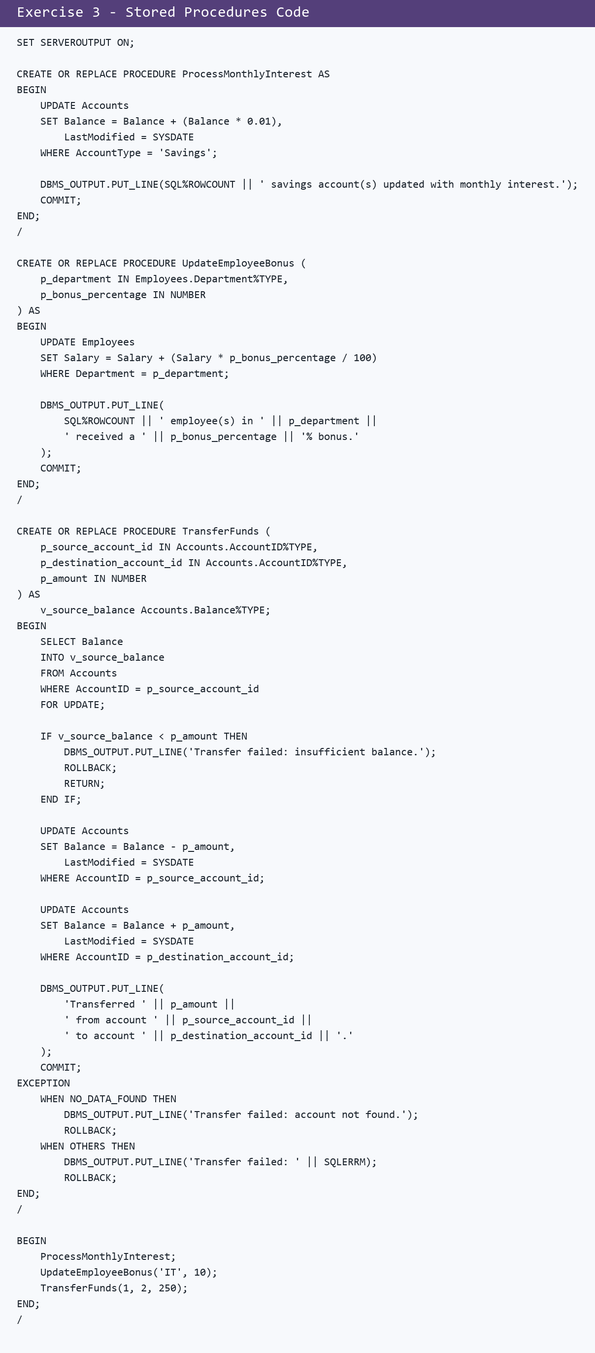

Exercise 3 Output Screenshot
