Week 3 Hands-on: Spring REST using Spring Boot 3

Document 1: 1. spring-rest-handson

Exercise 1: Create a Spring Web Project using Maven
Description: Created a Spring Boot application using Spring Initializr. Configured the project metadata, added Spring Web and Spring Boot DevTools dependencies, and successfully built and ran the application using Maven.
Source Code (pom.xml dependencies):
XML
<dependencies>
<dependency>
<groupId>org.springframework.boot</groupId>
<artifactId>spring-boot-starter-web</artifactId>
</dependency>
<dependency>
<groupId>org.springframework.boot</groupId>
<artifactId>spring-boot-devtools</artifactId>
<scope>runtime</scope>
<optional>true</optional>
</dependency>
<dependency>
<groupId>org.springframework.boot</groupId>
<artifactId>spring-boot-starter-test</artifactId>
<scope>test</scope>
</dependency>
</dependencies>
Output / Screenshot:
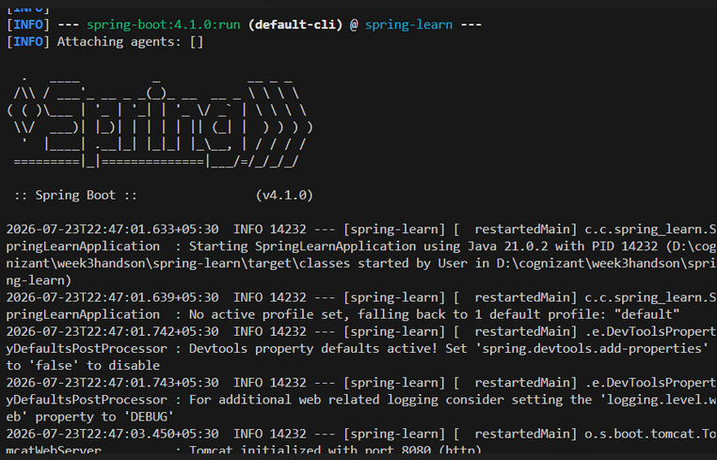
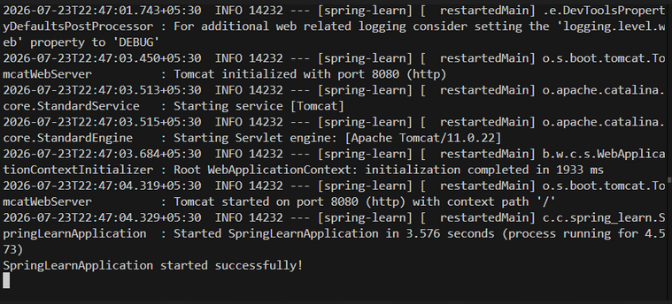

Exercise 2: Spring Core – Load Country from Spring Configuration XML
Description: Created a Country bean using a Spring XML configuration file and retrieved it using ClassPathXmlApplicationContext. Added debug logging to the constructor and setter methods to verify Spring's automatic bean creation.
Source Code:
src/main/resources/application.properties
Properties
logging.level.com.cognizant.spring_learn=DEBUG
src/main/resources/country.xml
XML
<?xml version="1.0" encoding="UTF-8"?>
<beans xmlns="http://www.springframework.org/schema/beans"
xmlns:xsi="http://www.w3.org/2001/XMLSchema-instance"
xsi:schemaLocation="http://www.springframework.org/schema/beans
http://www.springframework.org/schema/beans/spring-beans.xsd">

<bean id="in" class="com.cognizant.spring_learn.Country">
<property name="code" value="IN" />
<property name="name" value="India" />
</bean>

<bean id="us" class="com.cognizant.spring_learn.Country">
<property name="code" value="US" />
<property name="name" value="United States" />
</bean>

<bean id="de" class="com.cognizant.spring_learn.Country">
<property name="code" value="DE" />
<property name="name" value="Germany" />
</bean>

<bean id="countryList" class="java.util.ArrayList">
<constructor-arg>
<list>
<ref bean="in" />
<ref bean="us" />
<ref bean="de" />
</list>
</constructor-arg>
</bean>
</beans>
src/main/java/com/cognizant/spring_learn/Country.java
Java
package com.cognizant.spring_learn;

import org.slf4j.Logger;
import org.slf4j.LoggerFactory;

public class Country {

private static final Logger LOGGER = LoggerFactory.getLogger(Country.class);

private String code;
private String name;

public Country() {
LOGGER.debug("Inside Country Constructor.");
}

public String getCode() {
LOGGER.debug("Inside getCode method.");
return code;
}

public void setCode(String code) {
LOGGER.debug("Inside setCode method.");
this.code = code;
}

public String getName() {
LOGGER.debug("Inside getName method.");
return name;
}

public void setName(String name) {
LOGGER.debug("Inside setName method.");
this.name = name;
}

@Override
public String toString() {
return "Country [code=" + code + ", name=" + name + "]";
}
}
src/main/java/com/cognizant/spring_learn/SpringLearnApplication.java
Java
package com.cognizant.spring_learn;

import org.slf4j.Logger;
import org.slf4j.LoggerFactory;
import org.springframework.boot.SpringApplication;
import org.springframework.boot.autoconfigure.SpringBootApplication;
import org.springframework.context.ApplicationContext;
import org.springframework.context.support.ClassPathXmlApplicationContext;

@SpringBootApplication
public class SpringLearnApplication {

private static final Logger LOGGER = LoggerFactory.getLogger(SpringLearnApplication.class);

public static void main(String[] args) {
SpringApplication.run(SpringLearnApplication.class, args);
displayCountry();
}

public static void displayCountry() {
LOGGER.info("START");
ApplicationContext context = new ClassPathXmlApplicationContext("country.xml");
Country country = context.getBean("in", Country.class);
LOGGER.debug("Country : {}", country.toString());
LOGGER.info("END");
}
}
Output / Screenshot:

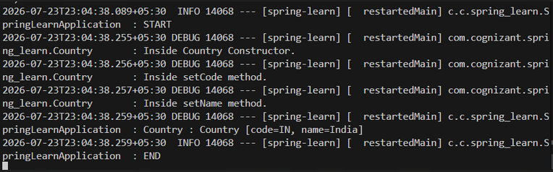

Document 2: 2. spring-rest-handson

Exercise 3: Hello World RESTful Web Service
Description: Created a REST Controller using @RestController and mapped a GET request using @GetMapping to return a "Hello World!!" string.
Source Code:
src/main/java/com/cognizant/spring_learn/controller/HelloController.java
Java
package com.cognizant.spring_learn.controller;

import org.slf4j.Logger;
import org.slf4j.LoggerFactory;
import org.springframework.web.bind.annotation.GetMapping;
import org.springframework.web.bind.annotation.RestController;

@RestController
public class HelloController {

private static final Logger LOGGER = LoggerFactory.getLogger(HelloController.class);

@GetMapping("/hello")
public String sayHello() {
LOGGER.info("START sayHello");
String response = "Hello World!!";
LOGGER.info("END sayHello");
return response;
}
}
Output / Screenshot:

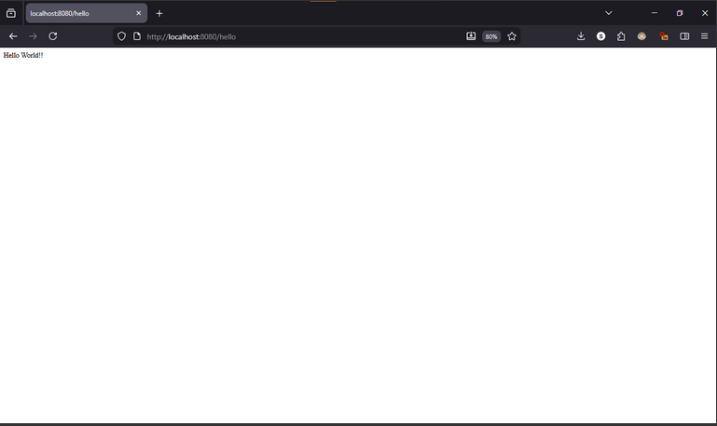

Exercise 4 & 5: REST - Country Web Service & Get Country by Code
Description: Developed a REST endpoint to return a Country object, which Spring automatically converts to JSON. Additionally, created a CountryService to parse a list of countries from the XML context and return a specific country based on a @PathVariable code provided in the URL.
Source Code:
src/main/java/com/cognizant/spring_learn/service/CountryService.java
Java
package com.cognizant.spring_learn.service;

import java.util.List;
import org.springframework.context.ApplicationContext;
import org.springframework.context.support.ClassPathXmlApplicationContext;
import org.springframework.stereotype.Service;
import com.cognizant.spring_learn.Country;

@Service
public class CountryService {

public Country getCountry(String code) {
ApplicationContext context = new ClassPathXmlApplicationContext("country.xml");

@SuppressWarnings("unchecked")
List<Country> countries = context.getBean("countryList", List.class);

for (Country country : countries) {
if (country.getCode().equalsIgnoreCase(code)) {
return country;
}
}
return null;
}
}
src/main/java/com/cognizant/spring_learn/controller/CountryController.java
Java
package com.cognizant.spring_learn.controller;

import org.slf4j.Logger;
import org.slf4j.LoggerFactory;
import org.springframework.beans.factory.annotation.Autowired;
import org.springframework.context.ApplicationContext;
import org.springframework.context.support.ClassPathXmlApplicationContext;
import org.springframework.web.bind.annotation.GetMapping;
import org.springframework.web.bind.annotation.PathVariable;
import org.springframework.web.bind.annotation.RequestMapping;
import org.springframework.web.bind.annotation.RestController;

import com.cognizant.spring_learn.Country;
import com.cognizant.spring_learn.service.CountryService;

@RestController
public class CountryController {

private static final Logger LOGGER = LoggerFactory.getLogger(CountryController.class);

@Autowired
private CountryService countryService;

@RequestMapping("/country")
public Country getCountryIndia() {
LOGGER.info("START getCountryIndia");
ApplicationContext context = new ClassPathXmlApplicationContext("country.xml");
Country country = context.getBean("in", Country.class);
LOGGER.info("END getCountryIndia");
return country;
}

@GetMapping("/countries/{code}")
public Country getCountry(@PathVariable String code) {
LOGGER.info("START getCountry");
Country country = countryService.getCountry(code);
LOGGER.info("END getCountry");
return country;
}
}
Outputs / Screenshots:
- For Exercise 4 (/country):
- 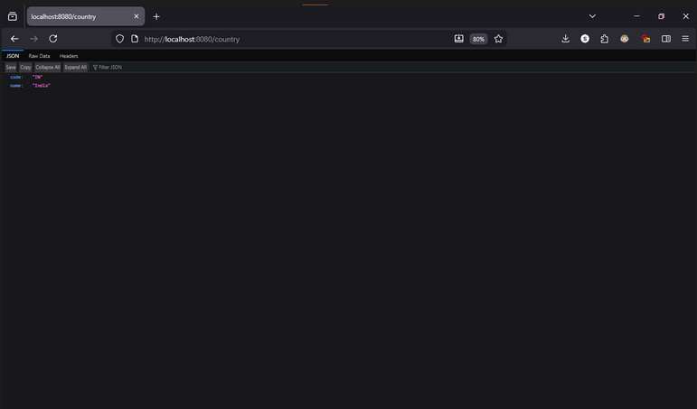For Exercise 5 (/countries/us):
