

**CZ4046 Intelligent Agents**

**Assignment 2 Report**

**Isaac Yang Lin Ramal**

**U1820798H**

Table of Contents

1. Player Design
   1. Code
   2. Methodology
2. Player Evaluation
   1. NicePlayer
   2. NastyPlayer
   3. FreakyPlayer
   4. RandomPlayer
   5. TolerantPlayer
   6. T4TPlayer
3. **Player Design**
   1. **Code**

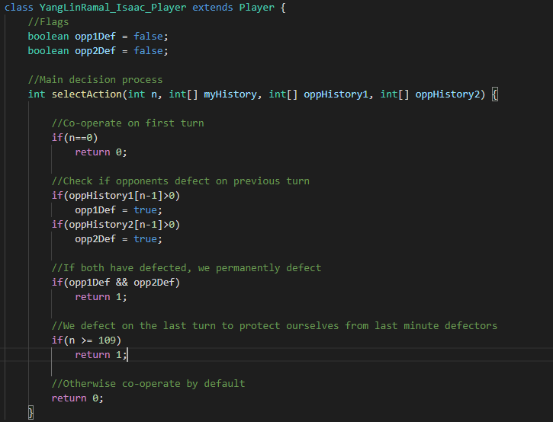

* 1. **Methodology**

**Rule 1: Co-operate by default**

Our agent will co-operate on the first turn. This is to check if our opponents are also co-operative or “nasty” players on the first turn.

If we were to defect from the start, it is highly likely that opponents will become defensive and start to defect as well. This would be overall a negative result in the long run.

**Rule 2: Keep our guard up**

Throughout the match, we watch our opponents moves and check our flags if they have defected. We start to permanently defect once both enemies have defected at least once.

We only wait for both other players to defect as firstly, a lack of tolerance will degenerate the match into a defection fest, whereas overly tolerant behavior will easily be taken advantage of.

Once we have defected, we do not give any more chances as it is likely that everyone has started to trend to defection and the cost of attempting to recover is not worth the possibility.

**Rule 3: We defect on the last round**

We only defect on the last possible round, i.e. n = 119. This is due to the fact that we will have a round where we are against either 1 or 2 copies of ourselves. Within that matchup, we should most definitely co-operate with ourselves to ensure the highest possible amount of points earned.

Any earlier timing to defect will result in the possibility that we will turn against our own kind and result in a net loss of points.

However, it is very likely that others will defect the closer it is to the last turn. As such, we must ensure our last turn is survivable by defecting. In the worst case, all other users would have defected. In the best case, all other users co-operated. Overall, it is a net positive as no repercussions would result from this action.

1. **Player Evaluation**

Fig 1 (Results of 100 tournament repetitions)

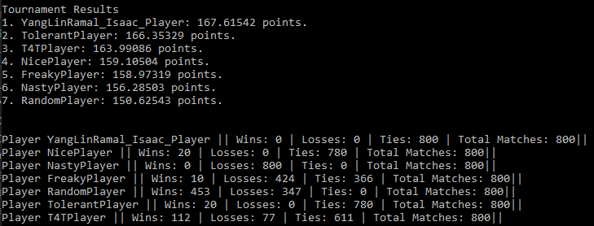

* 1. **NicePlayer**

**Me vs NicePlayer: 20 Wins 0 Losses 780 Ties**

NicePlayer constantly co-operates regardless of how both opponents have been acting. This can be taken advantage of by defecting. However, we only defect on the last round. Overall, we would be ahead by a few points when confronted with this type of opponent should the matches read n = 119.

In the viewpoint of the whole tournament, we will win NicePlayer due to the fact that it will always be taken advantage of by the other players

* 1. **NastyPlayer**

**Me vs NastyPlayer: 0 Wins 800 Losses 0 Ties**

NastyPlayer constantly defects regardless of the opponent’s behavior. While it may seem like a valid strategy from a statistical viewpoint, it is overall a poor method. This is due to the tournament being setup in a way that eventually you will go against copies of yourself. At that point, you will gain an overall much smaller amount of points as compared to co-operating.

We do not win against the nasty player due to the fact that it tends to defect from the first round whereas we attempt to give a chance to our opponents before defecting.

In the viewpoint of the whole tournament, we will win against NastyPlayer as it will tend to end up in a defecting match where a cooperative match will end up being more fruitful to all players involved.

* 1. **FreakyPlayer**

**Me vs FreakyPlayer: 10 Wins 424 Losses 366 Ties**

FreakyPlayer will decide whether or not to be either completely cooperative or defective right from the start of the match. On average, it will balance out between the two.

In those cases, it will either follow the playstyle of NicePlayer or NastyPlayer. This can be seen from its ~50% win rate against us.

This unpredictable behavior may seem enticing however, both manners of play eventually lead to it being taken advantage of or ending up in a defective match.

Against our agent, should FreakyPlayer decide to cooperate, as with NicePlayer, we will end up defecting against them in the last round to secure a lead. Should it choose to defect, we will observe the other players reaction before deciding to cooperate or to devolve the match into a defective one.

Overall in the tournament, FreakyPlayer will lose to our methodology simply due to the fact that it cannot maintain a cooperative relationship or it will constantly be taken advantage of.

* 1. **RandomPlayer**

**Me vs RandomPlayer: 452 Wins 347 Losses 0 Ties**

RandomPlayer decides on either cooperating or defecting each round in a match. This averages out to a 50/50 for each. Unlike FreakyPlayer, it constantly changes its decision regardless of the current match state.

This puts the agent in a losing position as it may allow itself to be taken advantage of in matches that have turned defective, or, turn a cooperative match into one that is defective.

Overall, we will have an easy time dealing with this style simply due to the fact that once we have defected, RandomPlayer will constantly put itself in a losing position to allow us to obtain more points.

* 1. **TolerantPlayer**

**Me vs TolerantPlayer: 20 Wins 0 Losses 780 Ties**

TolerantPlayer attempts to only defect should the amount of defections by its opponents surpass the amount of cooperation made. This is overall a similar strategy to ours, however it will return to cooperating should the opponents choose to cooperate again.

This is overall a decent tactic, however, in this environment, most players tend to choose one path or the other. As such, TolerantPlayer will be late to start defecting and also may choose to cooperate again even if it may put it in a losing position.

Our agent will pull ahead in cases where there is a cooperative match and we decide to defect in the last round.

Overall, TolerantPlayer scores very well and come in 2nd place due to its naturally cooperative methodology.

* 1. **T4TPlayer**

**Me vs T4TPlayer: 112 Wins 77 Losses 611 Ties**

T4TPlayer attempts to return the move of a random player in the previous turn. While in a 2 Player Prisoner’s Dilemma it may be a good tactic, within the tournament matches of 3 players, it makes a random choice between the two players to mirror. This puts it in situations where it may defect earlier than us or it may decide to cooperate for much longer than necessary.

We win during cooperative matches where we decide to defect on the last round, or if the other opponent occasionally chooses to cooperate and T4TPlayer copies them after we have chosen to defect.