Exam Paper – September 2007- Enterprise Database Systems - FT354/3

Please Answer Three Questions. All questions carry equal marks

Q1.

The DATA_DICTIONARY or SYSTEM_CATALOG, as it is also known, plays an important role in a DBMS, and in an Oracle DBMS as we have seen. What is the DATA_DICTIONARY? (10 marks)
Outline what type of information is held in the DATA_DICTIONARY, and the uses of this information. Give examples of the type of queries and information available. (9 marks)
What role does the DATA_DICTIONARY play in backup and recovery of a database? (6 marks)

Q2.

A vital part of managing and administrating a large database is that of Database Backup and Database Recovery. Discuss this statement outlining the key issues. (8 marks)
Also outline the options, and their requirements, available in implementing a Database Backup and Database recovery procedure with reference to the Oracle environment. (8 marks)
Outline the components of a Disaster Recovery Plan. (9 marks)

Q3.

Map the following Entity Relationship Model to a set of initial table design, showing Tables, columns, primary keys, foreign keys and unique keys. Draw the Relational Data Model. (8 marks)
Create a Table Instance Chart for each new table. Also show some sample data. (8 marks)
Show the SQL to create the three tables and their constraints. (9 marks)

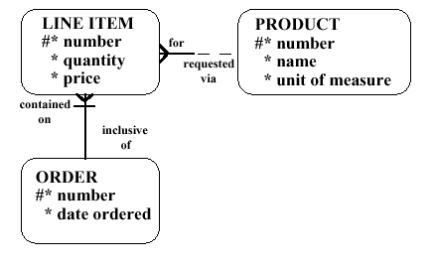
Q4.

(a) SQL statements can be grouped into 3 areas – DDL, DML and DCL. Outline the role of DDL statements, DML statements and DCL statements. Give examples of all statements. (9 marks)
(b) Outline the role of a trigger in maintaining a unique identifier on a table. What are the steps and requirements in implementing such a solution. (9 marks)
(c) What is PL/SQL? How can it be used in a database and in software development. (7 marks)

