AI-Assisted UAT Authorization Failure Analyzer
Evidence-based SAP UAT authorization diagnosis, minimum correction recommendation, controlled retesting support, and Change Management evidence preparation.
SCOPE | Diagnostic and recommendation assistance only. All permanent SAP changes remain subject to human review and the established Change Management process.

How the capability works
1. CAPTURE | 2. ANALYZE | 3. CLASSIFY | 4. RECOMMEND | 5. SUPPORT
UAT issue and exact business test step | Traces, logs, roles and restrictions | Authorization, other issue or insufficient evidence | Minimum correction or correct support route | Retest guidance and Change evidence

Inputs, analysis and outputs
Evidence analyzed  - UAT observation and test step  - User, system/client and timestamp  - Transaction or Fiori application  - Expected and actual result  - SU53 and STAUTHTRACE  - Gateway, OData and application logs  - Assigned roles and org restrictions  - Screenshots and defect details | AI-assisted analysis  - Correlates the technical error with the business activity  - Determines whether evidence supports an authorization root cause  - Identifies missing or incorrect authorization requirements  - Explains evidence, assumptions and information gaps  - Applies least-privilege and organizational restrictions  - Routes non-security issues to the responsible team | Standardized output  - Root-cause classification and confidence  - Supporting evidence and gaps  - Exact technical finding  - Minimum access correction  - Access explicitly not required  - Retest steps and expected result  - Permanent remediation recommendation  - Change evidence and audit record

Minimum correction details
Authorization object |  | Activity | Field value
Organizational restriction |  | Transaction | Service
Catalog |  | Target mapping | Role component
NON-AUTHORIZATION ROUTING | Functional | Basis | Workflow | Master Data | Integration | Development

Secure training and reference data
- Historical UAT authorization defects with reviewed and approved resolutions
- Anonymized SU53 and STAUTHTRACE results
- SAP Gateway, OData and application error logs
- Approved role designs, business roles and organizational restrictions
- SU24 authorization proposals
- Fiori catalogs, spaces, pages, target mappings and services
- Authorization-object and field documentation
- Approved Change Management records and retest evidence
- SoD rules, least-privilege standards and SAP Security policies
- Verified examples of configuration, master-data, workflow, Basis, integration and application issues
Data protection rule: Mask user IDs and sensitive business data. Use only verified, reviewed and approved organizational reference data.

Business and control benefits
✓ Faster UAT authorization issue resolution | ✓ Quicker separation of security and non-security issues
✓ Correct routing to the responsible support team | ✓ Reduced manual trace and log analysis
✓ Lower dependency on individual specialist knowledge | ✓ Consistent, explainable and evidence-based root-cause analysis
✓ Minimum-access recommendations that reduce overprovisioning | ✓ Faster and more controlled retesting
✓ Improved collaboration across SAP delivery teams | ✓ Standardized Change Management and audit evidence
✓ Stronger least-privilege and organizational-restriction compliance | ✓ End-to-end traceability of findings and recommendations

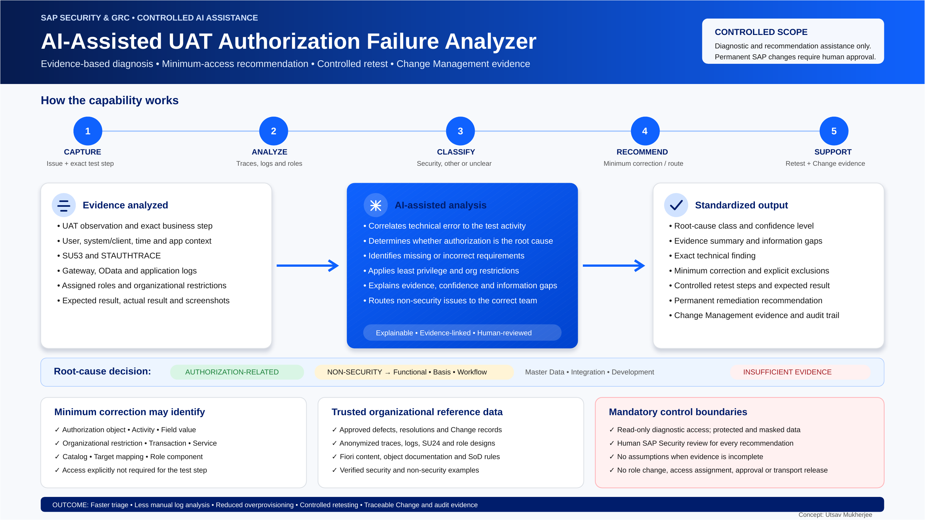

Mandatory governance and control boundaries
Read-only analysis  Diagnostic access only; no direct SAP changes. | Human review required  SAP Security validates every recommendation.
Least privilege  Recommend only access needed for the exact test step. | No assumptions  Insufficient evidence triggers a request for more information.
Protected data  Follow security, privacy, masking and retention rules. | Explainable decisions  Every conclusion remains traceable to evidence.
The AI does not modify roles, assign access, approve changes, release transports or implement permanent authorization changes in any SAP environment.

